Riding the Covid 19 Quarantine wave from Quito, Ecuador to Sydney Australia

Written by Dr Frances Black
edited by Diane Fisk
Copyright © 2020 Dr Frances Black
All rights reserved.
ISBN:

DEDICATION

Thank you Di for your wonderful editing of this manuscript.

I am so thrilled that Diane Fisk agreed to edit this book. We first met in kindergarten at Northbridge Primary School. Although there has been a big gap in our contact, it is so wonderful to be re-connected at this stage of our lives. I truly treasure our friendship and shared childhood.

CONTENTS

 | Acknowledgments | 7
1 | Quito- My Time for Testing my Limit | 8
2 | Re-acting and Responding | 17
3 | The Trip Home-My Time for Exhilarating Fun | 22
4 | Home | 28
5 | Quarantined at the Sydney Hyatt Regency | 30
6 | Friendship | 37
7 | Quarantined by Family at Manly and then Home at last | 39
8 | Conclusions | 45
 | Appendix-media Coverage | 51

ACKNOWLEDGMENTS

Thank you to all those, who supported me during this surreal experience. My love to my darling family - John, Nick, Katie and Olly and their special efforts to sustain me during my isolation.

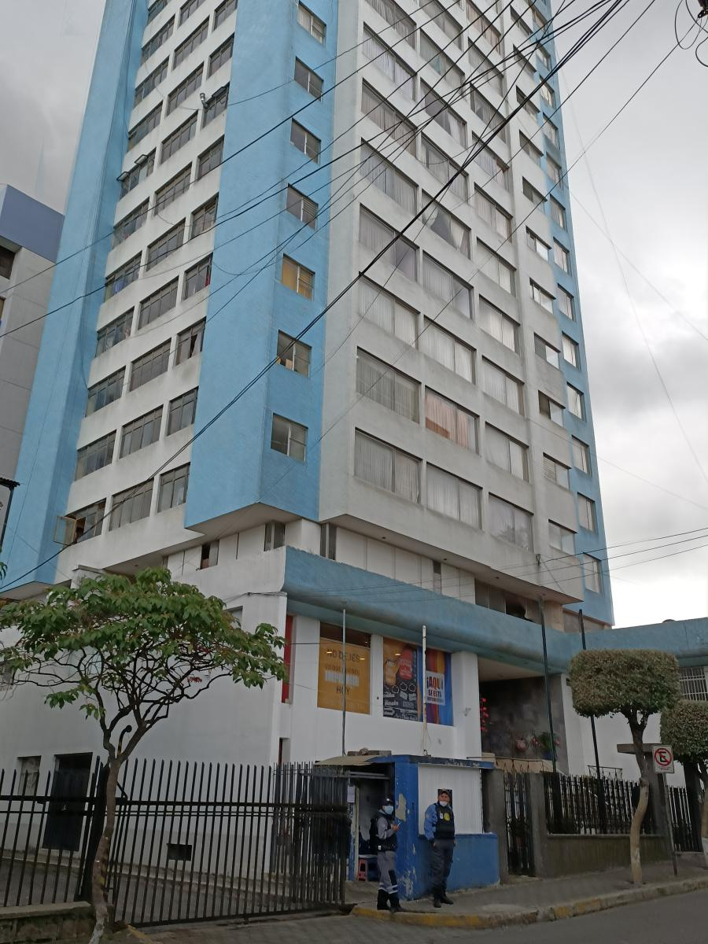
The apartment block where I lived in Quito

1 QUITO-My Time for Testing my Limits

There is an outpouring of emotion as the world reacts to the pandemic. Many extraordinary stories will emerge. I felt the need to record mine, as to me, it felt remarkable. At times I wondered if I was perhaps dreaming as my astonishing experience unfolded. This is a summary I wrote to family and friends at the time.

“I was one of the Australians stranded in Ecuador. I had just turned 70 and thought I could still handle an adventure. My adventure plan was to travel to Ecuador and live with a local family to learn Spanish. Two friends were to join me after this adventure, for a cruise around the Galapagos. Before we left, one friend cancelled as she has lung problems, requiring hospitalisation from time to time. Adding the possibility of corona virus to the mix was not a good idea.

I set off alone. My arrangement had been made on the internet. I was a little nervous about it eventuating as it had such a casual feel to it. I had not paid a cent and was told that Marcello would pick me up at the airport and drive me to his home, which he shared with his wife Olga. This is where I would live, close to school. All these people had received rave reviews on the internet. It was not reassuring to send the school head a message to say that I was en route from Santiago and to then receive a reply asking where I was planning to live. When I said ‘at Olga’s’, he replied ‘yes that is fine’. I got to Quito to find a message that they would not pick me up because I would have to be quarantined and they did not know how long that would be. I should phone when I had completed the quarantine. There was no quarantine, so I took a taxi to the house. When I walked in the door, I was greeted a little tentatively and Marcello launched into a speech in Spanish, the main theme of which was obedience and cleanliness re corona. I sensed a feeling of great fear from both he and Olga, so thought it opportune to tell them I was a doctor. That broke the ice. I spent the first day resting, as I was nervous about developing altitude sickness. I could feel my exercise tolerance was not as it usually is. The next day I chose to ride the hop on / hop off bus to get my bearings. As it turned out, that was the only sightseeing I was to do as the city was on the path to total lock-down. On the Sunday I walked around the local area and everything was closed. I was disappointed but attended school on the Monday and was delighted. I was the only student in the school and the teaching was excellent. The reason for the diminished numbers was that on Saturday the government had announced they were closing the borders.

The authorities gave a two day warning which was totally insufficient time for foreigners to leave. I was feeling somewhat unsettled, so right at the beginning I tried to get on a remaining flight. It was not possible. Reluctantly, my other friend cancelled as it was no longer possible to join me…… and of course our Galapagos trip was cancelled. My school was closed from Tuesday and I now spent two hours per day on Skype with my lovely teacher. I could have had more, but the lessons were very intense, so I kept remarkably busy with other activities, all in my room.

Let me describe Quito. I could only leave the apartment to go to the supermarket or bank. My hosts were more comfortable if we all minimised these outings. At first, I found this very difficult as there was so much I would have liked to see in this beautiful city with its magical ring of mountains. Olga told me that Quito is the little face of God - a beautiful image.
The streets were deserted, which to my mind made it safer than usual. I was worried about trotting down the street to the ATM to get a fistful of dollars and was planning on going to a covered ATM; no need now. Only police, ambulances and taxis were permitted on the road. There was a curfew imposed from 9 pm to 7 am which was a blessing as the normally noisy street was now beautifully quiet. The supermarket staff sprayed each customer with disinfectant and made sure each person was no closer than 6 feet to other shoppers. All businesses, schools, universities, churches…. basically everything except medical services were now closed. There was no public transport and you could be stopped and interrogated by police if you were outside. If the modelling for the disease was correct, then I believed Ecuador was leading the world in its public health response. I was unsure as to what the toll on the population’s health would be with this incarceration; so many people crowded into small spaces.

How was I feeling?

It had been a roller coaster as I tried to adjust to each new restriction and the implications. I had certainly imagined myself never leaving the place. I even asked my teacher about accommodation costs and areas for rental. I had been terrified as to what would happen if I got sick. It had been easy to imagine dire consequences but very frightening. In short, I had been experiencing an intense grief reaction, which I told myself I had to ‘fast forward’ in order to survive. I had to pull out all stops psychologically to deal with this. I felt very alone and isolated but had been well-supported by my husband and son. I was teary from time to time, particularly when speaking about home. The situation was not helped by sleep deprivation, a combination of altitude and fear. At the same time, however, I was really joying so many aspects of my existence there. I was programming myself to view it as a sabbatical, a gift, and an opportunity both for learning Spanish and for personal growth.
Adjusting to the dynamics that the three of us (Olga, Marcello and I) produced, required constant concentration and work. We communicated in Spanish which of course left room for error. I now know that I was so lucky on the day I walked in. Although, the school head, had told me months ago he had arranged my accommodation, he had not. When I sent my message that I was en route, he rang Olga and Marcello and pleaded with them to take me. They were understandably very much in two minds, as like everyone they were terrified. Luckily, their compassion won through. I learned that the reason I was not picked up at the airport was corona fear. I was hoping to leave the corona hysteria in Australia but not so. I think panic may be more of a danger to our health than the virus itself. They are both good people and Olga a beautiful caring earth mother. She believed that God sent me to be with them and her comfort to me was such that I shared her view although in a secular way. I learned that their family thought they were crazy to have let a foreigner into their house. I am sure most of the people I know would have thought the same.

My routine was pleasant. I did lots of exercise, learned Spanish and was very well fed and cared for. The couple have had students from age 33 years upwards with up to 10 staying at a time, so they were very accomplished and welcoming. These unusual times had just added much stress to the situation. No-one was allowed in the house other than the two of them and me. They were incredibly clean. I don’t think any virus or bacteria could have survived in the apartment! By day six of our ‘imprisonment’, I think we were all sick of it. At breakfast Marcello announced “no more corona talk”. I decided from the outset that I needed to be upbeat and jokey and keep out of the way. I assumed this confinement with a stranger in your home would become wearing over time. Fortunately, we were on the same wavelength re exercising and keeping busy.

Two days previously, Marcello had received a call from a 19 year old Dutch boy who had lived with them a few weeks previously and was returning from the Galapagos.
They were firm in their refusal that he would be unable to stay, but they did not feel good about it. They gave me his phone number, so this day was the first day I was able to speak to another foreigner in the same situation. His father had bought him a ticket for the coming Monday as there were four special flights over the weekend to Europe. He wondered if I wanted to join, so we were keeping in contact. I decided I would feel better when I knew his flight had actually departed. He was extremely nervous himself on that count.

Through all this I had been contacting our government in Australia as well as the local embassies. The support had been non existent. People spoke kindly but offered no help. During the last few days, my calls to the local Canadian embassy (our default one), were not even answered. Even in Chile our actual embassy seemed closed. I had been requesting an opportunity to connect with others in the same predicament, but this request had been ignored. I was sent a form letter in response, so I do not think my letter was read. Somewhere during this time, I lost email function and my family tech support had to guide me through a change to a new email provider. (The legacy of this is now further complicating the tortuous route through insurance compensation and refunds.)

John (my husband) was now helping me by contacting the local government member in Australia and trying to push things from his end, as was my son, Nick. I was heartened by the news that a rescue operation was being considered; fingers were really crossed.

Regarding flights, my original bookings had been cancelled and the travel agent had booked me on another option. However, I expected that to be cancelled closer to the date as there were no longer any commercial international planes flying. My travel agent suggested I research buses, but of course these did not exist as all the borders were closed. In any event, the trip would take three days and it was known to be very dangerous. At this stage, the only possibility was for some sort of rescue flight facilitated by our government.
I understood that other stranded tourists were living in hotel rooms, so I guess my predicament was similar to ‘the seven-star section of the prison’.

So…. back to the beginning…… this was evolving as a much more challenging adventure than I had initially anticipated and definitely not quite what I would have chosen! I was being truly tested; I was just hoping for a happy ending.

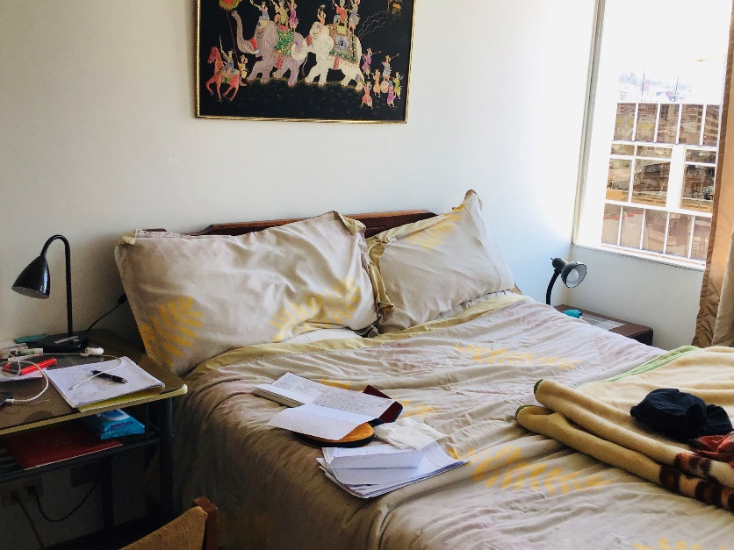
My bedroom in Quito

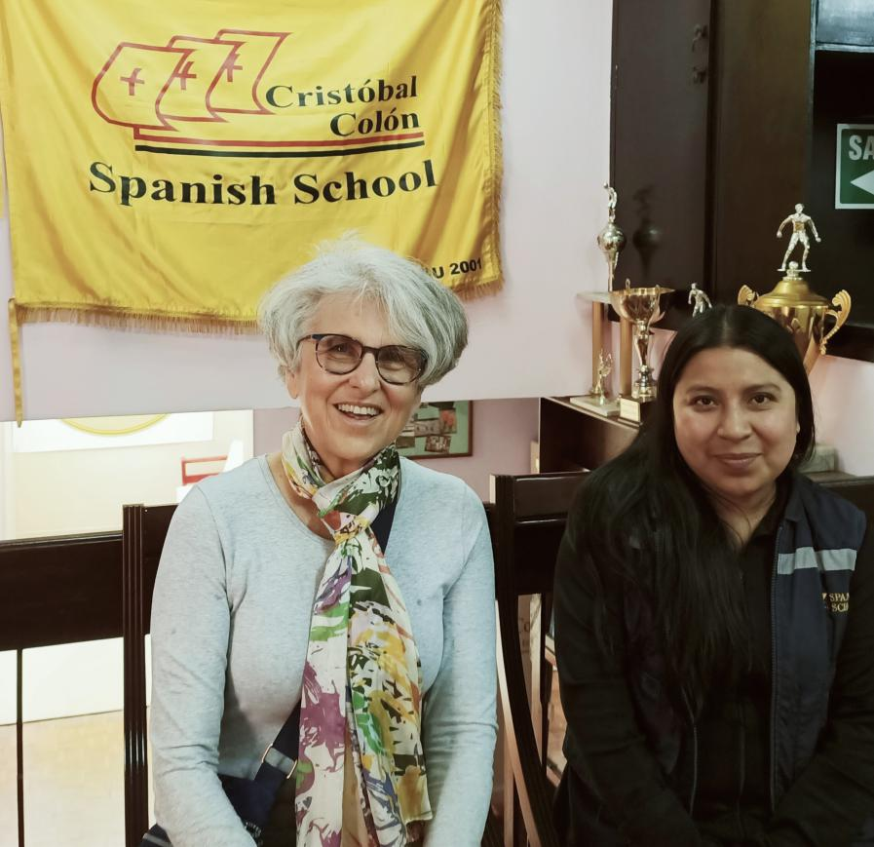
My teacher and I on the only day I saw her

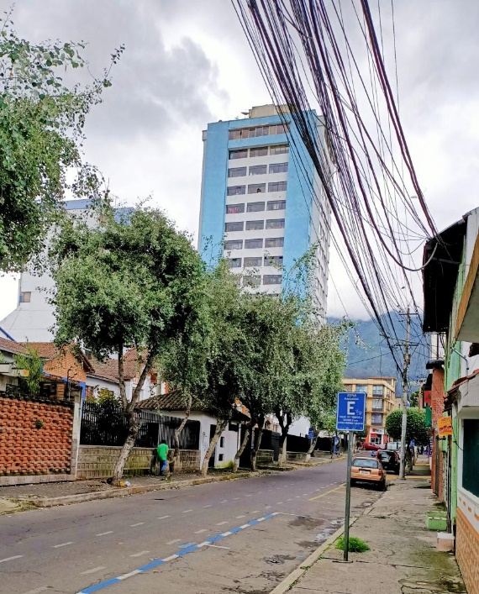
The street where I lived - very quiet during quarantine

2 Reacting and responding

At times I felt that the most effective way I could cope was to accept that Ecuador was my new home and that the Australian part of my life was over. So many people throughout the ages have had to live in places that were not of their choosing.

I was also conscious of the fact that I seemed to have split into a number of parts, each of which served a purpose in helping me adjust. The part I liked best was the joyful one, being able to enjoy the novel experiences I was experiencing. I was truly touched by the way my hosts treated me. It was exhilarating to be treated as if I were an eighteen year old student living with parents, albeit some twelve years younger than me. Marcello was the strict father who made and delivered the rules. His focus was on keeping the three of us healthy. As I learnt more about the virus, I felt his approach could not be faulted. He had quickly grasped the seriousness of the situation. He pre-empted the government’s edicts and from the very early days, forbade us (himself included) from leaving the apartment. Effectively, I had twelve days of strict quarantine before leaving Quito. In fact, moments before I left, Marcello videoed me to show I was leaving his care in good health. Like a caring Dad he told me on film, in no uncertain terms, that once I exited his door, my own health was my responsibility.

Along with my ‘dad’, there was the mum of the house, Olga, the epitome of a truly nurturing ‘Earth Mother’.

Olga and Marcello shared the cooking and Olga took great delight in show-casing typical Ecuadorian foods. Every morning my breakfast comprised a delicious blended shake of exotic fruits as well as two hard-boiled eggs and a roll accompanied by home-made jams. Dinner was always a soup and main course. It was impossible not to be influenced by Olga’s positive religiosity. She was quite convinced that God would take care of us. She believed that the only worthwhile legacy that the Spanish conquistadores had provided was Catholicism. She also had a great sense of fun. We danced to Latin-American music and every evening I translated jokes into Spanish. The adventurous part of me was delighted to be relating and coping with new people so well. My only other regular contact was my Spanish teacher, a twenty something, intelligent woman, whom I spoke to every day on Skype. She was extraordinarily compassionate and wise. I felt blessed to have such special people in my life.

I also enjoyed my daily routine. I exercised, danced, studied, played a bit of bridge, drew and meditated. As time progressed, I felt it was in my best interest to spend an increasing number of hours on trying to get home by telling my story to the media. The experience of that process was like a roller coaster; up and down. One minute there was a promising solution, the next it was gone. The part of me involved in that process was ‘the problem-solving’ part. I do love finding solutions and making plans. When the plans crashed, as they did, I felt a loss for a short time but then quickly made new plans and got on with it. Both these parts of me felt focused and calm. I told myself I would do what I could to influence the outcome. Given the reality of failures, I accepted that my power to influence was limited.

The final part of me that was definitely unpleasant, was the part that kept catastrophising. Things would get settled and this part would hone in with a series of undesirable “what ifs?” I realised that up to a point, this served a purpose. Imagining dire consequences led to solutions and jettisoned me into productive action. However, I had to work hard to lessen the intense fear that was part of this. Meditation was the key.

My sleep was affected profoundly. The first few nights I hardly slept. I recognised the short, hallucinatory intensely coloured dreams that kept me awake as the result of sleep deprivation. During this period, I managed 3 to 5 hours sleep every second night and fortunately felt energized after those nights.
On the days following near to zero sleep, I could still concentrate on my lessons; the concentration was a form of therapy. However, my speaking was slower than normal, and it was harder to hold it together emotionally. There was such an absurdity to have flown around the world to be locked in a room doing on-line activities that could so much more easily be completed at home.

There were other opportunities in the experience.

I was getting an intense glimpse into what displaced persons facing uncertain futures experience. During my catastrophising phase I imagined my family dying in Australia and funds drying up so that I would end up begging on the Quito streets. A more realistic worry was falling sick, (not necessarily with Covid) and being mistreated. It was obvious that in this climate, my medical evacuation insurance had no chance of occurring. I thought about Julian Assange and the downward trajectory that his life has taken. I consoled myself that I had had seventy good years and would cope with whatever followed. Initially my plan was to get to acceptance and enjoy the ride. The fast and furious pace of change adversely affecting me meant that I had to change this focus. I had to be pro-active.

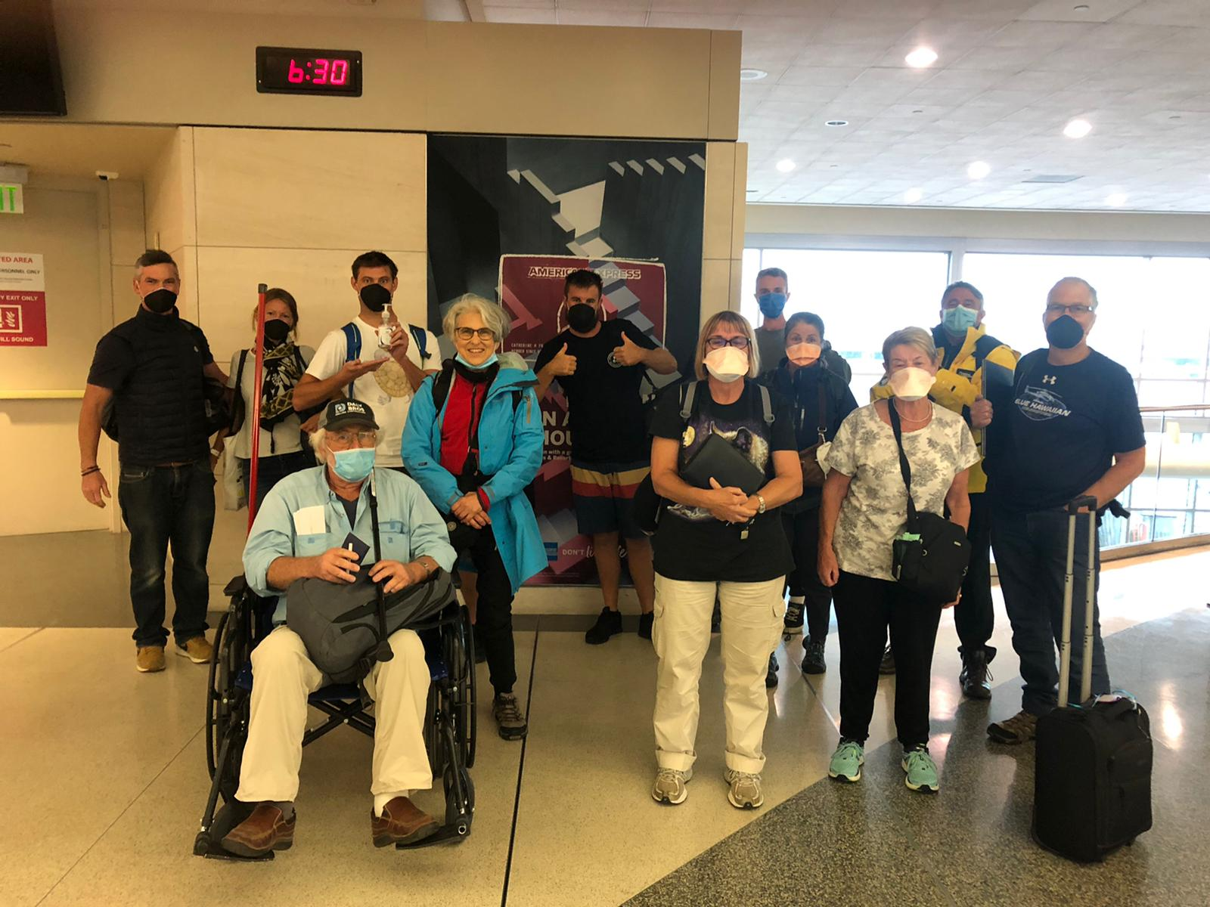
Returning home with fellow Aussies at San Francisco airport

3 The Trip Home - My Time for Excitement and Then Fun

I had problems that needed action. First stop was the local embassy and Smart Traveler in Canberra. Contacts with these departments were seriously disappointing. At first, I managed to speak to actual people who made it clear that their role was not to help. Travelers were on their own. These officials did not seem to understand that there was no way of leaving. The worst aspect of their desire for non-involvement was that they refused to give information, so that stranded Aussies could connect and share information. When I suggested that an opt-on list be created, I was told this would transgress privacy, which did not make any sense. I realised that my complete isolation from other tourists was probably unique, but I could not get this through to the Embassy staff. It felt like I was talking to robots who could not understand concepts but could just repeat pre-programmed meaningless phrases.

Finally, after about a week, things started to change. My son in Australia discovered that two relevant on-line Australian groups had been set up. One was called ‘Aussies Stranded in Ecuador’ and the other ‘Aussies Stranded in South America’. Even better, was the fact that the Ecuador one was managed by a man with whom my son had worked. Now, I could at least communicate with people in the same ‘boat’. The group was pro-active and was giving the support and problem solving that we had expected from our Embassy . They were really filling the gaping hole left by our government. Suddenly flights started appearing on line; the long latent period was broken. I am not sure if the lobbying work that so many of us undertook with media and local politicians had a causal effect. Several my friends contacted their local members on my behalf. A state member of a Sydney electorate wrote the most supportive, kind email that brought tears to my eyes. I assume our government had negotiated with the USA to make spaces available on the rescue flights they had put together for their own citizens. Flights that criss crossed all over the US taking five to six days to get home were not cheap. Horror stories of people buying tickets for non-existent seats abounded. At that point I thought it wisest to stay put. I decided my best option was to accept my destiny and relax into making my life here for the foreseeable future. Just as I thought I had found calm acceptance, I received a call from Ross, my son ‘s friend, to say he had found one of these horrendous sounding flights which would take 5 days and was at a good price. He had reserved a seat for me. My first reaction was ‘I don’t think I want this; I’m enjoying my equanimity’. I was finally comfortable digging in for the duration. I did not have a current ESTA to allow me passage through the USA. Ross told me this would now be approved in a few hours. At that stage I told Ross I would go online and let that determine my decision. As I dialed in to ESTA I could feel myself relaxing at the thought of going home; that was what I really wanted.

Within the hour my ESTA was approved. Meanwhile Ross had found a much better connection with shorter travel time. So began the wonderful care I received from Ross Turner, his wife Jodi and her brother Matt. I knew that as soon as my son, Nick, had put me in contact with Ross he had visibly relaxed and said “mum you’ll be right now. Ross is an amazing operator.” Never a truer word spoken!

I was nervous telling my hosts I was leaving the next day. Just as they felt a responsibility to me, I felt one to them. As far as I could work out, I was their only source of income. My worry was misplaced. The look on their faces was one of joyful relief. It was their sense of responsibility to me that was keeping them at home. Once I left, they planned to stay with their daughter and her family. They were happy for me in that I too, would be claiming my place with my family in my own country.

They were aware that my son and family had moved into our house and were currently living with my husband. I now felt under pressure that my trip home would eventuate. I had burnt the bridge of my safe haven.

On the morning I was due to leave I sat at breakfast with them, feeling I had the lead role in an action movie. What would the outcome be? Would the flight depart or would I be stranded? My catastrophising brain sprang into action - what if the USA discriminated against the elderly and wouldn’t let me in? Currently, in Quito no-one over the age of 55 was permitted to leave their home. They had to rely on younger people to do shopping for them.

I felt tense as the moment for my taxi pick-up approached. I had to firmly will myself into ‘observer role’ as I patiently explained the arrangements to Marcello in Spanish. He decided to improve them. I was not to wait in the foyer with security. Instead the taxi-driver was to alert security who would then contact me. As already mentioned, just as I was about to leave, Marcello decided to make a video. He pressed ‘record’ and I made a thank you speech in Spanish. He then responded. He wanted my husband, John, to see that he had fulfilled his responsibility; I was leaving his home in good health. Like a good father he reminded me that once I crossed the threshold of his home, I was responsible for my own health and actions. It was touching.

In the foyer I met my travel companions for the first time. Another layer of relief peeled away. The beautiful, rural drive to the airport passed quickly as we got to know each other. We had all sorts of official papers, none of which were needed for the cursory check at the airport. The airport was closed as it did not open until two hours before the flight.
The food-court opposite was overflowing with people. As we walked in we were greeted by friendly US embassy staff who were there to support their departing citizens. We learned that the US embassy has a staff of two hundred in Quito while the Canadian, which functions as our de facto local embassy, has three. No wonder our government was so slow to respond compared to that of the USA. We had been sold seats on a US repatriation flight. There was not a single spare seat so no social distancing on this leg. Whilst waiting, I enjoyed wandering around the food court chatting to various people and hearing their stories. The most noticeable group of people was a large contingent of attractive, young, conservatively dressed US citizens. The men wore white shirts, ties and suits and the girls, an assortment of long colourful dresses. We learned that they were Mormon missionaries fleeing danger. They were playing board games and having fun. The two hours passed quickly. I really enjoyed a meal with more chicken and meat than I had eaten in the preceding two weeks in total.

As we sank into our plane seats it did not matter that they were the smallest and most uncomfortable that it would be possible to design (think Tiger, Jetstar). Another layer of relief set in and yet another layer of anxiety peeled off as we landed in Houston.

I have a soft spot for the US having spent a year there as an exchange student attending the final year of high school. The interaction I was having on this leg of my adventure was so reminiscent of my first overseas trip alone, en route for my year in US when I was sixteen. The group I was travelling with out of Quito were thirty somethings. We were having such fun and I really felt as if I were young again.

The transition from the airport to our Houston Hotel went smoothly. As we were able to check our luggage through at Houston airport for the flight the following day, we really felt we would get home.

The hotel interlude was a wonderful respite; a little overshadowed by the necessity of being aware of corona precaution, as we were travelling through the world’s corona epicentre.

The shuttle and included breakfast were cancelled due to Corona. Only packet foods were available. I cooked oats with water in the microwave and added a small container of horribly sweet hazelnut flavoured milk for an interesting breakfast. As I hadn’t been outside for a fortnight, I decided the best thing I could do was to take a long walk. It was wonderful to walk on the grass amongst little pink flowers. I wandered through a community, inspecting the schools, an enormous stadium and a baseball field. I felt I had slipped back into my year as an exchange high school student in Ohio. The landscape was flat, green and the school architecture virtually identical to my high school in Akron, Ohio in 1967.

A wonderful part of this whole experience had been feeling the years peel away as I returned to the emotions of that earlier adventure. Excitement, trepidation and wonderful camaraderie; such a heady mixture. I was enjoying feeling sixteen with the wisdom and experience of a seventy year old.

Even though we arrived at our airport connections early, the time passed quickly. In the heightened emotional world that we were inhabiting, a near empty airport was a pleasant place to be. Other than the overhanging concern of touching, washing and disinfecting, the physical atmosphere we were travelling in was very good. Our flights after Houston were empty. We each had our own row and for the final leg I was business class and had a comfortable bed in which I slept really well. Once we boarded that homeward leg, I really felt the reunion with my family was within reach.

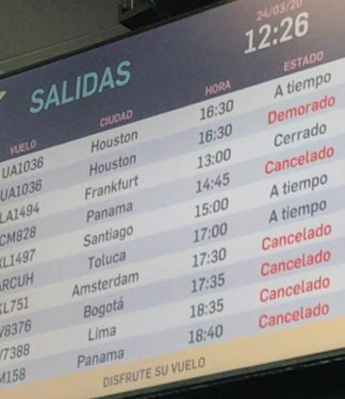
Quito airport showing more flights cancelled than actually going; we were lucky

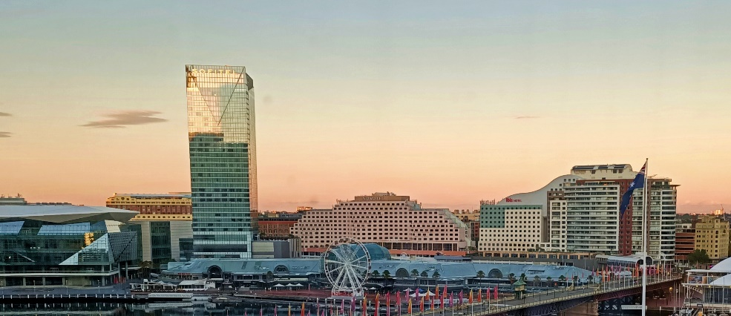
View from my Hyatt room - beautiful Sydney

4 home

The unmitigated joy of returning home had a déjà vu feel to it. The first memory related to returning home as an exchange student after a year away. The second memory was when my husband and I returned home after ten months of travelling in Europe. On that occasion we had an adventure too. Our flight was delayed in Rome and then again in Singapore. In those days the airline provided 5-star accommodation. As twenty somethings we were not complaining. Just as happened with the Quito rescue, we formed a lovely social group and had fun over the five days it took to get home.

As on the previous occasions, I felt such pride and love for my country when I arrived home. I have to admit over the last number of years the filth of Sydney Airport and surly laziness of the staff has been disappointing. Sadly, such a contrast to arriving in Perth or Japan; both airports are clean and the staff so helpful.

However, I am pleased to say that on this occasion, Sydney met the standard. The bathrooms were actually clean and border staff efficient, pleasant and even prepared to joke. It took about four and a half hours to get from Sydney Airport to my quarantine hotel room. The time passed quickly as it was interesting and fun. We were arriving on the second day of the gigantic and unusual public health manoeuvre of quarantining all in-coming overseas travellers for two weeks in hotel rooms at the government’s expense. Family and friends had warned us to expect chaos, as that was how the media were reporting the event. It was impressive to see how all the chinks had been ironed out. I felt we were in the hands of professional experts - the police, border control, army personnel, bus drivers and hotel staff. The ANZAC spirit was alive and well. Our bus driver was a real sweetie. He had been recruited from the Sutherland Shire and had no knowledge of city geography or hotels. He didn’t need that as the long line of buses travelled in convoy shepherded by the Federal Police. He was as excited as we were when he learnt our final destination was the Hyatt Regency.

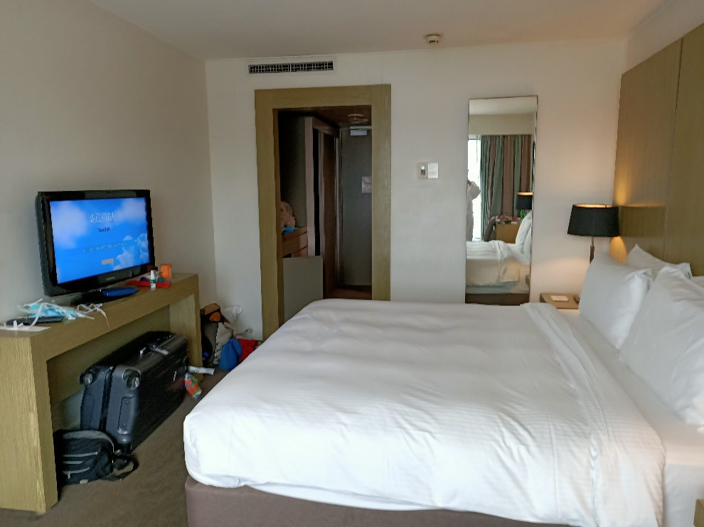
My Hyatt room-home for 14 days

5 Quarantined at the Sydney Hyatt Regency

I was escorted to my room by a policeman and told that under no circumstances was I to cross the threshold; no-one else was to enter.

The room looked like heaven to me. It had a beautiful westerly view over Darling Harbour opposite the Maritime Museum. I recognised a friend’s yacht moored outside the museum. I felt grateful.

The configuration of the room made it easy for one person; I do not think it would have been fun to be sharing the room. The bed was superbly comfortable, and there was a desk, an armchair and coffee table. It was not dissimilar to my bedroom in Quito. In Quito I had access to fresh air and could stick my head out of the open window. It was wonderful to feel the sun and fresh air. In Sydney my window did not open. I was insulated from the warmth of the sun and the noise of rain and wind. I was not going to let that small detail worry me.

I relished the idea of living in this space alone, free to do whatever I wanted when I wanted. Not everyone has this reaction. En route, I met a lady who was very keen to share a room with me both in Houston and in quarantine; not an attractive proposition especially with Covid 19. I am sure my husband and I would have opted for our own rooms, if we had been sharing the 14-day hotel quarantine experience!

As the door closed behind the policeman, I inhaled the delicious aroma of privacy, security and luxury. My first moment of the sabbatical I had been trying to achieve as a way of adjusting to events in Quito had truly arrived. In Quito the process had been interrupted by anxiety and the concerted effort to favourably influence the outcome of the trap I found myself in. The anxiety was removed. My first step was to unpack and shower. I threw the clothes I was wearing into a plastic bag. Their next port of call would be my washing machine at home. As I showered, I realised I did not have to wear clothes during the fourteen-day quarantine. I actually could keep my case full of clean clothes freshly washed in Quito by Olga. In my room I had unlimited access to fresh clean soft towelling robes which would keep me warm if required. This realisation had a liberating effect. In fact, this decision, which I confided to a journalist the very same day, became the heading of the article she wrote about me. It read “Naked Truth for those in Quarantine.” The article resulted in some funny emails from various groups that I normally meet with. The ukulele group were in the throes of organising Zoom meetings and were wondering, if I would attend naked.

The food arrangements at the Hyatt suited me well. We were given a special room service menu and a generous budget of $90 per day. There were plenty of delicious and healthy options available. Halfway through my ‘stay’, they added two delicious cocktails to the menu. I decided to allow the quarantine experience to drive me to drink. I am normally close to a tee-totaller. On two consecutive afternoons I chose a cocktail afternoon tea. I was quite drunk after both and took to my bed to prevent doing myself an injury. I loved the way the food was delivered; a knock on the door and by the time I had opened the door the delivery person had sprinted out of sight leaving a brown paper bag of food in disposable containers. Service was excellent and if there were significant mistakes, a phone call resulted in a quick rectification. I felt very spoilt. I had unlimited access to fresh towels and linen but had to make my own bed.

Every other day a cake box full of treats was delivered to the door. It contained chocolate, fresh fruit, muesli bars, chips and nuts. My eyes teared up with the abundant kindness so in evidence. A daily phone call with a nurse who rang to check how I was resulted in a ‘phone friendship’ that kept me well-informed about how the system operated should a person develop Covid symptoms or other illnesses in quarantine. I took a few courses on epidemiology and Covid from John Hopkins medical school in the USA.

There are so many ways to keep busy in the electronic age; I was in love with the way the world opened as I sat in splendid isolation in my hotel room.

I saw my first job as thanking the government for implementing a quarantine programme so humanely and efficiently. I felt compelled to make this a priority as my media coverage during my trapped phase in Quito had included severe criticism of the government. The frustration of being told to get yourself home from a country with closed borders was extreme. I had called the government cruel and callous to give this useless instruction. The Australian government seemed to be continuing the tradition of Marie-Antoinette when she allegedly told the starving masses crying for bread to eat cake. Getting the media’s interest to compliment the government was less successful than appealing for their assistance when criticising the government.

By contacting my local member’s office I was able to personally thank them for responding so promptly to my husband’s cry for help and they also passed a letter to the Prime Minister for me. I was thrilled to receive a personally signed reply from the Prime Minister. Once my ‘thank yous’ were out of the way I felt ready to continue with other projects.

I started the day with meditation and then a yoga sessions followed by my physiotherapy exercises. Breakfast was followed by a cappuccino and then writing this tome. I busied myself with a bit of work to help my son. Following this I did my second bout of exercise which was aerobic and weight training. I used bottles of wine as weights (at 375ml they were a bit light on).

Then it was time for my lessons; always a Spanish one and depending on time and mood I chose between art, ukulele and various on-line university courses. Interspersed, were phone calls from other quarantined buddies, family and friends. I prepared a list of activities to do with my four-year-old grand-son on line; these were generally story-based. Being a life-long lover of food, I very much enjoyed lunch, dinner and yummy snacks.

In the evening I wound down with Netflix in Spanish or reading. Finally, Tai Chi and then I fell asleep about 7.30pm.

It felt like undiluted “me time”; truly a sabbatical, a wonderful holiday. I was content and grateful.

The university on-line courses I chose were to better understand the 1918 world pandemic as well as the current Covid 19 one. In 1918 the combination of world war and disease was truly horrific. A course on the underlying epidemiological principles that determine our understanding and drive our reactions to pandemics makes it easier to cope. I prefer this information to the day to day emotional media coverage.

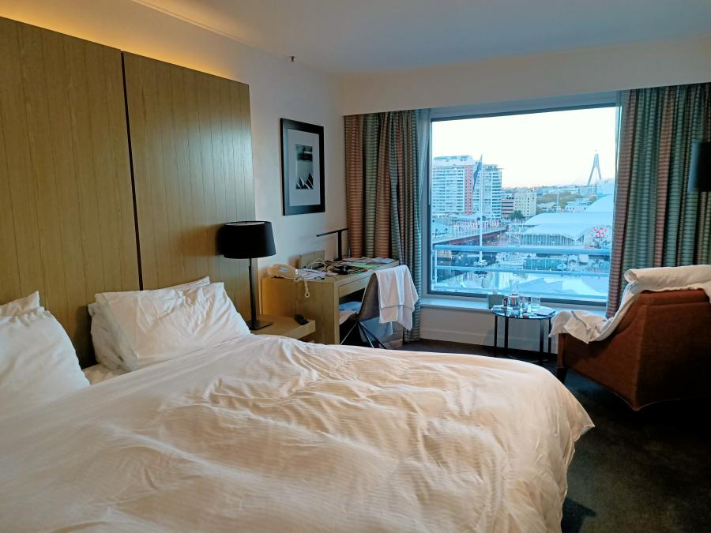
No fresh air but I did not let that worry me.

Food-glorious food
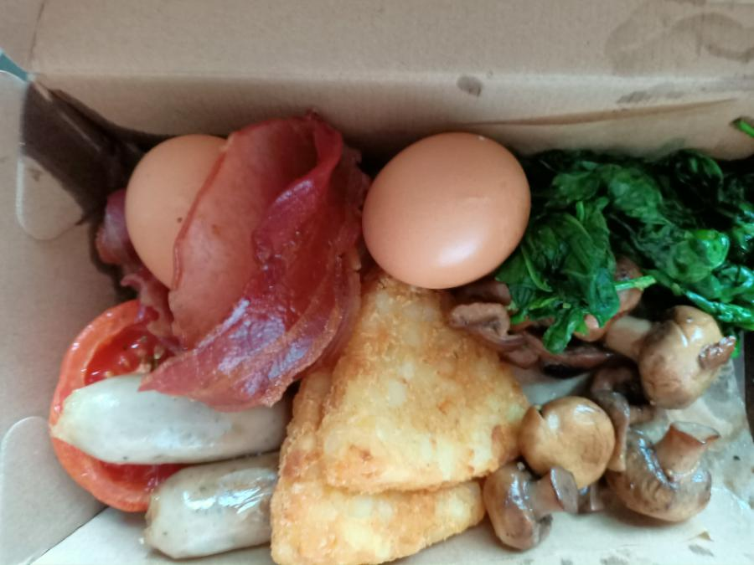
My first meal at the Hyatt and below, one of the second daily snack treat boxes
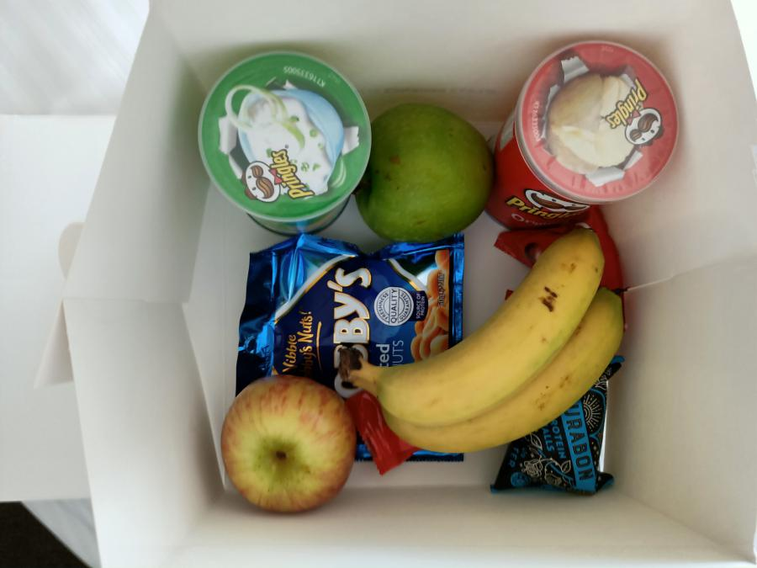

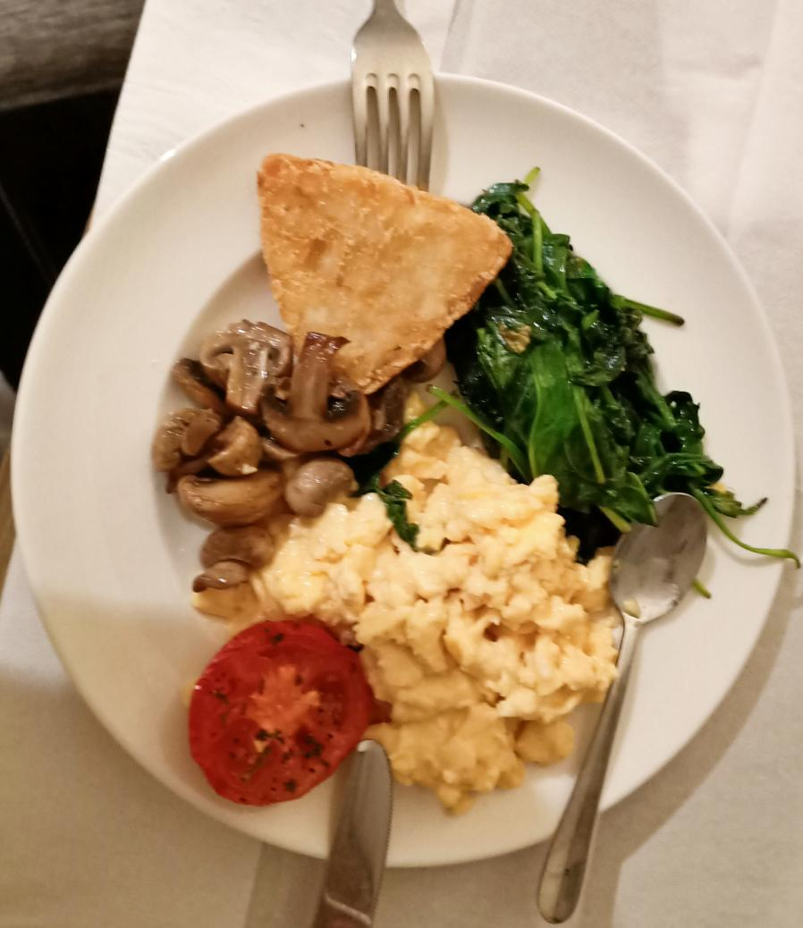

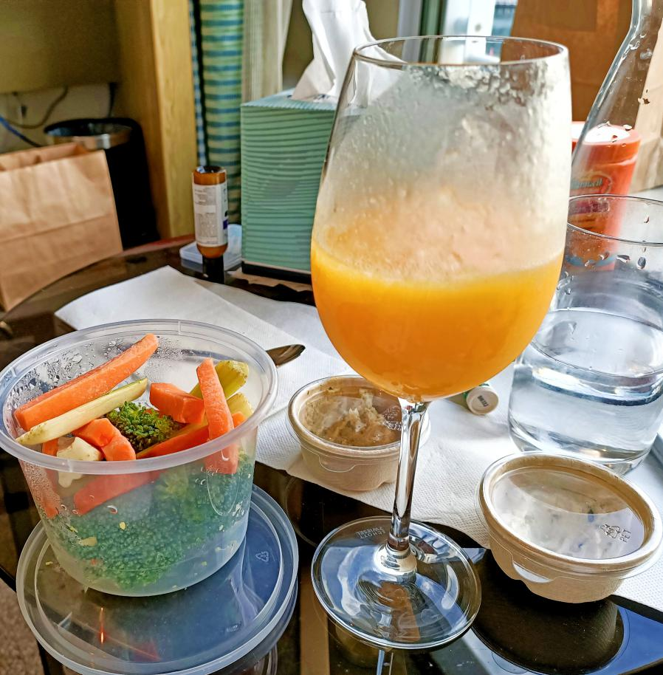
More delicious Hyatt food
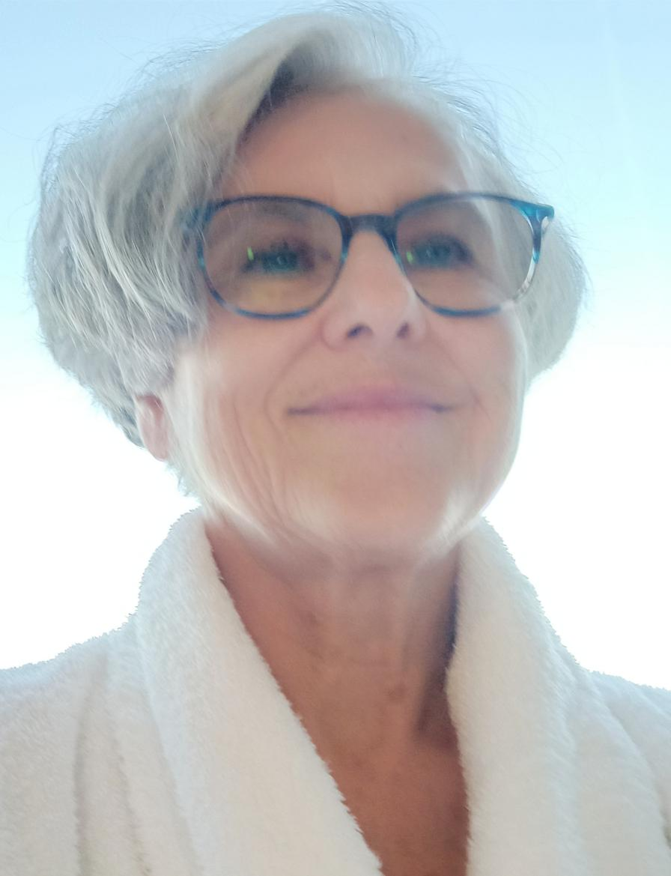
Dressed for a day at the Hyatt

6 Friendship

When the chips are down one learns so much more about one’s relationships and friendships. The last six years have given me ample opportunity to do this. However, although I have had a number of physical and emotional hurdles to accommodate, I try to be mindful of how small my problems are in the scheme of things.

In this particular episode, once it became apparent that I needed help, my husband, John and son, Nick slipped seamlessly into their roles to save me. I have a local friendship group and approached one of them to help me spread my media message. She did so well supervising those interested in assisting.

As word about my plight spread, I started to receive lovely messages. In Quito I found these incredibly helpful. I tried to acknowledge all of them by email, as I was often not in a space to talk to people other than family. I was particularly buoyed by daily jokes from one friend. These I used to translate into Spanish and share with Olga at dinner. She would contribute the ones she had received. It felt therapeutic. The irony as it turned out was that I was impressed that my friend had chosen to send me jokes rather than words. I attributed this to a sensitive understanding of my plight. One of the first calls I made when I hit Aussie soil was to phone and thank her for this sensitivity. She replied that the first she knew of my being stranded was this phone call. She had not taken any notice of my writing to tell her I was translating the jokes into Spanish. Her reaction to my call, was to berate me for my foolishness in travelling. In her defence, once she had time to respond rather than react, she apologised and explained her reaction was due to her shock at the danger I had been in. I had no difficulty forgiving and understanding. I also realise many people may have thought the same as this friend and believed I had travelled when restrictions had started, which was not the case.

7 Quarantined by family and then home at last-my time for family connection and love

My third quarantine was set-up by my family, who did not trust the arithmetic of the government in setting up the quarantine period. Having brought myself up to speed with the state-of-art knowledge on Covid 19, there were, unfortunately, a number of possibly significant unknowns in the equation and reasoning informing government decisions. The biggest problem was that there were not enough kits to test all those who should have been tested. Current estimates that 30 to 50% of Covid 19 positives had no symptoms was a real worry. At the point of my government quarantine, only those with at least two symptoms could be tested. This meant that the statistics the government was amassing were more likely optimistic than realistic. I was looking forward to this final quarantine phase. After this I would return with great gladness to the bosom of my precious family; my husband, my son, my daughter-in-law and grandson. I would try to make up for my deficit in not being home to do my share of caring and nurturing.

My son Nick, collected me from the Hyatt Hotel and delivered me to the amazingly comfortable two-bedroom unit in Manly owned by their good friends. It felt strange to leave my secure ‘isolation’ and enter the real world.

After unpacking, I walked for a few hours. Although I had not actively missed being outside, it felt good to be in the fresh air. I marvelled at the beauty. Nature was thriving, maybe even celebrating, whilst man suffered.

My plan was to walk 3 to 5 hours daily whilst in Manly. The weather was wonderful and each day felt joyful. My walks were mainly on bush tracks and dirt roads around North Head. The views of Sydney Harbour and the Northern Beaches were superb. Until the local beach was closed, I followed my walks with swims. The family had supplied all my food, so no need to shop.

On a number of days, I packed a picnic. One highlight was finding a photo of John’s father’s (my father in law’s) regiment in New Guinea on the War Memorial walk at North head. It is a fitting tribute to those, who fought for Australia.

Another highlight was meeting the pleasant man who makes the Queen’s carriages in an unassuming shed on North Head. The magic of my sabbatical continued. After five days I drove myself home and was greeted warmly but most effusively by my four-year old grand-son, whose delight I so much shared. He told me he had missed me. I arrived in time for my husband’s delicious home-cooked birthday dinner topped by a wonderful chocolate cake baked by my daughter-in-law; a definite change of pace during this next phase of Covid 19 quarantine. During the next three weeks we enjoyed the privilege of living together with our son, daughter-in-law and grandson. They had been with my husband for three weeks already and the three adults had everything under control. I was very impressed with the attention to important detail that they had developed. Our son and daughter- in-law worked at our home and we looked after our grand-son while they worked. Fortunately, our home is large enough to do this in style.

We have been asked to provide pre-school experience, as Olly (our grandson) will be with us until his parents feel more confident about him re-entering the pre-school environment. His teachers have provided us with great on-line resources. It was a very busy time and lots of fun. I feel so privileged to have had this opportunity. I found the family impressively well-organised with regular food deliveries and all of them cooking up a storm. We see no-one other than a few neighbours at a distance when we go down the back of our property. Olly stayed two nights in a tent in the backyard, one night with his mum and one with his dad. On both occasions we sat by a camp-fire eating damper and marshmallows. It felt like a wonderful family holiday.

After three weeks we moved into the next phase, which was helping them move into their new home in Northbridge. We stayed the Mother’s Day weekend helping them unpack and sharing their joy. I walked with Olly to what was my, and now his, primary school and we explored the caves I had discovered as a child. In this phase, Olly spent three days per week with us. He will continue his Ba-Nanny pre-school experience. I stay with them until the weekend. It was wonderful to watch him learn and understand; an unfolding flower.

Thus far, I feel the pandemic has changed my life for the better opening my eyes to new ways of enjoyable living.

Views from my North Head walks
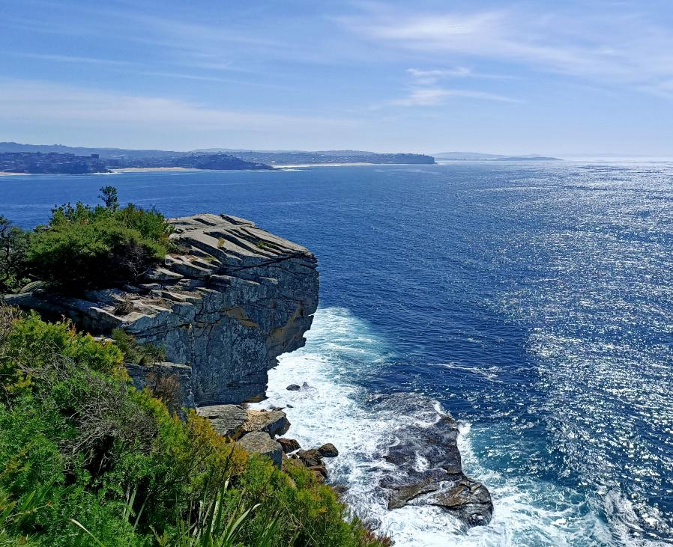
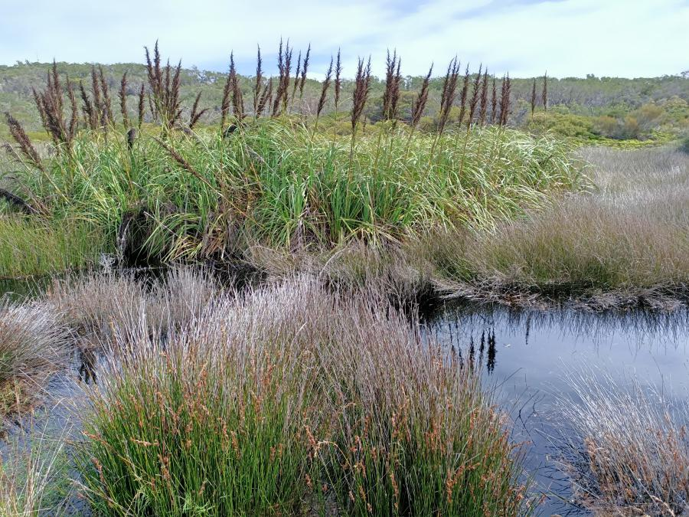
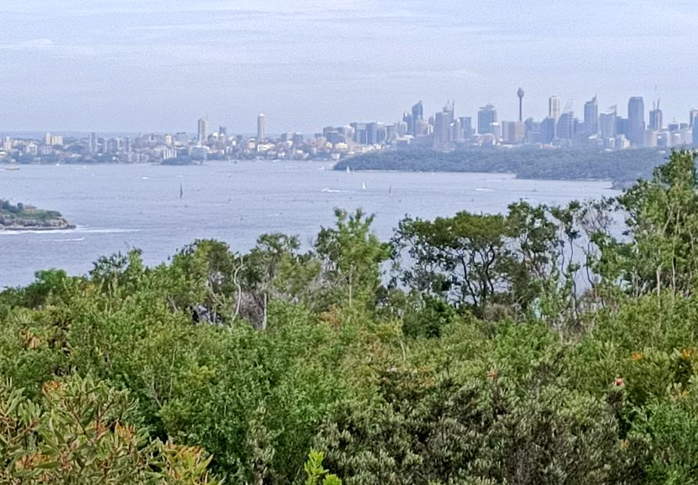
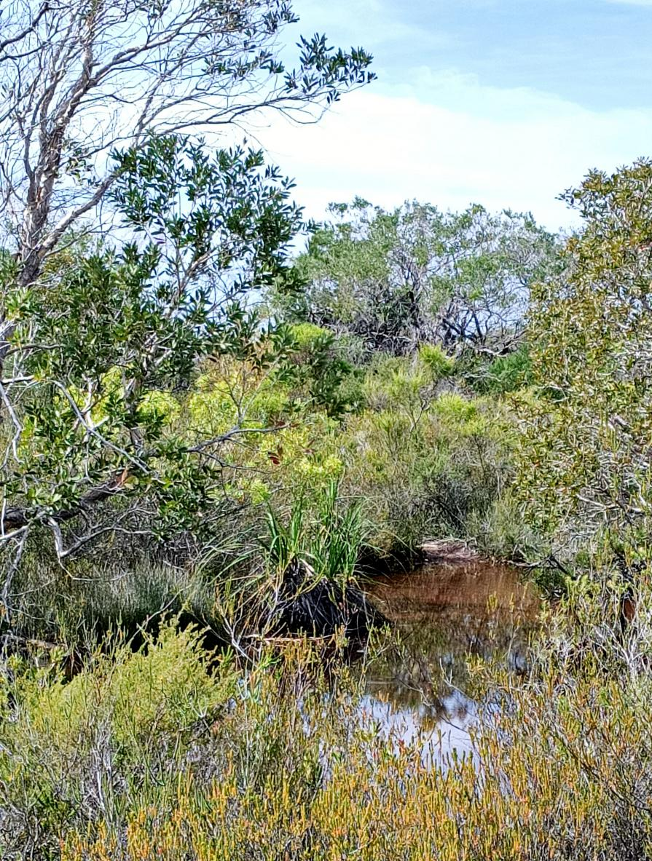
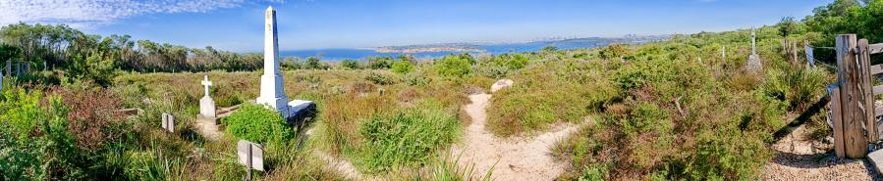

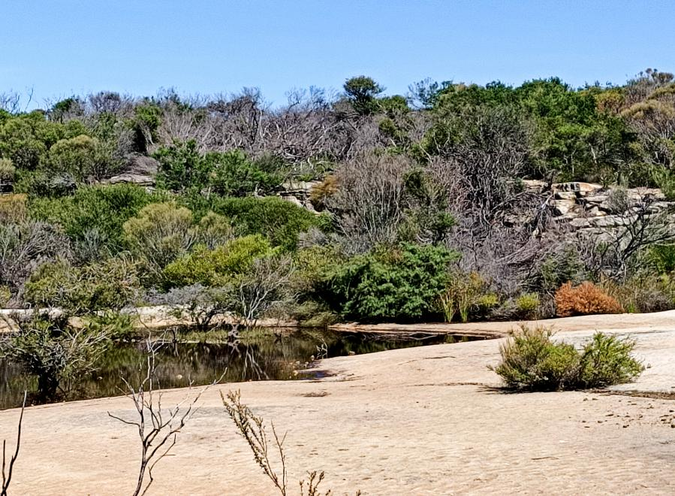
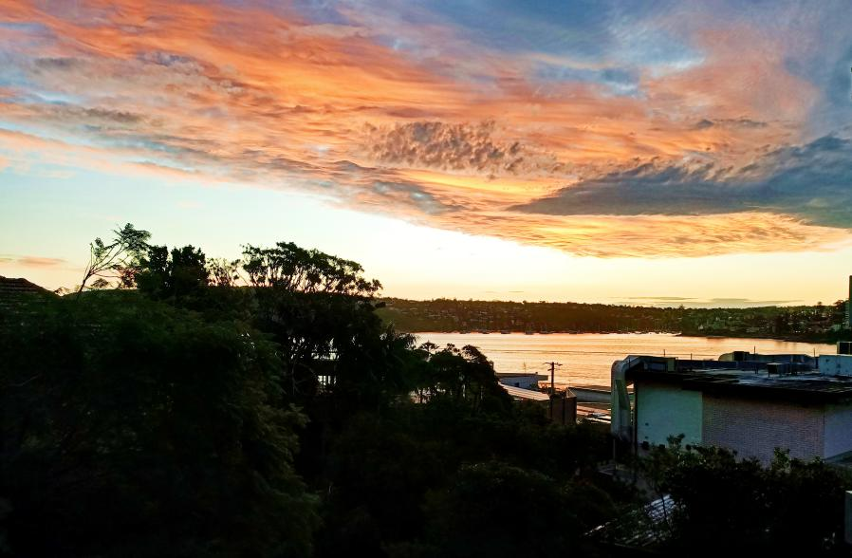
The sunset from my Manly apartment
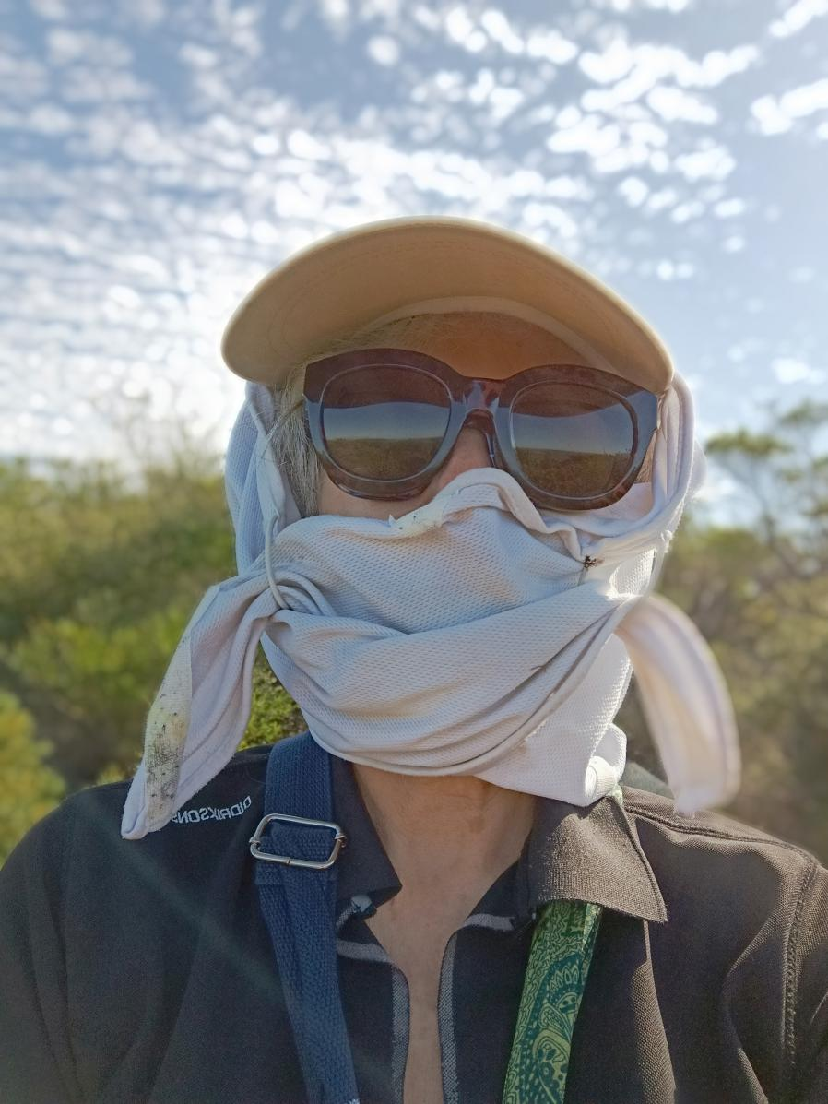
Dressed ‘a la covid’ for my walks

8 Conclusions

So, this is my story. Now to the fun part-making sense of the experience.

As I wrote, I set off intending to have an adventure - a pretty safe one… so I thought. As a retiree, it was a formula I had used many times. It is exciting to arrive on the door-step of a host family whom I have never met and to become part of the family for a short-time and, at the same time, to enjoy a return to the classroom like a kid. Interacting in this way is sheer joy for me. I have now spent a total of four months in five different countries studying three different languages. Never have I been disappointed with the experience. I always reassure myself before I set-off that my fall-back is, to check out and go to a hotel. So as adventures go, it feels quite tame. On this occasion it was to be followed by a fairly typical holiday, one that my demographic enjoys. Two friends were to join me for a small boat cruise through the Galapagos. We were going with a reputable large international company in comfort, if not luxury.

I was pleased to choose this easy option for travelling as both my husband and I had recently agreed that we had reached the stage where taking an easier option to travel was best. For the first time I used a travel agent rather than booking directly on-line. Our life-long habit has been to choose the road less travelled. This was to be the beginning of a change. As I sank deeper into the mire of my Quito adventure it seemed so ironic that I had fallen into a level of potential danger on this trip.

Of course, as you now have read, the trip went pear shaped. My attitude from the beginning was that I would enjoy and make the most of this unique experience.

I do like testing myself in different situations although the tests I devise are, in the scheme of things, quite safe. This experience had me reflecting on where this began. I think, that as with several my personality traits that I value, all come from my father, who was a wonderful nurturer.

I already mentioned that at the age of sixteen I undertook a year as an exchange student living with a family in Ohio. The year started in a strange way as we waited on the plane for two hours before take-off and then started flying only to be returned to Sydney airport a half hour later. We then all rang our parents, who collected us and took us home for the night. The following morning, we took off again. I remember when I awoke on that second morning, I really thought I did not want to go and my father had to cajole me into leaving. I am glad that I went as it was a very positive life experience. There is no way I would have tackled this adventure without my father’s enthusiastic backing. It set me on the path for these subsequent retirement language adventures like the Quito one.

Fear is so much a part of the human experience and given the uncertainty associated with returning home from Quito, I had to face that fear, which I did very consciously. Given the fight, flight and fright reactions possible to neutralise fear, I decided the only one that made sense was to fight and hence my frenzied media activity. It felt good to be focussed on problem solving and making sure it was a positive experience. Even though I was not sleeping, which I knew was not a problem in the short-term, I felt I was still working reasonably well and was not cranky. The discipline of a two hour Skype Spanish lesson meant I had to concentrate very hard. Some nights I would be wiped out at dinner when I was trying to converse in Spanish.

On a couple of occasions, I was in shock, feeling cold and uncontrollably shaky. This did not last long as I used mindfulness techniques to steer me out of it. I have spent much time developing this skill both in Buddhist retreats and at home.

I recognise that I derive comfort when I try to solve problems. I feel my self leaving the emotion behind as I cast myself into observer role and plan how to get out of danger. On this trip my mind returned to an earlier memory of doing this. It was when I was sixteen, during my exchange year. I was on a weekend bus trip to Washington. I was by far the youngest participant. On this day we visited Mt Vernon, George Washington’s estate. I arrived back at the bus to find it had left. Darkness was fast approaching as the few last cars were loading up. I could feel myself sizing up the situation. A night in the cold car-park was not appealing. I noticed an attractive young couple with a daughter aged about 8. They looked like my only hope. I made a bee-line for them explaining my predicament. They offered me a ride back to my hotel in Washington, about an hour away. As we chatted in the car, they invited me to join them for dinner. It was Mother’s Day. The evening was the highlight of my Washington trip. We ate in a quintessential southern style mansion converted into an up-market restaurant.

In Quito I felt I was drawing on those same survival skills that I had used in Washington all those years before.

However, this current event was more serious. I kept thinking that I was probably sharing thoughts with all those in history, who find themselves unexpectedly in adversely changed circumstances. I thought of my grandparents fleeing Vienna in 1938, as well as all the myriads of misplaced people in our world d today.

I thought about the function of fear and remembered Roman Gary’s insights. I read this wonderful top French author during my twenties. Some of his observations are still with me. He writes about wealthy capitalists erasing their corporate fears during an annual African hunting safari. The safari allows them to face real physical danger which is an antidote to the “impotent” fear of modern life. The last time I remembered this was when I heli-skied in Canada. At the start of the week I was so fearful but enjoyed the aftermath at the end of the trip when my fear had dissipated. I could see surviving the Quito experience as providing that wonderful sense of relief once I reached home. Concurrent with riding the merry-go-round of emotion during my entrapment, I was pleased to note that a part of me stayed calm. I felt reassured by the equanimity that I was able to access.

I had worked so hard over the last six years to accommodate, accept and grow from the knocks I had received. I felt this effort had not been wasted and was in fact paying dividends in this experience. I was not only surviving but was enjoying the experience.

Worst case scenario was that I would never get home and was now entering a new and final phase of life.
The government’s initial lack of interest and the unprecedented nature of the problem made me feel that this worst- case scenario could actually eventuate. In a sense it was as if I had died, yet still had the ability to see how friends and family were continuing their lives.

On the trip home I felt I had been reborn and was once again much younger. I had no difficulty slotting into earlier more youthful ways of being. It was truly exhilarating to capture the feeling of adventure I had experienced on that first trip to the USA aged sixteen.

The hotel quarantine fortnight was such a gift - a time to regather myself. In Sydney, the government took control of my life and thanks to the creature comforts of the Hyatt Hotel and modern electronics, life was fun.

Overall, I would not have missed this life experience. It made me feel well and alive. I find the world so interesting, as the pandemic unfolds. I realise it might be the death of us.

Many times, I have thought of the Confucian curse “may you live in interesting times”.

I am lucky to have the resources to turn “interesting” to “worthwhile”. As always, necessity is the mother of invention.

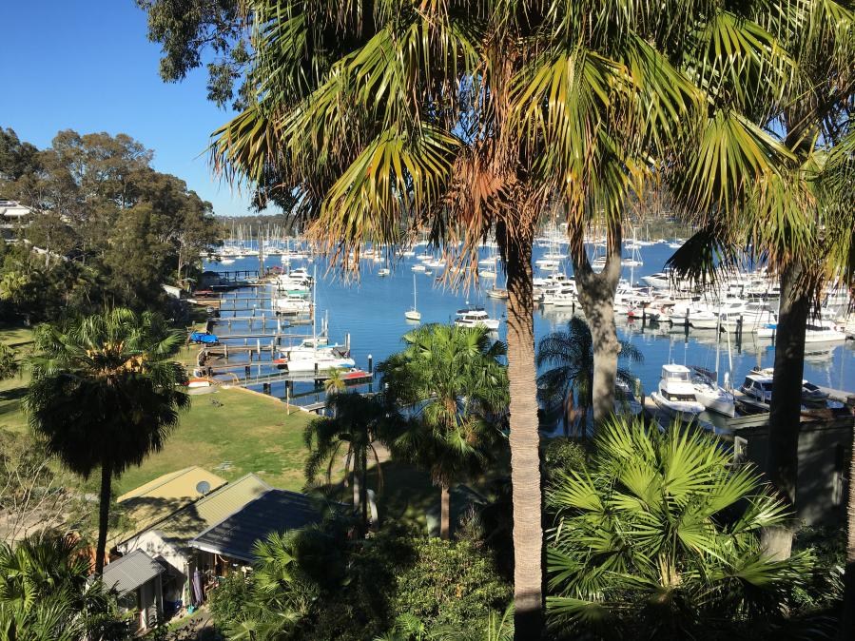
Home sweet home
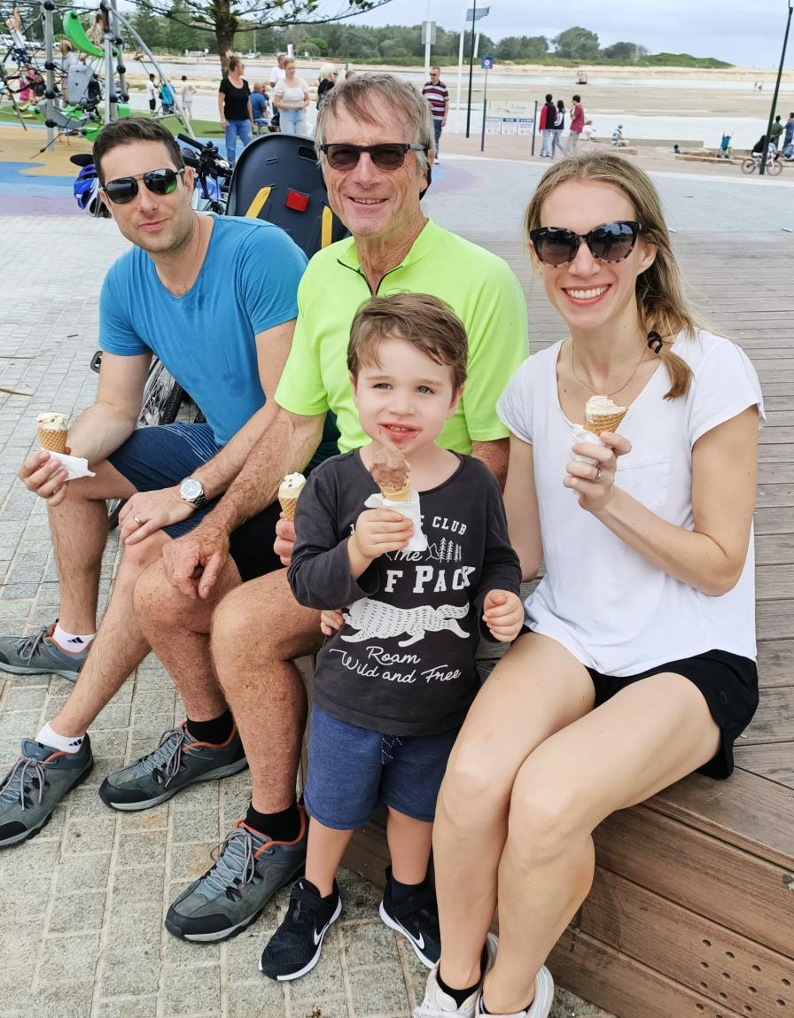
My beautiful family
Appendix Media coverage

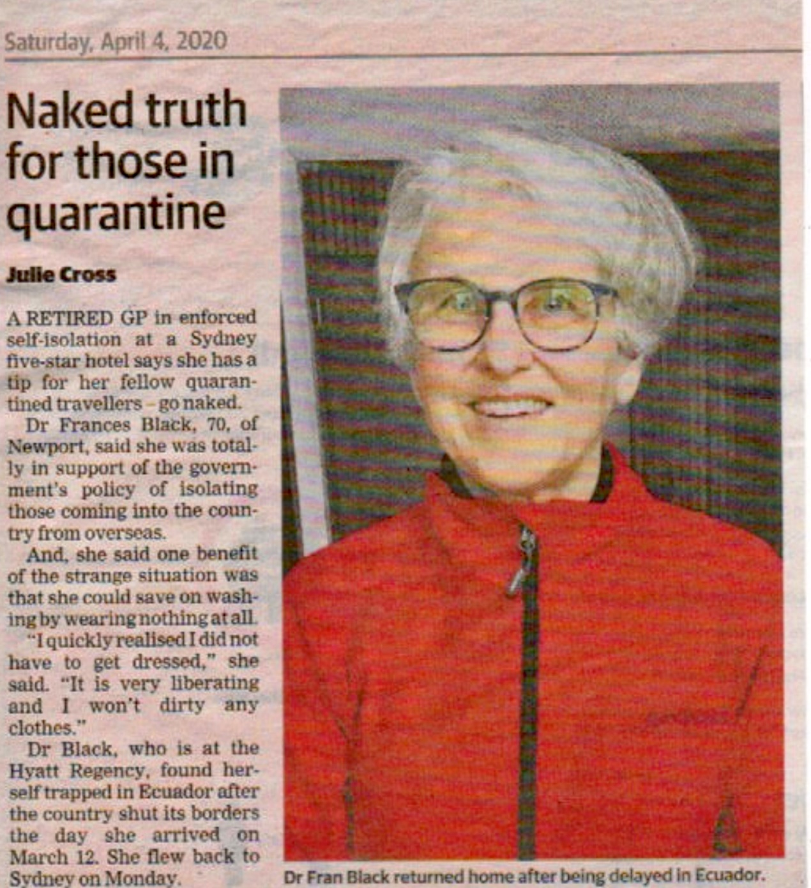
Above is the only article of which I have a copy. From the feedback I received it caused much hilarity. I felt happy to make people laugh at this stressful time.

Below I have included the media coverage I was able to locate as an appendix. It was hard to find and I think there are other pieces. On-line newspapers make it difficult to keep track and I don’t know why it is so bitsy in places rather than proper articles.

'Come and get me': Australians stranded in Ecuador increasingly desperate to leave
Ben Doherty
Those trapped by the Covid19 shutdown say there is no way out without a government backed repatriation ﬂight Follow the latest Australia coronavirus blog for live news and updates See all the latest coronavirus from around the world See all our coronavirus coverage
Tue 24 Mar 2020 15.23 AEDT the Guardian

Dr Frances Black, also from Sydney, said it had been a “roller coaster” trying to adjust to the imposition of each new movement restriction. “I have certainly imagined myself never leaving the place. I have been terriﬁed as to what would happen if I got sick. It has been easy to imagine dire consequences and very frightening. In short I have been experiencing an intense grief reaction, which I have told myself I have to fast forward through in order to survive.” Black said she’d felt “alone and isolated” despite the love and support of her husband and son. “I have been teary from time to time, particularly when speaking about home. The situation has not been helped by sleep deprivation, a combination of altitude but mainly fear.” Black said the support from the Australian government had been “non-existent”. “They speak kindly but oﬀer no help.”

Daily Telegraph and Manly Daily March 25

Former GP doctor Frances Black stuck in Ecuador
A former Sydney GP stuck in Ecuador, after they shut the airport because of the coronavirus crisis, says she’s frightened for her life and has made a desperate plea to Prime Minister Scott Morrison for help.

A retired northern beaches GP stranded in Ecuador because of the coronavirus emergency says she’s frightened for her life and has appealed to the Prime Minister Scott Morrison to get her home.
Dr Frances Black, 70, of Newport, said she left Australia on March 12 and arrived the day before a series of changes limiting movement came into effect.
“On the very day of my arrival, the Ecuadorean Government announced they were closing the borders,” Dr Black said.
“Right at the beginning I tried to get on a flight home but it was not possible.
“There is no way that we can come home as the airport is closed and this means there are no commercial flights.
“The only way we can comply with this order is if our government liaises with Ecuador to evolve a means of safe conduct.

“On behalf of all of us I beseech my government to please make our going home a reality.”
Dr Black, who was a GP at Collaroy Plateau, CEO of the Manly Warringah Division of General Practice for 18 years and wrote a weekly column in the Manly Daily, said she is stuck in a small room in a family homestay on a volcano in the capital Quito.

She said the streets are isolated, they have a curfew and only supermarkets and medical facilities are open.

She said the family she is staying with are lovely and provide breakfast and dinner but the owner is so worried about COVID-19 they have warned her if she goes shopping out she won’t be allowed back in the home.
Dr Black said she has one tin of tuna that will see her through lunch for the next three days and then nothing.

She said she has dealt with the isolation by doing Latin American dance videos on YouTube, studying Spanish, online drawing and bridge classes and video calls to family.

Yesterday she spoke on the phone to another stranded Australian for the first time since the lockdown and has also connected with others via What’s App group Aussies Stranded in Ecuador and Aussies Stranded in South America Facebook group.

She said the isolation and her predicament has been very hard to deal with.
“I have been terrified as to what would happen if I got sick,” Dr Black said.
“It has been easy to imagine dire consequences and very frightening.
“In short I have been experiencing an intense grief reaction, which I have told myself I have to fast forward through in order to survive. I have had to pull out all stops psychologically to deal with this.
“The limitations enforced here are much greater than Australia. The people are poor and live in much smaller spaces.
“I am scared I am living on a volcano and when and how it bursts I cannot predict. I would like to survive.”
Her husband John has contacted MP Jason Falinski on her behalf.
Dr Black added as a retired GP she may be able to help her community if she could make it home.

Daily Telegraph April 2 2020
Dr Frances Black’s naked tip for isolating travellers in hotel quarantine
A retired GP in enforced self-isolation at a Sydney five-star hotel says she has a tip for her fellow quarantined travellers – go naked.

Dr Frances Black, 70, of Newport, said she was totally in support of the government’s policy of isolating those coming into the country from overseas for 14 days as it was essential for slowing down the spread of COVID-19.

Dr Frances Black who is quarantined in the Hyatt Regency in Sydney. And, she said one benefit of the strange situation was that she could save on washing by wearing nothing at all.
“I quickly realised I did not have to get dressed,” she said.
“No-one is going to come bursting into my room.

Julie Cross, Manly Daily Subscriber only | April 2, 2020 12:34pm
A former GP has a tip for her fellow travellers quarantined in hotels after arriving from overseas — go naked. She also said she’s so busy there are not enough hours in the day to do everything she wants.
Dr Frances Black’s naked tip for isolating travellers in hotel quarantine
“It is very liberating and I won’t dirty any clothes.”
There are currently more than 3000 returned Australians holed up in hotels around the country, with many of them complaining about the quality of food and lack of fresh air.
Dr Black, who is now at the Hyatt Regency, found herself trapped in a small flat in Ecuador after the country shut its borders the day she arrived on March 12.

She flew back to Sydney on a $4000 flight via Houston and San Francisco on Monday and is now in quarantine.
Dr Black said isolating in hotels helps keep hospitality workers in jobs, saves people working out the logistics of self-isolating at home safely without infecting other members of their family, but most importantly will help slow the spread of the disease.
“To the people criticising having to isolate, the question I would like to ask them is do we want to be living in a country that looks after its citizens and our health?” she said.
Dr Frances Black a well-known former GP on the northern beaches, was a GP at Collaroy Plateau, CEO of the Manly Warringah Division of General Practice for 18 years and wrote a weekly column in the Manly Daily, said she wasn’t bored in isolation and in fact she didn’t have enough hours in the day to do everything she wanted even though she doesn’t watch TV.

She said she was busy doing online exercise classes, art and Spanish lessons, as well as reading.
She said the food was good and she was also catching up with friends and family via video calls – where she puts her hotel bathrobe to spare any blushes.

Dr Black said when she gets home she is most looking forward to seeing her four-year-old grandson again, as well as her husband John.

Daily Telegraph April 4
100 Mackellar residents stranded overseas due to coronavirus restrictions
Mackellar is believed to be one of the hardest hit suburbs in terms of residents stranded overseas because of the coronavirus emergency.
Up to 100 residents from the northern beaches electorate of Mackellar are believed to be stranded overseas because of the coronavirus emergency.

A spokesman for Federal MP and member for Mackellar Jason Falinski said while the foreign office could not give exact numbers they have been told the electorate has one of the highest numbers of residents who are abroad and unable to get home.

He said they knew of Mackellar residents who are stranded or recently rescued from countries such as Cambodia, Austria, Uruguay, Guatemala, Peru, Ecuador, India, Croatia, Serbia and Argentina and on cruise ships including MV Greg Mortimer, Coral Princess and the Ocean Atlantic.
MP Jason Falinski’s office is helping stranded residents abroad. Picture: Adam Yip The Mackellar electorate includes suburbs north from Dee Why to Palm Beach and west to Forestville, Frenchs Forest, Belrose, Oxford Falls and Terrey Hills.

Julie Cross, Manly Daily Subscriber only | April 4, 2020 7:00am
Mackellar is believed to be one of the hardest hit suburbs in terms of residents stranded overseas because of the coronavirus emergency.

Mr Falinski’s spokesman said they have been contacted by 25 people or their families directly, although many more are believed to have gone straight to the embassy for help.
It is believed the number of residents stuck abroad could be as high as 100, but no official figures are readily available.
Mr Falinski said the Department of Foreign Affairs and Trade was doing an amazing job in difficult circumstances.

One resident who was stranded in Ecuador but who arrived back in Sydney on Monday is former GP Frances Black, 70, of Newport.
Dr Frances Black, 70, of Newport, sent an SOS video to Prime Minister Scott Morrison before getting a flight back to Sydney on Monday. She is currently isolating at the Hyatt Regency and said she was being well looked after.
In a letter of thanks to Prime Minister Scott Morrison for getting her home, Dr Black said initially it was a battle to get help from the embassy and she was told several times “she was on her own”.
However, shortly after her husband John contacted Mr Falinski’s office, US flights were made available for purchase by stranded Aussies.
She spent around $4000 getting back via Houston and San Francisco. She is very appreciative of the way the Australian government responded with their well-orchestrated compulsory two week hotel quarantine.

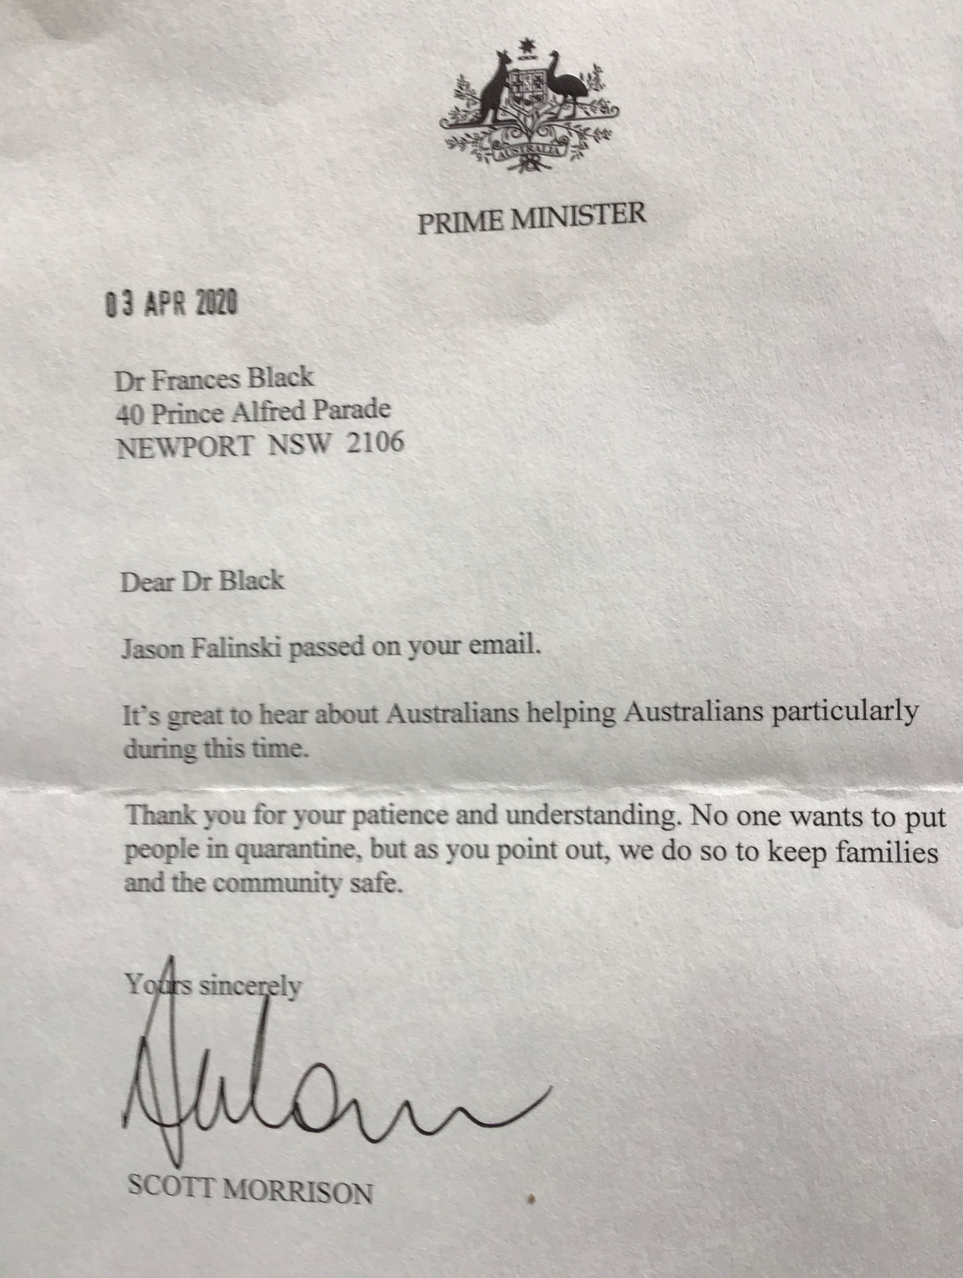

This is the response I received to my thank you to the Federal government. I was pleased to receive it

