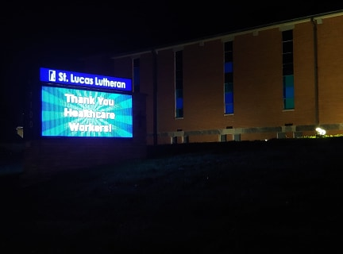
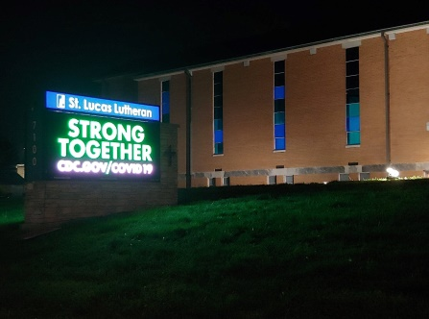
These are some of the slides presented on the signboard of a local Lutheran Church in St. Louis, Missouri. These images show how local churches are working to encourage the community during these difficult times. They foster a positive morale within the community with their statement of “Strong Together,” and they acknowledge the hard work of healthcare employees within the community.
In several of these slides, including one not shown here, they provide the address to the CDC webpage for COVID-19 to urge people to remain up-to-date on the pandemic as it progresses.

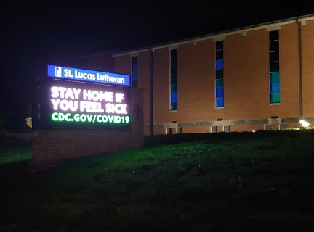
They also encourage people to engage in safe practices in order to help minimize the spread of COVID-19. They implore people to stay at home if they feel sick, and, in the last image, they address some of the measures they have taken to ensure that people within the community are able to continue participating in their religious lives without endangering themselves and others. These images demonstrate the responsibility that this church feels toward the community and how they are using their position and resources as a religious organization to help the community get through the pandemic safely.
