Living through the COVID-19:

Monday 04/06/20:
Being quarantined is not the best experience. Especially because I am stuck at home and only get to go out to when it means going to work. Today I had online classes and after that I got ready to go to work. Today I worked from 6-11 pm. It was a common shift. Busy with online orders and busy with take-out orders. Today wasn’t anything special or alarming.
Tuesday 04/07/20:
I woke pretty late I believe around 12 p.m. Got up prepared breakfast and did the usual. Which is to find something to eat. Turn on Netflix to watch one of my Korean dramas. That typically last an hour per episode. Normally I’ll watch one but if the storyline is really good, I end up watching more than one.
I was patiently waiting for a package that I’ve been anticipating for quite some time. I ordered my favorite instant noodles. They tend to be my stress-free food and snacks. I’m scared to go food shopping on my own with this whole Covid-19 situation. My package arrived at 3 pm. I was finally happy lol.
Basically, I focused the rest of the day finishing up a presentation that had to be presented tomorrow. I took most of my day than anticipated.
Wednesday 04/08/20:
Woke up a little late to my class for my Music course. We had to present today. Woke up just in time to start the presentations. But didn’t really had time to brush my teeth or wash my face.
After class I went straight to finish my test for Philosophy. It was long and I was scheduled to work at 4 pm. But my plans had to be altered because I was still working on my exam that is was due at 11:59 pm. I finally finished it at 8 pm and was like yeah, I need a break overall. Because I had been on that same seat since 11 a.m. I transitioned myself to the sofa and watched Netflix. I was more tired than anticipated so I actually went straight to sleep.
Thursday 04/09/20:
Today I woke up a little late and had barely any time to finish my post quiz for Geology that was going to close at 12 pm. After the quiz I got up from my seat and head to the kitchen to look for breakfast. What Americans like to say around this time “it’s time for brunch”. But for me since I’ve technically just got up and haven’t had anything to eat, it still breakfast for me.
I was casually in the kitchen just hanging out with my parents. That my dad quickly finds himself startled. He is casually watching the news and is shocked to see the demographics of who is affected the most. In this image is what practically what my dad saw in the news. Which basically it focuses on individuals who are hospitalized in Dallas. Hispanics is that biggest percentage. In the video it focused on how Hispanics tend to be the most affected because they tend to socialize the most with close relatives. Especially in serious crisis as these many Hispanic families worry about the whereabouts of close relatives and spend time with them the most. But I quickly left the kitchen because I chose to continue working and you can say that me and my dad aren’t exactly in good terms.
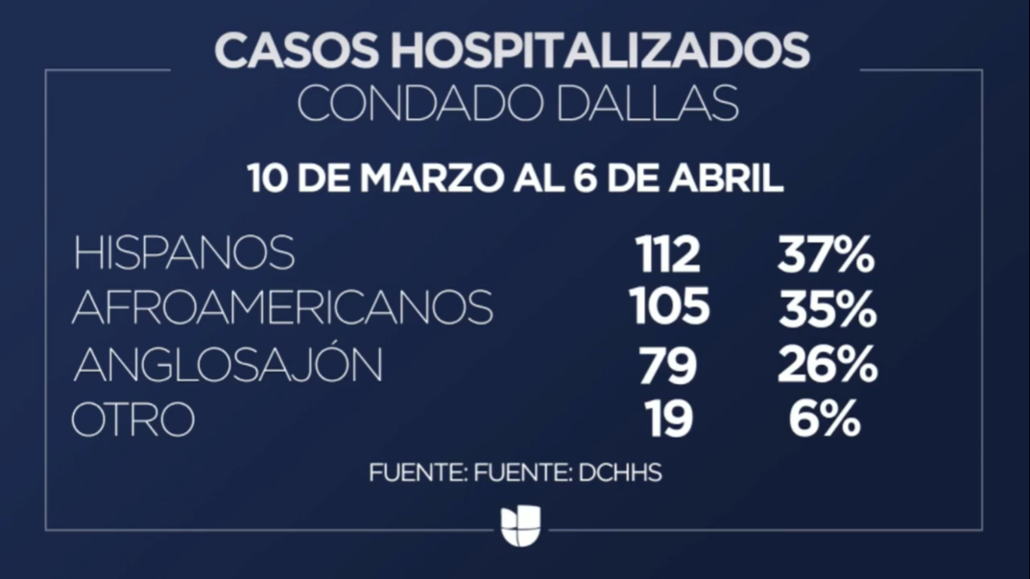
Univision. “El 37% De Hospitalizados Por El Coronavirus En El Condado De Dallas Son Hispanos.” Univision, 8 Apr. 2020, www.univision.com/local/dallas-kuvn/el-37-de-hospitalizados-por-el-coronavirus-en-el-condado-de-dallas-son-hispanos-video.

Today at night was when me and my friend heard some news about Wonho. He was a member of Monsta X and left the group in November 2019. Wonho has appeared all over the media and he declared he will continue as a solo artist. It broke my heart knowing that he isn’t coming back to Monsta X. A group in which he was cherished by the members and fans. It was good to hear that he will continue doing what he loves the most which is to sing and produce music. I will continue supporting him in his career because his story is sensitive and admirable. He deserves so much love and support from fans just as Monsta X does. But I was just glad that he didn’t shut himself off from making music. I’m looking forward to his future path.
Friday 04/10/20:
I woke up like at 12 pm and found myself in front of the fridge. Trying to decide what is fast and convenient to eat before work.
For work today I was running a bit late because I was being a potato overall. My best friend text me whether I can give her a ride today to work. I explained to her about my situation. It turns out she was running late as well. Yeah, we arrived to work at 4:30 pm and was scheduled to work at 4 pm. So not that bad but I was sad because those 30 min I could’ve gotten paid.
Work was very busy and it was never ending with online orders. I was constantly running back and forth. From the cashier to the back, bagging chips. It was a crazy shift overall.
Saturday 04/11/20:
I woke up like at 1 pm and had to work at 4 pm. I had to think fast as to what would be more convenient to enjoy my day before work. I decided to do my hair quickly. I dress up ready to work. Now all I needed was to do my makeup.
Today I only had coffee and one taco of carne asada for breakfast. It was 3 pm time for me to do my makeup and head to work. My best friend texted me about giving her a ride and I explained once again about my situation. Yeah. We went to Subway before work because we both haven’t really ate much and woke up decently late. We got to work and ended up eating subway in the office. Of course, I didn’t clock in because technically I wasn’t working. I ended up only eating half of my subway footlong. And clocked in at 4:30 pm is as if I was late. Today a customer came and asked for hand sanitizer. Normally we have some for the public. But with resources running short. Apparently, we aren’t giving out to the public anymore and have them stored in the back. That was news to me.
Today was definitely busy and it’s always me and my best friend to be the last ones in the restaurant. By the way my best friend went to the same high school as me and we ended up working in the same place. It’s funny because a lot of people tend to struggle to say her name and always want to pronounce it as Nancy. That’s a clue to her name and I doubt you’ll ever guess it. But yeah me and my best friend tend to spend a lot of time together especially after work.
Sunday 04/12/20:
Now this is the latest I woke up this week. I woke at 3 pm and slept at 4 am. So, I basically slept for about 13 hours. For breakfast I had ¾ of coffee cup and ¾ of a steak taco from Chipotle. Basically, you can conclude that I was close to finishing but then didn’t. Then I was craving instant noodles and some snacks. I left my breakfast sitting there and headed to the kitchen to satisfy that craving. While eating my noodles I was enjoying one of my K-dramas that I am currently watching. It is called Because this is my first life it came it out in 2017 and has 16 episodes. I just found out how many episodes it has and now I’m sad. Because I am so close in finishing it, I’m in episode 13. I like the lead it sort of resembles one of my favorite idols (Chae Hyungwon).
While eating my noodles I figured today is a good day to clean my makeup brushes. Then I also figured that today is a good day to do laundry. This is a good day to get a lot of chores done. Today I would normally go to work but since it is a holiday Chipotle is closed. Oh, and today has to be the one of the most Minnesotan day ever. We are already in springtime where it is normally sunny or rainy on a casual day. But Minnesota is like “Oh we are! Sorry I forgot we moved on” because today it is snowing like a normal winter day. Like the snow is actually piling up.
Wow I can’t believe I found myself reading my horoscope just for fun. I haven’t done that in a while. So, it was weird indeed my astrological sign is Capricorn. I do believe to be down to earth and a lot of the characteristics do describe me. But I don’t necessarily believe how it can tell how my daily, monthly, and yearly life is predicted. No one can necessarily predict your life or the outcomes because everyone faces different obstacles and live in different environments.
Today we had dinner like at 8 pm that is normally very late for us. Because my dad works in the morning tomorrow. So, he usually goes to sleep like at 9-10 pm the latest. For dinner we had barbequed ribs baked in the oven. Due to the specific weather we had to deal with today. I can say that for this week I have been sleeping late and waking up late. Having breakfast and lunch at the same time. Sometimes dinner that would be Chipotle food related. I am totally done with Chipotle. When they send me on break, I have a mini panic attack on what to get. I get Chipotle because it is free and why would I say no to that. When a lot of work areas don’t get that same perk. Usually throughout my shift I tend to think what I will eat today.
Monday 4/13/20:
Once again today is snowing. It doesn’t really make sense but it is. I mean it should be spring already. But I guess Minnesota likes to play with our feelings. It is actually quite a weird 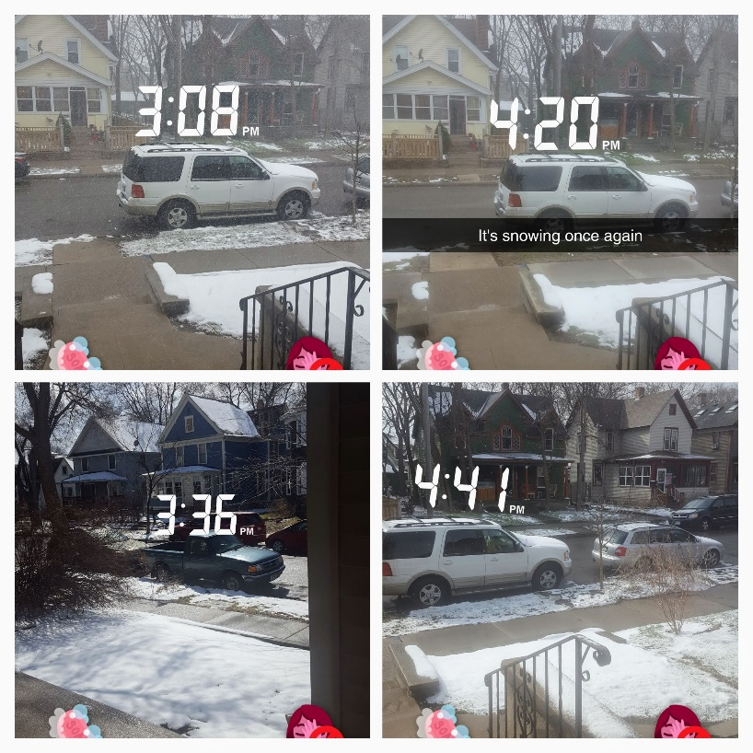day because it is snowing and then it is not.
The times in between when it stopped snowing and continued are not that big of a difference. But the thing is every time it snowed it got cloudy and inside my house it got dark. During the day I like to open the curtains and use the natural light rather than turning on the switch. I was doing homework when I noticed all of sudden it got dark. I was confused as to why. But yeah ,the weather just kept on playing with my feelings. Today I have to work at 6 pm to closing.
Work was definitely quite a busy day and but it made time go fast.
Tuesday 4/14/20:
Today I woke up at 9 a.m. to get ready for my appointment at 10 a.m. with an academic counselor. It was quite overwhelming getting to see what the next two years has to offer. But I will definitely survive. At the same time, I am sort of looking forward to it because it is all related to my major.
I took a nap after having my meeting and woke up at 4 pm. It’s good that today I didn’t have to go to work. But for some reason I was feeling down and it was hard to motivate myself to do homework or do anything productive. I started on an assignment at 5 pm and didn’t get to finish till 8:30 pm.
My brothers really wanted to go to McDonald’s and for some reason they really wanted me to go with them. I ended up going with them, I really thought they wanted me to go to be the plug (basically for me to pay). But no, it was contrary my brother was the one inviting. I only got an order of 6-piece chicken nuggets and only ended up eating 2 from the 6.
I still had another assignment for Wednesday morning and I worked on it with a partner. We finished at 2 am and I didn’t go to sleep till 4 am because I was watching some episodes of my drama to destress.
Wednesday 04/15/20:
Today I woke decently on time since I had class at 9:15 am. I was definitely on time and was doing homework in between before my philosophy class. My second class ended at 2:30 pm and just had enough time to eat before going to work. My shift was at 4 pm. My mom had made Caldo de pollo con arroz rojo which basically translates to Chicken stew with Mexican rice. It was good I will not be in denial. But it was a hot meal and it definitely wasn’t the greatest quickie. I managed to eat ¾ of my meal and had to run to work.
Work was definitely hectic and for some reason I was so out of it. It could be because I had midterm the next day.
Thursday 04/16/20:
Today I had guests over and they were my parents’ guest. I had work till 6 pm but since I didn’t really want to see these guests. I left a little early. Besides Chipotle will let me chill over before my shift and I can just clock in when my shift starts. My mom brought it up and asked me whether I was mad. I answered to her honestly that yes, I was. It was frustrating how she says a thing and does the other. It was just interesting how she is over here talking bad about other people how they have guests over in times like these. Says she won’t do and she makes me and my siblings to enforce the same practice. But what frustrates me the most is that she thinks just because the guests take a shower, it is ok for them to step inside the household. I left pretty mad, not at her overall but more like her not being able to say no to her guests. I made sure for her to tell my dad it won’t be my fault now that we get Covid-19.
This is private and I understand that it’s only you who is reading this but my dad has made it clear that he doesn’t like it that I work (during Covid-19). The first time he got mad at me was when I dropped the news about how our classes will go online. That’s where he brought up that I should decrease the number of going to public areas and with friends. He made sure to add that if I don’t do that “It will be my fault that the family gets infected with Covid-19” not only that “If your mom gets it and dies it will be your fault”. Great going what nice things to say to your daughter who you truly love so much. But this was all through phone. The second time was when he wanted me to take a week quarantined. That’s when I responded, “I can’t” and he didn’t quite get it and I kept on repeating myself with the same response. That’s when he’s like “what do you mean, you can’t” and I responded “There is tuition and other expenses to take care of” that’s where he lost it and got mad. He started saying all sorts of things to me and made sure once again to say it while pointing his finger at me “If this family was to get infected it will be your fault” and I was about to tell him already with a quivering voice “I won’t take the fault”. But that’s when my mom jumped in and started to talk to him how that’s not an appropriate thing to say. You can say that me and my dad aren’t completely friendly to each other at the moment. He likes to pretend like what he said is correct and pretend like nothing really happened. But to be honest I’m hurt how such harsh words came out of his mouth and he said it to me. Me and my dad tend to fight a lot but we have never really been this cold to each other before.
I only brought this up because as the summary of this it was going to be my fault that we get Covid-19. But now it isn’t really because my parents had guests over. Now that changes the whole story.
Friday 04/17/20:
I had slept a little over 4 hours and had to be up for my 9:15 am class. At 11 am Monsta X released a new music video for their song You can’t hold my heart. Let me tell you it was amazing and my mom had to check on me because I was fangirling on another level. She taught I was going crazy and indeed I was. But that was totally the highlight of my day. I say that because for every workday I feel like my day has ended.
My parents once again had guests over and it was kind of frustrating because my parents were the ones that brought up on having no guests over. So, I brought it up if I can have guests over since they already had guests over. They said as long as they followed the basic practices to prevent Covid-19 then it should be ok. But I can tell that they weren’t so convinced about it.
Saturday: 04/18/20:
I woke up at 2 pm because I received a phone call from my best friend. She wanted to talk and was dealing with personal family problems. I was startled with her call and felt like I was useless. Because usually these kinds of conversations are hard of what to say and there are limitations to what our reality holds. When she told me with what she was dealing with. First thing that came up in my mind is that I have to be there. I want to be at her side 24/7. I feel like the time I’m not with her she is lonely and afraid. The problem that she is facing is serious and complicated. It has undergone various visits to court and to have to deal with this matter once again is frightening.
Me being unable to actually do anything I was disappointed and shocked throughout the day. I didn’t get out of my room until 4:30 pm and took a quick shower. Around 5 pm my parents were cleaning the microwave and the stove. So practically my food options that needed to be reheated were limited. So, me feeling hopeless and unbothered I snatched a bad of Hot Cheetos and made up my mind that will be my breakfast.
While in disappointment, I am sitting in the couch and normally I would turn on Netflix. But I didn’t instead I turned on the TV and just stick to whatever channel was on and the volume wasn’t all that great. Because my mom was using this day to be cleaning day and her music was pretty loud. All I did to sort of enjoy TV was to add captions. Time flew and before I knew it the news came up and it was talking about how bad it is New York with Covid-19. Since social distancing is impossible the are now asking for the residents to wear masks in public areas. A lot of markets already have signs that if they don’t have a mask on, they cannot enter.
Campbell, Jon. “New York's Coronavirus Mask Order Just Took Effect. Here's How Police Will Enforce It.” Rochester Democrat and Chronicle, New York State Team, 18 Apr. 2020, www.democratandchronicle.com/story/news/2020/04/18/new-york-coronavirus-mask-order-takes-effect-how-police-enforce/5151375002/.
I was sitting in the couch practically the whole day and didn’t really do much.
Sunday 04/19/20:
I woke up at 1 pm and reminding myself that even if I’m unbothered with my emotions and don’t feel a thing or two. I do have a reality and can’t completely ignore it. I may be experiencing a type of depressive disorder. But that is something for me to deal with on my own and muster up the courage to seek for help.
Ok I was heading to work at 3:30 pm my shift was at 4 pm. That’s when my friend asked me if I can pick up her mom on the way to pick her up. Might as well since I was pretty close. I picked up my friend after dropping off her mom and we were ready to start a crazy shift. We were running low on things. She asked if I can go to Hopkins and get some things. I mentioned how I am not willing to go alone. And eventually we ended up making the decision in sending someone else.
The shift was definitely crazy by the government we can only have five people max inside the building. It got out of control that we had more than that. That we even had to lock the doors so people can stop coming in. If for some reason people kept on coming in, we would have to force them to go outside. Because if inspection came in and saw how many people we had, we could literally get the place closed down. That’s how crazy it got and it didn’t calm down till 8 pm. That’s around the time I went to break and I was quite exhausted.
Monday 04/20/20:
Today I woke up very tired indeed. My Sunday shift was very exhausting and quite the roller coaster. I had a lecture for geology at 9:30 am and woke up at 9:25 am to join zoom. People were still getting there so I snoozed my alarm for an additional five minutes of sleep. I woke up and all I really remember is that once I heard the professors voice. My eyes were very heavy and once again I fell asleep. I woke up to the part of where the professor commented how by the end of the class, we will be having small group discussions. All I really remembered was telling myself to be prepared both physically and mentally. Once again, I fell asleep and woke up to where the professor said we will be taking a five-minute break.
Guess what I fell asleep again and woke up to the professor asking everyone if they’re back from their break. That’s when I decided that the best for me is to officially get out of bed. So, I took all my things and was heading to the living room. The living room I may say so myself is the safest place for me to be focused. I have a dining table that originally had six seats. In our kitchen we have a tiny table with two seats. But because my parents got new seats for the kitchen. The old chairs are now part of the dining table. There is a total of eight seats in the dining table. Out of the eight seats there is one corner in specifically that I like to do my schoolwork and be completely focused. I tend to spend most of day in that chair. That chair isn’t necessarily the most comfortable but it does limit me to distractions. But anyways that is where I went to be more focused for the rest of class.
Before my shift today is at 6 pm I went to my room to get it a bit organized. Honestly having more time to be home has been harder on me. Instead of actually having time to clean my room it has only become messier. So before leaving to work I made sure to have a visible floor.
Today at the beginning of my shift I had to deal with an angry customer who dealt with his anger directly at me. To be honest I didn’t know how to react and the only thing I could do was smile. He kept on saying things like “why couldn’t you do your job right” “all you had to do was check and didn’t”. I offered to remake his bowl and got even more mad and exclaimed if that is all we can do. I’m like in my mind well the only two things we can do for him is remake his meal or offer a refund. Today was definitely hectic and would explain the story in detail. But honestly, I don’t think I’ll forget his face and words.
Tuesday 04/21/20:
Today I woke up in hopes that my hold was gone and I should be able to register for classes. Honestly, I didn’t know how things work at all. I received an email from my academic counselor acknowledging how I haven’t signed up for any classes yet. I had to email her back how it isn’t that I’m having doubts it’s more like I wasn’t able to. Because I had a hold on my account.
This day I was sort of dreading it because I was hoping to be able to register for classes and was worried that I wouldn’t get the classes I wanted. The most productive I was by actually trying to properly look at myself and start to take care of myself more seriously. For instance, I’m a very anxious person and when things start to get out of hand. I start to scratch myself specifically my hands and neck. I started to notice how this isn’t a healthy habit and I need to take immediate action. So, I focused my mind in putting schoolwork aside and start to take care of what matters the most. Which is me.
Wednesday 04/22/20:
I was supposed to work today but managed to find someone to cover me. I simply had too much homework and it was stressful enough to go to work. Honestly, I called my best friend who is the apprentice at Chipotle. Which is a position lower from the general manager of Chipotle. I called her to see if she was free and see if she can help me out with homework. But instead she took it as finding someone to cover me and did find someone to cover me. I didn’t want to skip work because I’m worried, I won’t make enough to pay off tuition. But I have to admit my top priorities, one of them being school. So, it was ok to miss work and my worries should always be focused on my academics.
Though I already made up my mind about focusing on my academics. My motivation was so low and hard to push past it. I kept telling myself that you need to push harder and you can do it. Yes, can you believe it I have a mental fight with myself. I sat on the same chair for over 12 hours. It could be that yeah, I got up every once in a while, and making sure I’m eating. Because sometimes when I’m unmotivated to do anything it means everything. That includes eating, doing schoolwork, taking a quick shower, etc. But obviously I know I’m better than that. So, I kept taking baby steps. I managed to finish my schoolwork for that day and felt pretty accomplished because with all I was dealing. It was something I should considered a productive day.
Thursday 04/23/20:
I woke up decently on time because geology reading quiz that opens up at 11 am. So far this week I have been doing well in taking care of myself physically.
I ordered dominos. At first, I was just going through the order process just for fun. But now that my mom took it seriously. I had no other choice but to order. Sure, I made be a bit tight on money and honestly my money should be used responsibly. But it shouldn’t hurt to get some food and get it delivered.
Today outside my neighborhood there were many cars one by one passing by. They each had signs and I wasn’t able to really read what any of the signs said. I wasn’t sure if it was to celebrate earth day. I believe I saw a sign that read “We miss you” that’s when I was really confused. So, then I thought it was a friendly protest to end quarantine. People had music playing out loud and there was even a mascot. My mom found it entertaining and went outside to wave at each car. I was too shy so I was watching them through the covers.
Friday 04/24/20:
I woke up at 8:45 am and I got to admit that’s probably the earliest I woken up this week. I was on time to my class. Class ended earlier and got to do my homework that’s due today.
I found out that today we are wearing masks and it’s a part of our Chipotle uniform. The masks aren’t necessarily the most comfortable. Because it’s just a piece of cloth and it gets really hot. I have glasses so it gets foggy at times. The masks aren’t necessarily to protect us but more to make the customer feel at ease. To be honest we be looking like ninjas.
Today’s shift was very busy especially with our online orders. Our sales are above average. It almost feels as if its summer.
(I was strolling through the Chipotle website to see if they made it clear we are wearing masks. That’s when in FAQs said that they are doing free delivery. No wonder it’s crazy and I can’t ever predict if it will be slow or busy. I searched this up Sunday 04/26/20)
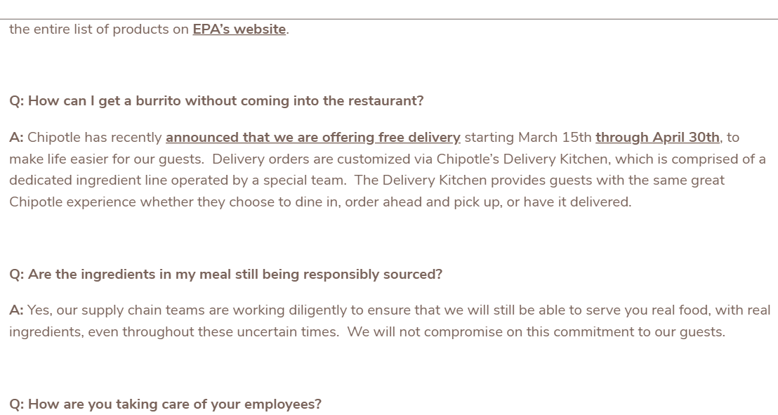
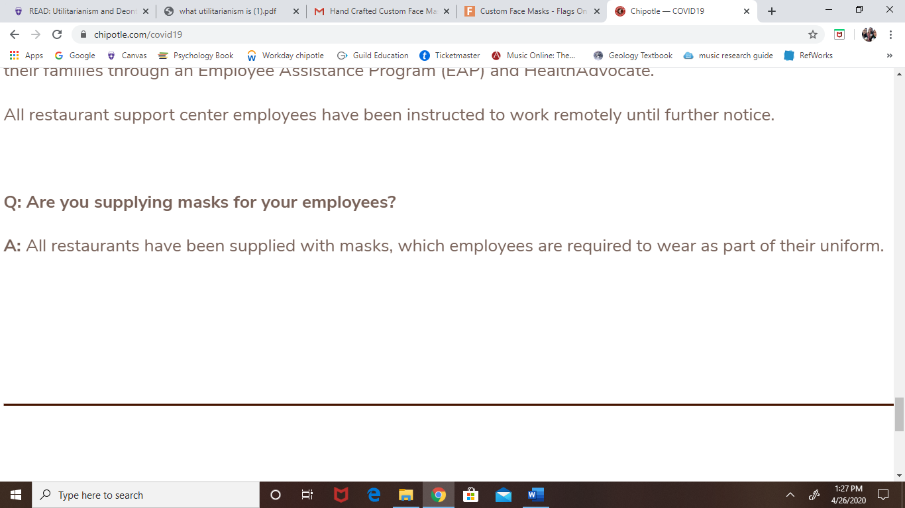
“HOW WE'RE TAKING ACTION.” Chipotle, www.chipotle.com/covid19.
Saturday 04/25/20:
Another beautiful day because I don’t work today.
My day honestly flew. Once again, I did what I was most afraid of which is not doing anything. At least academically related. Today I went to Target with my brothers. Our parents sent us out to go buy hamburger buns. Obviously, they wanted us to go to a grocery shop. But I’ve been meaning to go to Target to get some essentials that I need. But I’ve been afraid to go alone. My brothers were walking straight on to go get the buns but I wanted to stop at the beauty isle. So, I drifted off and got my things and that’s when I noticed I was alone. I was actually freaking out and called my brother to find him. I kept saying where exactly I can’t see you. Normally I wouldn’t care less where they drifted out and we would agree to meet somewhere specific. But with this Covid-19 and new regulations I was a bit frightened. It took us like 2 hours lol and our parents were pretty mad but at least they didn’t further question us.
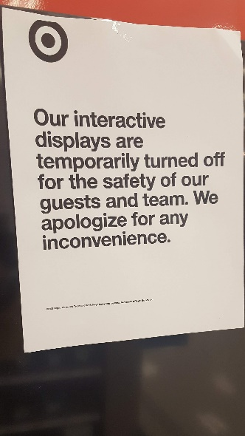 I spotted this in the technology isle. Each interactive device has this sign.
Later today me and my mom did online shopping. She’s been meaning to buy makeup for a while. I promised that today I had time to spare to help her out. We did some online shopping. Every time I look for makeup there is this eye shadow palette that I want to get. But it’s a bit pricey and I keep saying I’ll get it another time when I have money to spare. That day never came. So, I decided to make the move today and it feels good. I was going to pay for everything. But since we are getting it from Macy’s my mom wants to use it with her Macy’s card to use some sort of coupon and to get points. Basically, my dad ended up paying. I told him I want to pay him back and he says that I should pay back once I have stable salary and have a career. It’s ok at least it gives me time to save money for his birthday. It isn’t too far it will be like in three weeks or so for his birthday.
I ended watching like four episodes of Love is blind it’s decent.
Sunday 04/26/20:
Today I have a shift at 4 pm and so far, I have been responsible in showing up on time. My position is cashier. Not a lot of our crew know cashier or like that position. Since I’m the best at it I am forced to be there. It’s ok sometimes and sometimes it’s annoying.
Today my manager made an announcement to the crew. She said that when she’s in charge or another of our managers the mask is optional. But when our team leader shows up it is mandatory. So obviously I took it off because that mask is so uncomfortable. For some reason I’m more distracted when I have that mask.
Since this is due today and I usually have work. I make sure to finish updating my day today during my break. My break varies in time. Sometimes it can be as early as 5 pm or as late as 9 pm. But yeah, every Sunday shift I do my report for today during my shift.
It’s about to end and just say that today isn’t as bad.
Monday 04/27/2:
Today we had lecture and were assigned a lab. For some reason for every workday I feel the most productive and rushed to do my homework. Working 4x a week can get pretty boring but the paycheck is always beautiful.
Work is was decently busy and me and my crew member finished at around 12 am. That’s a tad too late but yeah, it’s typical.
Tuesday 04/28/20:
Work has been very busy and my body is fatigued. I have no energy left to actually be productive.
My day went by fast and next thing I know is that its 2 am. Yep I was definitely very productive in being in the couch.
Wednesday 04/29/20:
Today was my last class for Music and that was news to me. Class today for philosophy was longer than usual. Right after his class ended and I quickly got my things to work at 4 pm today. I arrived on time and found out that one of our crew members called in. It was tough shift without her.
After my shift my friend needed a ride so I gave her a ride. On the way back to go home I got pulled over. I was definitely afraid of getting a ticket. Long story short I didn’t get a ticket and just a warning. Thank god. I had to tell people about it because I wasn’t expecting to get pulled over. I haven’t told my parents lol. Let’s just keep it low with them.
Thursday 04/30/20:
Another day went away and didn’t really do anything productive. It’s 3 am and that’s how I know I didn’t get anything done.
None other than having two meetings. One with my mentor and the other with the financial counselor.

Friday 05/01/20:
I woke up to only work on homework that was due today. I had work at 4 pm today. I woke around 10 am and kind of bummed out I didn’t hear my alarm. Today I had a meeting with my geology professor at 11 am and woke up just in time to have our meeting.
Today I was running a bit late to work because this one assignment was more important than going to work. I obviously let my manager for the shift know. My manager of my shift turned to also be running late. That’s my best friend so it was a bit funny.
My best friend was running late as well and said if she could get a ride. Might as well she be on the way and why not lol. I gave her a ride and that’s when she dropped the bomb. She said if I heard what the governor of Minnesota said today. I responded with how I didn’t really get the chance to today. That’s when she tells me about how they are extending the lockdown till May 18, 2020 and that he strongly encourages individuals to wear a mask when being outside of home.
“Newsroom.” Office of Governor Tim Walz and Lt. Governor Peggy Flanagan, 31 Jan. 2020, mn.gov/governor/news/.
My shift today was definitely very busy and online orders were non-stop. I’m definitely going to be sore for a couple of days. I can’t feel my feet. We finished pretty late.

Saturday 05/02/20:
I woke up to see my email and that’s when I check out my financial aid package. My package left me pretty satisfied. I wanted to tell my parents but they weren’t home at the moment and had to wait for them to arrive.
Today I asked my dad for permission if we can use the attic space to hold a small party for my best friend. I know that during these times were not supposed to have people over. But overall my best friend hasn’t really ever celebrated a birthday party. So, she’s been meaning to do something. It took some convincing and guess what I won. So, we will be using the attic space to hold the party. Now we just need to take care of party decorations and food. We got this.
My mom made a pina colada drink which technically it was pineapple drink. It was very tasty. And it was a good drink to end my day.
Sunday 05/03/20:
Today I woke up at like 11 am I would say that’s not that bad. I got out of my room and since my room is so close to the kitchen. I noticed that my mom made pancakes. She made them with chocolate chips my favorite. I ate two by themselves they’re already so good like that. I was feeling a bit lazy in making myself a cup of coffee. So really all I had for breakfast was the pancakes. I didn’t really get to turn on the tv. Was mainly focused on doing homework assignments. My mom and me are on our first day of our menstrual cycle. It’s funny sometimes we do be having it at the same time. Other times she either beats me a day or it be the other way around. My mom commented how it’s funny how now she be acting like me when I’m on it. By that she means swing moods, laziness, and what not. I wasn’t offended at all and instead I was like “yes, I get you”. My cramps be kicking in at random moments. I obviously made sure to take two Advil pills to reduce the pain.
My mom made Sopa de fideos basically Mexican noodles. We also had leftovers from yesterday’s Carne asada (Mexican barbeque). It was really good. The noodles was so warm in my belly that it helped with the cramps.
I arrived to work a bit late because I was finishing up some assignment. Work was hectic as ever. I was definitely stressing and felt like I couldn’t handle it. My best friend was running late and she usually helps to bag orders and check-in with online orders. We fell a bit behind with orders and I have to be running back and forth to check-in with both carryout and online orders. Once again, I am very sore and knew this day was going to hectic. I was relieved that the customers today were understanding and patient. To be honest when it get his hectic and customers say their order was supposed to be done who knows what. We actually lose track of time because orders just keep on piling. So, we tend to wait for the people to come and we ask for their names. So, we can start on their orders. It gets very tough honestly with the weather getting nicer the orders don’t seem to be slowing down. At least it makes my day go faster. But that just makes it harder for me to get up the next morning.
My day went by fast and I finished my responsibilities quite fast so I can get to do my check-in for today. But dayumm I am very tired. Today me and my best friend are planning on getting tacos after work.
Monday 05/04/20:
I woke up just in time for my geology lecture and was ready to take some notes. Class was the usual and it was quite interesting. At the end of the class we were put in breakout rooms to work on the Volcanic lab. This lab mainly focused on completing math problems and each question was connected to each other. I tried my best in understanding the lab and what math processes were involved to get the answer. At the end of the class the professor made the choice to gives us full credit for the lab since we already did it all together as a class.
After class I had time in between before my next class at 1:15 pm. I quickly got up and checked out what I can have for breakfast. Usually I find my mom every morning either watching the news, a movie, or a series. It’s interesting because then I would come by when the episode is about to end and I’m over here asking her so many questions for context. This never gets old and my mom doesn’t seem to mind me asking her every time.
After my second class I had time in between before my shift at 6 pm. My mom has been meaning to go to the clinic to pick up her medication. I wanted to go visit the bank as well. So, I tagged along with my mom. On our way to the bank I could not believe the line of cars waiting to be attending. I was quite shocked and honestly, I would have taken a picture but I was the driver. I made the decision to skip the bank and my mom was telling me how my dad needed cash. So, me and my dad made an exchange I gave him a certain amount of cash and he deposited that into my account. Then with this process I was finally able to pay off this semester.
When I got home it was soon to be time for me to head to my shift. I was feeling ok about going to work this time. I even took a mini nap before heading to work.
My shift was quite busy and left pretty late. All the time I’m like “ok, this time we’re getting out early” and yeah it doesn’t work out that way. But I always look up for the best and hopefully the shift will become a reality. I mean getting out late means two things. One I get paid more hours and second I sleep less. That’s probably why I be waking up late lately.
Tuesday 05/05/20:
I woke up at the usual time, that being around 12-1 pm. Yep, that’s definitely not early and yeah what a great time to eat breakfast. I actually had a whole plan planned out throughout the week. But already waking late is not helping out. I knew I had a lot of assignments due for the week but it was such a tiresome duty. Work last night was indeed busy and my body still aches. Lately Chipotle has been very busy with online orders. I mean that’s good for us because it keeps us busy and makes time fly fast.
Today my day was alright and I was able to do homework assignment comfortably. I also enjoyed my day overall. Not a lot of stress for the meantime.
Wednesday 05/06/20:
Oh, darn my Wednesday’s are usually tough on me. I actually don’t have any time to do homework. Technically I should have time, since I no longer have online class in the morning. My next class isn’t till 1:15 pm and my shift is at 4:00 pm. But this already makes me lazy and want to sleep in more. But anyways what is done is done. I woke up pretty late and just enough time to get ready and eat before heading to my online course.
Today my philosophy class took a bit longer than usual and was running a bit late to work. But I made sure to let my manager know about my situation. For my philosophy final the professor chose to do a final project. The professor gave us two options to choose from. I am quite satisfied with either option. They both seem interesting and I’m looking forward to it.
Today work was really busy and oh boy I still can’t believe how my time flew. For closing, it was much tougher because the manager wanted me to do a little extra responsibility. I was already quite tired but I managed. I kept pushing myself to go faster and do my more work efficiently. To be honest I can’t really feel my feet. Lately that’s how I be feeling after each of shifts. Tired and honestly once I get cuddled up in bed I knock out fast.
Thursday 05/07/20:
I actually think today is the latest I’ve gotten out of bed. I got up at 2 pm and barely with any motivation to do much. Honestly, my schedule is free because I am not scheduled to work today. So, I should have plenty of time to work on homework assignments and being productive.
Since, my day was pretty much gone because I got up late it felt as if time was flying than usual. At some point I realized I should to laundry. I did and it was quite a lot of work. Because my washing and drying machine is in the basement and I had to go up and down a floor. Quite a lot of effort and energy was required. Because my laundry is worth three weeks of clothing. So, yeah it was bit heavy.
While my clothes was either washing or drying, I focused on getting assignments done in the time in between. It takes 26 minutes to wash and 40 minutes to dry (at least that is the way I set it up for when I do laundry). I had two loads so, I definitely had more than enough time to get things done. I also took the chance today to organize my room a bit. Honestly cleaning my room can be quite complicated because once I start something, I make a new mess. It can never be completely clean. But oh well at least begun cleaning and organizing my room a bit. The messier my room the messier I am with being organized with everything else (homework assignments, overall being productive).
Friday 05/08/20:
I sometimes wish I can change my sleeping schedule anytime soon. Because that way I can enjoy my day more and be more productive. I woke up like at 12 pm and had to work at 4 pm. I had an assignment due at 10 pm tonight and it was a group project effort. Already Chipotle closes at 10 pm and my breaks are only 30 minutes. That’s already a given that there is not time to do during or after work. So, I had to think fast and plan of how I will complete my part before work. Ok I quickly took a quick shower and for some unknown reason I thought it was best to clean up my room a bit. Then I quickly did my makeup and hair so I can completely focus on my part of the assignment. But then my mom said that the food is ready and I should eat. Honestly, I haven’t had breakfast or any food in my system. Sometimes I’m stressed and feel like there is not time in between to eat. But I quickly ate something so I can have enough time to finish my assignment. Luckily luck was on my side and was able to finish my part successfully before work.
Work was very hectic but since we managed to keep up with online orders we didn’t really struggle to much. I will not lie there was definitely a great amount of online orders coming in. It was a bit tiresome after the quantity was decreasing. It was busy and online orders would still come in due by 9:45 pm. Our restaurant closed at 10 pm. Today my best friend was craving McDonald’s and there was a quite a line for the drive thru. It was around 12:40 pm and I was just surprised to see the number of vehicles out this late. Today on our way to the gas station to pick up an energy drink, my best friend dropped the bomb. She said something about promotion and making the final decision. To be honest I was quite anxious and nervous. For a moment I thought they were going to promote me as a service manager because of who knows what the reason it may be. But thank goodness that was not the case. It was actually more of a title than anything major and the only difference it caused there was a $0.15 increase in my paying rate. It was actually quite exciting that they considered me to have that title. I mean she was explaining me what the position and title meant. Honestly, I was already taking care of those responsibilities on my own as cashier. The cashier position is not so bad but if you want to avoid angry customers than it’s important to go above and beyond. That could probably explain why I am tired at the end of the shift.
Saturday 05/09/20:
Me and my best friend had planned this day as an official meet-up. My best friend wants to have a small party celebrating her 20th birthday. She has actually never had a birthday party before. It’s funny how inconvenient her luck can be because last year 2019, we had work and it was a rough shift. That night we ended up leaving at 4 am close to 5 am. Around 3 am the dishes didn’t seem to disappear anytime soon and honestly it wasn’t the best experience. It’s true that we were getting paid but our body were so tired. Yeah, her birthday last year was no fun at all. So, this year she wants to something even if it’s something small. We will be hosting the party at my house and it will be in the attic. It is quite spacious and the space was actually used as a studio. In the meantime, the space is available and with my parent’s permission we were able to use the space for the party. Basically, today we planned to go shopping and buy decorations and snacks.
She had a shift at target from 8-12 pm and planned to go shopping after her shift. I woke up a bit late it was 11:37 am and quickly texted her to let me know when she’s ready. My body obviously quite tired from the night before decided it was best to take a small nap till 11:45 am. I found it weird of not receiving a response back. So, I quickly got up and started getting ready. Still no response and continued getting ready I even managed to a full make-up look. Finally, a response and her shift was running a little longer than planned. It’s ok, the day was still long and being an hour behind shouldn’t be so bad. The plan was for her to check out the space and plan how to decorate it. We also had to check out our resources we had so we can make a list of what is left to get. We wanted to set up half of the things today so, we wouldn’t have to worry too much about it later. That was a great idea because setting things up in the attic was quite tiresome.
The places we had planned to visit was Dollar tree, Target, and Walmart. We only got to Dollar tree and Walmart and thought it was great to call it a day. So, we actually headed back at my place to drop the things in the attic. We got to chill a bit and have quick study date. It was getting quite late and had to part ways soon. What I found interesting today was our trip to Walmart. Today was a rainy day and there was an actual line to get in. I’ve heard that they wouldn’t allow you in if you didn’t have a mask on. So, I made sure that everyone that was with me to have one on with them. To my surprise there was a handful of individuals who did have a mask on. But considering the amount of people inside the store it is a good call for us to wear our masks. Ever since the quarantine has begun, I haven’t really gone out to many places. None other than going to work and I was only aware of what my workplace was doing during Covid-19. Today making a quick visit to Walmart mad me curious to check out what Walmart was doing to act upon Covid-19.
Smith, Dacona., “Changes to Our Shopping Process to Encourage Social Distancing.” Corporate, corporate.walmart.com/newsroom/2020/04/03/changes-to-our-shopping-process-to-encourage-social-distancing.

Sunday 05/10/20:
Today even though I got up pretty late, I was able to rest comfortably. Because I had already finished all my assignments that are due today. But for some unknown reason I haven’t turned them in yet. So, I made sure to turn it in before going to work today at 4 pm. So, for me waking up late actually didn’t bother me that much as it did throughout the week. I comfortably got out of bed and served myself a cup of coffee and enjoyed my Netflix series. I’m currently watching The king:Eternal monarch the episodes come in on a weekly basis. On Friday and Saturday an episode comes out. Since, I work Fridays and Saturday I focus on finishing up homework assignments, Sundays tend to be the most convenient time to enjoy my show. With the semester soon coming to an end. The amount of assignments are not getting any lighter. But we all deserve a small break every once in a while, and by watching Netflix helps me release stress.
Got to enjoy the two episodes that came out for this week and the series is so good (at least for me because I love watching K-dramas). Each episode are an hour long and my day has officially coming to an end. It was time for me to get ready for work. Hopefully work isn’t that bad today (fingers crossed). For some unknown reasons Fridays and Sundays tend to be the busiest days in Chipotle. Saturdays are not that bad; I find that quite funny. I’ll come back in a moment and check-in about how my shift is so far. Normally I don’t get to go to break not until the rush has ended and since I’m cashier I get to go to break last (not a lot of people know how to do cashier, so there’s no other choice but for me to wait). It’s kind of sucks to be honest but it’s not that bad.
Ok, I’m currently in my break and I’m shocked to see how slow today is. I’m not sure whether it has to with the weather or because it’s mother’s day. I wish I could be at home celebrating mother’s day with my mom as well. But that’s not my luck for this year. There isn’t much to say about my shift today. Hopefully our night isn’t too long.
Monday 05/11/20:
Today would’ve been my last lecture for Geology. But in reality, the professor wishes to hold our last zoom meeting as a class on Thursday. But technically speaking today is our last lecture and on Thursday we will just do some quick informal presentations and Kahoot.
My day today was mainly focused on doing homework before heading out to my shift.
My shift was decently well today but for some reason we finished late. It was just me and my manager that were left in the restaurant.
Tuesday 05/12/20:
I woke up decently early. I don’t know why but every time on the days I don’t work my day goes by fast. I be feeling like I wasn’t productive at all. But I did start on some homework and cleaned my room a bit. I be cleaning my room a lot lately that’s because there is always something, I make a mess on. My room can never be spotless clean. But my day overall was quite simple and was good not going to work.
Wednesday 05/13/20:
Today was quite a decent day and had my last philosophy class. I received a text message from my manager of the shift today. She lets me know about not being able to come to work today and that another manager was going to be taking her place.
Lately every Wednesday I’ve been canceling on going to work because it is school related. I didn’t want to that to her once more. But when she gave me the news of her not coming. I quickly let my boss know I won’t be able to come in because finals are around the corner. So, I ended up not going. Instead used this day to focus on homework assignments and extra credit.
Thursday 05/14/20:
Today I woke up at 7 am and couldn’t believe it myself. The reason why I was up earlier than usual was because me and my group members agreed to work on a project together. Unfortunately, only me and one of my group members woke up early and my second group member was running a bit late. Honestly, I had like 4 hours of sleep. So, waking up felt like I’ve only closed my eyes for a bit and didn’t really sleep. But overall, I was up and working on my assignment with group member.
Earlier today I called my best friend to check-in with her because she told me about having a busy schedule. Lately she’s been lacking in waking up early, just like me. I called and to my surprise she was up, that’s good. Throughout our conversation that’s when she tells me about the recent announcement that the Governor of MN said. Apparently, the Governor of MN announced on Wednesday that malls will begin to reopen. This Sunday will mark the end of staying at home. I was shocked to hear about this and the mall of America won’t be opening till June 1st but this still feels pretty soon.
9, FOX. “Minnesota Malls: What Is Opening and When.” FOX 9 Minneapolis-St. Paul, FOX 9 Minneapolis-St. Paul, 14 May 2020, www.fox9.com/news/minnesota-malls-what-is-opening-and-when.
It was already planned before that me and my friends we were going to do some additional shopping for my best friend birthday party. But the birthday girl herself was dealing with a family emergency and unfulfilled chores she didn’t get to finish. She ended up not coming along. So, it was just me and another of the party host. I wouldn’t necessarily say she is classified as my friend. But she’s my coworker. My day was definitely wasted on this small shopping experience. But I got home around 9 pm and had to reconnect with my group members to continue working on our assignment. We ended up staying up by 2 am.

Friday 05/15/20:
Today is actually my dad’s birthday and he got out of work early. So, I got to wish him happy birthday before heading out to my shift. Me, my mom and brothers had a quick meeting before heading to my dad. We decided to sing happy birthday to him and hand him his gift. We all gave him a hug. My mom had to wake me up to tell me to get up quickly. So, to tell you the truth I was a bit rough looking. But when I got up my mom and brothers were telling me how my dad was in a grumpy mood. I was like “oh wow really” but I was like “let’s sing him a happy birthday song, hopefully that cheers him up”. They weren’t really convinced with my idea but we managed to get to it. Our singing was a bit rough but the action is what counts.
Today I had a big assignment due and I knew I needed more time. So, I communicated with my manager to let them know about my situation. I was going to be coming in a bit later than my scheduled time.
My shift was a bit rough. I didn’t get break till 10 pm. The demand on online orders didn’t stop incoming. And by the end of the night we were hit hard. We ran out of both rice’s, pinto beans, Fajita veggies, and steak. That’s quite a list because whenever we run out of just one thing customers be pretty dissatisfied. They be like “it’s only 9:30 pm how can you guys be out of steak?” to be honest I don’t know what to say but apologize for the inconvenience. Because I know how it feels. One time I went to Applebee’s and was craving barbeque ribs. It turns out they were out and I was a bit sad. But my shift today was definitely tiring and we had to at least close down the restaurant twice. Because people don’t respect the five people capacity limit. Just as online orders kept growing that door dash people kept piling. I honestly wanted to give up on that shift. But all of us were going through a hard time and we didn’t even have enough time to even take a water break.
Saturday 05/16/20:
My mom planned this last minute, she invited a few guests over to celebrate my dad’s birthday. In the forecast it said that there was a 90% chance of rain. But even so, my mom had her plan B for everything to work out.
Today I woke up pretty late around 1 pm. I knew I had homework due today yet I got up late. I was sort of hoping to bake a cake for my dad’s birthday. But with me waking up late that kind of seemed unlikely. I still had lots of homework to get to. The guests didn’t arrive till 7 pm. I didn’t end up finishing an assignment till 10 pm. Since my young cousin is a girl and my brothers are not exactly calm and quiet. I had to make time for her and hang for it a bit. I was uncomfortable because I knew I had lots of homework to get to and I work tomorrow. But she was worth the break. She ended up leaving around 1 am and stayed up till 4 am working on an assignment.
Sunday 05/17/20:
I’m still shocked to see how far I’ve come and school is officially close to an end. I woke up decently late at around 12 pm. I knew I had a big assignment due and had to get to it as soon as possible. I felt so much pressure and so little time. My shift was at 4 pm and that meant I only had three hours to get it done.
I built up the courage to call the day off because I felt like I needed to do well on the assignment. So, school came first then work. I’ve haven’t really called off a Sunday before but it had to be done. I ended up not going to work today and focused mainly on homework. Finals around the corner this week has been busy with non-stop homework assignments. My cousin ended up coming by for lunch. She was surprised to see me doing more homework. She thinks that I only get like one assignment and boom I’m done for the week. But so far that hasn’t been my case and at least not this week. Because I took the day off today, I didn’t get to spend time with her and had to apologize for the lack of attention. She did invite me to a movie night at her place and I told her about my availability. But it’s funny because are age difference is quite big. I mean she’s 12 and has way too much energy for me. But at least she is understanding and doesn’t push my buttons multiple times. She did push my buttons today but it’s because she was being quite annoying. But I mean I was understanding after and apologized in cased I scared her. Because we don’t really see each other often. But I ended up taking a baby nap to take a break from my homework and next thing you know she already left. I think I said goodbye but I don’t really remember.
I ended up finishing my assignment late at night. My night was alright and I’m about to sleep. It was weird not going to work today.

