Transcription of item 27723 by Angelica S Ramos 07/07/2021
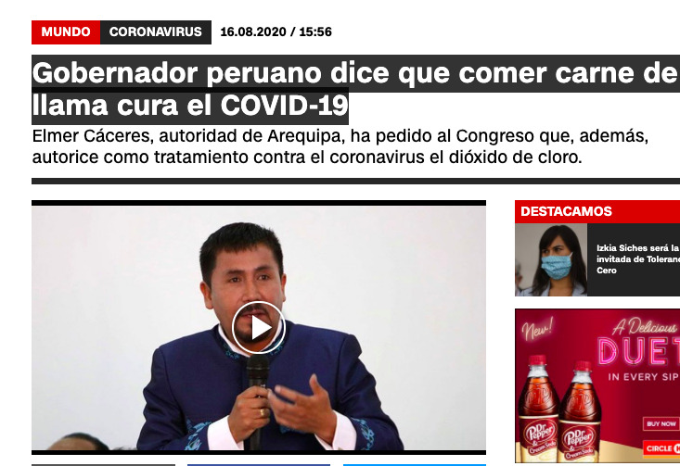
WORLD CORONAVIRUS
Peruvian Governor says that eating llama meat cures COVID-19
Elmer Caceres, authority of Arequipa, has asked Congress to authorize the use of chlorine dioxide as treatment against the coronavirus.

