On The Verge Of Tears
I think I speak for all of us when I say that we have had enough of the COVID-19 pandemic. From losing our family members to living off of unemployment. It’s safe to say that we have had enough. Living in a pandemic has caused a lot of us to experience extreme changes at such a fast pace, changes that we were unprepared for. As a Muslim, the pandemic has robbed me of the only two holidays that I celebrate, Eid-Al Adha, and Eid-Al Fitr. Imagine not being able to celebrate your only two holidays. For Muslims, there is no Christmas, Halloween, Thanksgiving, 4th Of July, Easter, Valentines, etc. All we have is Eid-Al Adha and Eid-Al Fitr. But in order to move forward, you cannot only have a negative view, you must always remember that there is a silver lining.
Just because you weren’t able to celebrate your holidays doesn’t mean that the world is over. Because of the pandemic, I have had a chance to get closer to my family and friends. I finally had a chance to catch up on my hobbies. During this pandemic, I was able to lose 10 pounds off of my body. I would train with my brother and sister, I was able to strengthen the bond between us as siblings. I was able to get a job and work from home, I was finally earring some type of salary. While not all of this is due to the pandemic specifically, it is because of the pandemic that I was able to take those first steps. With everybody being home at all times of the day on all days of the week, I had to find a way for us to bond together.
Unfortunately, whenever there is something good there is bound to be something bad a few steps behind it. My mother was recently diagnosed with stage 3 cancer. Just as I was beginning to get the hang of living happily in a pandemic, I got hit with the terrible news. I am constantly scared for her, I am scared that she might get COVID-19, and many things. But once again you have to look at the silver lining. Recently I have been taking her out for walks, I am trying to help her regain her physical strength. I believe that she has the power to beat cancer. And I believe that we have the power to beat COVID-19, lets not let a disease push us around.

- Eid 2019: A picture of me, my brother, and my sister. (Pre-COVID)
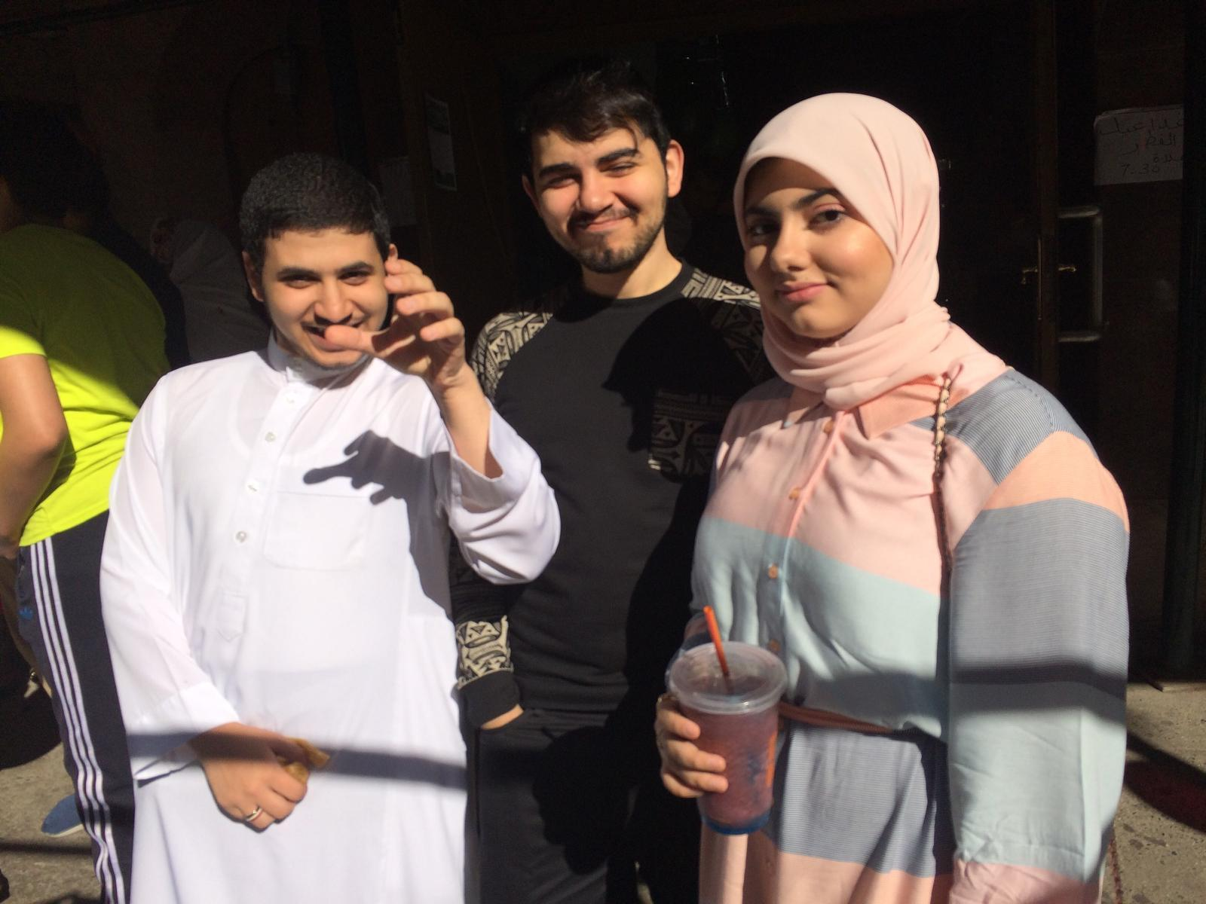
Eid 2019: A picture of me, my brother, my sister, and my uncle. (Pre-COVID)
