Translation of item number 16242 by Angelica S Ramos 06/29/2021
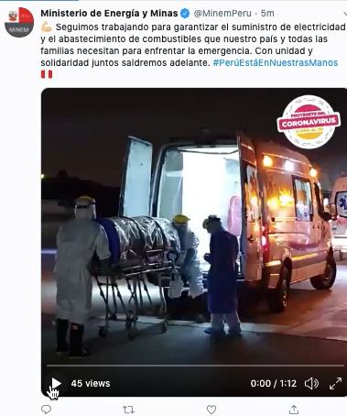

We continue to work to guarantee the electricity supply and fuel supply that our country and all its families need in order to face this emergency. With unity and solidarity together we will carry on.

