Translation of item number 16791 by Angelica S Ramos 06/29/2021

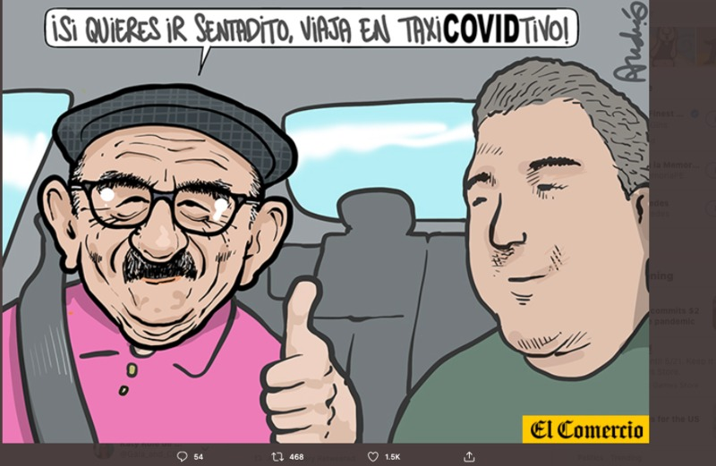
“If you want to go seated, travel in the covid taxi!”
Andres Edery
“La chiripiorca” (translators note: this term has no direct translation but means to freak out)

Robert
“@FrenteAmpiloPe and his grandfather of evil. Screwing up the country. If he wants to go seated then he should pay for a taxi. This dumb man @EnriqueFCHA…definitely responsible for deaths.”

MiXTirRo
“When you confuse your feelings of solidarity, replace them with the interests of a certain group. On the side of a relegated law (drowning in fines) or are you a zoquete or talmado.”

