Translation for item 10864 by Angelica S Ramos 07/06/2021
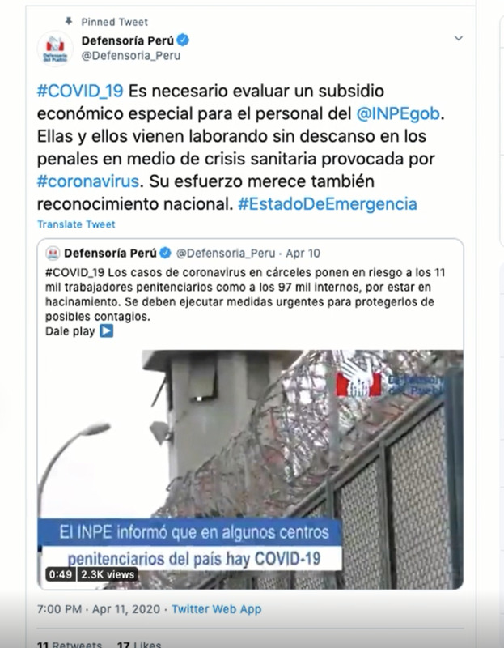
Defensoria_Peru Twitter Account
#COVID_19 It is necessary to evaluate a special financial subsidy for the staff of the @INPEgob. They have been working tirelessly in prisons in the midst of a health crisis caused by #coronavirus. Their efforts also deserve national recognition. #EstadoDeEmergencia

Defensoria Peru
#COVID-19 cases of coronavirus in jails have put 11 thousand jobs at risk likewise it is putting the 97 thousand inmates at risk because the jails are overcrowded. Urgent measures must be taken to protect them from possible infection.

The INPE informs that in some jails some inmates have contracted COVID-19

