Translation of item 27725 by Angelica S Ramos 07/06/2021
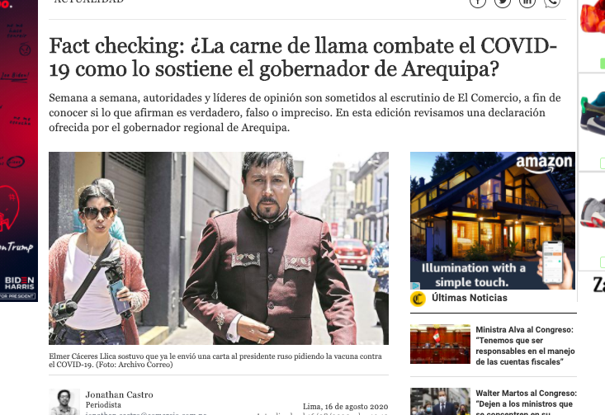
Fact checking : Does llama meat fight COVID-19 like the governor Arequipa insists?
Week by week, authorities and opinion leaders are subjected to the scrutiny of El Comercio, in order to know whether what they claim is true, false or inaccurate. In this edition we reviewed a statement offered by the governor of Arequipa

