- Trip to Chania, Crete: Wedding of the Century for the Family (Title)
- As a public health expert, I did not travel during the COVID-19 pandemic, even as some of the restrictions were lifted until the summer of 2022. The prompt of “when travel restrictions were lifted” is vague as to meaning due to the complicated circumstances which makes it difficult to consider what taking a trip in this time period encompasses. In June, 2022, I travelled with a large part of my extended family to Crete to be together and witness the marriage of the oldest nephew. The couple had postponed their wedding because of the pandemic and ended up getting married by a justice of the peace in their hometown by themselves. The bride had dreamed of her ideal wedding and planned for it when it was possible. She wanted to be married on Crete as both her parents had grown up there and she had travelled to Greece extensively as she was growing up.
My memories of the trip include the attention to detail that was given so that the attendees could truly experience Crete. Several side trips were planned to “experience the island” including to an olive oil farm and a monastery. (description) Our strongest memory was the food- fresh seafood and attention to flavor. My daughters continue talk about the food in Greece and why we don’t do better in America.
The wedding itself was spectacular. It was located at a winery that had become an events space. Because the bride has family on Crete, I believe we were fortunate to experience a local wedding. An orthodox priest performed the ceremony. Dancing went on until the early morning hours.
In terms of continuing COVID-19 restrictions, there really were none. My immediate family wore masks on flights but it was not required. The day after the wedding, the bride and groom were told that three of their friends who had travelled from America had tested positive for COVID. The next day the bride developed symptoms and the following day, so did the groom. Miraculously, none of my immediate family developed symptom. We had brought antigen tests and all tested negative before we left Greece, w=even though we were not required to test. (Description)
- Arizona State University, HST 643, and History of Tourism. Family wedding, Crete (tags)
- Text story with photos (Type)
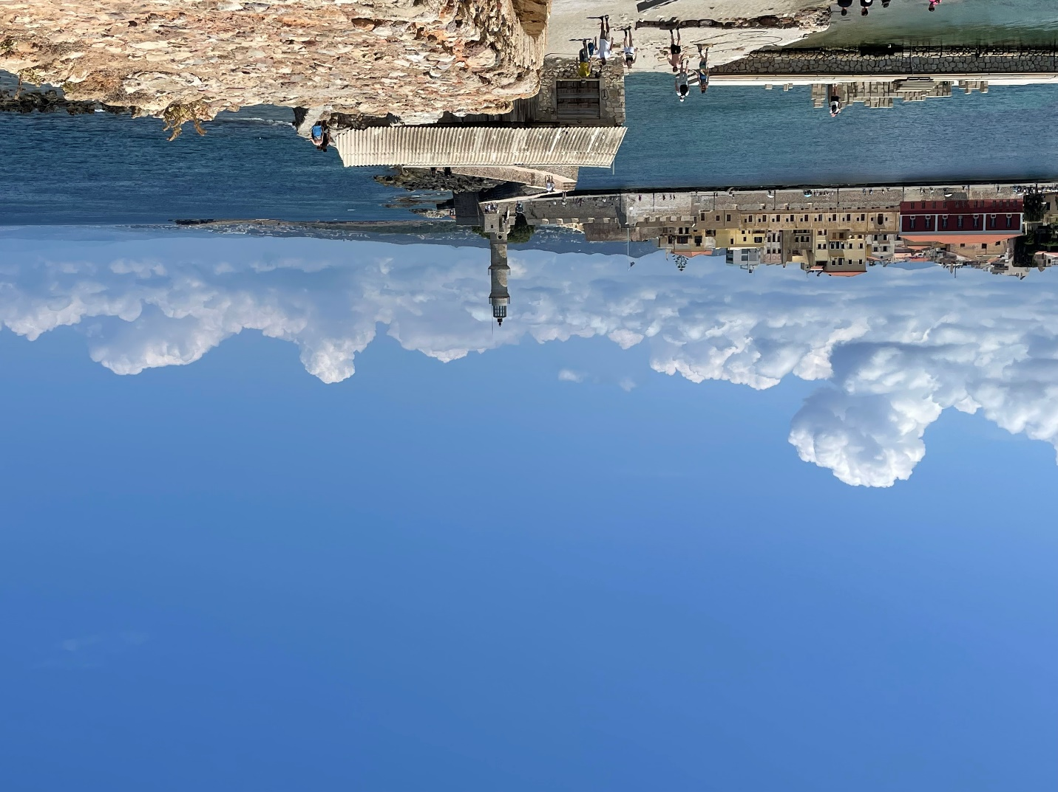
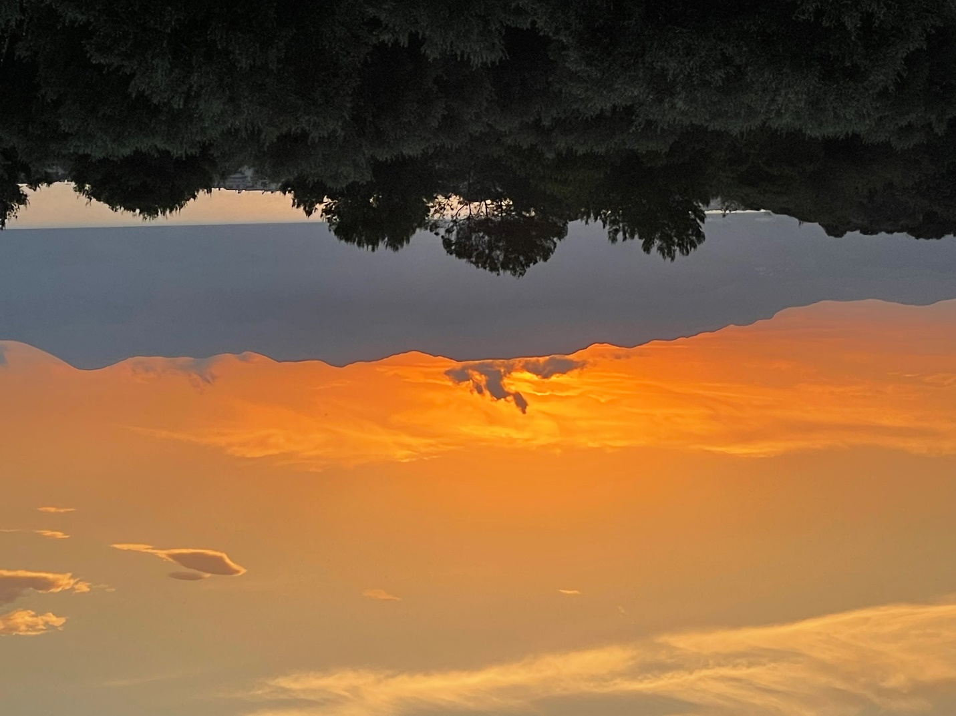
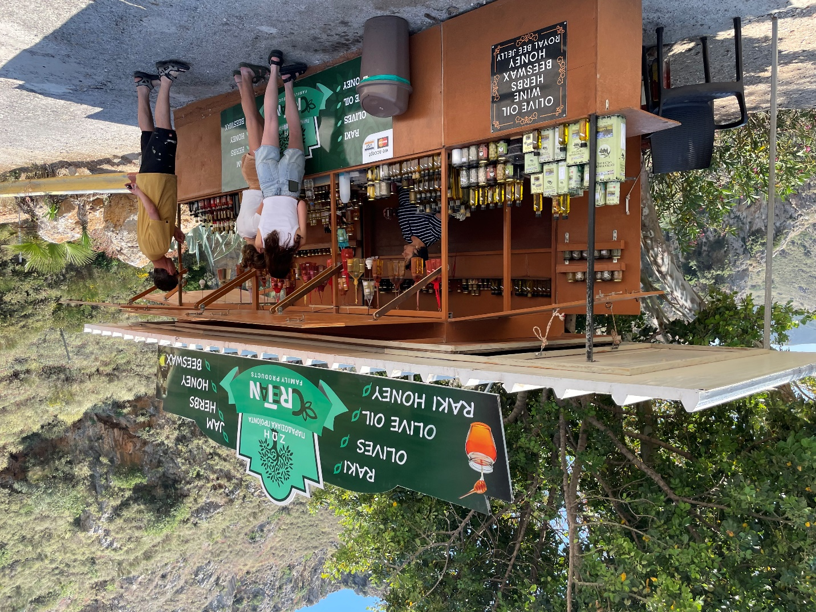
We documented the trip in photos. I do not use social media. I also did some watercolor sketches that are private to me.
- June 12-23, 2022 (date)
- Susan Pepin (contributer)
- Chania, Crete (location)

