Translation of item 28259 by Angelica S Ramos 07/06/2021
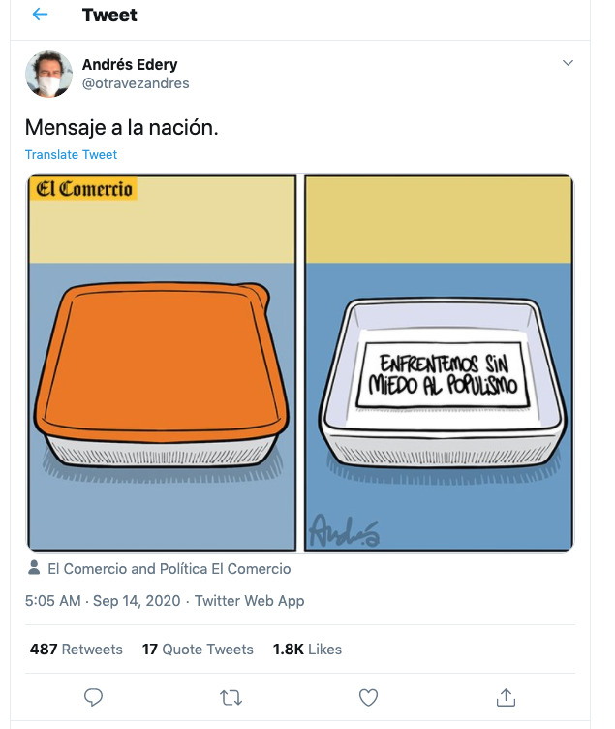
Message to the Nation
“Lets confront fear of populism”

