Translation of item 10860 by Angelica S Ramos 07/03/2021
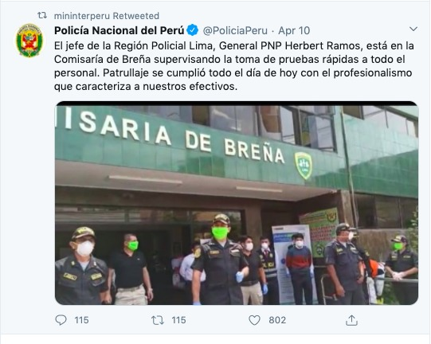

National Police of Peru
“The head of the Lima Region Police, General PNP Herbert Ramos, is in the Commissioner of Brena overseeing the taking of rapid tests to all staff. Patrolling was done all day today with professionalism that characterizes our troops”

