Translation of item 12795 by Angelica S Ramos 07/06/2021
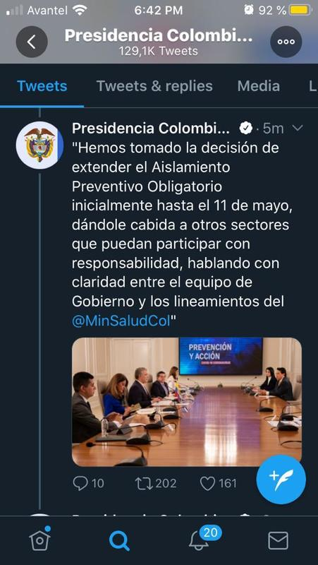
We had made the decision of extending the Mandatory Isolation and Prevention initially until the 11th of May, giving space to other sectors that can participate with the responsibility, conversing with clarity in between teams of the government and the rules of @MinSaludCol

