Translation of item number 16917 by Angelica S Ramos 06/23/2021
*ALL IMAGES HAVE THE SAME HEADER*-
Histories
A quarantine diary, by Andres Edery
Again Andres – Look at the graphics Andres Edery has published in the magazine since 2018. Politics, National, International, Lima, Sports, our country: all summarized in his drawings
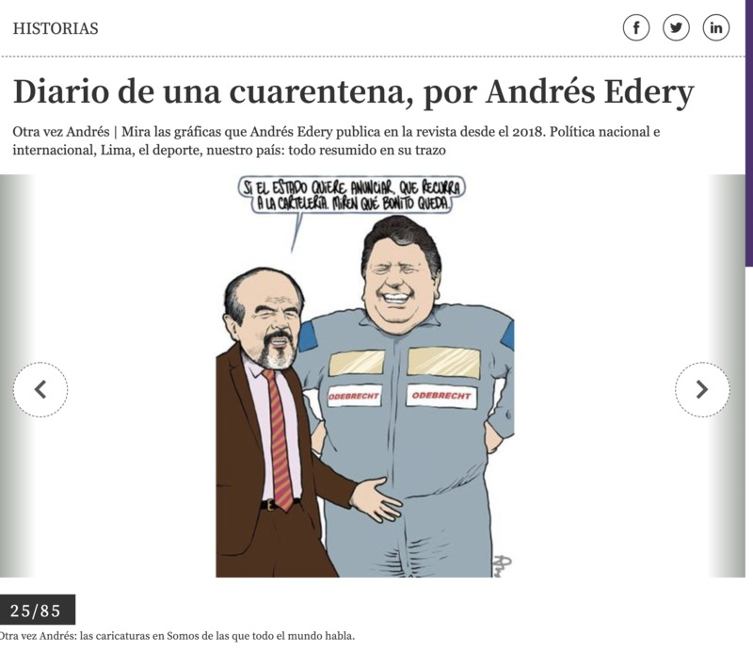
Yes, the state would like to announce that it will resort to signage. Look how nice it is.
25/85
Again Andres: The cartoons in Somos that the whole world talks about
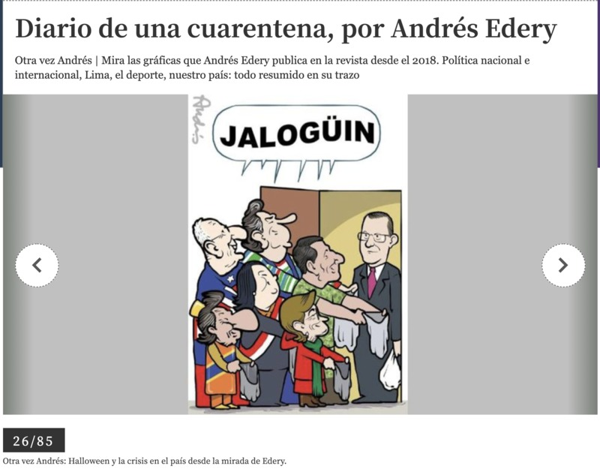
Halloween
26/85
Again Andres: Halloween and the crisis in the country from Edery’s point of view.
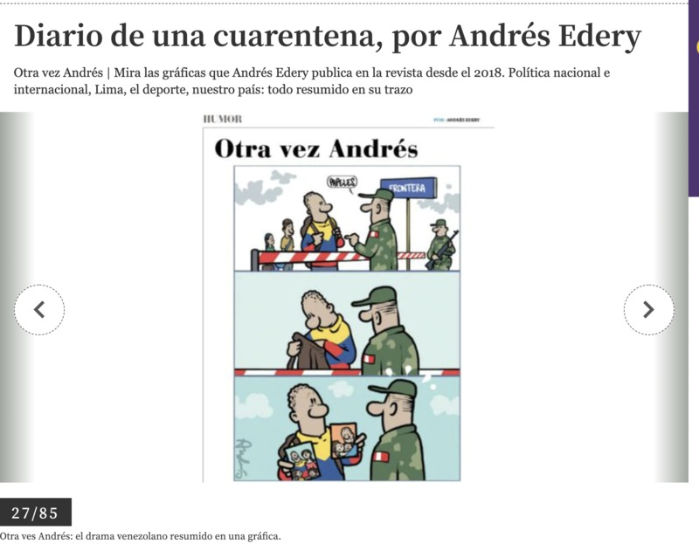
“papers” BOARDER
Again Andres: The drama of Venezuela summarized in a cartoon
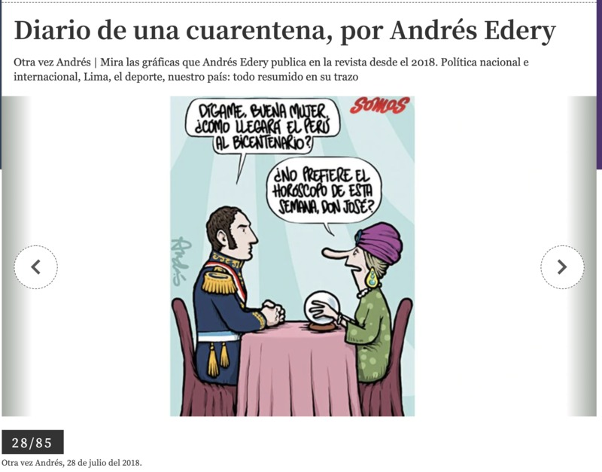
“Tell me good lady, how will Peru reach the bicentennial?”
“Would you not prefer this week’s horoscope Mr. Jose?”
28/85
Again Andres, July 28, 2018.
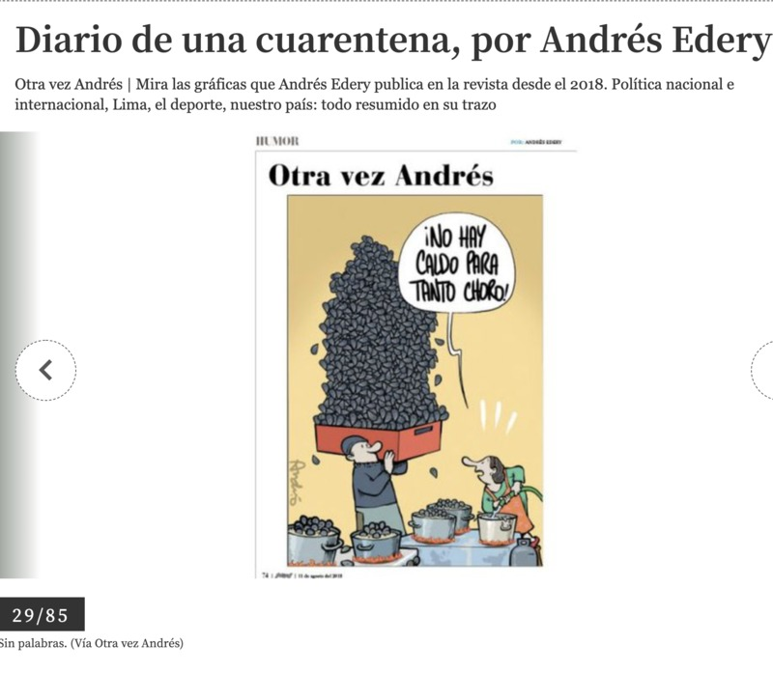
“There is no soup for so much “choro”” (choro is a Peruvian mussel soup but also refers to a thief)
29/85
Without words (from Again Andres)
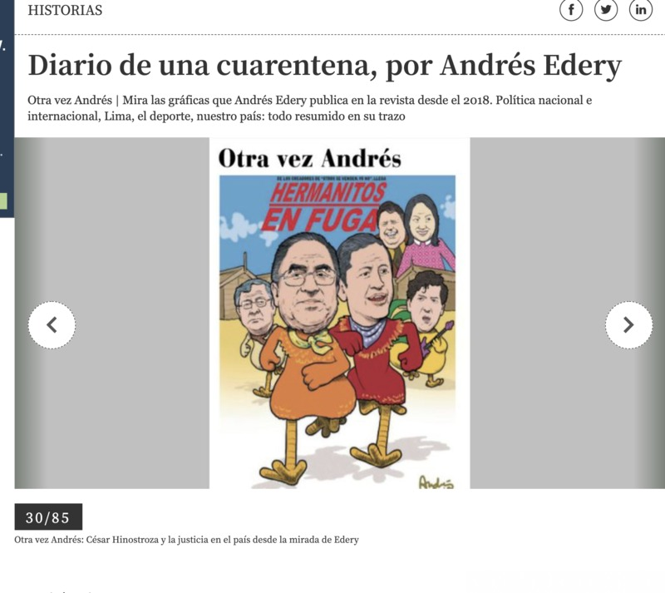
Little brothers on the run
30/85
Again Andres: Cesar Hinostoza and the justice of the country through the eyes of Edery
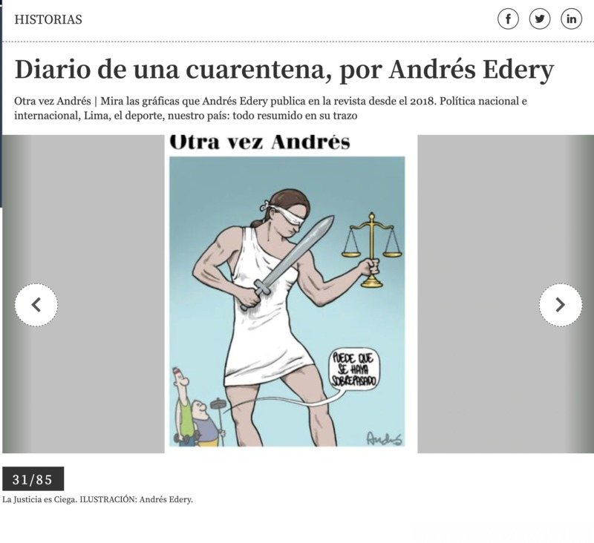
“It may be that it’s been overcooked”
31/85
Justice is blind. ILLUSTRATION: Andres Edery.
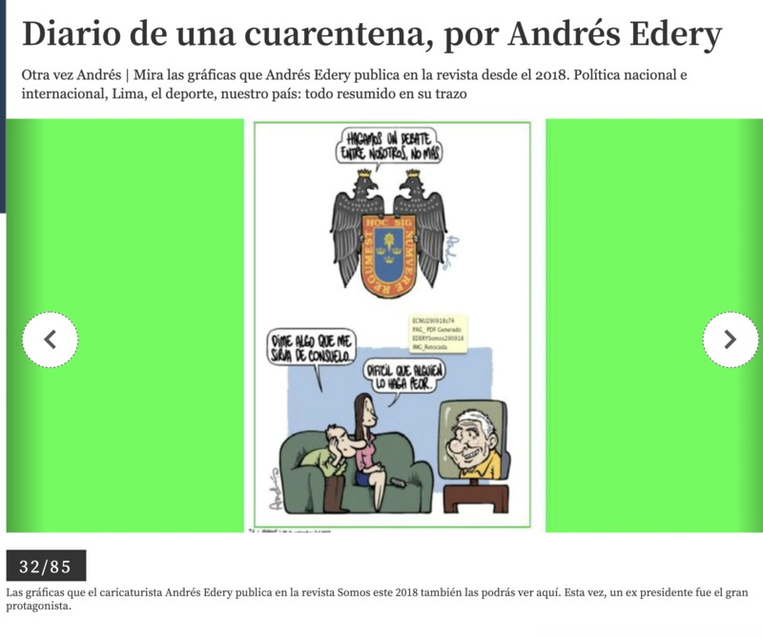
“Let’s have a debate between us, no more”
“Tell me something that will comfort me…”
“Difficult for someone to make it worse…”
32/85
The graphics that cartoonist Andres Edery published in the magazine Somos this 2018 they can also be seen here. This time, an ex-president was the grand protagonist.
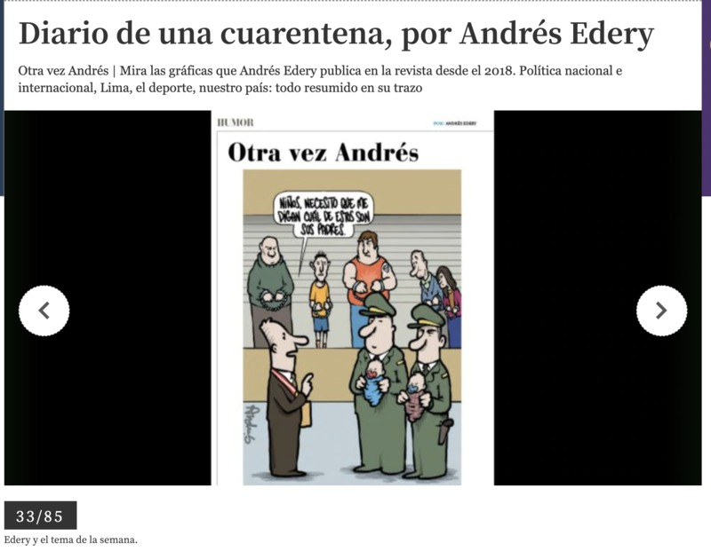
“Children I need you to tell me which one of these is your father”
33/85
Edery and the topic of the week.
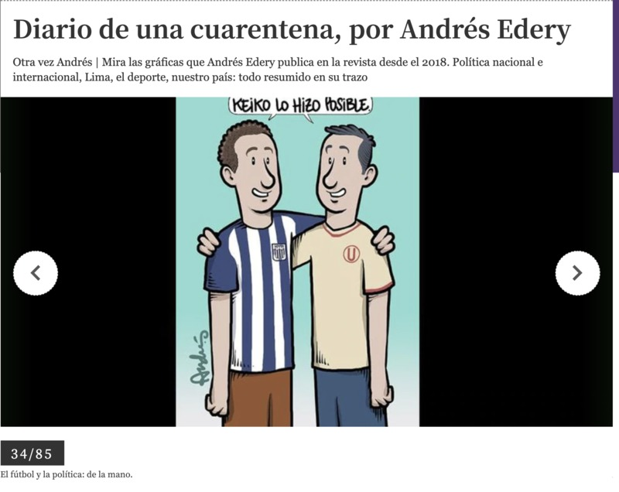
“Reiko made it possible”
34/85
Soccer and politics: hand in hand
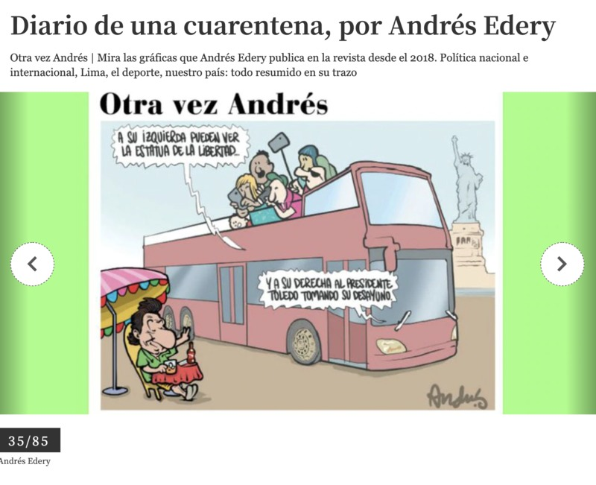
“On your left you can see the statue of liberty”
“And to your right the president Toleda drinking his breakfast”
35/85
Andres Edery
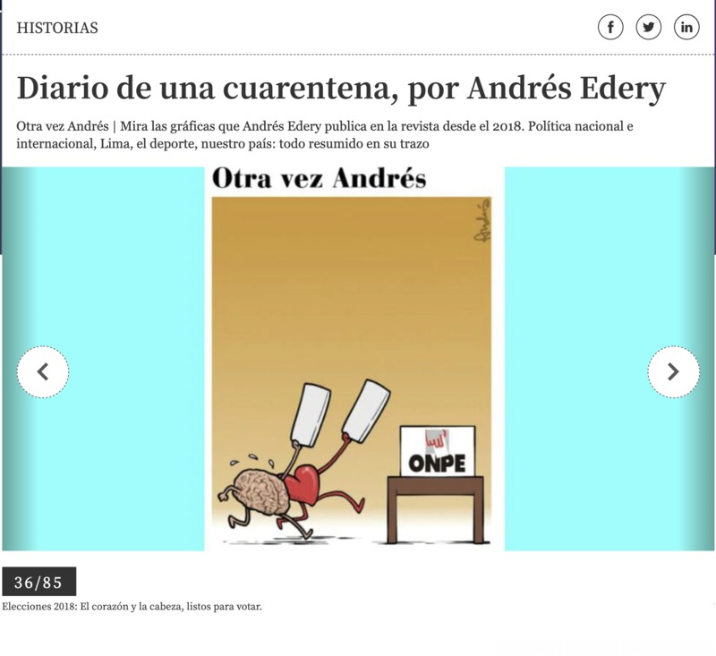
The ONPE is the National Office of Electoral Process in Peru
36/85
2018 Elections: The heart and the brain, ready to vote.
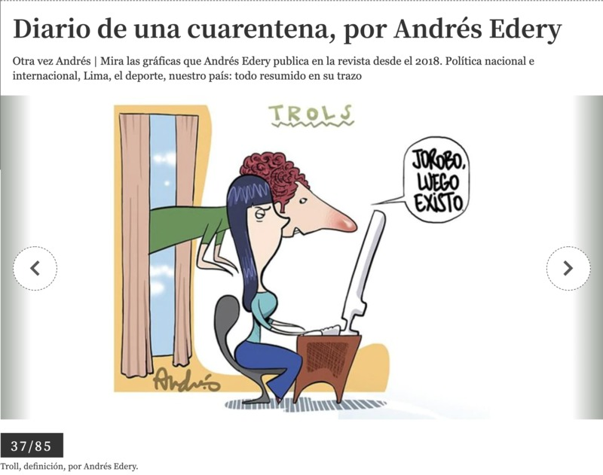
Trolls
“Ill bug and then Ill exist”
37/85
Troll, definition, by Andres Edery.
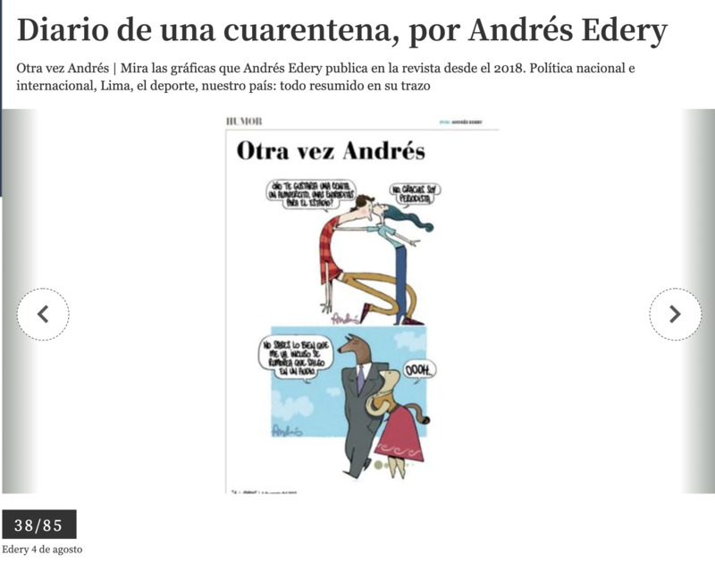
“Wouldn’t you like a dinner, a lunch, some tickets for the stadium?”
“No thank you, I’m a journalist.”
“You have no idea how good I’m doing. There’s even a rumor that I’m featured in an audio”
“OOOOH…”
38/85
Edery August 4th
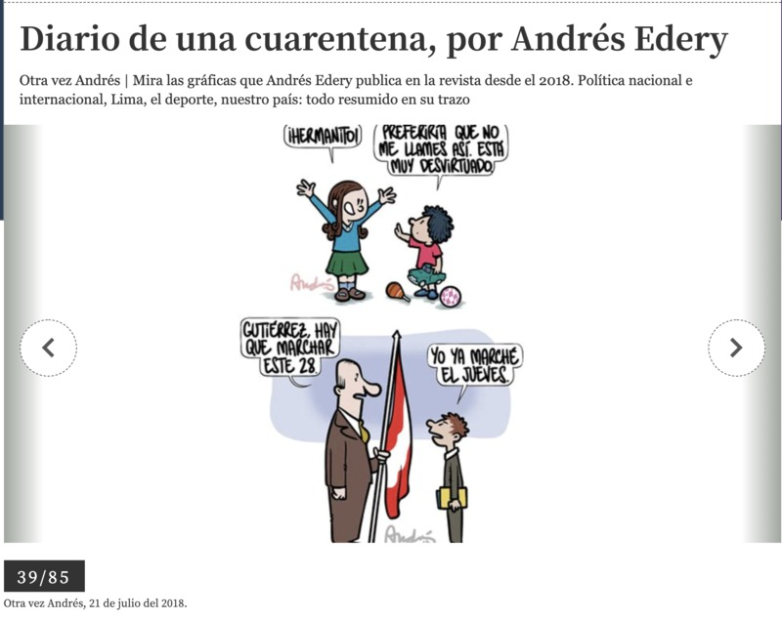
“Little brother”
“I would prefer that you not call me that. It’s too valueless”
“Gutierrez, we have to march this 28”
“I already marched on Thursday”
Again Andres, July 21, 2018.
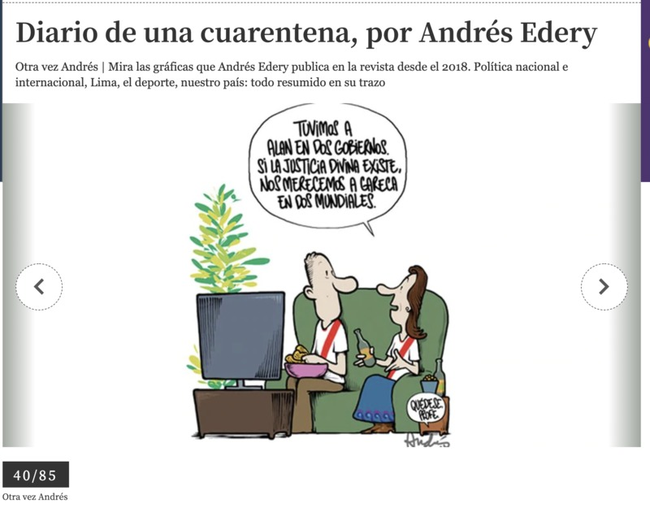
“We had Alan in two governments. If divine justice exists, we deserve Gareca in two world cups.”
40/85
Again Andres.

