Translation of item number 17281 done by Angelica S Ramos 06/22/2021
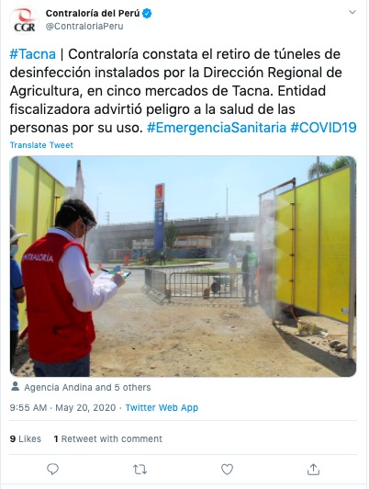
#Tacna – Contraloria notes the removal of disinfection tunnels installed by the Regional Agriculture Directorate in five markets in Tacna. The supervising entity warned against the health risks for people who use them. #EmergencySanitation #COVID19
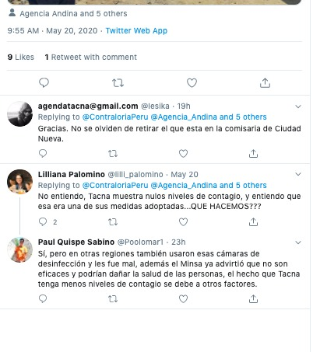
Agendatacna@gmail.com
- Thank you. Don’t forget to retire the one that is in the commissary of the city of Nueva.

Lilliana Palimino
- I don’t understand, Tacna shows zero levels of contagion, and I understand that this was one of the adopted measures. WHAT DO WE DO???

Paul Quispo Sabino
- Yes, but in other regions they also used these forms of disinfectant and it went bad. Plus in Minsa they have already advised that they are not effective and can damage the health of a person. The fact that Tacna may have lower levels of contagion is due to other factors.

