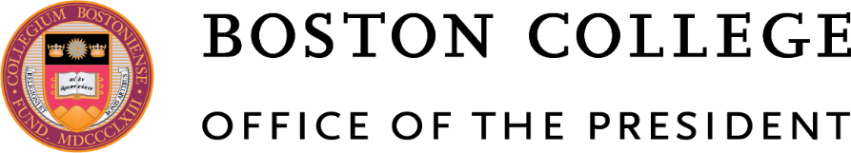

March 23, 2020

Dear Members of the Boston College Community:

The COVID-19 virus has had extraordinary effects on our world and personal lives, and I write to provide an update on Boston College’s response to this pandemic as well as offer some thoughts as we go forward amid current and future challenges.
As many of you know, the University announced on March 11 that it was canceling all on-campus classes through the end of the semester and moving to online instruction on March 19. That shift has gone well, thanks to the generosity, commitment, and adaptability of so many students, faculty, and staff; and I am deeply grateful for their efforts. Individuals in Information Technology Services, the Center for Teaching Excellence, and the Center for Digital Innovation in Learning also have been particularly helpful with distance teaching and learning, and I thank them as well.
In another change, Boston College closed its residence halls on March 15, except to students facing international travel restrictions or serious personal issues. Those who had been living on campus and required to leave will receive a prorated refund or credit for board and room charges to their accounts by the end of this week. Approximately 375 undergrads are now in residence on Upper Campus and going to McElroy for meals.
Massachusetts Governor Charlie Baker issued an emergency order this morning “requiring all businesses and organizations that do not provide ‘COVID-19 Essential Services’ to close their physical workplaces and facilities” from noon on March 24 through noon April 7, and encouraged them to continue operations remotely. The order included an exemption for higher education institutions so that they can still deliver necessary campus services. Many staff and faculty at Boston College have already been working remotely; and given this new state action, more will be joining them. All employees will be expected to continue working, but in a different mode. Further details will be issued by vice presidents and deans.
The coronavirus has touched everyone associated with Boston College, generating anxiety, fear, and concerns about personal health and safety. As of today, one student on campus has tested positively for COVID-19 and is now in isolation at the Thomas More Apartments, which also includes University Health Services; and 19 others, mainly those who were studying abroad this semester and then returned directly to their homes or to off-campus apartments, have also been diagnosed with the virus. Please know that our Facilities staff members are committed to cleaning and disinfecting campus buildings, particularly common spaces, multiple times per day; and the remaining campus community has been urged to follow guidelines for social distancing.
No doubt, this pandemic has particularly affected the Class of 2020, and I am saddened by that. Senior year is a special time in the life of a college student, and I know our seniors were eagerly awaiting such events as Marathon Monday, Senior Week, and Commencement. A decision will be made soon whether Boston College will be able to hold its Commencement ceremony on May 18. If that should not be possible, every effort will be made to have a suitable event to honor graduating students at a later date.
The coronavirus sweeping the globe and the accompanying disruption have brought medical concerns and financial pressures to the world. These events have also shown that we human beings are not in control of our lives as much as we may have previously thought, and recent weeks have also reminded us about the importance of relationships and faith. Since its founding in 1863, Boston College and its community have faced significant challenges and prevailed, and I remain confident that will be the case with COVID-19. I am grateful for the many ways students, faculty, staff, parents, alumni, and friends have helped Boston College in recent days through words and deeds; and I count on that in the future as well. It is essential that we continue to be connected with one another directly or indirectly, and that we draw comfort and hope from our heritage and mission as a Jesuit, Catholic university.
I pray for the Boston College community every day, and I invite you to do the same. May the following words from the prophet Isaiah inspire and sustain us in coming days and weeks:
“They that hope in the Lord will renew their strength, they will soar as with eagles’ wings; they will run and not grow weary, walk and not grow faint.”

Sincerely,

William P. Leahy, S.J.
President
Office of the President
140 Commonwealth Avenue
Chestnut Hill, MA 02467

