Translation of image number 9844 done by Angelica S Ramos on 06/30/2021
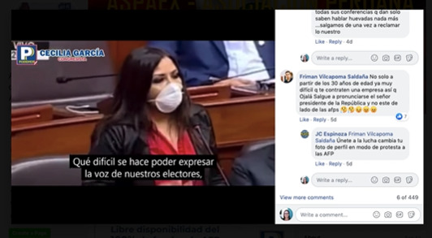
Cecilia Garcia
“It is so difficult to express the voice of our electors”

Comment section:
“all the conferences they give they only speak hollow words nothing more…lets go outa reclaim what is ours”

Friman Vicapoma Saldana
“Not only that but at the age of 30 it is already very difficult for a company to hire you so I look forward to seeing what the president of the Republic has to say and not the AFPS.”

JC Espinoza replying to Friman Vicapoma Saldana
“Join the fight change your profile picture in to protest the AFP”

