#DUQStories
#COVID-Senior
Late August 2019:
I was so excited to begin my senior year in high school. I couldn’t wait to play in the football games and attend the school dances. I imagined all the good times my friends and I would have. The year started out as most did with the teachers reviewing the syllabus for each class and discussing the rules we were expected to follow.
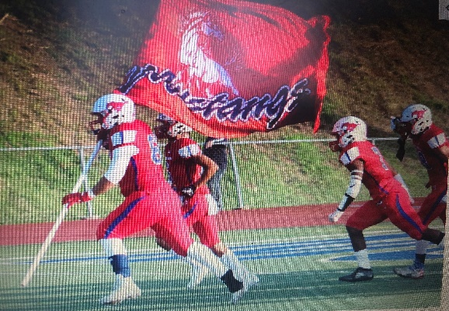
September 2019:
The first football game was amazing and I looked forward to each Friday so I could play under the lights
November 2019:
The Fall Ball was in a couple of days. I picked out a suit and tie and ordered flowers and anticipated a night of memories.
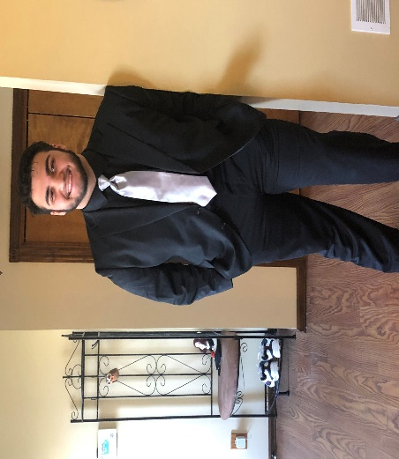
December 2019:
Christmas break came and went and all were excited for the new year. Many believed 2020 was going to be the best year yet.
January 9, 2020:
I began hearing about a new mysterious sickness that was similar to pneumonia. The cases were from Wuhan, China so I didn’t think about how it would affect me.
January 21, 2020:
The first case of the Coronavirus was found in Washington State. The sick individual recently traveled to Wuhan, China. I still wasn’t concerned and attended classes in school and went about my daily life.
January 31, 2020:
The World Health Organization declared a public state of emergency. I was young and healthy and didn’t worry. Everything was still open. My friends and I went out to eat, watched basketball games, and visited each other’s houses.
March 6, 2020.
Governor Wolfe reported the first two cases of coronavirus in Pennsylvania. This was getting a closer to home now, but it was still a great distance from my house.
March 12, 2020:
Governor Wolfe implemented social distancing. I had no idea what this meant. I began to start feeling a little uneasy now but really wasn’t that concerned. I watched the news and read information from my phone as far as I could tell this virus was affecting those with a weakened immune system and the elderly. I wasn’t in either category, so I carried on with my daily life of school and outings with my friends.
March 13, 2020:
This would be my last day of face- to -face learning at my school. Governor Wolfe announced that all schools were to be closed for two weeks. Everyone was excited to be out of school.
March 16, 2020:
Restaurants and bars were ordered to close for dine in customers. I thought this would be only for two weeks and I was still able to talk to my friends on Xbox.
March 20, 2020:
My dad began feeling the symptoms of the coronavirus. He went to be tested. They were not sure how long it would take to get the results came back and he was to isolate until he knew. He began feeling worse. He had a fever of 104.00 degrees, horrible headache, body aches, loss of smell and scent. He was sick for three weeks.
My high school decided to finish out the year with remote learning. I had to make sure my computer was charged each night, complete assignments on the chrome books, and remember to do daily attendance.
Graduation and prom were just around the corner and everyone thought the shut- downs would be over by then.

May 2020:
Prom was cancelled. Graduation would be but we had to wear masks and there would be no audience to congratulate us for all of our hard work. We social distanced and walked across the stage one by one as our loved ones stood in front of the stage and tried to take pictures.
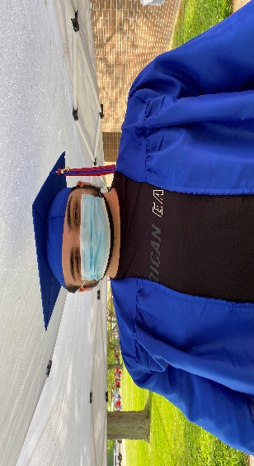

Being isolated in the house was hard. I am very active and was used to going all the time. I didn’t expect this would happen. People were dying from a virus that scientists didn’t know much about. All you heard or saw was the number of people affected and those that died.
February 2021:
As of today, 26 million people in the United States have been diagnosed with COVID-19 and 457,491 individuals died. As of today, nothing has changed or gone back to normal. We still have to wear masks, social distance. I get upset thinking this will never end. Maybe, I should have worried more.
