A Field Trip to the Doctor
February 9, 2021

About five days ago, I developed a stye under my left eye. A stye is an infection of the eye caused by clogged oil glands in the eyelash. This is not something I’ve ever experienced before, as I don’t wear makeup (they are typically caused by leaving makeup on too long). I sent a picture of it to my friend, Stephanie, who works in the medical field, and she told me if it became swollen, to seek medical attention. So, since that’s what happened, I set up an appointment with ASU Health Services.
To do that, I went to the online health portal and set up an appointment with urgent care. After I scheduled the appointment, someone at Health Services called me to confirm the appointment. They also walked me through a set of questions which have become routine to ask due to the Covid19 pandemic. First, they asked if I had tested positive or been exposed to anyone with Covid19 in the last two weeks, then they asked if I had any of a large number of symptoms related to the virus. I didn’t, obviously, since I was going in to get treatment for a stye, but the questions have become so routine that they are just expected – part of the “new normal” of the Covid19 world.
Even though the pandemic is of course the most pressing thing about the world today, that doesn’t mean other illnesses or medical issues have disappeared. People are still getting colds, coming down with the flu, getting staph infections, dealing with sinus infections and allergies. The Covid19 virus has become such a public health crisis that all the other millions of viruses, infections, and illnesses that people are dealing with are going virtually ignored. Which, while understandable, is still a significant silence.
In any case, I went to the doctor for a non-Covid19 reason, had to answer tons of screening questions so that the doctor’s office could ensure I wasn’t coming in with Covid19 (ASU Health Services is not equipped to handle that), and walked out with a prescription for topical Erythromycin, which is a broad-septic antibiotic. Now, I have to apply it to my eyelid six times a day for a week. In 33 years, this is the first time I’ve ever had a stye. I honestly wish I could go back to never having experienced one. They hurt!
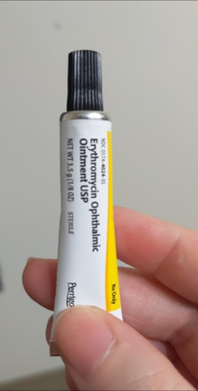

Kelly “Ky” Greene

