This morning the first thing I saw on my social media pages was the announcement that ‘Asian giant hornets’ were spotted in the U.S. for the first time. On top of worrying about the COVID19 pandemic we now must worry about killer hornets. This year was supposed to be a new and great start for everyone but clearly 2020 is nobody’s year. A lot of people are trying to deal with all the stress of 2020 by making memes. I thought instead of having a negative entry for my post I would put together a couple of different memes that made me smile.
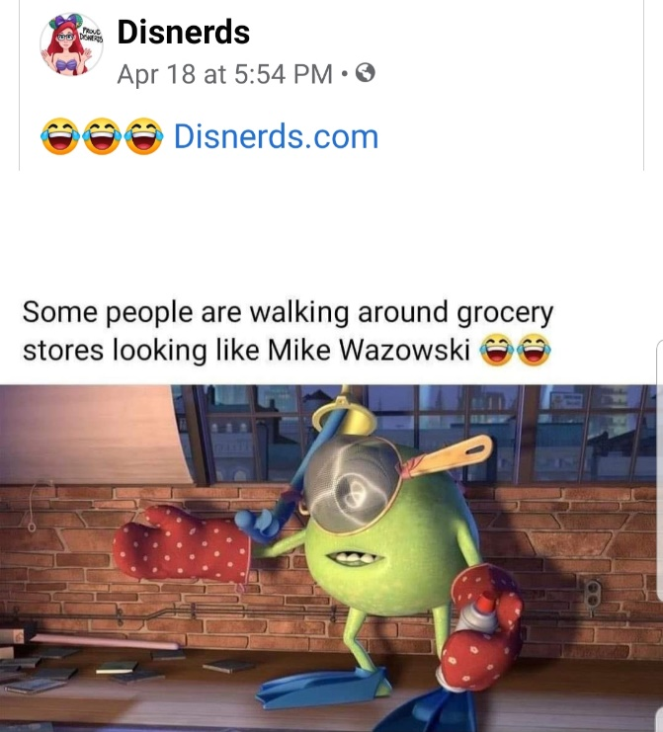
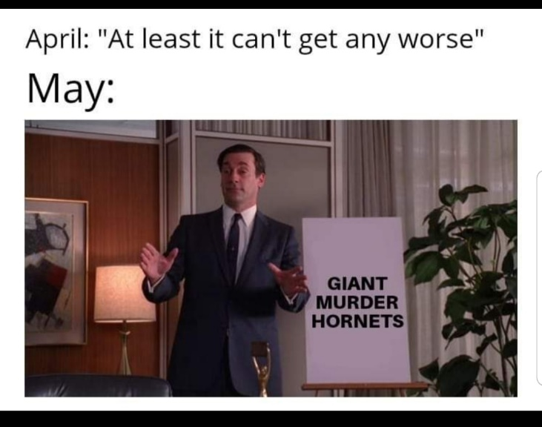
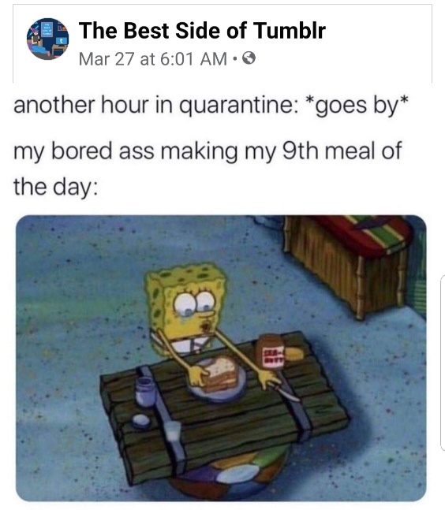
Photo credit: Hey there memes it’s me Ya Boi (facebook page)

