Grace MacDonald
Prof. Kulich
Politics of the Pandemic
15 August 2020
Moakley Archive
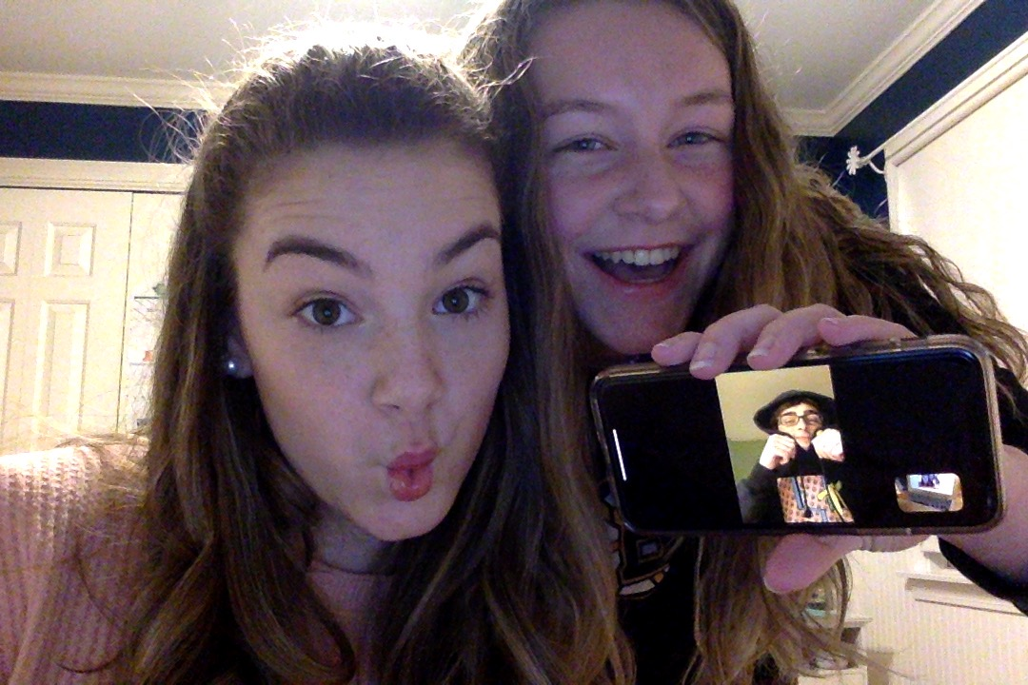
Family Photo

The pandemic hit just as I had gotten into a relationship. With the stay at home order, my boyfriend and I were unable to see each other, so we relied on technology to stay in touch. We texted and Facetimed every day, and my little sister often sat in on our conversations and chatted with us too. I believe that quarantine made me and my boyfriend’s relationship stronger, and formed a nice little friendship between him, my sister, and myself. Those Facetime calls were the best part of my day, and I would consider them a big part of my pandemic experience.

