Translation for item 10863 by Angelica S Ramos 07/06/2021
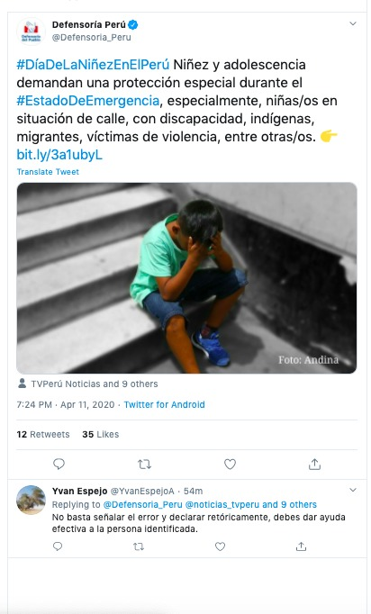
#DayOfChildhoodInPeru Children and adolescents demand special protection during the #StateOfEmergency, especially children on the street, with disabilities, indigenous, migrants, victims of violence, among others.

Yvan Espejo
It is not enough to point out the error and make a rhetorical declaration, you should effectively help the identified person.

