Translation of item 10868 by Angelica S Ramos 07/06/2021
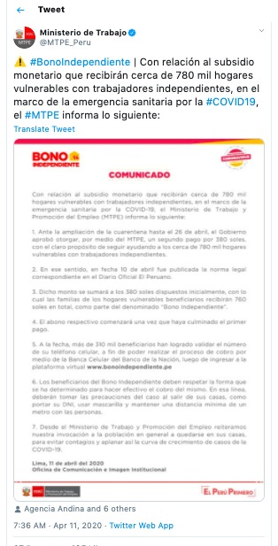
With regard to the monetary subsidy that about 780 thousand vulnerable households of independent workers are about to receive, in the context of the health emergency due to Covid-19 the MTPE informs the following:
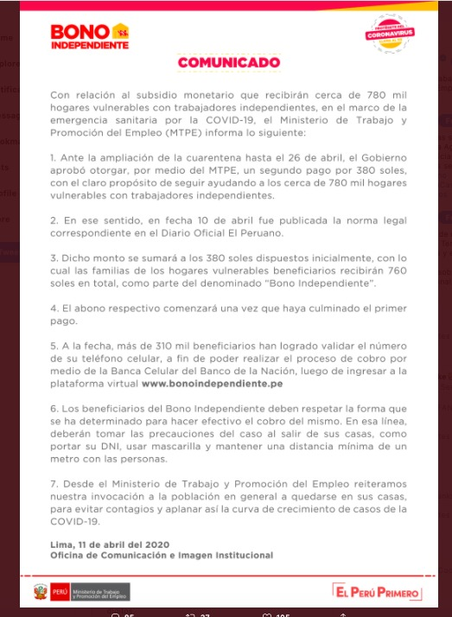
1. In view of the extension of the quarantine until April 26, the government approved to grant, through MTPE, a second payment for 380 soles, with the clear aim of continuing to help the nearly 780 thousand vulnerable households with independent jobs.

2. In this regard, on April 10, the corresponding legal norm was published in the Official Diary of Peru.

3. This amount will be added to the 380 soles initially arranged, the families of the vulnerable households will receive 760 soles in total, as part of the so-called “Independent Bond”.
4. The respective payment will begin once the first payment has been completed.

5. To date, more than 310 thousand beneficiaries have been able to validate the number of their cell phone, in order to be able to carry out the process of charging through the Cellular Banking of the National Bank, after entering the virtual platform bonoindependiente.pe

6. Independent Bond beneficiaries must respect the form determined to collect the cash of the Independent Bond. In this line, they should take precautions of the case when leaving their homes, like carrying ID, wearing masks and maintaining a minimum distance of a meter between people.

7. From the Ministry of Labor and Employment Promotion, we reiterate our appeal to the population in general to stay in their homes, in order to avoid infections and thus flatten the growth curve of COVID 19.

Lima, April 11, 2020
Office of Communication and Institutional Image

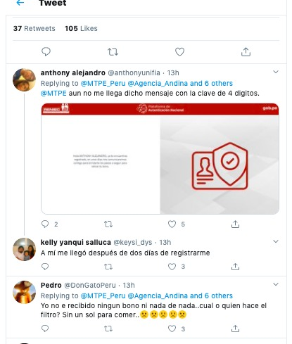
Anthony Alejandro
I still do not get that message with the 4 digit key

Kelly yanqui salluca
I got it two days after registering

Pedro
I have not received any bonus or anything…who or what makes the filter? I’m without a sol to eat…

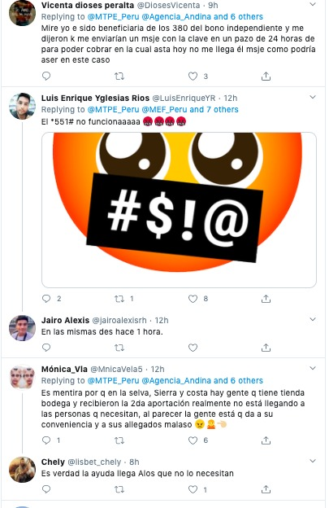
Vicenta dioses peralta
I was benefitting from the 380 independent bonus and I was told that they would send me a key in a 24 hour time period to be able to charge. I have yet to receive any message what can I do in this case

Luis Enrique yglesias rios *551# does not work Jairo Alexis I’ve been in the same place for over an hour
Monica Via It is a lie because in the jungle, Sierra and Costa there are people who have a store and received the second contribution, this is really not reaching the people in need, apparently the people are doing what is convenient.

Chely It’s true the help is getting to those who don’t need it

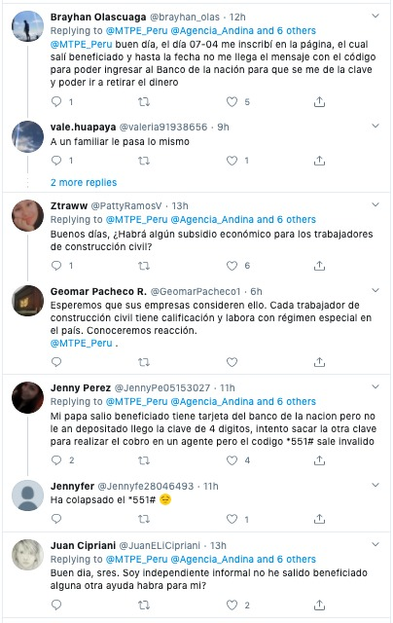
Brayhan Olascuaga
Good day, the day 07-07 I signed up on the page, which said I was to be a beneficiary and to date I do not get the message with the code to be able to enter the Bank of the Nation so that I could be able to withdraw money

vale huapaya
The same thing happened to a relative

Ztraww
Good morning. Is there some economic subsidy for civil construction workers?

Geomar Pacheco R.
We hope your companies will consider this. Every civil construction worker has qualification and works with special regime in the country. We will know about reaction

Jenny Perez
My dad was found to be a beneficiary and got his bank card but he never got the 4 digit key, I tried to take out the other key to make a charge but the code *551# is invalid

Jennyfer
*551# has collapsed

Juan Cipriani
good day, gentlemen. I am independent informal has there been any help for someone like me?
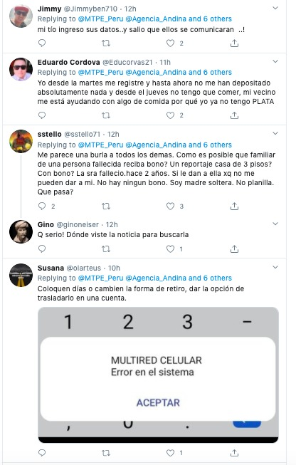
Jimmy
my uncle entered his data... and they were able to communicate..

Eduardo Cordova
I registered on Tuesday and so far they have not deposited absolutely anything and since Thursday I do not have anything to eat, my neighbor is helping me with some food because I no longer have SILVER.

sstello
i find it a mockery of all other people. How is it possible for a deceased person's relative to receive a bonus? A 3 story house report? With bonus? The lady died two years ago. If they give her why cant they give me. There are no bonuses. I am a single mother. No silver. What's wrong?
Gino
how serious! Where did you see that news so I can look for it

Susana
Assign days or change the form of withdrawal, give the option to transfer it into an account

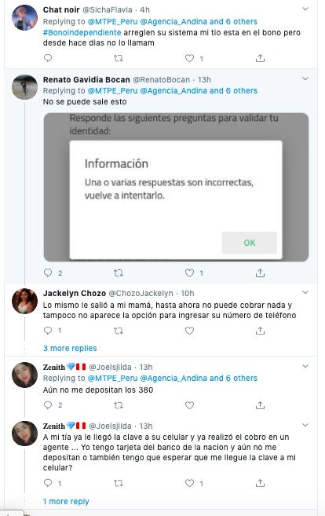
Chat noir
#bonoindependente fix your system. My uncle is in the bonus but for days has not been called

Renato Gavidia Bocan
you can't, it comes out this.
Jackelyn Chozo
The same thing happened to my mom, so far I cannot charge anything and we don’t have the option to enter your phone number

Zenith
They have yet to deposit the 380

Zenith
My aunt got the key sent to her cell phone and I already made a charge... I have a card from the national bank and still have not received a deposit do I also have to wait for the key to reach my cellular?

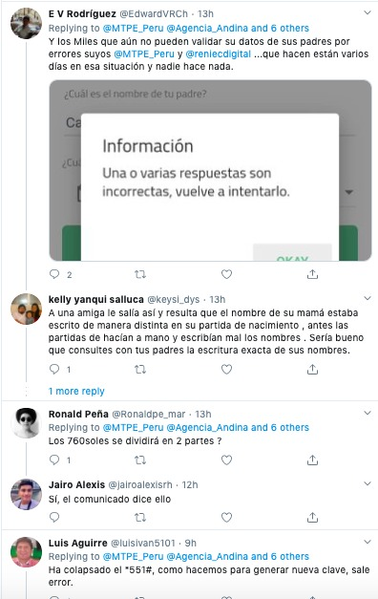
E V Rodriguez
And the thousands who still cannot validate their data from their parents because of your mistakes @MTPE Peru and @reiecdigital... what are you doing so many days and still in this situation and no one does anything

kelly yanqui salluca
That happened to a friend and it turns out that the name of his mom was written differently on his birth certificate, before those were done by hand and the names are misspelled. It would be good if you consult with your parents for the exact spelling of their names.

Ronald Pena
the 760 soles will be divided into 2 parts?

Jairo Alexis
yes, the statement says so.

Luis Aguirre
The *551# has collapsed, what do we do to generate a new key, error comes out.

