Pandemic Hack: Homemade child’s mask

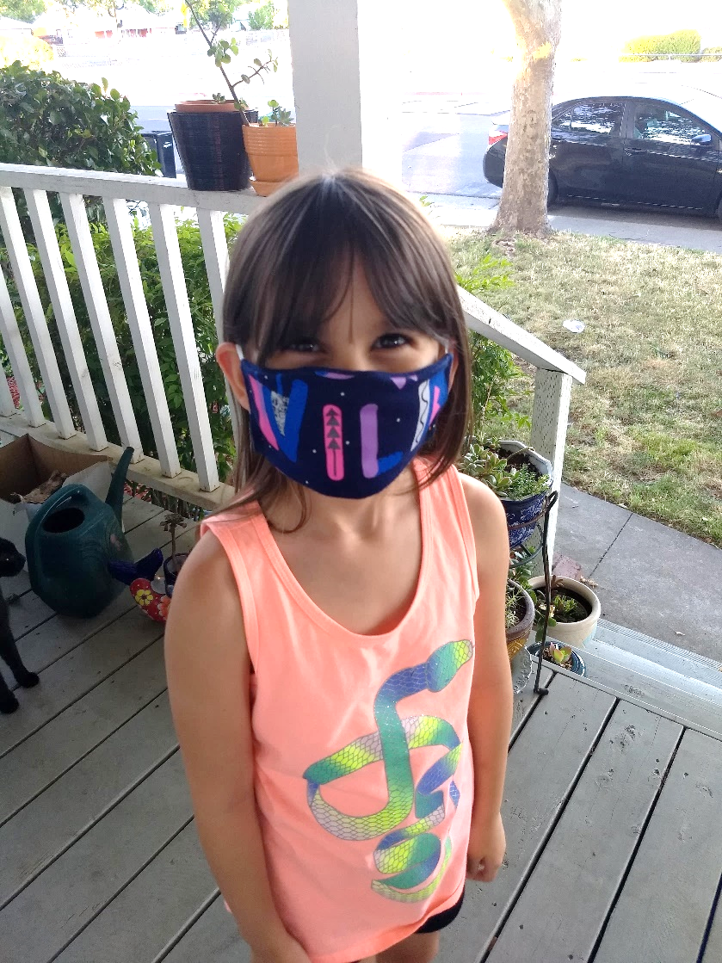
Figure 1. “Wild” child in the first year of the COVID-19 plague.
Like many other people, I made a homemade mask for my child in 2020. We tried a few “standard” sized masks for her, but none fit her ears and face quite right, making my littlest one uncomfortable on top of stressed for public outings. Fortunately for us, my mother, paternal grandmother, and paternal aunt gifted me with the skills and knowledge to sew from a young age and my mom gave me my first sewing machine when I had my first child just about 18 years ago. This mask is cut from a pajama shirt that the littlest had outgrown, reading, “Be Wild/Be Free.” She felt so comfortable in her new “WILD” mask, that she wore it around the house for the rest of the day!
#pandemicprompt, #HST580, #ArizonaStateUniversity, #pandemichack, #mask, #wild, #child

