Batshit Behaviors during the Pandemic
Social Media Analysis (Meme)
Since December 2019, with nearly 521,127,460 people infected, over 6,263,321 dead, and hundreds of millions in lockdown across the globe, the coronavirus pandemic has brought the world to a standstill. The pandemic has lasted for more than two years, and some certain patterns of human behaviors are observed. Since most of people are lockdowned, hence in direct relation to this, there has been a surge in online screen time – much of it on Social Media networks. As devastating as the epidemic has been worldwide, as we know, humans inevitably have used humor to ease the strain on this new situation. They also serve as important propaganda for the times, whether they reinforce the message, raise awareness, or perpetuate the problems that we all face more personally every day.
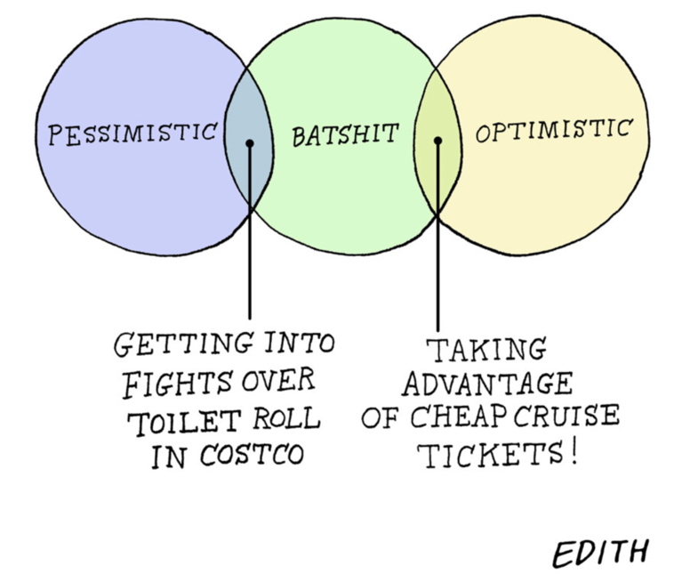
This comic image prior to social distancing and lockdown focused on some apt venn diagrams relating to how one felt at the time. The three circles in the image represent the similarities and differences between three types of people in the U.S.-- pessimistic, “batshit” and optimistic people. “Batshit” is an unrefined, vulgar, slang that means very irrational, excited, or angry. Calling people “batshit” satirizes that most people got crazy and lost their rationality as a commonality because of the pandemic. The two overlapping places were depicted as two types of human behaviors -- “Getting into fights over toilet rolls in Costco” and “Taking advantage of cheap cruise tickets!” “Getting into fights over toilet roll in Costco” explains how pessimistic people who are also batshit acted on the outbreak of the COVID-19 pandemic; “Taking advantage of cheap cruise tickets!” delineates how optimistic people who are also batshit behaved during the COVID-19 crisis. This meme was also created during the time when the Diamond Princess cruise ship was on quarantine due to a COVID-19 outbreak.

According to A Journal of Plague the Year by Daniel Defoe, fear and anxiety made people act in a certain way that can be immoral.
But, on the other hand, this was another of the inconveniences of shutting up houses; for the apprehensions and terror of being shut up made many run away with the rest of the family, who, though it was not publicly known, and they were not quite sick, had yet the distemper upon them; and who, by having uninterrupted liberty to go about, but being obliged still to conceal their circumstances, or perhaps not knowing it themselves, gave the distemper to others, and dreadfully spread the infection, as I shall explain further hereafter (pg. 17, Defoe).
He describes how people tried to hide because of the fear that they should shut up their houses, which eventually made the situation worse. This situation depicted by Defoe is in line with “toilet paper chaos,” happening during the pandemic. Fake news was spread to people that toilet paper produced in China had been contaminated by the Covid-19 virus and had been recalled. People believed the news and went to Costco and stocked up on the toilet paper to buy uncontaminated toilet paper that was already in stock before the pandemic. The anxiety and fear that some people of the U.S. felt panic, eventually led it to be out-of-stock nationwide which triggered other citizens. This chaos threw people into total confusion and made them anxious and the pandemic worse. The behavior that people were obsessed with buying and keeping toilet paper was because of their rising common interest to survive during the pandemic. Thomas Paine stated “Common interest regulates their concerns, and forms their law; and the laws which common usage ordains, have a greater influence than the laws of government. In fine, society performs for itself almost everything which is ascribed to government” (pg. 2, Paine). People’s common interest was stocking up all toilet paper as much as possible. This common interest and anxiety were spread worldwide and people in Austrailia, Singapore, Taiwan, Hongkong, and Japan were triggered to stock up on toilet paper with the same common interests like in the U.S.
Furthermore, the U.S. government was one of the causes that generated toilet paper chaos, and this situation can be applied to Thomas Paine’s example of England. He mentioned “The riots of 1780 had no other source than the remains of those prejudices which the government itself had encouraged” (pg. 4, Paine). Although the U.S. government did not encourage the shortage of the toilet paper, the government was sitting on its hands and made the situation worse. The U.S. manufacturing, distribution, and retail industries produce only the estimated amount that they are going to sell within a day because of their goals to maximize production efficiency. Toilet paper producers were in the same situation. However, even if the production line was urgently increased, there was no way to solve the “shortage of resources.” This is because there was no way to increase production as the supply of materials essential for daily necessities such as toilet paper was due to the COVID-19 pandemic. In particular, the government created a situation where a supply shortage could occur without considering the possibility of a national emergency, causing a situation where there was no toilet paper even six months after the COVID-19 pandemic.
On the other hand, some individuals benefited from the pandemic, as the sentence in the image, “Taking advantage of cheap cruise tickets!,” shows. Under the pandemic, cruise tickets became cheaper because of the negative images of cruises from the Diamond Princess cruise line. Some people benefited from it by purchasing the tickets cheaply and enjoying cruising, although many doctors warned individuals to stop traveling because of the high possibility of spreading or getting coronavirus. The point about some individuals benefiting from the pandemic is in line with Daniel Defoe’s opinion. Defoe introduces the example of the mock astrologers who fooled poor people who asked “whether there would be a plague or no” by answering “Yes” to continue their businesses and benefit from those poor individuals (pg. 8, Defoe). This example shows not only the aspect of benefitting from the pandemic but also the prospect of sacrificing others for their benefit, which resonates with those who enjoyed cruising with the high possibilities of spreading COVID-19. Such human selfishness became distinct, especially during the pandemic. Thomas Hobbes seems to convey that humans are inherently selfish under the state of nature by stating, “Of all voluntary acts, the object is to every man his own good,” and asserts the importance of having sovereignty (pg. 12, Hobbes). In some countries, including Japan, there had not been effective laws or orders for going out during the pandemic, and some individuals went out just for fun which contributed to the increase in COVID-19 cases. Therefore, “Taking advantage of cheap cruise tickets” might implicate the people’s selfishness of benefitting themselves by sacrificing others and the need for effective rules.
Throughout the paper, the meme which shows both the pessimistic and optimistic sides of the COVID-19 pandemic is examined. From the pessimistic point of view, it is found that “getting into fights over toilet rolls in Costco” in the meme is in line with the point made by Defoe that fear leads individuals to act in immoral ways and with Paine’s idea that government is one of the main causes of chaos. Also, from the optimistic view point, “taking advantage of cheap cruise tickets” resonates with Defoe’s idea about people benefiting from the plague and Hobbe’s thought that people are inherently selfish. Since humans have still been affected by the pandemic, it should be vital to learn from the past and various philosophers to find ways to manage and overcome Covid.

