*These translations were done for item number 17050 by Angelica S Ramos on 06/22/2021
TRANSLATION
Andres Edery
- Chaparron, get on a taxi/bus right now

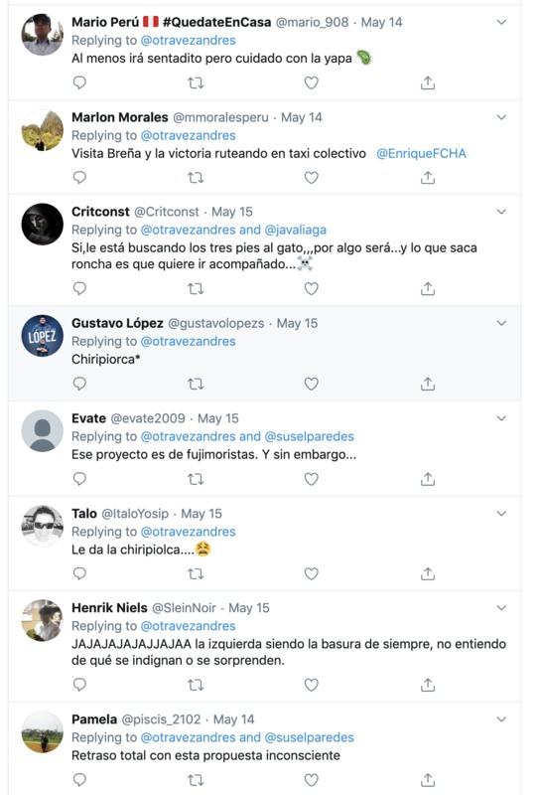
TRANSLATION-
Mario Peru #QUedateEnCasa
-At least he will be seated but be careful with the “yapa” (means “a little extra”)

Marlon Morales
-Visit Brena and victory by routing by collective taxi @EnriqueFCHA

Critconst
- Yes, he is looking for the cat’s three feet (meaning “getting into something reckless or damaging”)…it will result in something…and what brings out welts (not literally, but meaning something that is annoying or frustrating) is that he wants to go with it.

Gustavo Lopez
-Chiripiorca (means to flip out, go crazy or freak out)

Evate
- The project is of the Fujimoristas (policies and ideologies of former President of Peru Alberto Fujimori). And yet…

Talo
- It’s given him the “chiripiorca” (meaning to flip out, go crazy, or freak out)

Henrik Niels
- HAHAHAHAHAHAHA the left being garbage as usual, I don’t understand why you’re outraged or surprised.

Pamela
- I totally backoff after that unconscious proposal

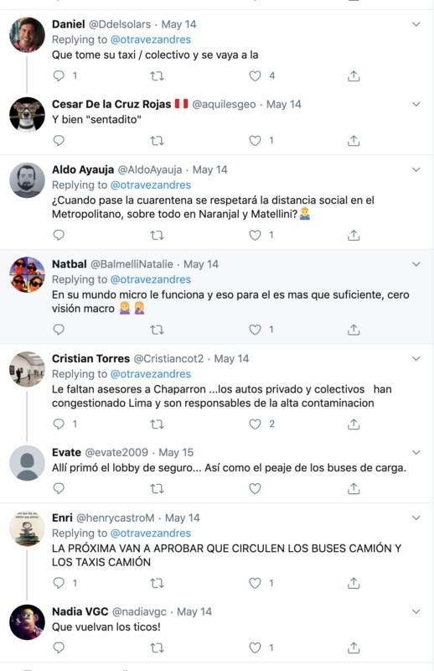
TRANSLATION
Daniel
- He should take his taxi/bus and go fuck himself (the term “vaya a la” is a polite way of saying an exploitive)

Cesar De la Cruz Rojas
- and well seated

Aldo Ayauja
- When the quarantine passes will social distancing be respected in the metropolitan, especially in Naranjal and Matellini?

Natbal
- In his micro world this works and that is more than enough for him, his vision is macro

Cristian Torres
- He lacks Chaparron advisors…the private and collective cars have congested Lima and are responsible for the high pollution

Evate
- There cousin in the security lobby…as well as the toll of the cargo buses

Enri
- NEXT THEY WILL APPROVE THE CIRCULATION OF BUSES AND TAXIS
Nadia VGC – Return the Ticos! (Tico is a small car that was used mainly as Taxis in the 1900s)
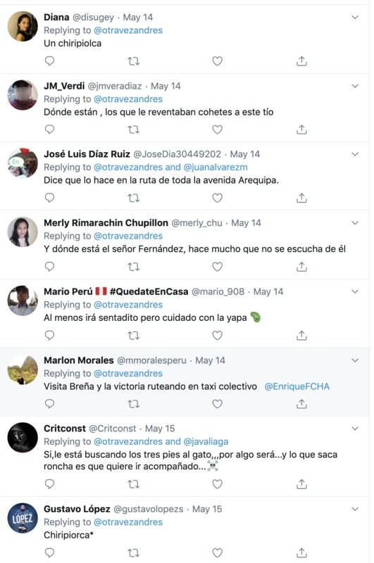
TRANSLATION
Diana
- A “chiripiorca” (means to flip out, go crazy or freak out)

JM Verdi
- Where are those who threw fireworks at that guy?

Jose Luis Diaz Ruiz
- They say he does it all the way to Arequipa avenue.

Merly Rimarachin Chupillon
- Where is Mr. Fernandez, he has not be heard from for a long time.

Mario Peru #QUedateEnCasa
-At least he will be seated but be careful with the “yapa” (means “a little extra”)

Marlon Morales
-Visit Brena and victory by routing by collective taxi @EnriqueFCHA

Critconst
- Yes, he is looking for the cat’s three feet (meaning “getting into something reckless or damaging”)…it will result in something…and what brings out welts (not literally, but meaning something that is annoying or frustrating) is that he wants to go with it.

Gustavo Lopez
-Chiripiorca (means to flip out, go crazy or freak out)

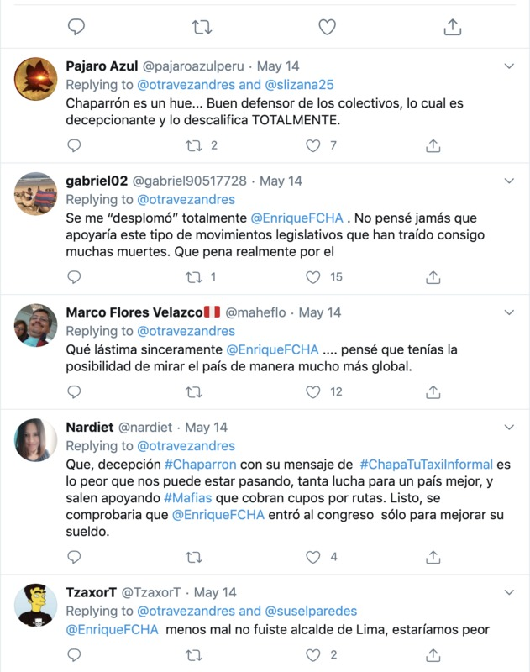
TRANSLATION
Pajaro Azul
- Chapparron is a good defender of the buses, which is disappointing and disqualifies him COMPLETELY

Gabriel02
- I am totally knocked out @EnriqueFCHA. I never thought he would support that type of legislative moves that have brought on so many deaths. What a real shame.

Marco Flores Velazco
- That sincerely hurts @Enrique FCHA… I thought you were capable of seeing the country in a much more global manner.

Nardiet
- What a disappointment #Chaparron with his message of #ChapaTuTaxilnformal. It’s the worse thing that can be happening to us, so much work for a better country but they go out supporting #Mafias who charge quotas for routes. Soon it will be proven that @EnriqueFCHA entered congress just to improve his salary.

Tzaxor T
- @EnriqueFCHA At least you weren’t mayor of Lima, we would have been worse off

