Michelle Peterson
Covid-19 personal experiences
Images from Spring 2020

An example of empty streets. A common sight all over the world during the Covid-19 Pandemic

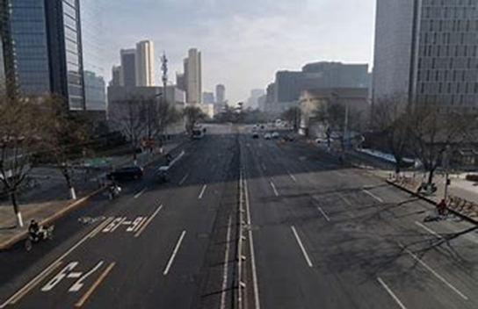

An example of empty shelves at the grocery store.

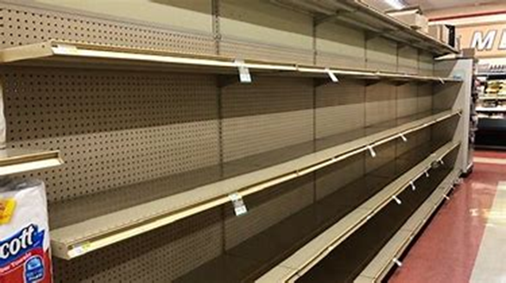
It became common for people all over the world to wear masks in public.

