REDACTED
October 30, 2020
Professor Ciafone
Macs 317
Flu Flies: October 8, 1918
Stephan Gitagama, who is a Chief Executive Officer at National Media Group, once said, "in these times, it is the duty of the media to provide authentic and correct information to the people." In 2020, we are still suffering through a traumatic pandemic known as the Coronavirus. However, where do we get this information about the Coronavirus? The media is essential to give us the answers to all the questions we have in our minds. However, not many people focus on the past, such as the Spanish Flu, and how the public got their information. Of course, many people in the past did not get their information as quickly and accurately as we do today. The only way people would get their information about the Spanish Flu would be the newspapers. However, the newspapers did not spread the information quickly enough to benefit the soldiers fighting in the war, who were suffering in crowded camps on how to avoid the Spanish Flu.
On October 8, 1918, The Atlanta Constitution newspaper in Atlanta, Georgia, discussed many vital topics connecting to the soldiers and the Spanish Flu. There were many different topics relating to the soldiers. Such as, German wanted peace with America and ended the war. Secondly, the newspaper gives credits for the honor roll of soldiers who were sacrificed, wounded, or died from the war. Finally, the government announced many opportunities for soldiers interested in the medical fields in which the government was willing to pay for housing and classes. However, the newspaper focuses not only on the soldiers but also on the Spanish Flu itself. Such as advertising a reliable spray from Dobell's solution to avoid catching the Flu, giving tips to make sure how the people are cautious if someone has the Spanish Flu, and closing down public gatherings, theater, churches, and schools to decrease the number of deaths from the Flu.
One topic in the newspaper addresses an important solution: how one military training camp made a difference than any other camps to avoid the Spanish Flu. The newspaper covered Camp Gordon, the first Military training camp that decreased the number of deaths compared to other camps. There were many regulations for the soldiers to follow to avoid catching the Spanish Flu. First, the soldiers had to wear gauze masks while sleeping, and they needed to wear hoods or towels to cover their entire face. Secondly, they needed to stay in a temporary camp where there were no tents or covers. Finally, the camp visitors were limited to relatives only, and the meetings were closed, making the soldiers unable to communicate with their loved ones. The camp believed these rules would help stop the spread of the Spanish Flu.
This document about the Spanish Flu news makes me think about my COVID-times and helps me be more aware of current soldiers in the military, such as what was happening to them right now and the rules they need to follow to survive. The newspaper of the Spanish Flu and technology of the COVID only focuses on important topics to avoid having the Spanish Flu, and update more about when the virus will end. Many people may not think about the soldiers and assume that they are fine. However, today, the soldiers have more opportunities and resources to reach out to their families than the soldiers in 1918. Secondly, the newspaper has a similar idea as the COVID of how not to catch the virus. Such as the mask was the main priority everyone needed to wear and stop social gatherings to not have the virus. I feel we live through a similar timeline to be social distance and protect ourselves from the virus.
Today, we have more resources than the people did during the Spanish Flu. Similar to the Spanish Flu, there are many positive cases, but COVID has fewer deaths than the Spanish Flu. Now, we have the technology, less war with other countries, more social distancing opportunities, and better communication with our families. Nevertheless, I predict it is more costly than the Spanish Flu, mostly from the military training camps, people taking the COVID-19 testing, and people who travel need to stay in the hotel to end their two-week quarantine to wait for their result. However, we are trying our best to take advantage of these resources we have rather than people who sacrificed and did not have many resources during the Spanish Flu.
Additionally, there is more cost maintenance to make sure the recruits do not have COVID. Such as housing the recruits, paying for the masks, and cleaning supplies for training. There are more opportunities for the students recruited to have time to contact their family members, more sanitization in the camp, and making sure the recruits do not have COVID. For now, I predict that there will not be as many deaths of soldiers and around the United States compared to the Spanish Flu. I think as long as many training camps and the people follow the rules there is a great portion we make a successful difference from the time of the Spanish Flu.
In conclusion, Stephan Gitagama once mentioned how the media is essential because the media provide accurate information to the people to avoid the virus. During the newspaper and my COVID times, I believe that we live through the same timeline as the Spanish Flu. Such as making sure we wear a mask, trying to figure out when the vaccine will be ready, and closing down social gatherings. However, we do not focus on the soldiers of what happened to them and how they are being cautioned during COVID. The Spanish Flu newspaper helps me understand it is important to know what is happening to the soldiers, nurses, and doctors and how they are protecting themselves through the Spanish Flu. Overall, during my COVID times, we should be grateful that we have more opportunities and resources than the time during the Spanish Flu. 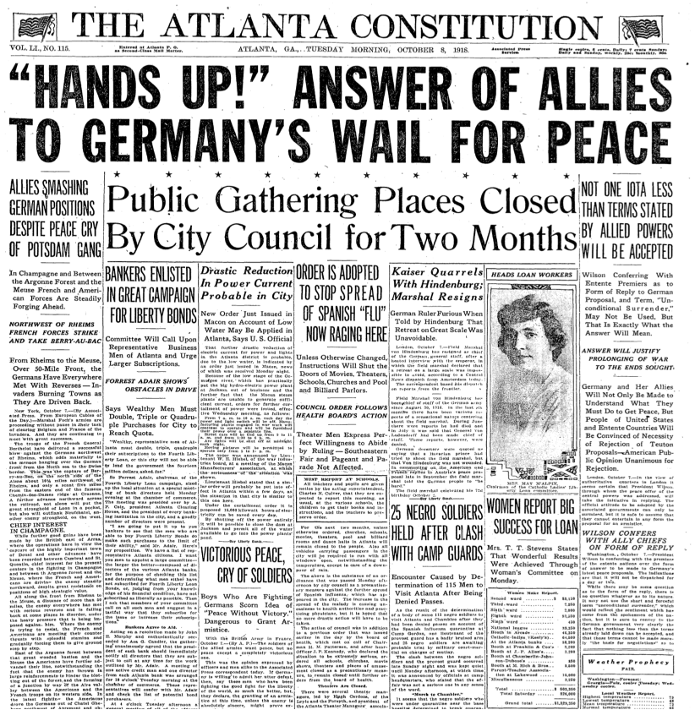
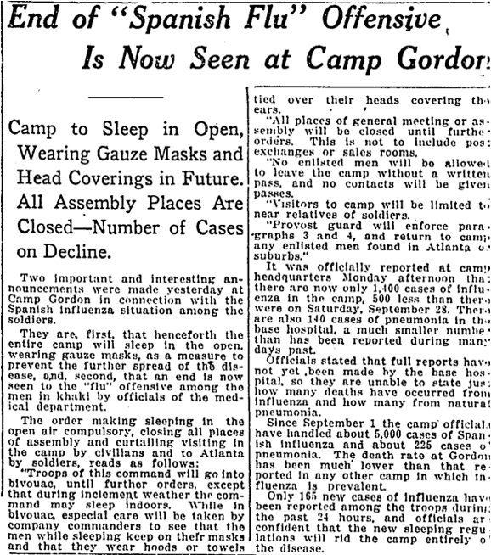
"End of "Spanish Flu" Offensive is Now seen at Camp Gordon: Camp to Sleep in Open, Wearing Gauze Masks and Head Coverings in Future. all Assembly Places are Closed--Number of Cases on Decline."The Atlanta Constitution (1881-1945), Oct 08, 1918, pp. 10. ProQuest, https://search-proquest-com.proxy2.library.illinois.edu/docview/497041657?accountid=14553.

