Translation of item 11196 by Angelica S Ramos
President: Only one person per family is allowed to go out.
Peruvians: let's go on a family trip to the supermarket.
Why are we like this?

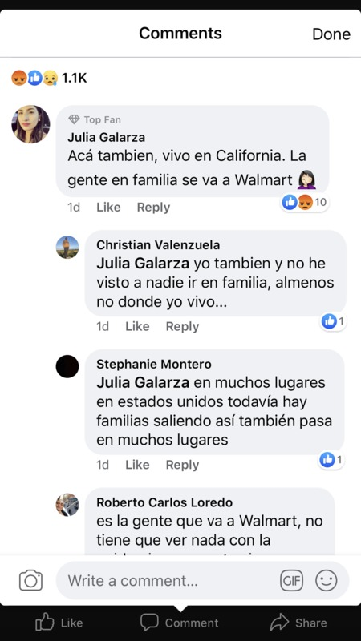
Julia Galarza
Here too, I live in California. People go with their family to Walmart.

Christan Valenzuela
Me too, I haven’t seen anyone go with their family, at least not where I live.

Stephanie Montero
Julia Galarza in a lot of places in the United States there are still a lot of families going out this also happens in a lot of places.

Roberto Carlos
It’s the people that go to Walmart, it has nothing to do with
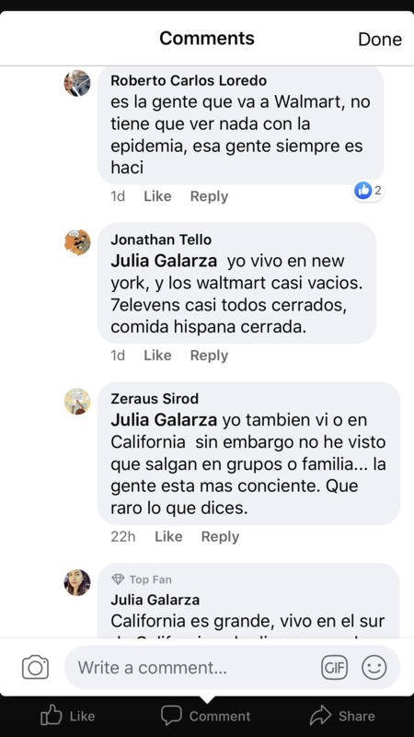
Roberto Carlos
It’s the people that go to Walmart, it has nothing to do with the epidemic, people are always like this

Jonathan Tello Julia Galarza I live in New York, and Walmart is almost empty. 7elevens are almost all closed, Hispanic food closed.

Zeraus Sirod I also live in California but I have not seen families go out…the people are more concious. How weird what you mentioned.

Julia Galarza California is big, I live in the south

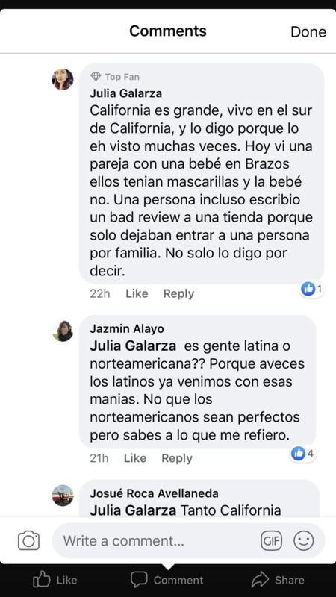
Julia Galarza
California is big, I live in southern California, and I said it because I have seen it several times. I saw a couple today with their baby, they had masks but their baby didn’t. A person wrote a bad review for a store because they only let one person in per family. I don’t only say it to say it.

Jazmin Alayo
Is it Latino people or North American people?? Because Latino people usually come with those bad habits. I don’t mean that North Americans are perfect but you know what I mean.

Josue Roca Avellaneda Like California
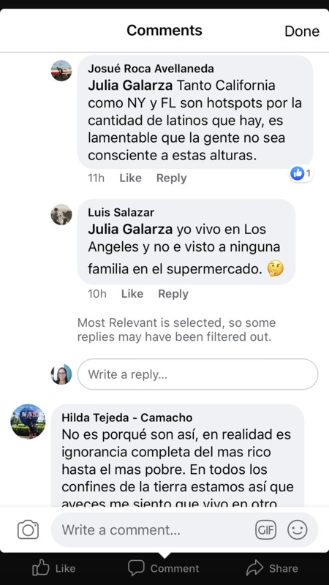
Josue Roca Avellaneda
California like NY and FL are hotspots for the amount of latinos that there are, its sad that the people are not considerate to that level.

Luis Salazar
I live in Los Angeles and have not see any families in the supermarkets

Hilda Tejeda – Camacho
Its not because they are just like that, in reality its complete ignorance from the richest to the poorest. All across the world we are the same way, sometimes I feel like I live in another

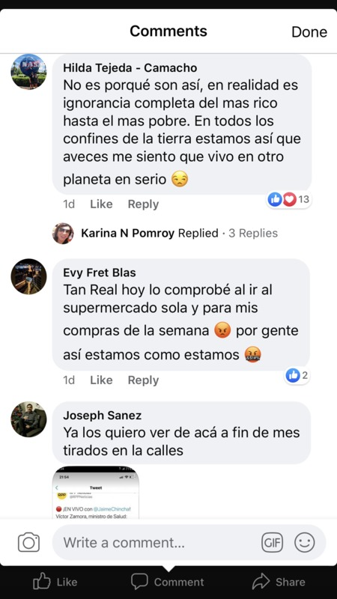
Hilda Tejeda – Camacho
Its not because they are just like that, in reality its complete ignorance from the richest to the poorest. All across the world we are the same way, sometimes I feel like I live in another planet seriously.

Evy Fret Blas
So real today I witnessed this when I went to the supermarket to buy what I needed for the week. Because of people like this we are where we are.

Joseph Sanez
I want to see them here at the end of the month in the streets
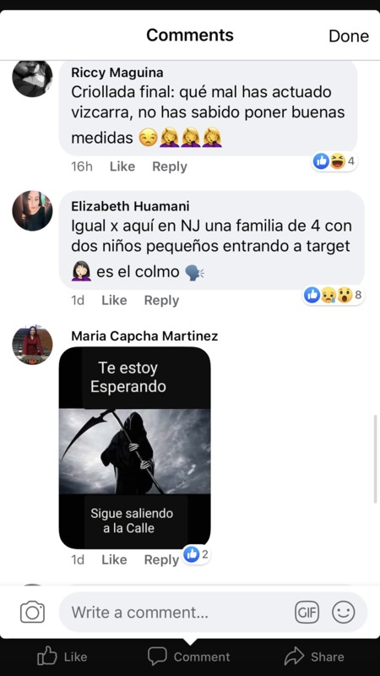
Riccy Maguina
How bady you have acted Vizcarra, you didn’t know how to put into place good measures

Elizabeth Huamani
Same here in NJ a family of 4 with two small kids going into a target its annoying.

Maria Capcha Martinez
Ill be waiting for you, keep going out

