Travelers Nevertheless
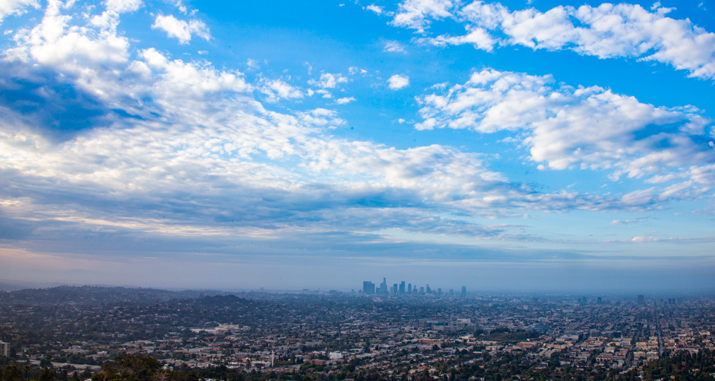
Photo: Nick Winslow

In 2020, my family and I planned to return to Paris to the same Montmartre apartment where my wife had first informed me of our daughter's existence three years earlier. It was to be an anniversary celebration. Our perception of Paris as a cosmopolitan city with world-class food and art attracted us. That first visit gave us memories that made Paris a part of our family history. When COVID struck, we postponed our return trip once, twice, and then indefinitely. When we finally gave up on air travel, I was relieved. People’s erratic behavior made me disinterested in going to the grocery store, much less getting on a bus in the sky. Not having my daughter witness another stranger’s public meltdown became a priority. But we were getting stir-crazy.

Instead of Paris, we traveled to visit my brother in Santa Monica. But it wasn’t our idea at first. During the height of the pandemic, we were wildfire evacuees, happy to find shelter near family. While the Bureau of Land Management was bulldozing a fire line around our neighborhood, we gained access to the unoccupied half of my sister-in-law’s childhood home: a six-bedroom, streamline moderne manor house turned duplex. Surrounded by brutal stucco apartment buildings, that architectural artifact became our pied-a-terre. We set up camp.

The BLM saved our home, but throughout the pandemic, we returned to Santa Monica every six weeks for a week at a time. Los Angeles provided more to do than our rural Northern California hometown. The cultural climate was less politically charged. During the stay-at-home order, we holed up in the compound, working away on our laptops. Delivery drivers brought groceries and supplies as we cooked, read, and listened to the radio. During our summer visits, when restrictions eased, we set off on outdoor adventures.

We went to drive-in movies at the Greek Theater and picnicked at the Hollywood Forever Cemetery. We ate meals at makeshift sidewalk patios. Sometimes, we wore our masks between bites. We ate lobster rolls and sipped wine on a Melrose sidewalk during a thunderstorm. We walked to Venice. We had a socially distanced visit with our old Hollywood neighbors. It was fun to do everything outside, and the atmosphere was one of perseverance rather than outrage. Our relationship with Los Angeles and the family we have there deepened. However, once the mask mandate ceased, we felt more at ease visiting our usual destinations. We returned to England. Annual trips to New York’s West Village resumed. We will be there next week, and we return to Paris next year. We hope.

