Translation of item number 16918 by Angelica S Ramos 06/22/2021
*ALL IMAGES HAVE THE SAME HEADER*-
Histories
A quarantine diary, by Andres Edery
Again Andres – Look at the graphics Andres Edery has published in the magazine since 2018. Politics, National, International, Lima, Sports, our country: all summarized in his drawings

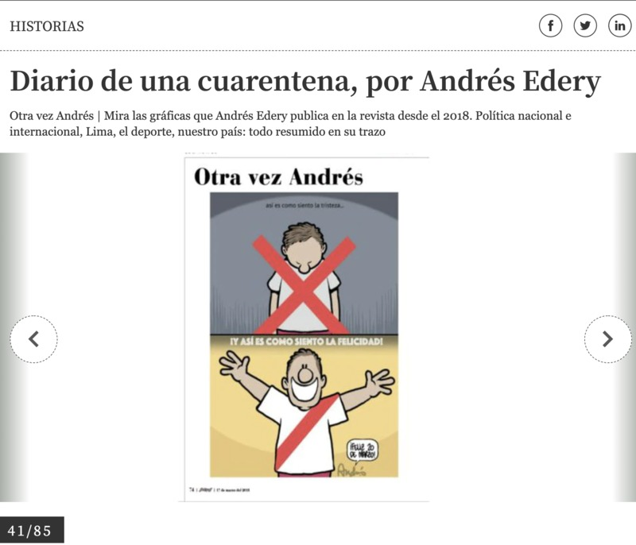
This is now I feel sadness
This is how I feel happiness
-Happy 20th of March
41/85

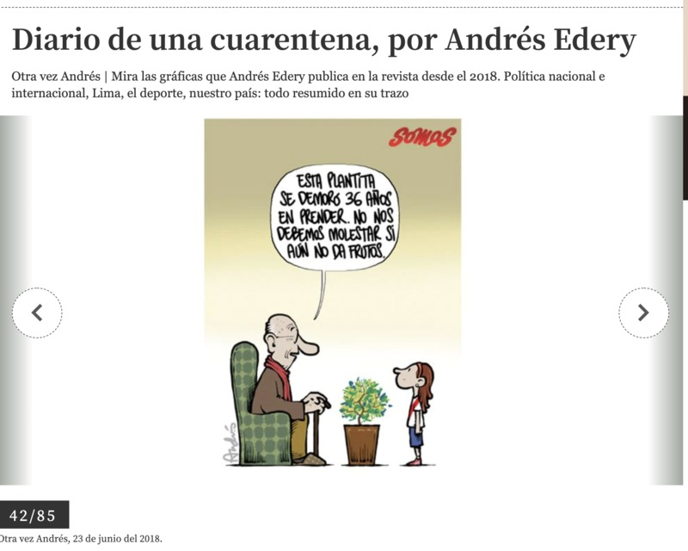
This little plant took 36 years to bloom. We shouldn’t be bothered if it still doesn’t bear fruit.
42/85

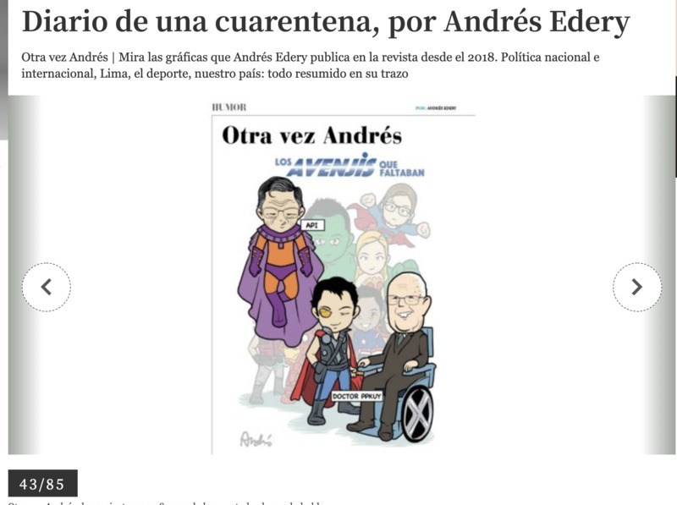
The missing avengers – API (sewer and utilities company) DOCTOR PPKUY (political party)
43/85
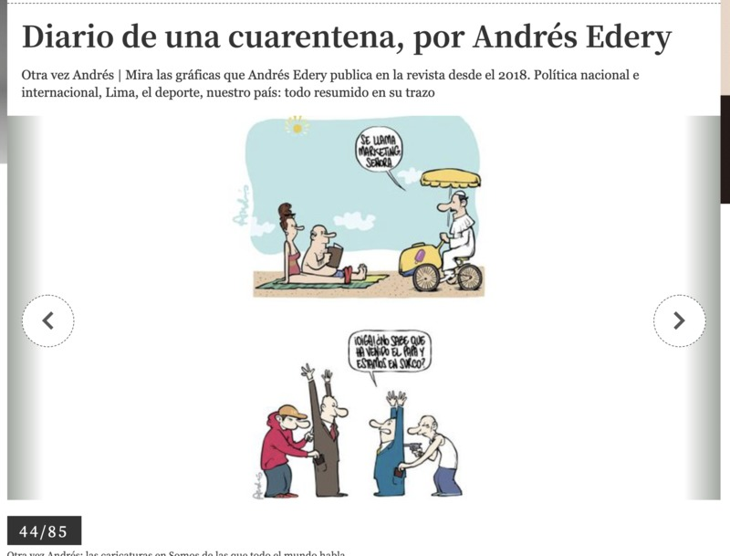
-It’s called Marketing lady
-Hey! Don’t you know that the Pope has come and we are in furrow?
44/85

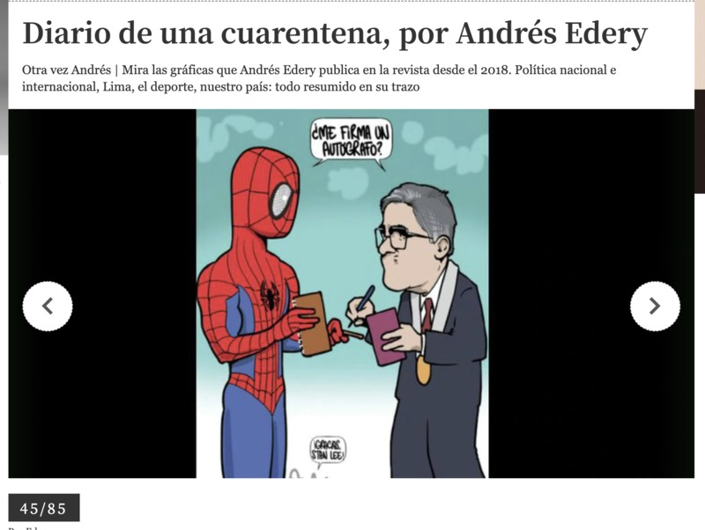
Can I have your autograph?
45/85
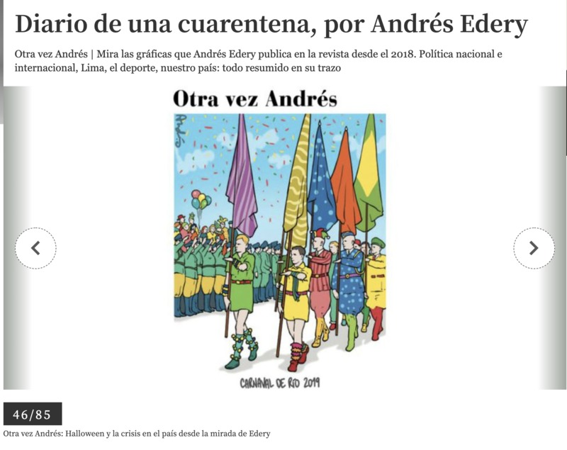
Again Andres
Rio Carnival 2019
46/85
Again Andres: Halloween and the crisis in the country from the perspective of Edery

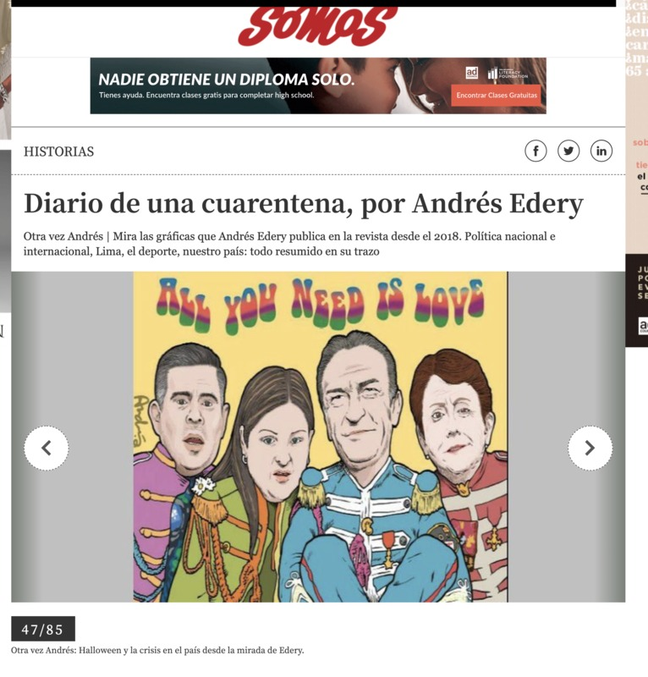
47/85
Again Andres: Halloween and the crisis in the country from the perspective of Edery

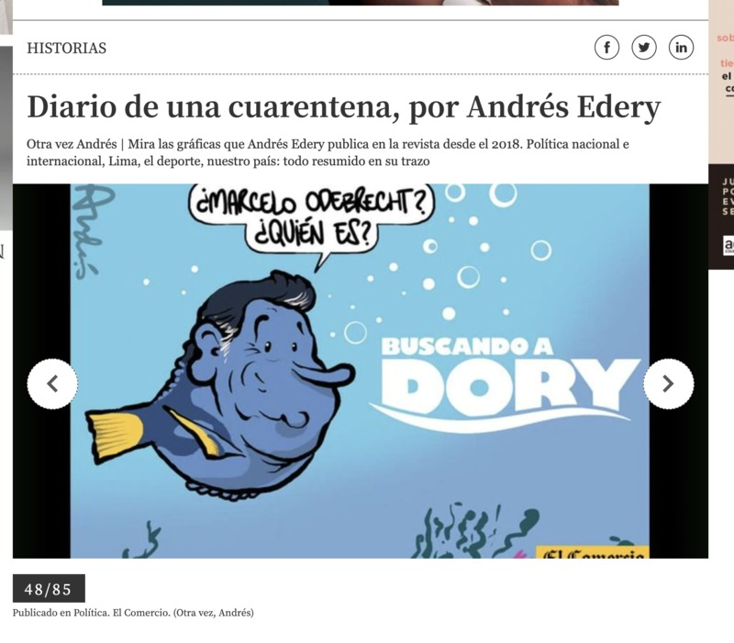
Marcelo Odebrecht?
Who is that?
“Finding Dory”
48/85
Published in Politics. El Comercio (Again, Andres)

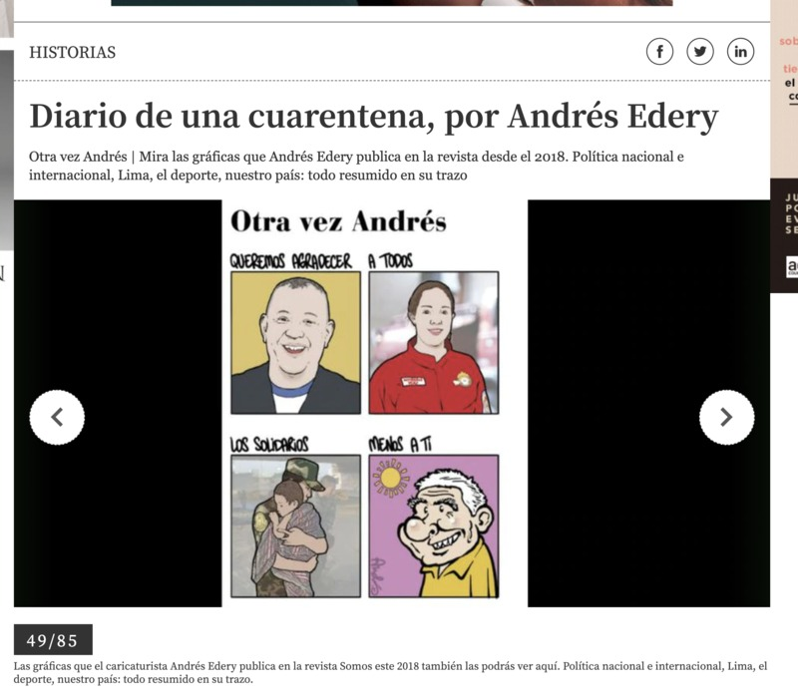
Again, Andres
We want to thank everyone
The supporters
Except you
49/85
The graphics that the cartoonist Andres Edery published in the magazine Somos in 2018 can also be seen here. Political national and international, Lima, Sports, our country: all summarized in his drawings

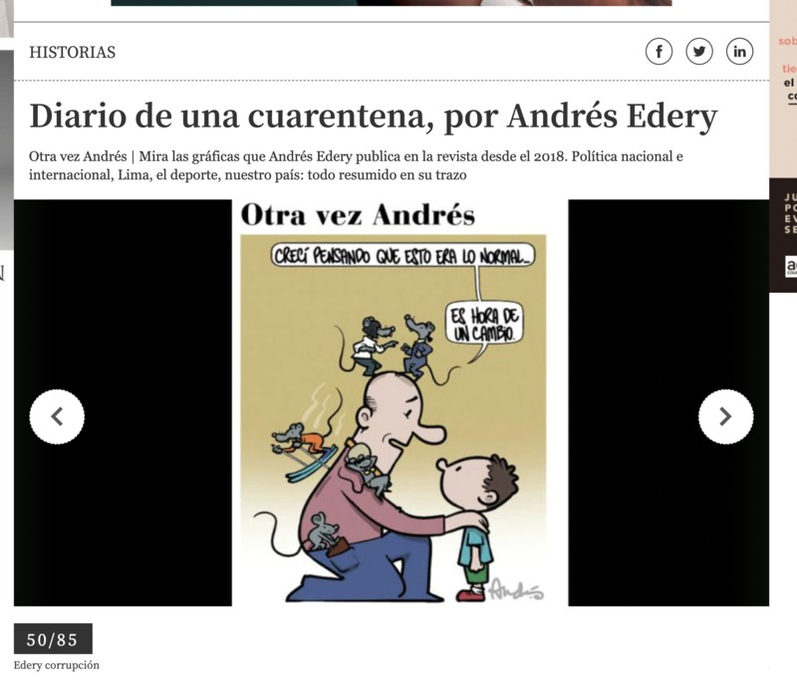
I grew up thinking this was normal
It’s time for a change
50/85
Edery corruption

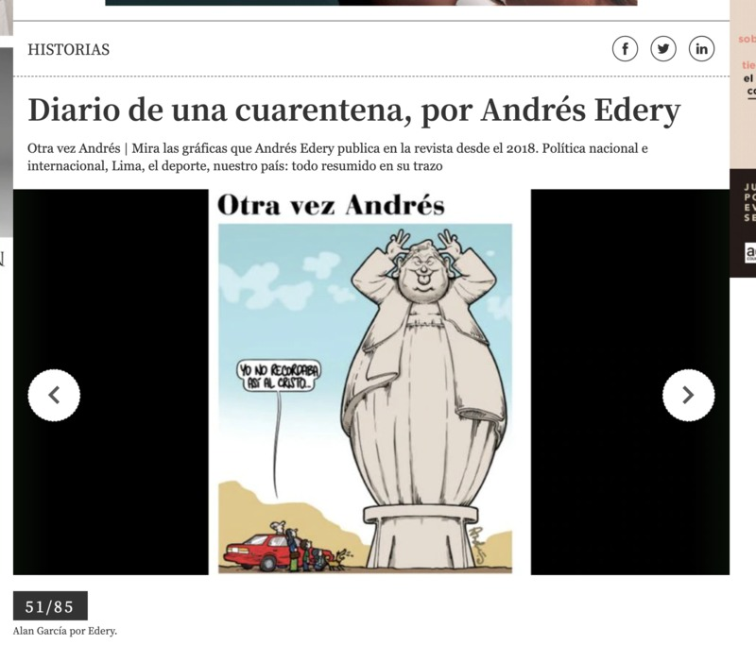
Again Andres
I don’t remember Christ looking like that
51/85
Alan Garcia by Edery

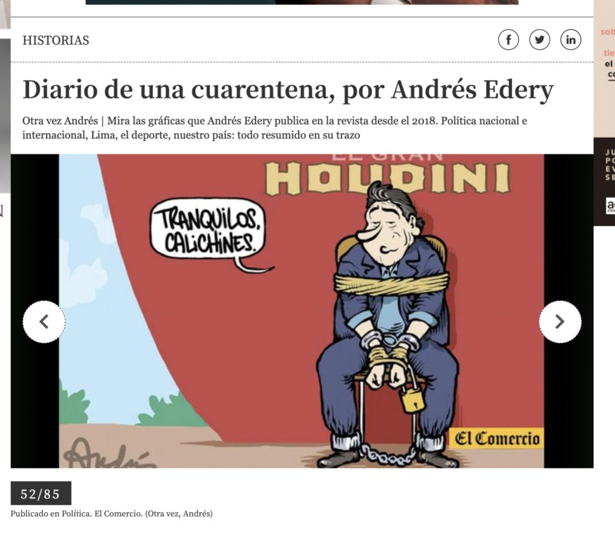
Calm down rookie (the term calichines means novice, beginner)
52/85
Political publication. El Comercio (Again, Andres)
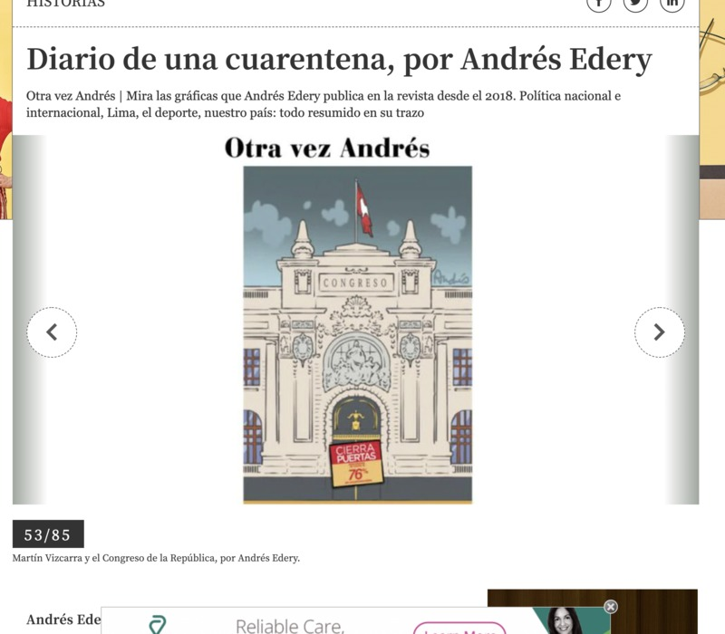
Congress
Close the door
53/85
Martin Vizcarra and the Congress of the Republic, by Andres Edery

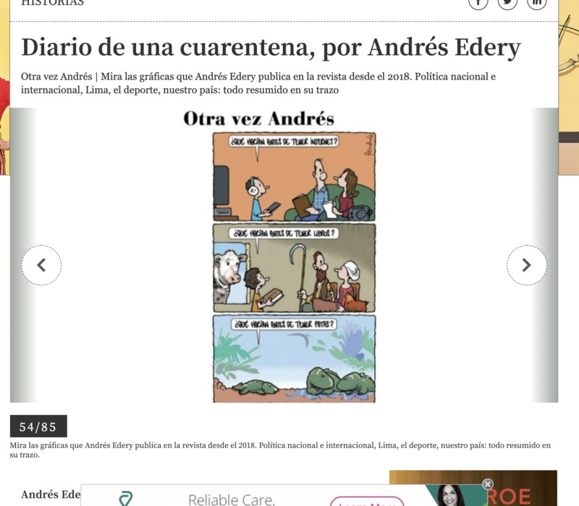
What did you do before you had internet?
What did you do before you had books?
What did you do before you had feet?
54/85
The graphics that the cartoonist Andres Edery published in the magazine Somos in 2018 can also be seen here. Political national and international, Lima, Sports, our country: all summarized in his drawings

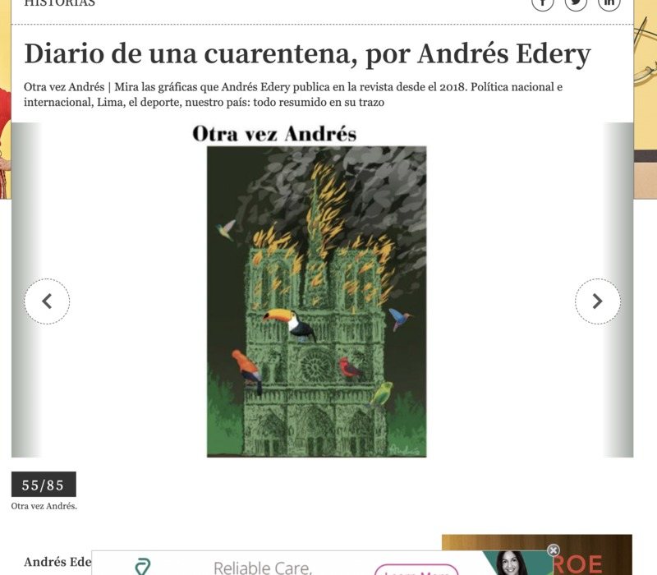
55/85
Again Andres

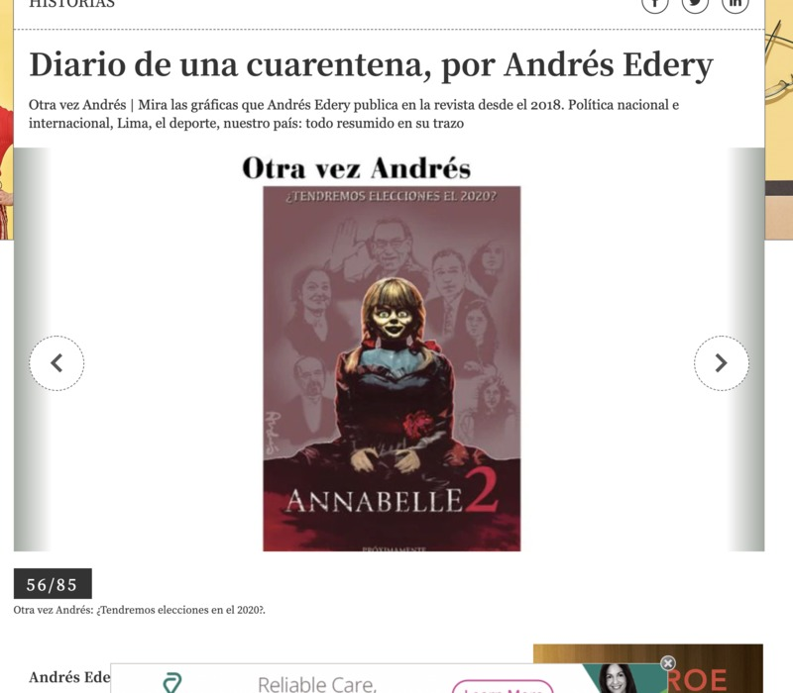
Will we have elections in 2020?
56/85
Again Andres: Will we have elections in 2020?
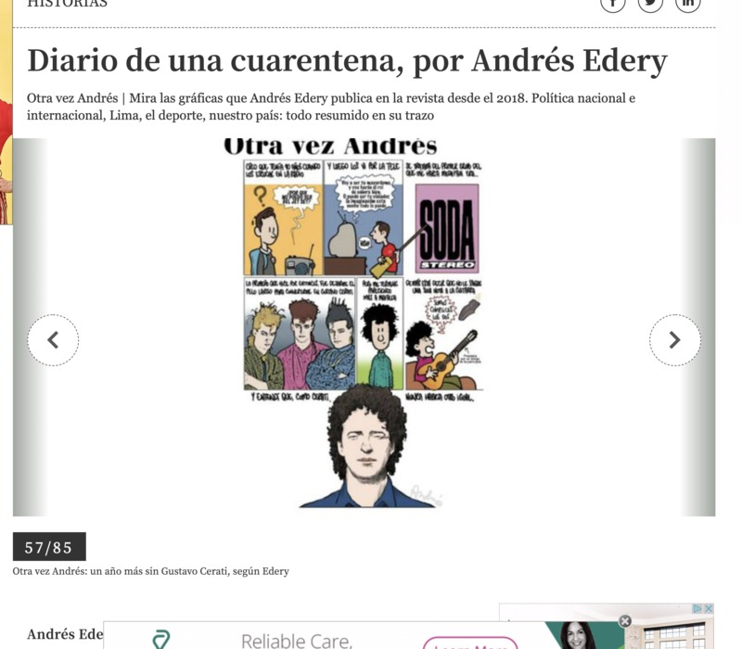
I think I was 10 years old when I heard it on the radio
“Why couldn’t he be from the Jet Set?
And then I saw them on the TV
“I will be your butler, and you’ll play the role of the Mrs. Or I can be your violator, anything is possible with night time imagination”
It was about the first group that made me a super fan. It was Soda Stereo
The first thing I did was let my hair grow to transform into Gustavo Cerati.
But I ended up looking more like Mafalda.
Plus I couldn’t get one note out of my guitar
“We’re both accomplices”
Then I understood that no one would ever be like Cerati
57/85
Again Andres, Another year without Gustavo Cerati, by Edery
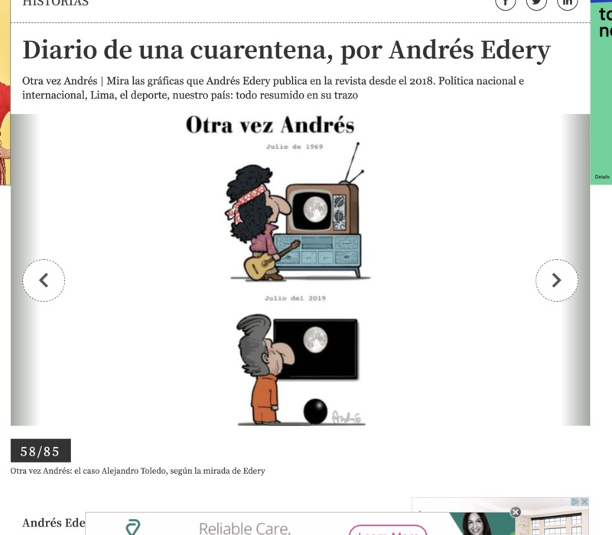
July 1969
July 2019
Again Andres, the case of Alejandro Toledo, according to Edery

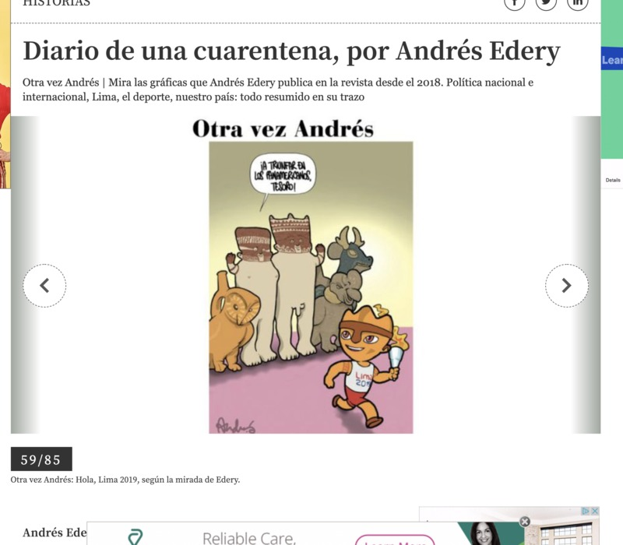

Find victory in the Panamericanos treasure!
59/85
Again Andres, Hello, Lima 2019, according to Edery
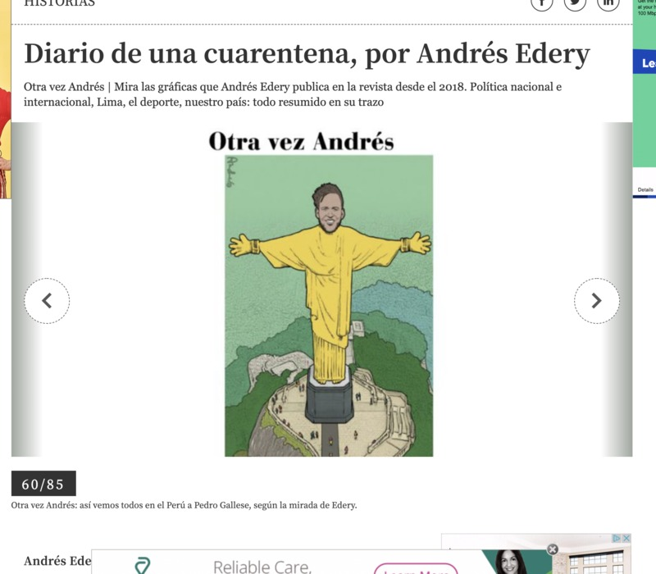
60/85
Again Andre, This is how all Peruvians see Pedro Gallese, according to Edery

