Translation of item number 17051 was done by Angelica S Ramos on 06/22/2021
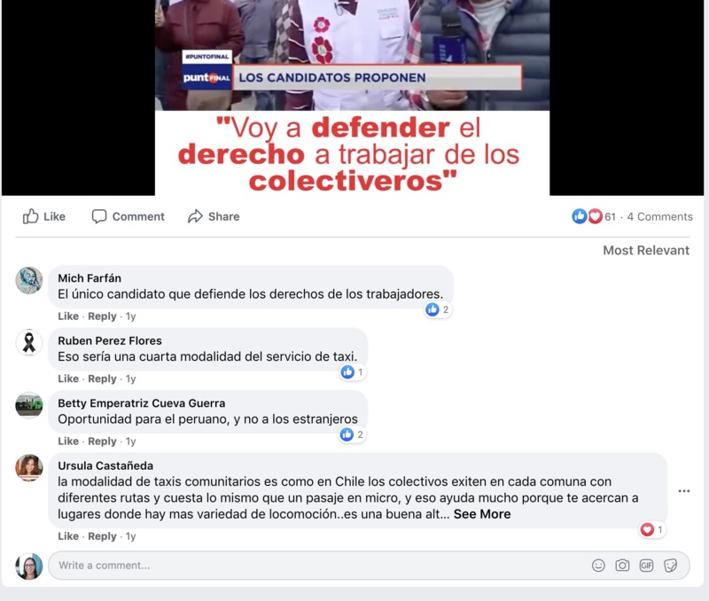
Headline – The Candidates Propose
“I will defend the right to work for the bus drivers”
Comment Section –
Mich Farfan – The only candidate that defends the rights of the workers
Ruben Peres Flores - That would be a forth rate taxi service.
Betty Emperatriz Cueva Guerra – Opportunities for Peruvians, not foreigners
Ursula Casraneda – The type of Taxi community is like that of Chile. The buses exist in every community with different routes and costs the same as a ride in a micro, this helps a lot because it gets you closer to places where there is a variety of transportation…it is a good alt…

