Translation of item 10858 by Angelica S Ramos 07/03/2021
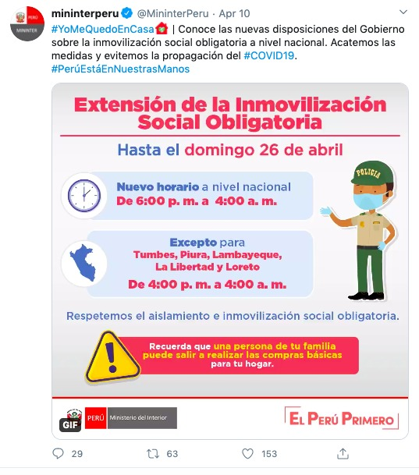
“#IWillStayHome – Know the new government provision of mandatory social immobilization at the national level. Let us comply with the measures and avoid the spread of #COVID19.”
#PeruIsInOurHands

“Extension of mandatory social immobilization
Until Sunday April 26
New hours at the national level
From 6pm to 4am
Except for Tumbes, Plura, Lambayeque, La Libertad y Loreto
From 4pm to 4am
Lets respect the isolation and mandatory social immobilization
Remember that a member of your family can go out and get the basic necessities for your household”

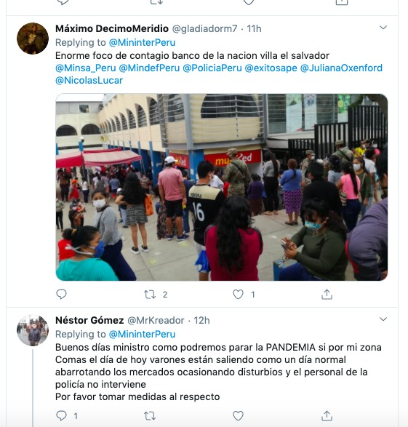
Maximo DecimoMeridio
Replying to @MinisterPeru
“Huge focus of contagion bank of the nation of El Salvador”

Nestor Gomez
Replying to @MinisterPeru
“Good morning minister how can we stop the PANDEMIC if in my city like today men are going out like any normal day crowding the markets causing disruptions and the police does nothing to intervene. Please address the issue”
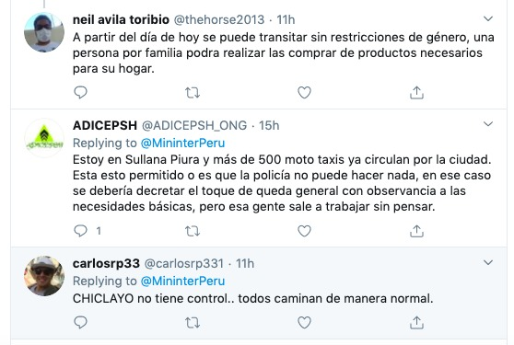
neil avila toribio
“At the end of the day a person can travel without restrictions to buy the necessary products for their household.”

ADICEPSH
Replying to @MinisterPeru
“I am in Sullana Piura and more than 500 taxis are all over the city. Is this permitted or is it that the police cant do anything, in that case there should be a general stay at home order with allowance for basic necessities, but these people go out to work without thinking.”

Carlosrp33
Replying to @MinisterPeru
“CHICLAYO has no control…everyone walking around like normal”

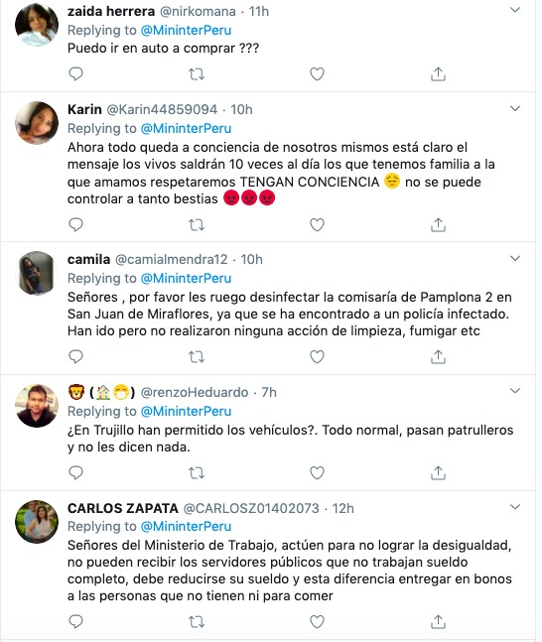
Zaida Herrera
Replying to @MinisterPeru
“Can I go in a car to buy?”

Karin
Replying to @MinisterPeru
“now everything depends on the conscience of ourselves, the message is clear the living will go out 10 times a day those who have families we love and respect HAVE A CONSCIENCE it cannot be controlled so much beasts”

Camila
Replying to @MinisterPeru
“gentlemen please I beg you, disinfect the commissary of Pamplona 2 in San Juan of Miraflores, it was discovered that a police officer had been infected. They have gone but have not realized any action of cleaning, fumigation etc.”

@renzoHeduardo
Replying to @MinisterPeru
“Are cars permitted in Trujillo? Patrol cars drive around like normal and they don’t say anything”
Carlos Zapata
Replying to @MinisterPeru
“Gentlemen of the department of labor, act not to achieve inequality, you cannot achieve public servants that do not work for full pay. The salary must be reduced and this difference delivered in bonds to people who do not even have money to eat.”

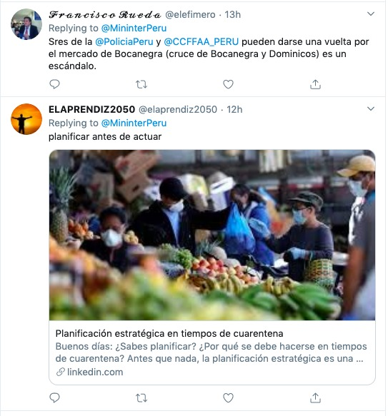
Francisco Rueda
Replying to @MinisterPeru
“Gentlemen of the @PoliciaPeru (Peruvian Police) and the @CCFFAA_Peru can you please take a walk around the market of Bocanegra (crossing of Bocanegra and Dominicos) it’s a scandal.”

ELAPRENDIZ2050
Replying to @MinisterPeru
“Plan before you act”
*title of article attached is “strategic planning in times of quarantine”
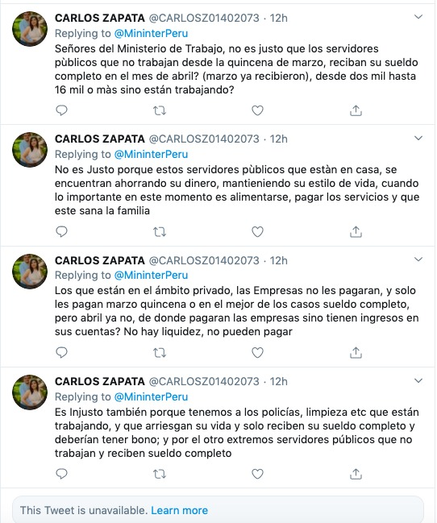
CARLOS ZAPATA
Replying to @MinisterioPeru
“Gentlemen of the Department of Transportation, it is unjust that the public workers who have not worked since the fifteenth of March receive their full paycheck in the month of April (they have already received March), from two thousand up to 16 thousand or more if they have not worked”

CARLOS ZAPATA
Replying to @MinisterioPeru
“It is unjust because those public workers who are at home are saving their money, maintaining their life style, when whats important now is food, paying for services, and that their families are safe”

CARLOS ZAPATA
Replying to @MinisterioPeru
“those who are in the private sector, the companies will not pay them, and only pay them March 15 or at best full pay, but not in April. How will they pay their workers if they have no money in their accounts? There is no liquidity, they cannot pay”

CARLOS ZAPATA
Replying to @MinisterioPeru
“It is unfair because we have police, cleaning etc who are working, and who risk their life only to receive their full pay, they should receive a bonus, and the other extreme public servants do not work and still receive their full pay”

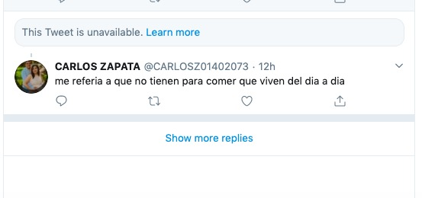
CARLOS ZAPATA
“I’m referring to the ones who don’t have enough to eat and live day to day”

