Week One:
4/6/20: Monday
9:15 am: Another day at home with online classes.
I seem to have stopped caring about how I dress. My days are now slow filled with nothing. Nothing really happens on a Monday whether I’m at home or at school, Monday’s are just the beginning to another long week.
4/7/20: Tuesday
I don’t have classes today, so I spent the day finishing my assignments. I have a lot to do. Lucky for me, I now also have a lot of time. I was bored at home but not bored enough to get a head start on all my work. Do you see my problem here?
7:00pm: It was getting late, but I began my History paper, then my Music presentation. I was going to play a game with everyone, and it was so exciting. 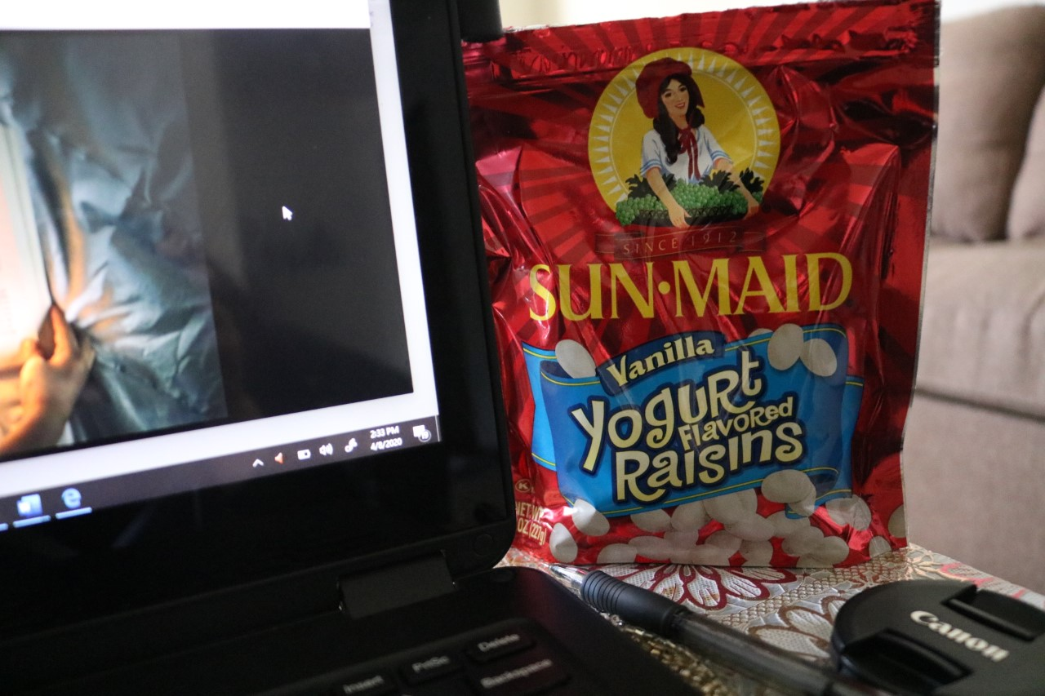
Fun fact: I enjoy yogurt covered raisins. Sitting here typing away as usual.

4/8/20: Wednesday
9:30pm: I sat through a long lecture in Geology. This was when I realized I needed an office space, or somewhere where I can sit up straight and work diligently. The living room wasn’t doing it for me. It was a regular old day at home. I finished my Music presentation for the next day and was ready to go. I also enjoyed some photos taken by my cousin as I worked.
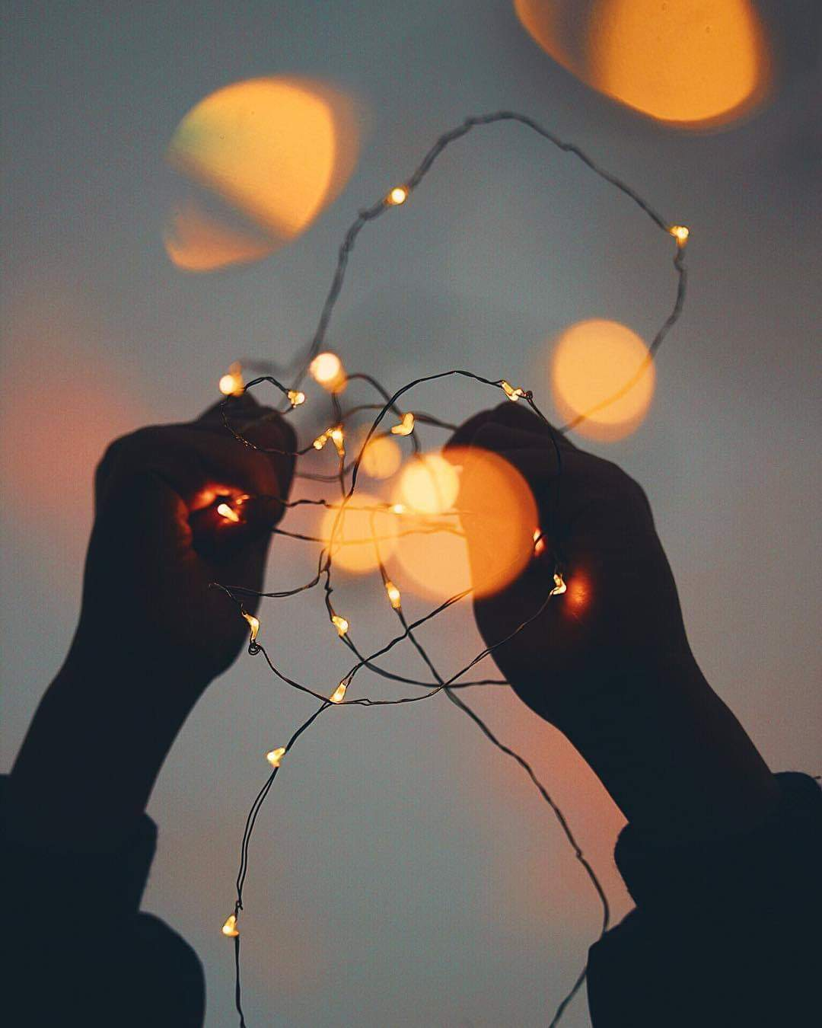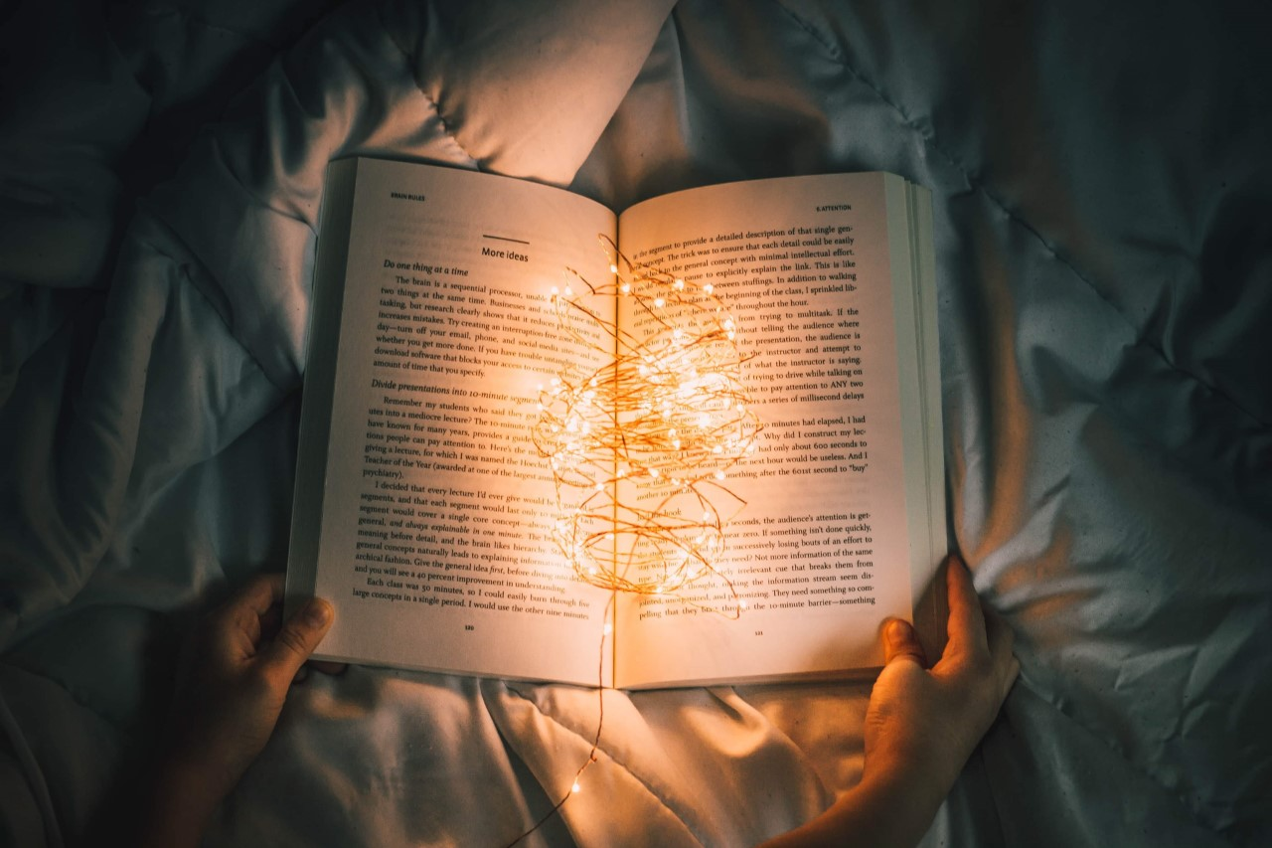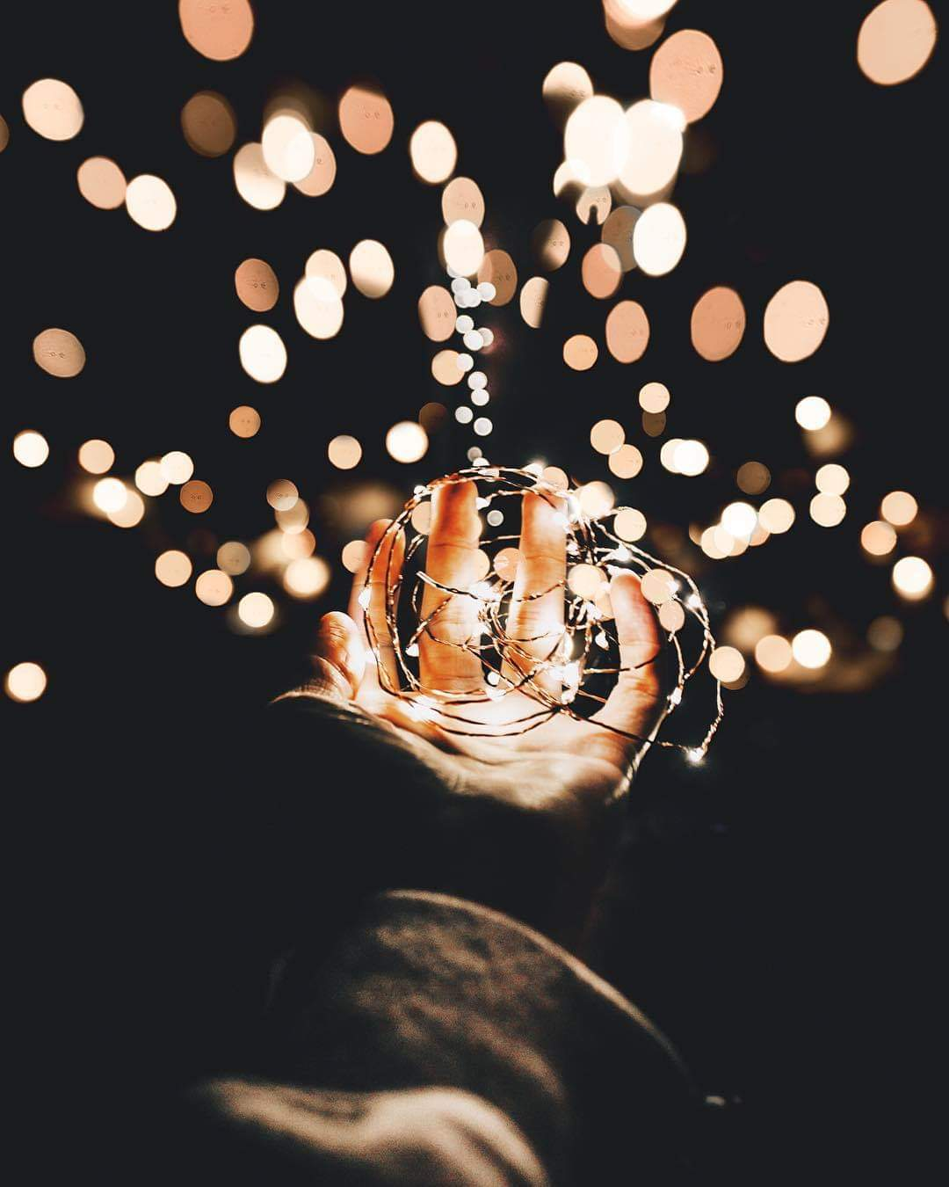
I mean, look at the aesthetic of these pictures.

4/9/20: Thursday
9:15am: I presented my Music presentation in class. It went well! Provided some information on music and how I use music as a cooping mechanism during these trying times. I the n played a game called Song Association with the class through zoom, this is where I provide you a word and you’ll have to sing a song with that word in the lyrics. I’ll be honest, I though we were going to have to sit there in total silence, but everyone pulled through and sang within their rooms.
Later that day I finished an exam for my Philosophy class.

4/10/20: Friday
Online classes are getting easier as time goes by. I’ve been lazier and less productive around the house.
The week was filled with assignments and long class lectures. I’ve completely given up on dressing up and getting ready in the morning. My assignments are in on time and I am lazier by day.

Week Two:
Monday 4/13/20: My week started off like any other day during quarantine. Slow and non-interesting. At 9:15 am I started my music class. The class and I sat at our homes learning through zoom. We went over class presentations, upcoming assignments, and group presentations/assignments. The class felt longer than usual. Later that day, I worked on upcoming assignments and watched Netflix shows until 2:00 am.

Tuesday 4/14/20: I don’t have classes on Tuesday. I spent the day working on school assignments and watched more Netflix. I really wish I did various interesting and fun activities so I can share my fun filled week but sadly, I stayed home and watched Netflix.

Wednesday 4/15/20: I started the day off with my Geology class. The class felt long, and it dragged on for hours. We went over our upcoming exam study guide and played various games of Kahoot in preparation for the hard test. Later that day, I had my History class. I spent the rest of the day working on assignments. I also met with an academic counselor in order to talk about the classes that I had to take as I transfer on over to the 4-year campus.

Thursday 4/16/20: This day was another music day. I had my music class and spent the afternoon cleaning the house. Later, when I finished my Philosophy class, I, along with everyone else, registered for our classes. It was a struggle, but I did it! I felt so exciting but stressful.

Friday 4/17/20: I woke up early to take my Geology exam. It was tough, I’m not going to lie. My score was not as nice as I wanted it to be. I spent the rest of the day working on assignments and staying inside. Nothing interesting happened this day.

Saturday 4/18/20: I woke up and ran some errands with my family. I haven’t gone out in a while so this felt nice as I can finally get some fresh air.

Week Six:
Monday 5/11/20: I’ve been going to sleep extra late these days resulting to my mom scolding me daily. It’s pretty funny actually. On Monday I joined my LAG zoom meeting to talk about graduation and our plans to perhaps celebrate as a cohort. We wanted to bid farewell to one another on a power point slide almost as if it was a high school yearbook. Afterwards I spent the day doing homework.
Tuesday 5/12/20: Since there’s no classes on Tuesday, I spent this day as a self-care day. I realized I haven’t done so in a while and I could use it since it’s the final week of class and the week before finals. It’s crazy to think that this week really was the final week. It does not feel real. If we were all saying our goodbyes in person, it’ll be much more touching and perhaps much more emotional. Saying goodbye over online classes just does not feel the same.
Wednesday 5/13/20: On Wednesday I joined my Geology class while in bed. Though I like to get up, get ready, and be awake, I just could not bring myself to crawl out of bed this morning. Probably because I stay up till 3:00am every day. I laid in bed while my Geology professor walked through our final paper along with our final exam. The class was short and ended rather quickly. Afterwards I joined my history class where we also went through some of our final assignments. Not much is happening, but the final assignments and exams are still as stressful as ever. I spent the day working on final assignments and projects. You guessed it, I went to sleep extremely late again.
Thursday 5/14/20: On Thursday I spent the morning watching various YouTube videos. I have been living off YouTube during quarantine. I spent the day inside switching back and forth on YouTube, Netflix, and my social medias. Not the most productive thing to do but there was literally nothing to do. I joined my Philosophy class later that day to talk some more about race. Afterwards, I spent a small amount of time on homework.
Friday 5/15/20: I realized that I spend a lot of money on things whether I’m forced to stay inside or free to go out. Not a good thing but it’s keeping me company. I spent the day working on my history paper. A lot was due the upcoming weekend. I prepared myself for a long stressful weekend.
Saturday 5/16/20: I spent this day working on my final Geology paper. Throughout the year, we had to conduct research on a mineral we had chosen and write a paper about it. I had no idea it as going to be this hard. I struggled on finding useful information when I began the research. My mineral was named Wolframite, and it’s deposited throughout China. Majority of the people in my cohort had worked in groups to get the paper done but I chose to do the paper by myself. Was this a bad decision on my part? Perhaps. I spent this day struggling to gather good information for my paper. The research I had done before was just not good enough. Can you believe I spent the entire day on one paper for one class? This is college for ya. Luckily, I pulled through and finished without breaking down. It was late but again, these days I don’t sleep until 3 in the morning, so I watched some Netflix. I’m still watching the show Extracurricular and it gets better each episode. I won’t spoil anything, but it really is the quiet ones that surprise you the most.
Sunday 5/17/20: The workload does not stop. On Sunday I locked myself up in my room just to finish projects and assignments. I’ve realized that my studying essentials were water, my laptop, and scented candles. I got to work, and it was an absolute pain to get through everything. One step at a time, I pulled through once more and finished everything for the weekend. Now I just have to worry about the real deal, the exams. Please call for backup.

