COVID-19 Contribution
Dialogue on Race: An Open Forum

For my contribution, I would like to highlight one of the most publicized events that occurred during the first few months of COVID-19, the George Floyd killing and my actions to bring unity after. This incident put a spotlight on social issues that have been long swept under the rug, racism, racial violence and police brutality. During this time, members of the Air Force spoke out and initiated conversations about race, and racial disparities within our ranks. I chose to step up and give my contributions by helping to facilitate these discussions and bridge the gap seen amongst members with different racial identities. Below you will find a breakdown of each slide with a description on why I chose certain mediums, language and videos/images to be as affective in addressing my audience as possible. From this conversation I established a Diversity & Inclusion program that allowed for our unit to highlight and appreciate the diverse nature and background of our unit members. I continue to discuss and elaborate this topic because in light of COVID-19 I believe it’s important to also reflect on our morality and how we apply it to everyday decisions and actions in the world. While COVID-19 is destructing and horrible, we as people do not have to be and by challenging our way of thinking we make room for subtle improvements in the world.

The title of this discussion is “Dialogue on Race”. I Chose this specific title because I want my audience to be aware that is NOT only an educational piece, but one to inflict emotion to draw my audience to reflect on the topic at hand and feel safe to have an open discussion.
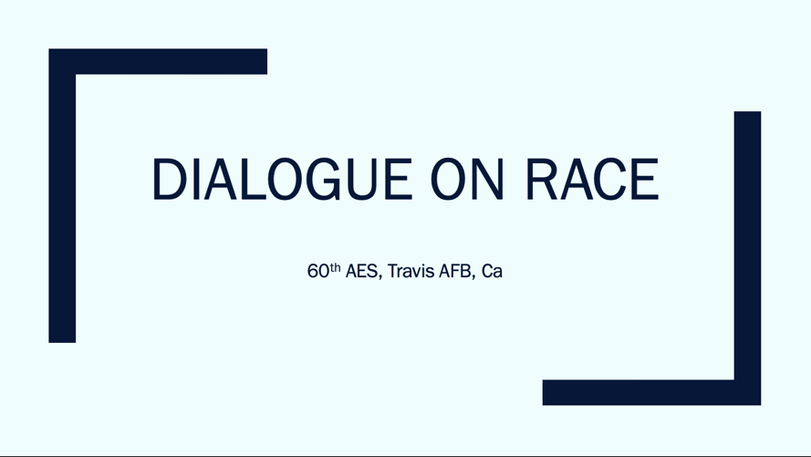

The First video I chose to present to my unit, my audience, is called “Systemic Racism Explained”. I chose to use this as my opening visual so that my audience can reflect on what racism is and how it systemically affects all people of color throughout the rest of my presentation, and throughout our discussion. I chose to use a quote from the movie “Philadelphia” to explain racism in the most simple and obvious manner. The quote used is,
“This is the essence of discrimination, formulating opinions about others not based on their individual merits but rather on their membership in a group with assumed characteristics.”
I believed this statement to be powerful because it implies that some of those group “memberships” aren’t voluntary (i.e. the color of your skin) and we often associate our racial biases (assumed characteristics) on those people instead of associating by their individual efforts.
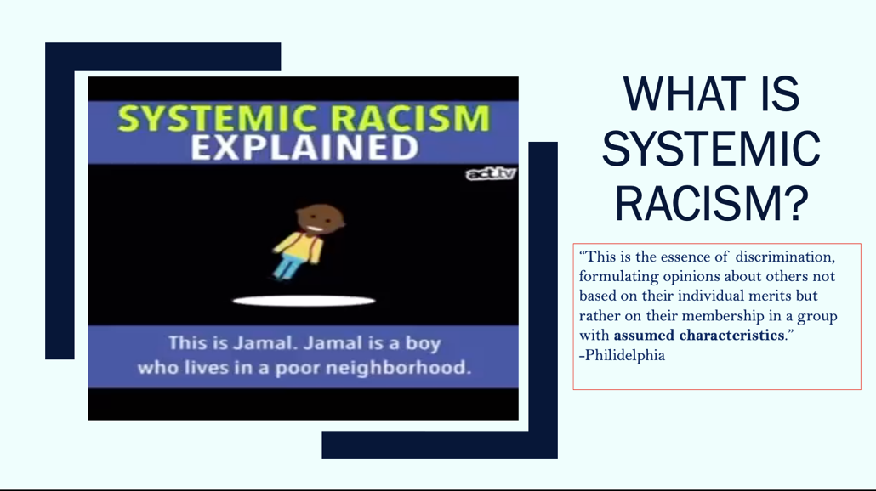
https://www.youtube.com/watch?v=YrHIQIO_bdQ

I then proceed to present the audience with the video of George Floyd’s death. I realized that maybe my entire audience haven’t seen this video and we cannot discuss the issue without seeing it, being a witness of it first-hand. How can we discuss what we do not know? My purpose is not to talk about Mr. Floyd as an isolated incident, but to show my audience that this specific situation (death by police brutality) could have/and has had the face of many other people of color. 9 minutes doesn’t seem like much time when you think about passing time until you sit for 9 minutes and watch the tragic death of a man. That is my point.
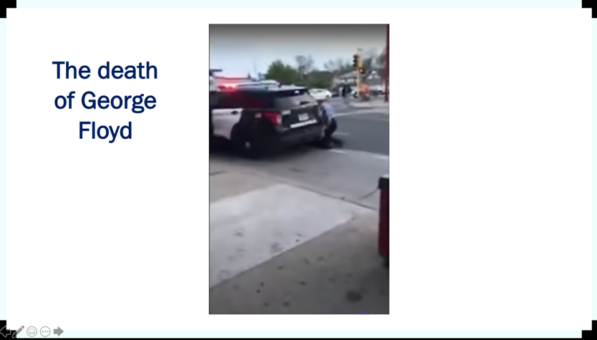
https://www.youtube.com/watch?v=IUav_lXMbnU&feature=youtu.be&fbclid=IwAR3v35A8iRpi0oO2ZvwF7U2Y_qWxv0jx6DONSn9-mVSlS5geLAN35nQDsdc

I then chose to share a few words from an excerpt Chief Wright wrote (you can also find this down below) because this shows that NO ONE in our ranks is above talking about this subject, and that it is the very exact conversation that we need to be having. I chose to highlight some points from his 2nd paragraph where he admits to the Air Force’s own racial problems and states that this is every leader across the force’s responsibility in making sure that this problem sees an end. I chose this section because I’m sure there are many leaders who feel that this discussion is hard, awkward, and would much rather once again walk on by it, but as a military leader siting there, and seeing these words, I could only hope that they know this message is for THEM and that they are not excused from this issue.
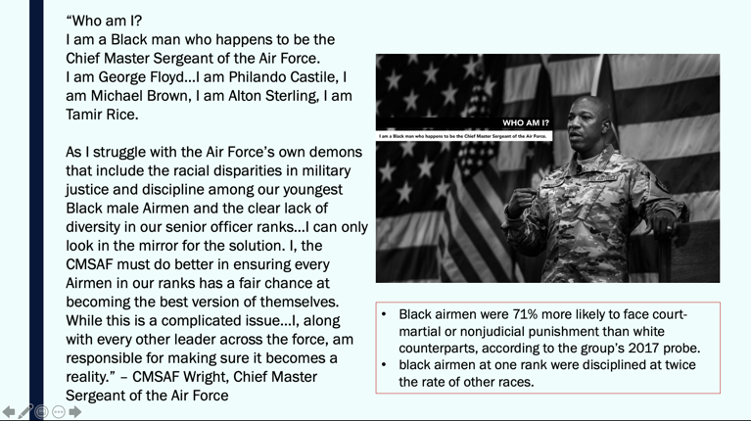
I chose to place a video of the Air Force Chief of Staff and Chief Wright having this conversation to once again reiterate that this is a problem that will only be solved if we attack it from the bottom up. To have our highest leadership in the Air Force having this conversation, should push our local leaders to do the same. I wanted to use this video as a segway into our discussion forum to remind my audience that yes, whether you are black, white, or in between, whether you are in a leadership position, or in the bottom tier of our ranks, this message IS for you.
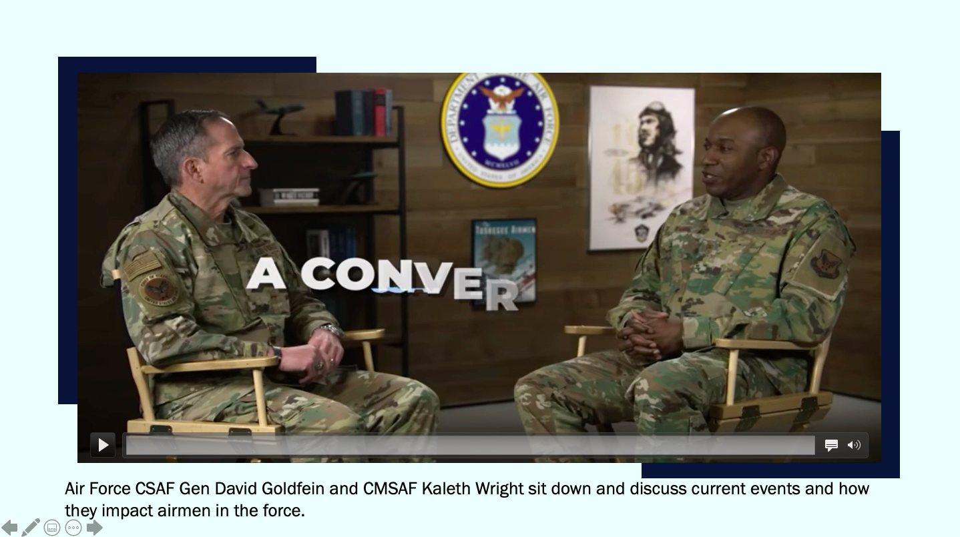
https://www.youtube.com/watch?v=D3syQ0VCVQQ

Discussion Questions:
- What are some prejudices you might hold that you may not be aware of?
- What are some of your personal experiences with racial bias in/outside of the Air Force?
- When you hear people in your circles making racially biased comments, do you speak up? Why or why not?
- Have you ever been accused of being racist? How did it make you feel? Did it change your behavior? Why or why not?
These are the 4 discussion questions I want to present to my audience so that we can gain a new perspective on how this not only affects black airmen in our unit but everyone. To not only hear what it’s like to be personally victimized by color bias, but to see the perspectives of people who may have been suspected of being racist, would shape the conversation for the better. 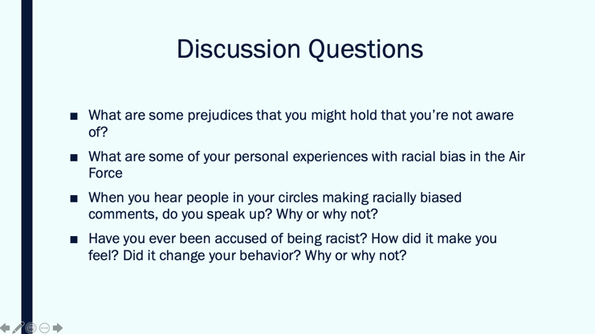

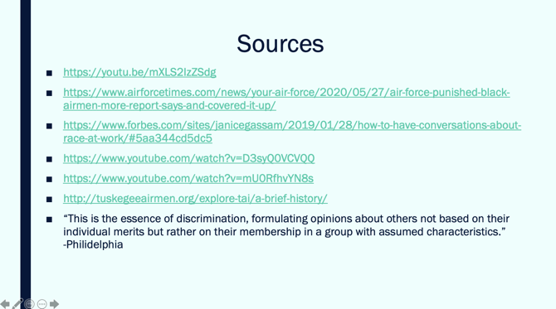

Please find below, the words by Chief Wright on this matter. Thank you.

Words From Chief Wright
Who am I?
I am a Black man who happens to be the Chief Master Sergeant of the Air Force.
I am George Floyd…I am Philando Castile, I am Michael Brown, I am Alton Sterling, I am Tamir Rice.
Just like most of the Black Airmen and so many others in our ranks…I am outraged at watching another Black man die on television before our very eyes. What happens all too often in this country to Black men who are subjected to police brutality that ends in death…could happen to me. As shocking as that may sound to some of you…I hope you realize that racism/discrimination/exclusion does not care much about position, titles or stature….so yes, it could happen to you, or one of your friends, or your Airmen, or your NCOIC, your Flight Chief, your Squadron Commander or even your Wing Commander. This, my friends, is my greatest fear, not that I will be killed by a white police officer (believe me my heart starts racing like most other Black men in America when I see those blue lights behind me)…but that I will wake up to a report that one of our Black Airmen has died at the hands of a white police officer.
As I struggle with the Air Force’s own demons that include the racial disparities in military justice and discipline among our youngest Black male Airmen and the clear lack of diversity in our senior officer ranks…I can only look in the mirror for the solution. I, the CMSAF must do better in ensuring every Airmen in our ranks has a fair chance at becoming the best version of themselves. While this is a complicated issue…I, along with every other leader across the force, am responsible for making sure it becomes a reality.
What have I been doing?
Not enough…I have done my share of community service work, been in involved in mentor programs, voted in local, state and national elections, but I’ve come to the conclusion that whatever I have done in the past is just not enough. So, I spent the last week, “plotting, planning, strategizing, organizing and mobilizing” just as Killer Mike, the popular Atlanta rapper and activist encouraged us to do. Twenty-five of my closest friends (White, Black, Asian, enlisted, officer and civilian) and I have an ongoing dialogue where we began by acknowledging our right to be angry about what is happening.
We eventually moved beyond the rage and began to think about what’s next? What could or should we be doing as a group and as individuals to stop this from happening in our communities across these United States? We don’t have all the answers, but we do have some of the most brilliant minds, many, who have first hand experience with this topic and we will continue working towards a solution. While we can’t change the world, we can change the communities we live in and more importantly, those where our Airmen strive to be seen, heard, and treated as human beings. I have also not done enough as your most senior enlisted leader…while we have made progress in many of the areas that impact our Airmen and families; I believe that we have not made much progress in this area of racial injustice and diversity among our ranks. This is why I’m working with General Goldfein, first and foremost to have a full and thorough independent review of our military justice system. We will look to uncover where the problem lies and how we can fix it. We are also working to improve the diversity of our force, especially within the senior ranks. I hope this message triggers responses and ideas from each of you on things we can do better.
What should you be doing?
Like me, acknowledge your right to be upset about what’s happening to our nation. But you must then find a way to move beyond the rage and do what you think is right for the country, for your community, for your sons, daughters, friends and colleagues…for every Black man in this country who could end up like George Floyd. Part of my group’s solution involves helping to bridge the communication and understanding gap between law enforcement and young Black men. You decide what works best for you, where you can have the most meaningful impact and most importantly, what you can stay committed to…we didn’t get here overnight so don’t expect things to change tomorrow…we are in this for the long haul. Vote, protest peacefully, reach out to your local and state officials, to your Air Force leadership and become active in your communities…we need all hands on deck. If you don’t do anything else, I encourage everyone to fight, not just for freedom, justice and equality, but to fight for understanding. You might think you know what it’s like to grow up, exist, survive and even thrive in this country as a Black person…but let me tell you, regardless of how many Black friends you have, or how Black your neighborhood was, or if your spouse or in-laws are Black…you don’t know.
You don’t know the anxiety, the despair, the heartache, the fear, the rage and the disappointment that comes with living in this country, OUR country every single day. So, take the time to talk to someone – your brand new Airmen, your NCOIC or your Flight Commander - about their experiences so that you have a better understanding of who they are, where they come from and what drives them. Frankly, you owe this to every Airmen, but I’m asking you specifically to pay attention to the Black Airmen in your ranks during this trying time. Don’t misunderstand me, they don’t need, nor do they want any special treatment…but they deserve to be treated fairly and equally, both by our United States Air Force and these United States of America…this begins with you, and I am asking, no fighting, for your understanding.
Like you, I don’t have all of the answers, but I am committed to seeing a better future for this nation. A future where Black men must no longer suffer needlessly at the hands of White police officers, and where Black Airmen have the same chance to succeed as their White counterparts. Trust me, I understand this is a difficult topic to talk about…
Difficult…not impossible…
Difficult…but necessary.
Who am I…
I am Kaleth. I am a Black Man who happens to be the Chief Master Sergeant of the Air Force and I am committed to making this better.

