Translation of item number 9849 done by Angelica S Ramos on 06/30/2021
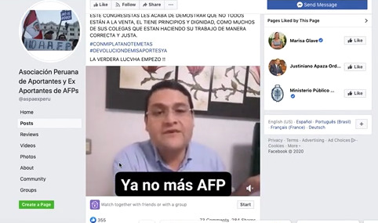
Peruvian Association of Contributors and former Contributors of AFPs

This congressman has just demonstrated that not everyone is on sale, he has principles and dignity, like many of his colleagues who are doing their work in a right and just way.

The real fight has started.

“No more AFP”

