Life as a Quaren-teen: The COVID-19 Files of Jacquelyn Slade

Journal Entry
First, here is a journal entry I wrote about COVID:
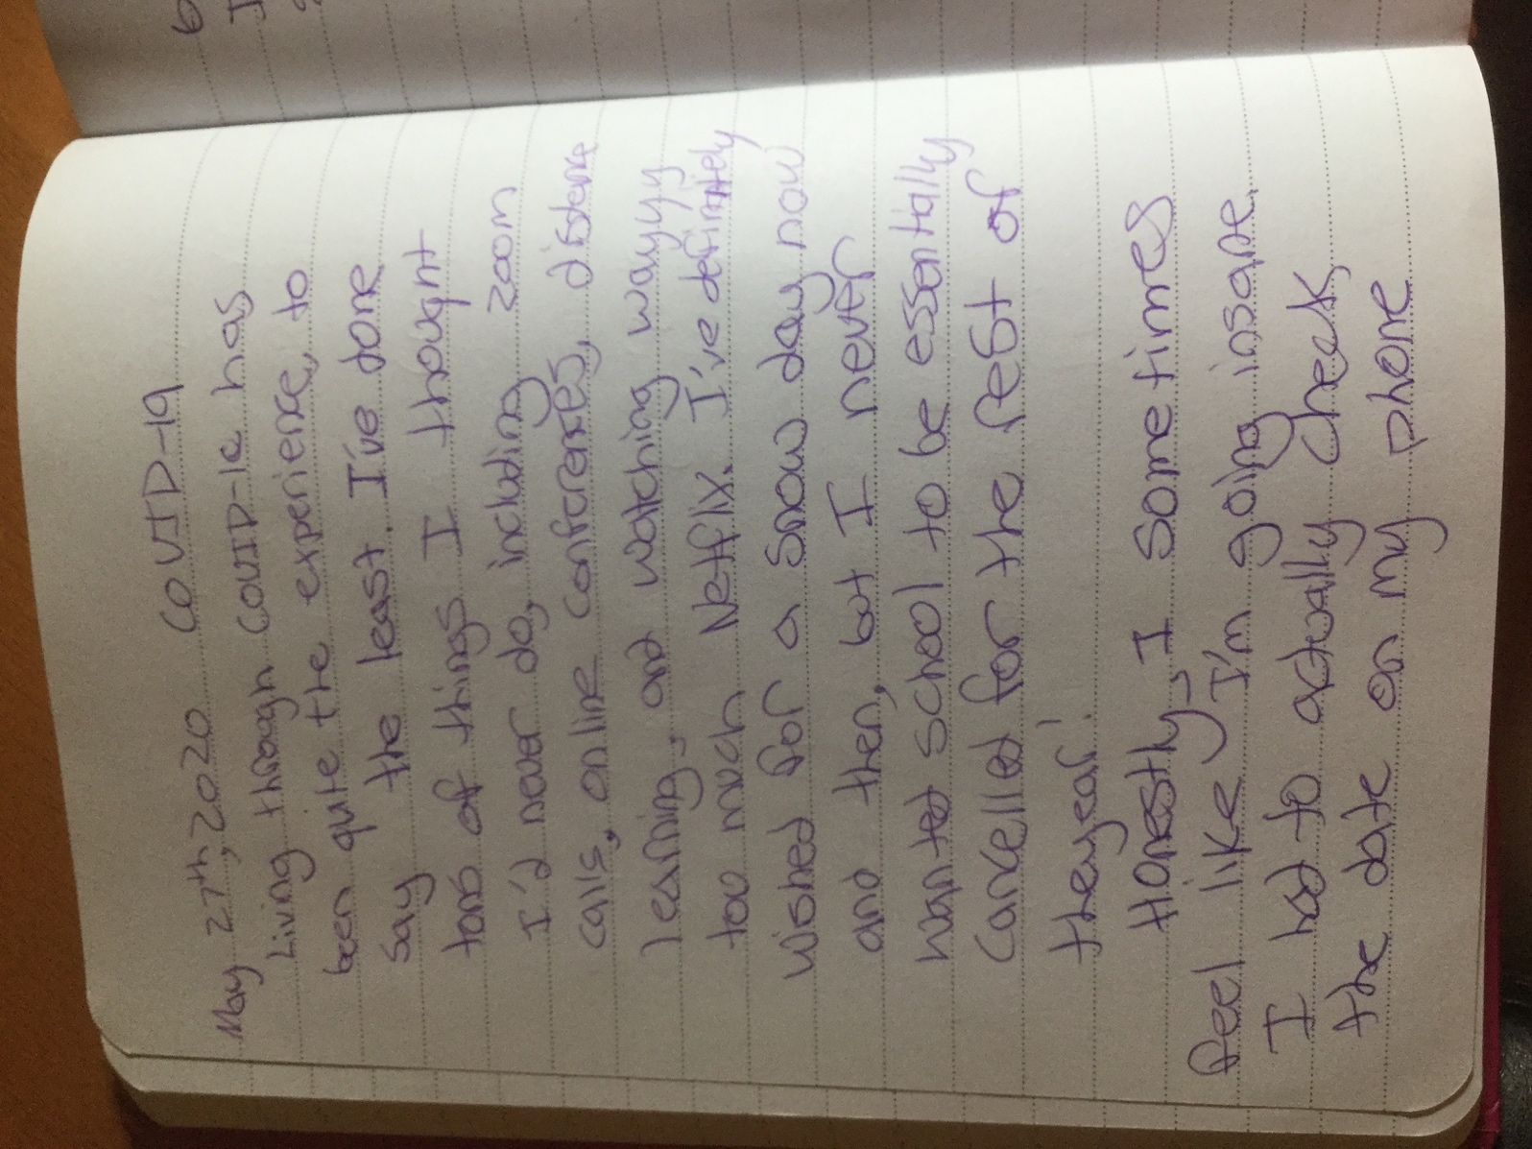
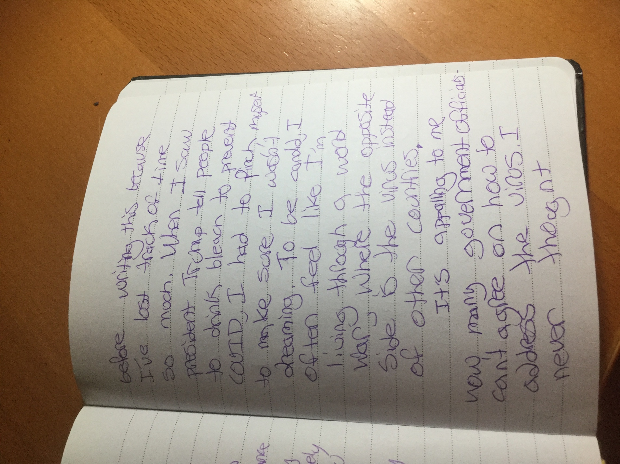
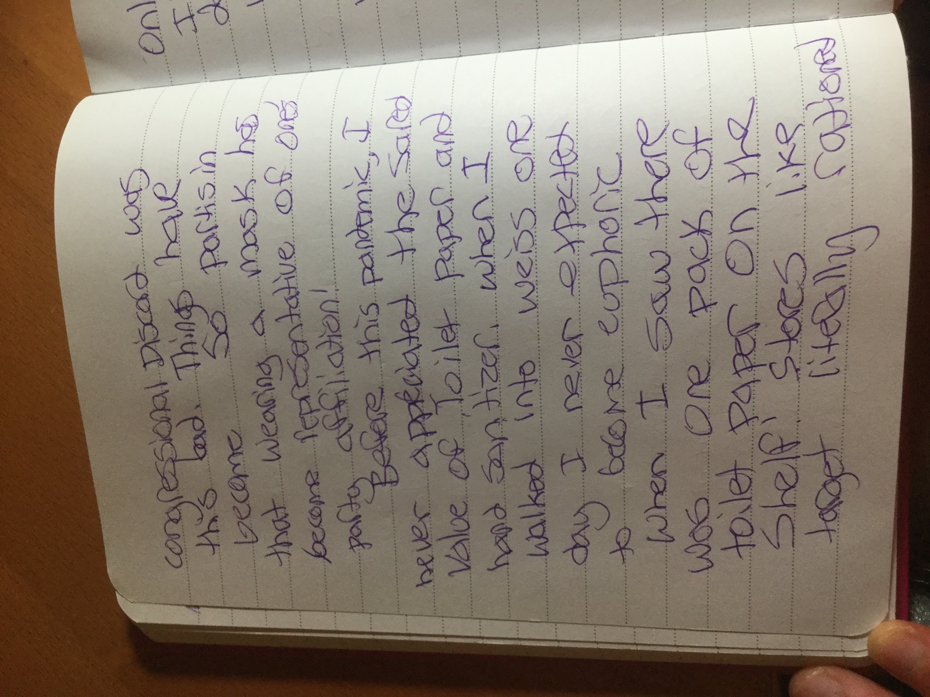
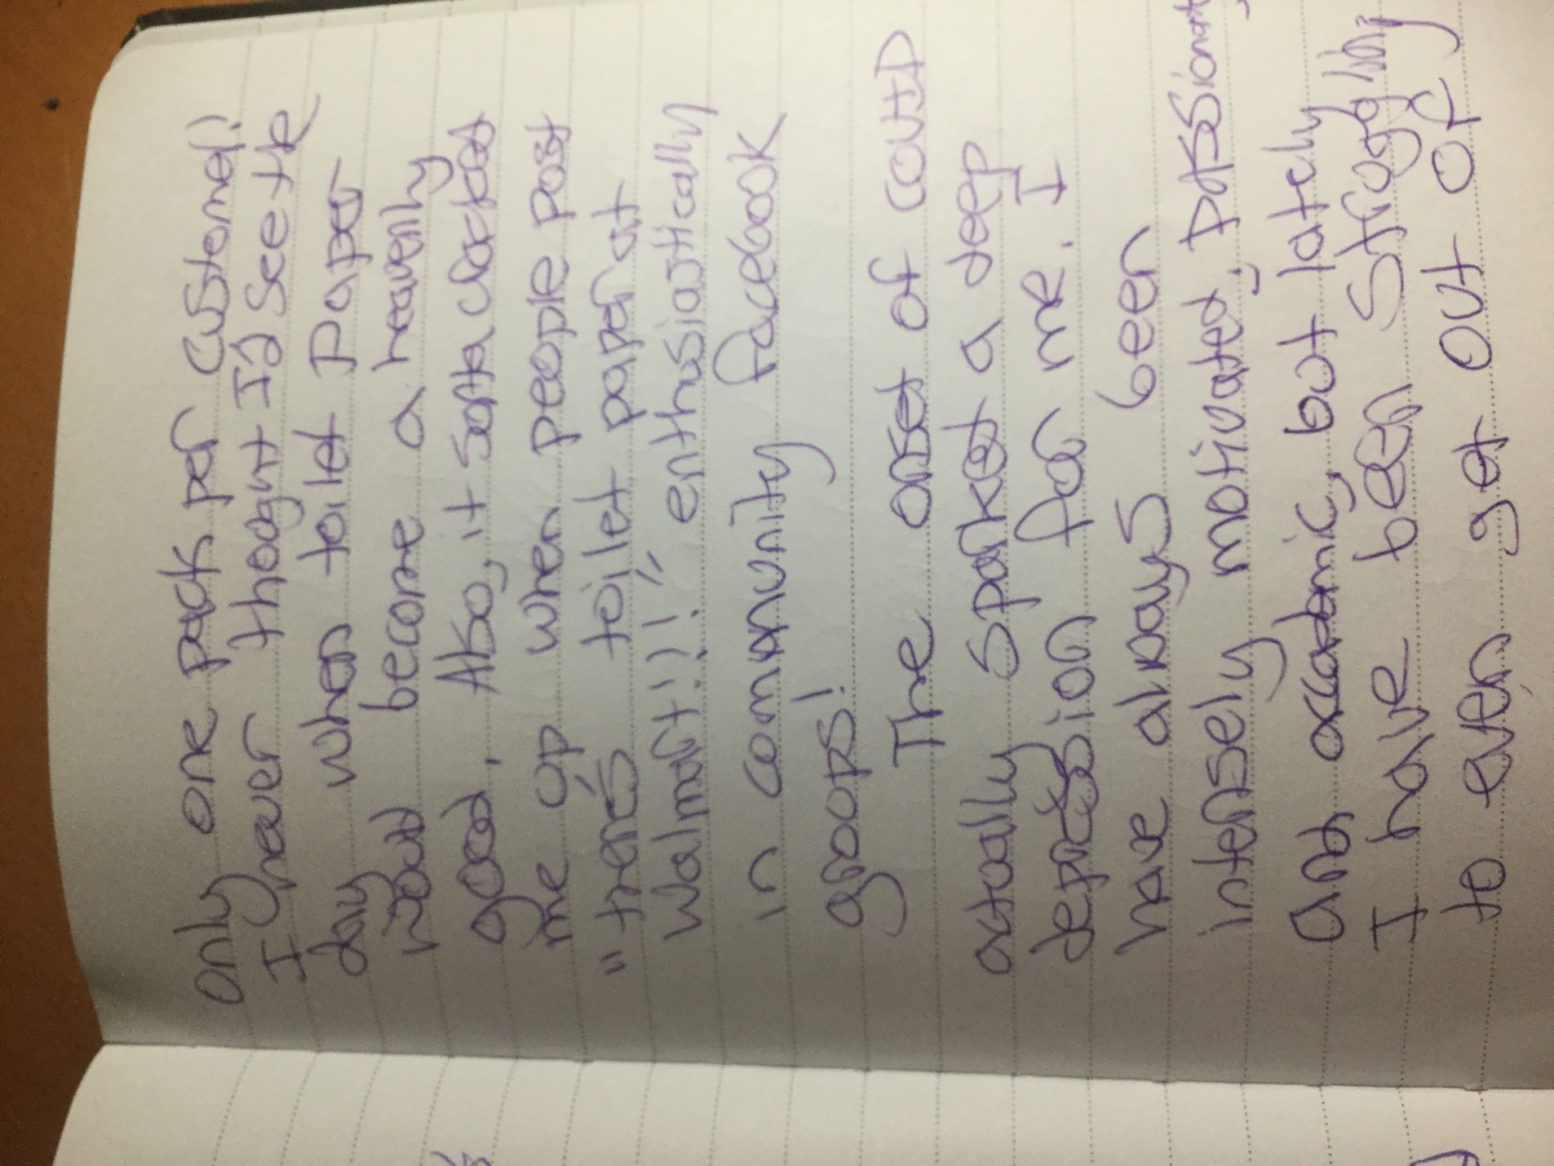
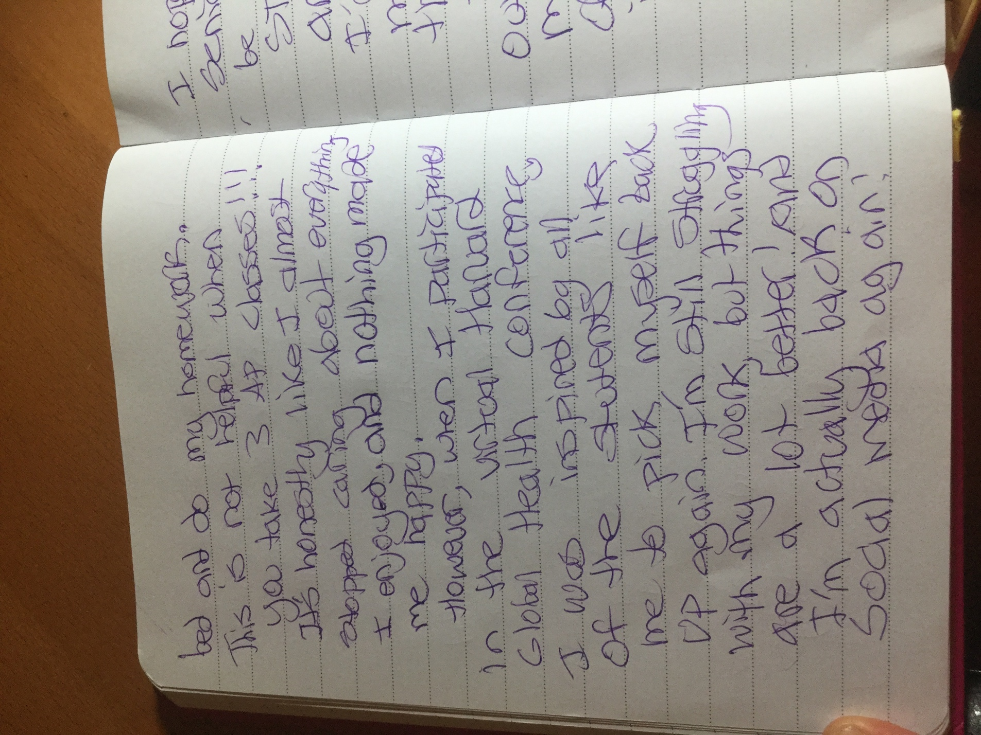
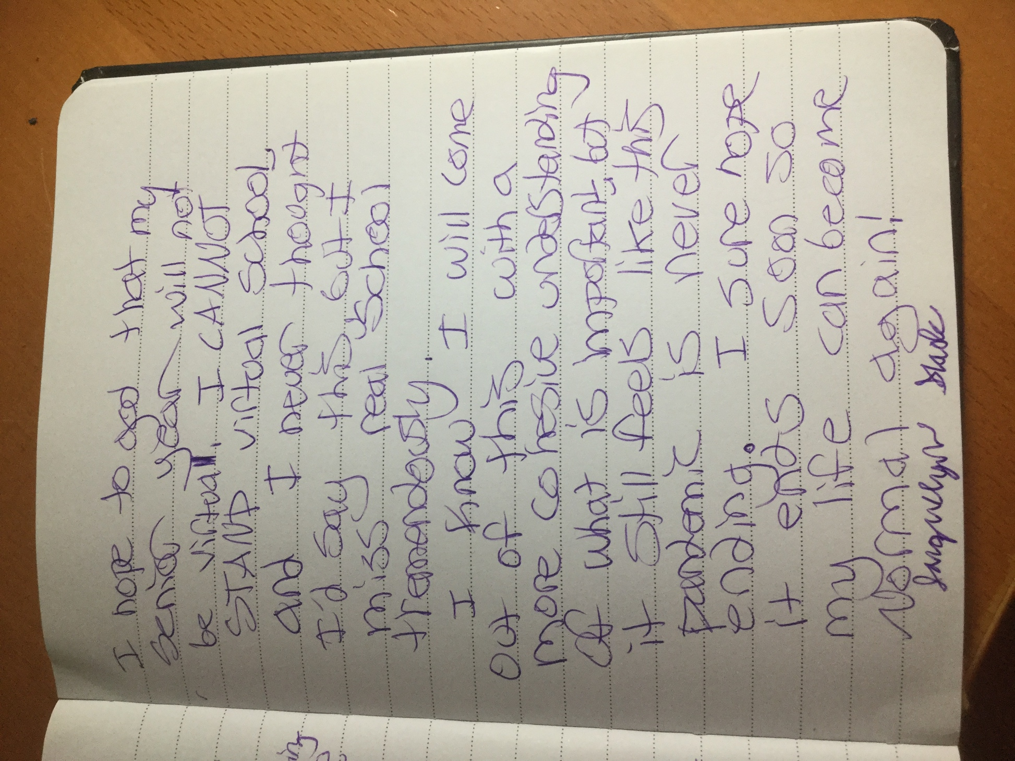
Newspaper Articles:
Here are some newspaper articles from my local papers—bonus—2 were written by me!
Homeless Initiative Seeking Donations by Akika Kyland-Carroll County Times

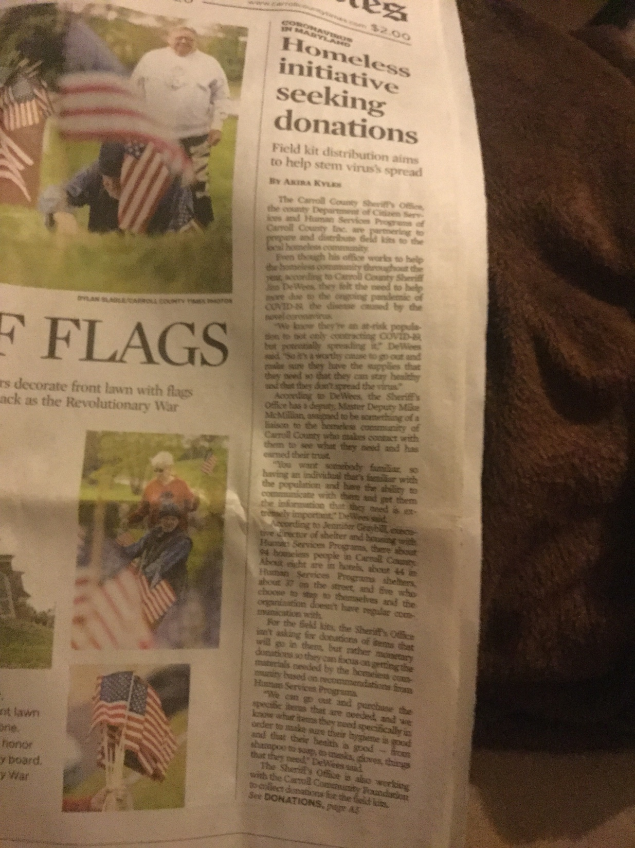
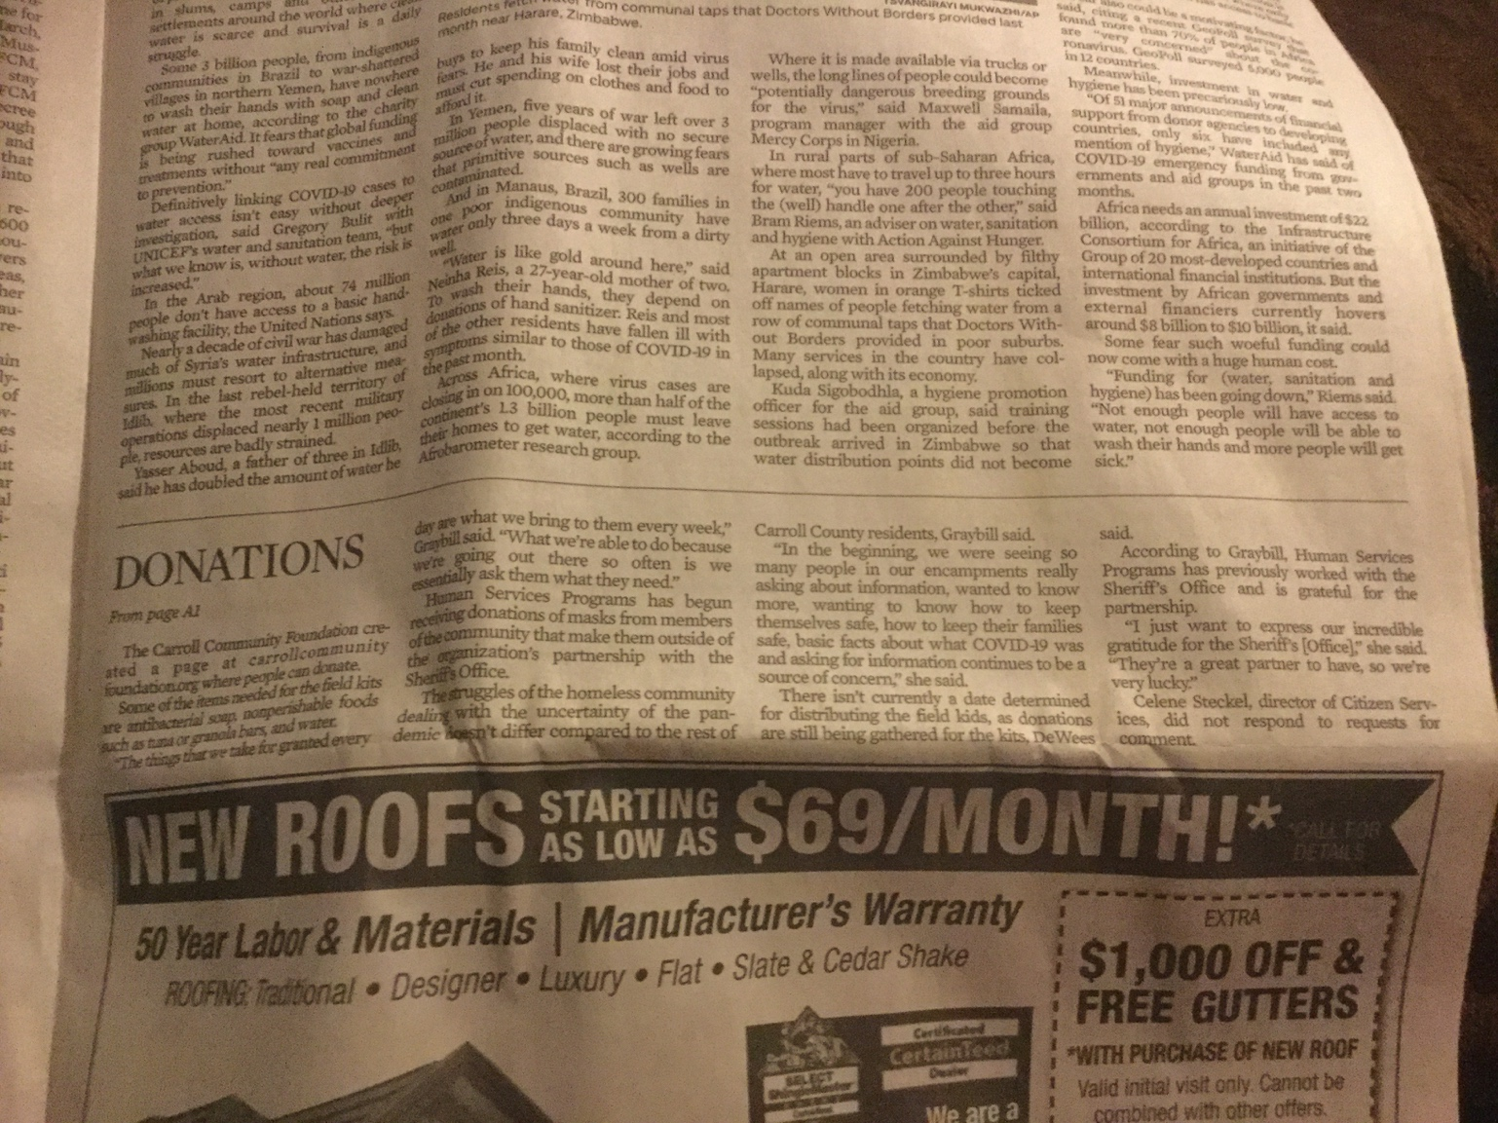

Stages of Grief by Adam Kilgore—Carroll County Times/Washington Post
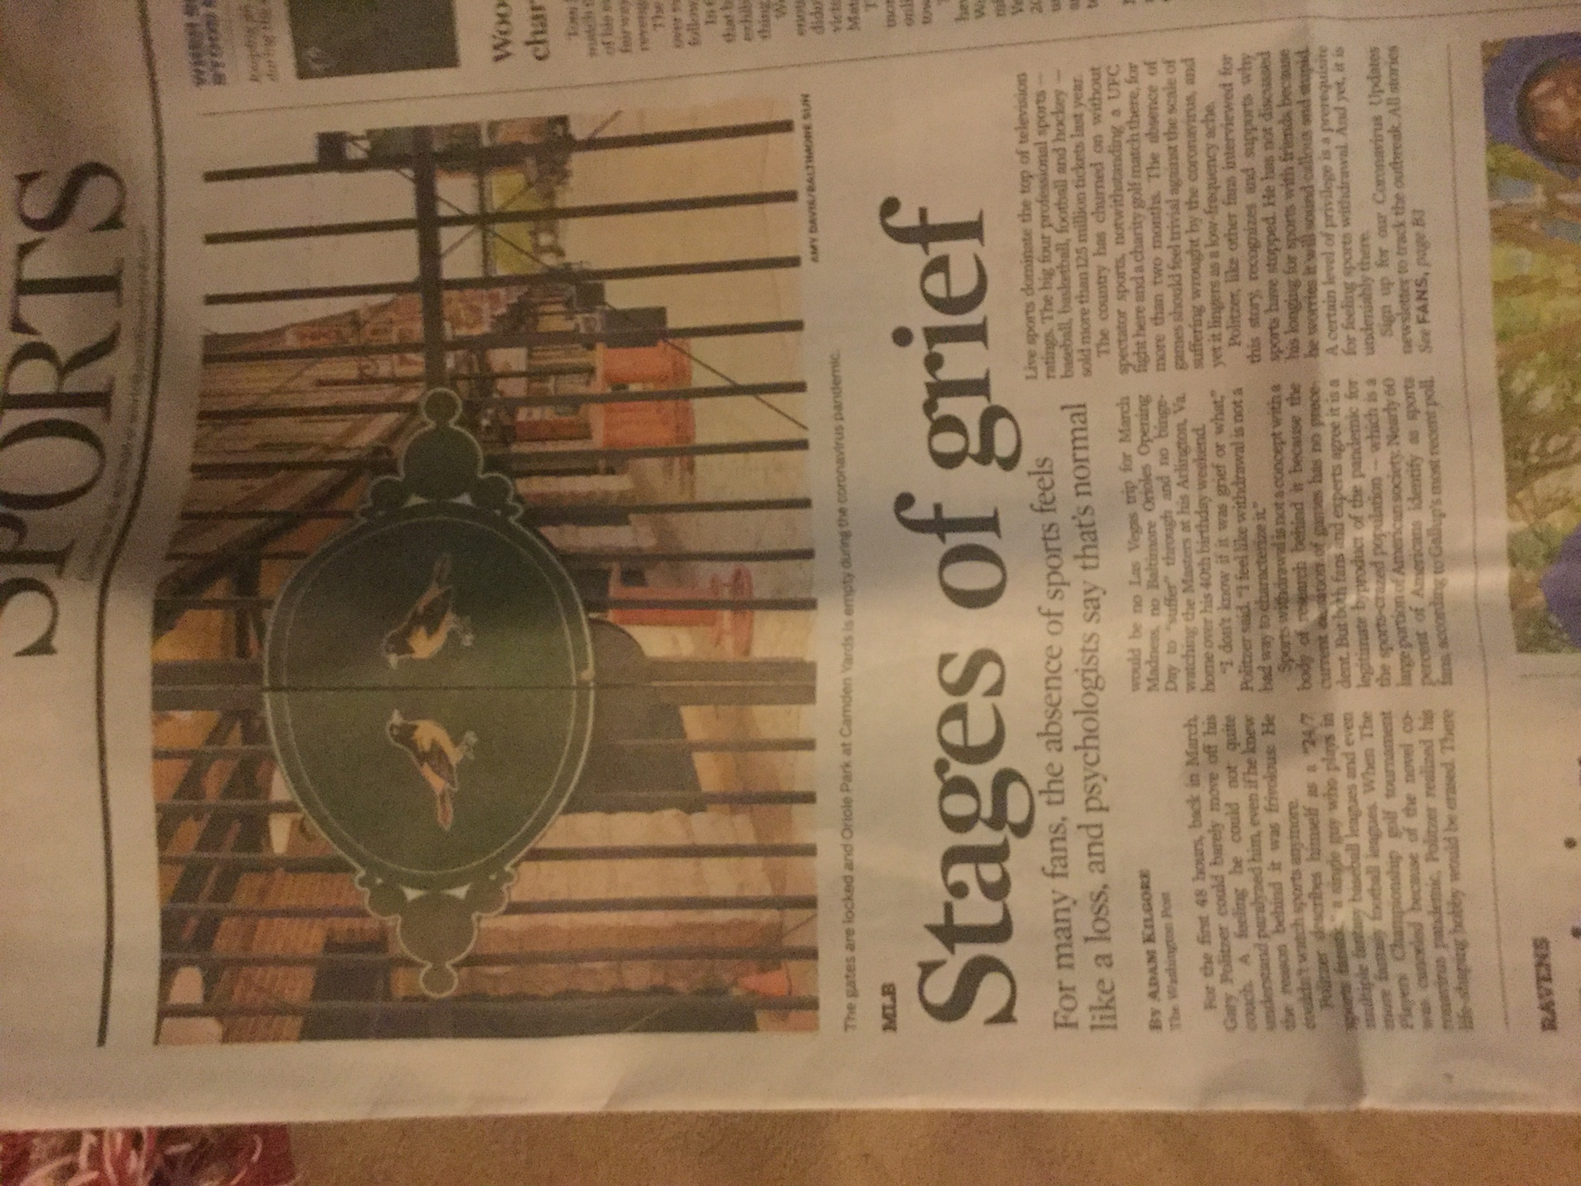

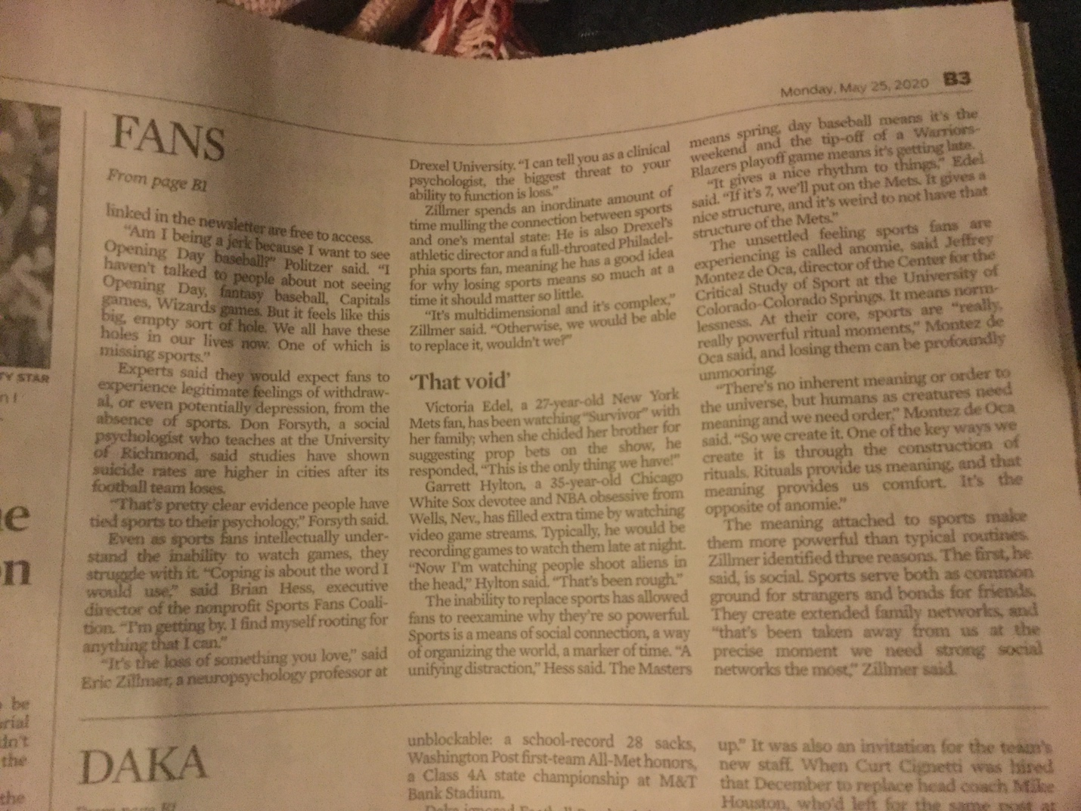

Trump More Concerned About Market than Coronavirus Itself Letter to the Editor by Jacquelyn Slade—Carroll County Times
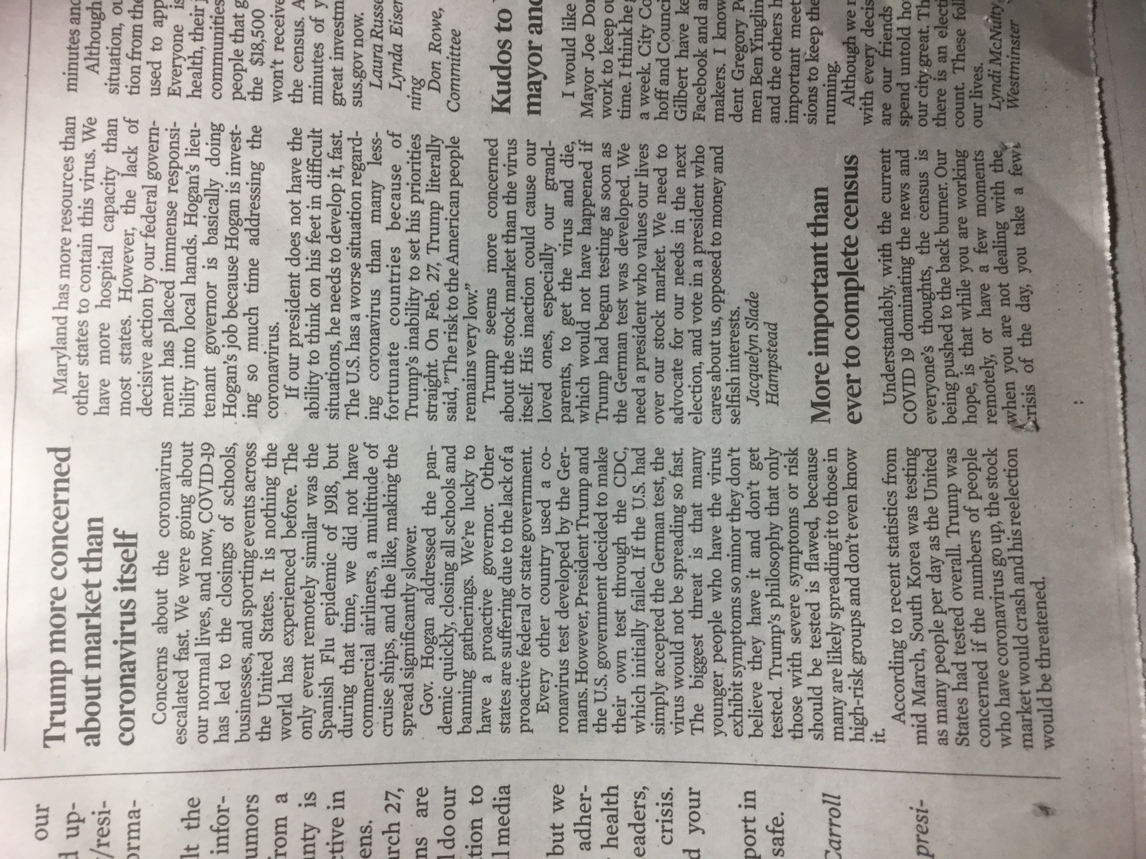
Trying to Stay Productive as a Quaren-teen by Jacquelyn Slade – Mason-Dixon Surveyor
(Included 2 pictures)
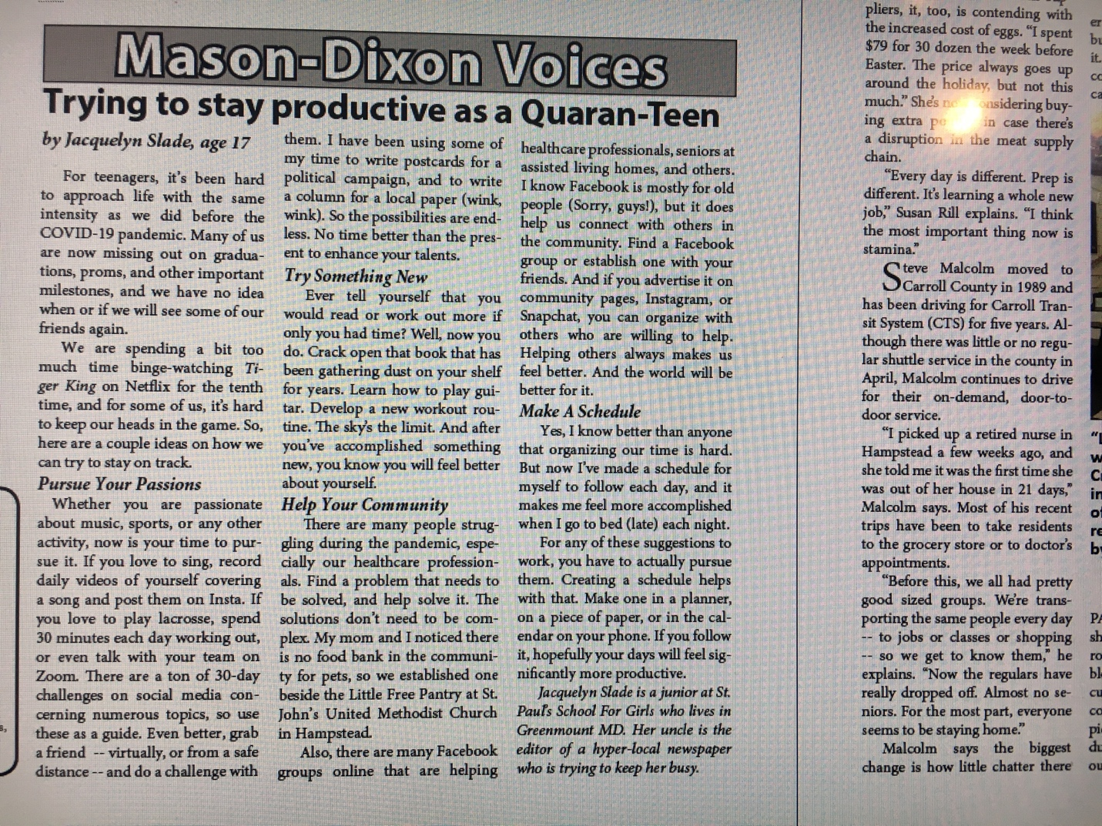
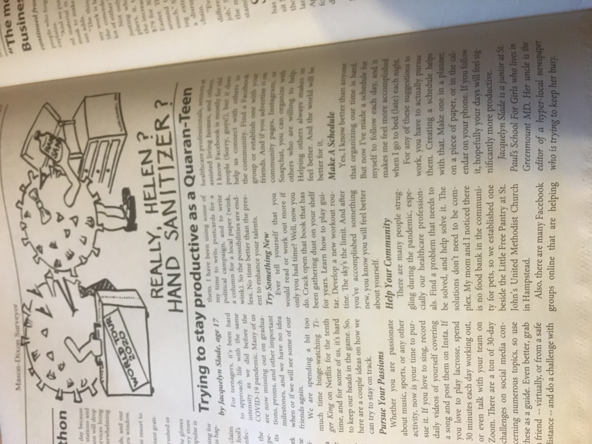
Signs and Pictures
Lastly, I have included some signs and pictures, many of which are quite humerous.
Toilet Paper and Water Ration Sign at Weis
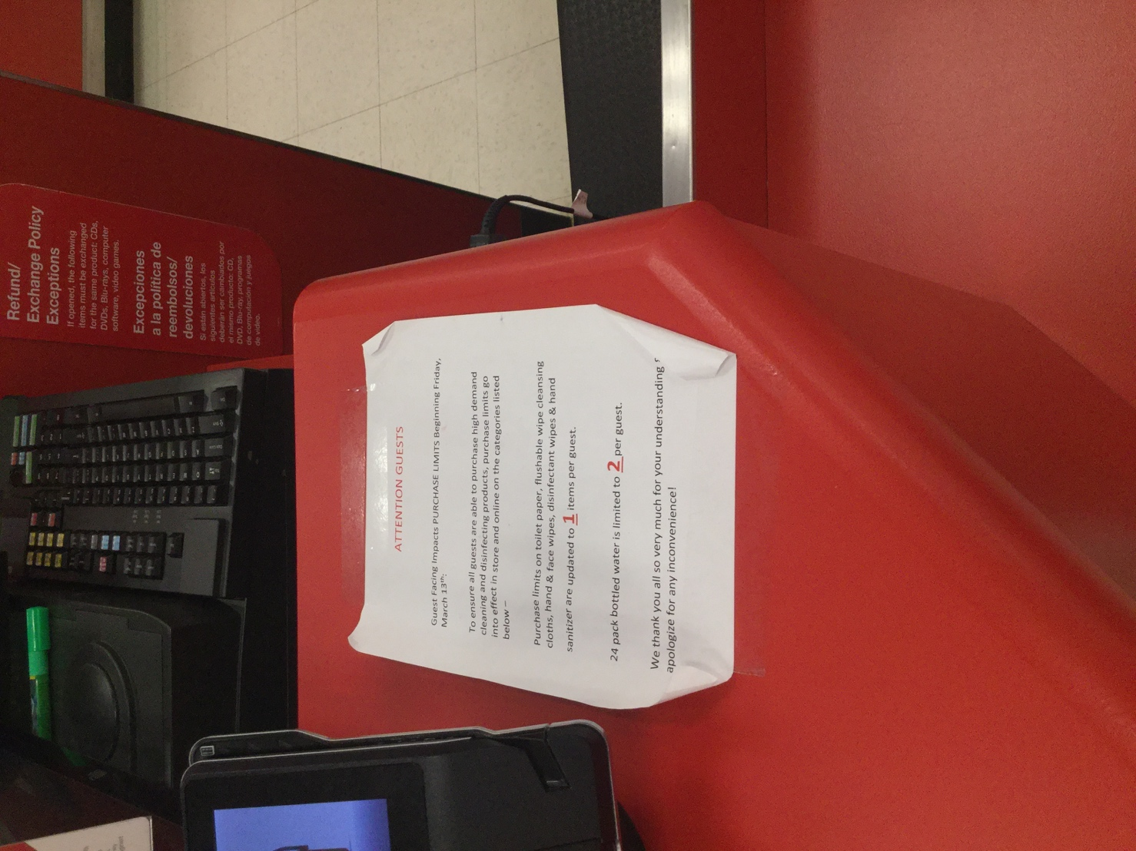

Toilet Paper Ration Sign at Target
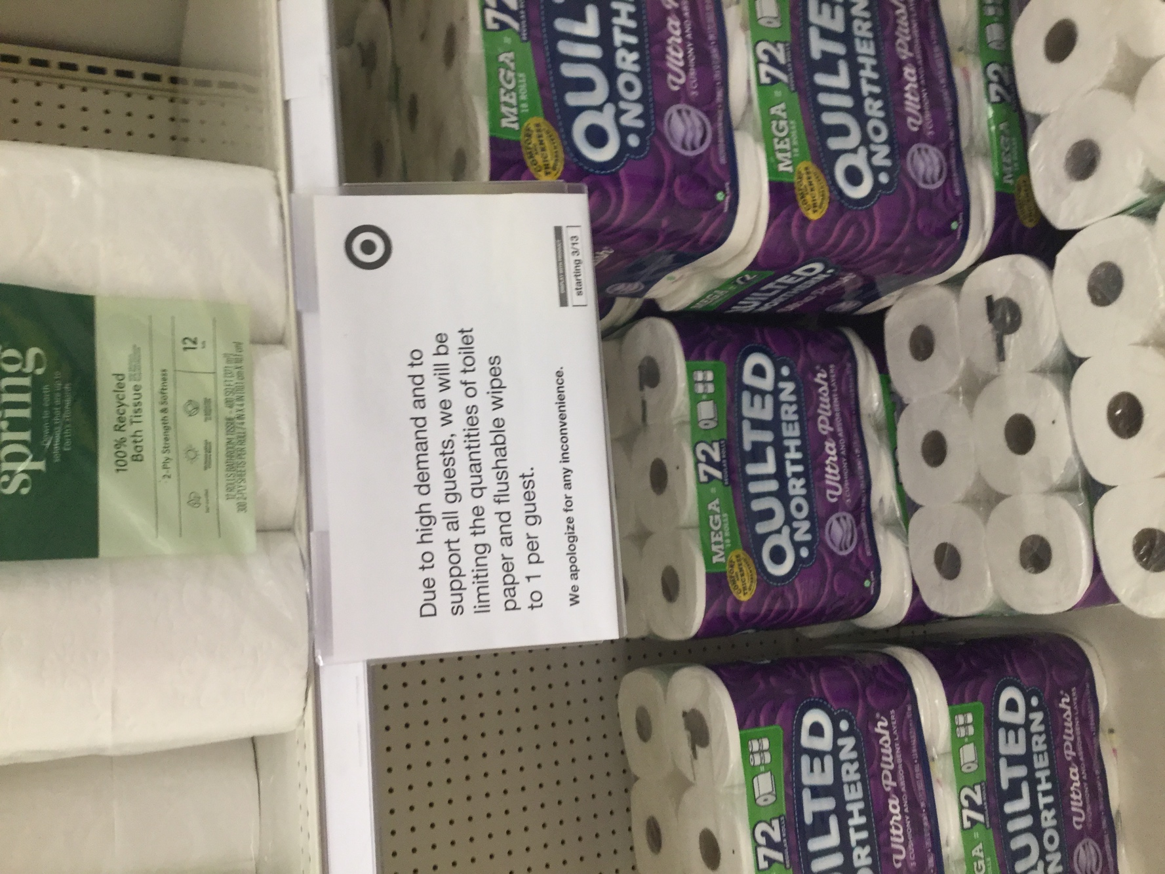
*I am also submitting this document to the archival source in the ny times article you sent out‼‼

