Translation of item number 16238 by Angelica S Ramos 06/29/2021

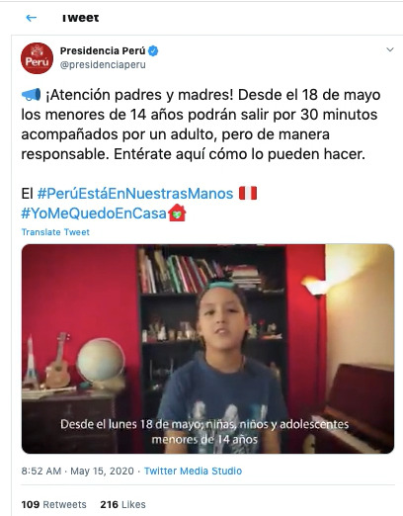
“Attention fathers and mothers! Ahead of May 18 all those under the age of 14 will be able to go outside for 30 minutes with an adult, but in a responsible way. Find out here how.

#PeruIsInOurHands
#IWillStayHome

