Translation of item number 17062 done by Angelica S Ramos 06/22/2021 ASR
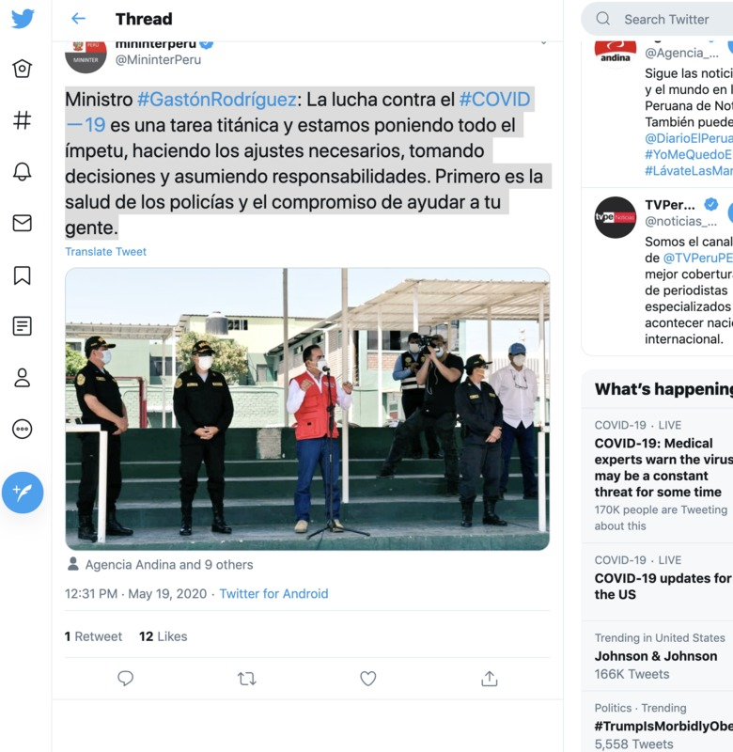
Minister #GastonRodriguez: The fight against COVID-19 is a titanic task and we are putting up a fight, making the necessary adjustments, making decisions and assuming responsibilities. First is the health of the police and the responsibility of helping our people.

