I was in my 2nd semester of my Undergraduate program at SDSU when the COVID-19 pandemic occurred. California declared a state of emergency on March 4, 2020, the schools closed and March 16, and the stay at home order was declared on March 19, 2020. The state of emergency in California did not officially end until February 28, 2023. We initially thought that the lockdown was for a couple of weeks and then life would go back to normal, but that is not what happened. Schools continued to be closed down and all courses were put on Zoom for more than one year. I live in Imperial County and that had one of the most restrictive lockdowns in the state. Basically nothing was open but grocery stores and Walmart for a long time. When restaurants were able to open, it was only for takeout service. All activities in California were closed including amusement parks. Other states were not as restrictive, so I decided to travel to Florida to visit Disneyworld.
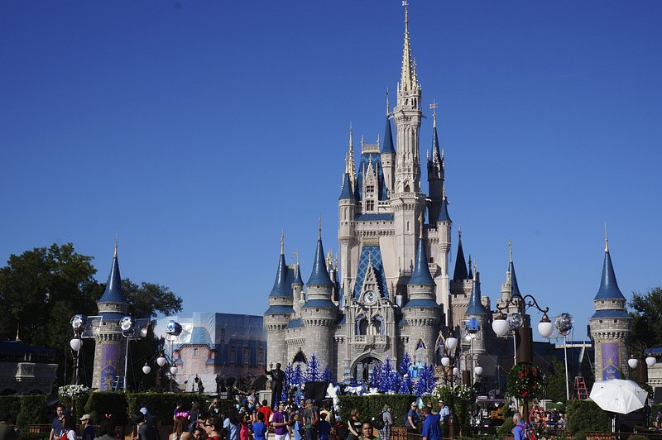
Travel was actually very inexpensive during COVID. Many people were scared to travel, scared even to leave their homes. The airline industry was hit hard during COVID. People were afraid that the closed circulatory air system in planes and close proximity to other people would spread the virus. All flights in the US were cancelled for a while. When airlines were able to open again for flights, they only sold every other seat so people would not be next to each other, unless you were traveling with a group. Airlines advertised that their filtration systems were very sophisticated and would filter out the virus. People would look at you with fear if you coughed in public, even with a mask on. Everybody wore masks everywhere. We wore masks on the plane and in the airports. Every surface was being sanitized. They would spray everything on the plane with sanitizer between flights and we were given wipes to use ourselves on the trays and arms of the seats. The same thing was true in the airports. There were hand sanitizer dispensers wherever you went. All the tables in eating areas were wiped down between customers. One good thing that happened was that everything was always clean. But my backpack also always had a supply of masks, hand sanitizer and sanitizing wipes.
Social distancing was the buzz phrase. Any line that you stood in had markings for people to stay 6 feet apart. This was true at the airports and at Disneyworld. Even in Florida, which was much less restrictive than California, social distancing was a thing. All the lines for rides in the park were marked for social distancing, but groups could stay together. The lines all seemed super long because of the social distancing, but they moved fairly quickly. People were separated on rides and the rides were not filled to capacity. The ride operators left spaces between people or groups. This gave a new feeling of personal space. Usually people are close together in crowds, but during this time you were seldom jostled in line. It was weird because you also did not interact as much with people around you in line. People isolated into their own little bubbles of perceived safety. We had to wear masks everywhere in the parks, except when actively eating or drinking. Restaurants were open and you could eat inside, which was great because it was hot in Florida even in October. Overall, it was fun to get outside of my house and be able to go and do things that were restricted in California. I enjoyed the trip and no one that I was with got sick on the trip. I was a good experience that I probably would not have been able to afford normally, but the pandemic allowed me to have this experience.

