Destiny Gabin
8/20/2021

What COVID-19 Meant for My Mother:
A Latina Small-Business Owner’s Experience in the Bronx.
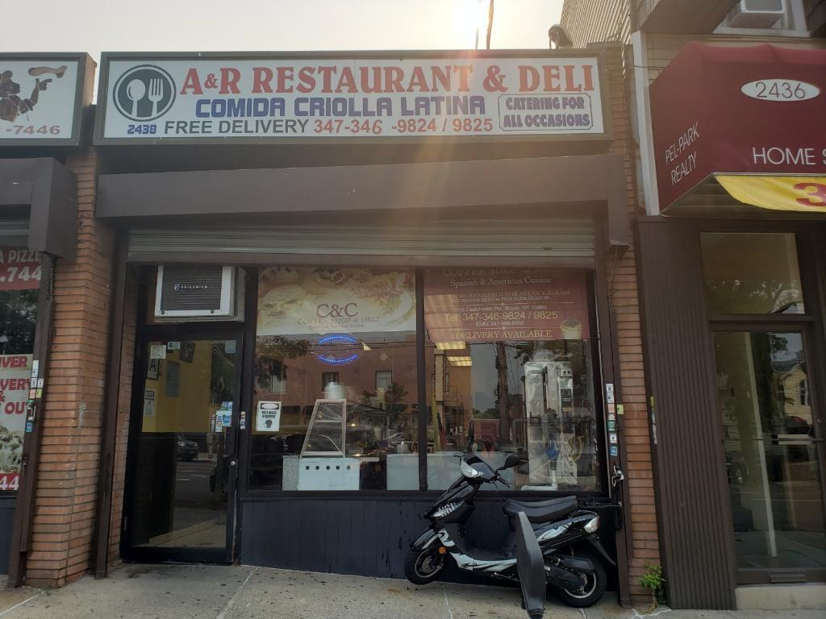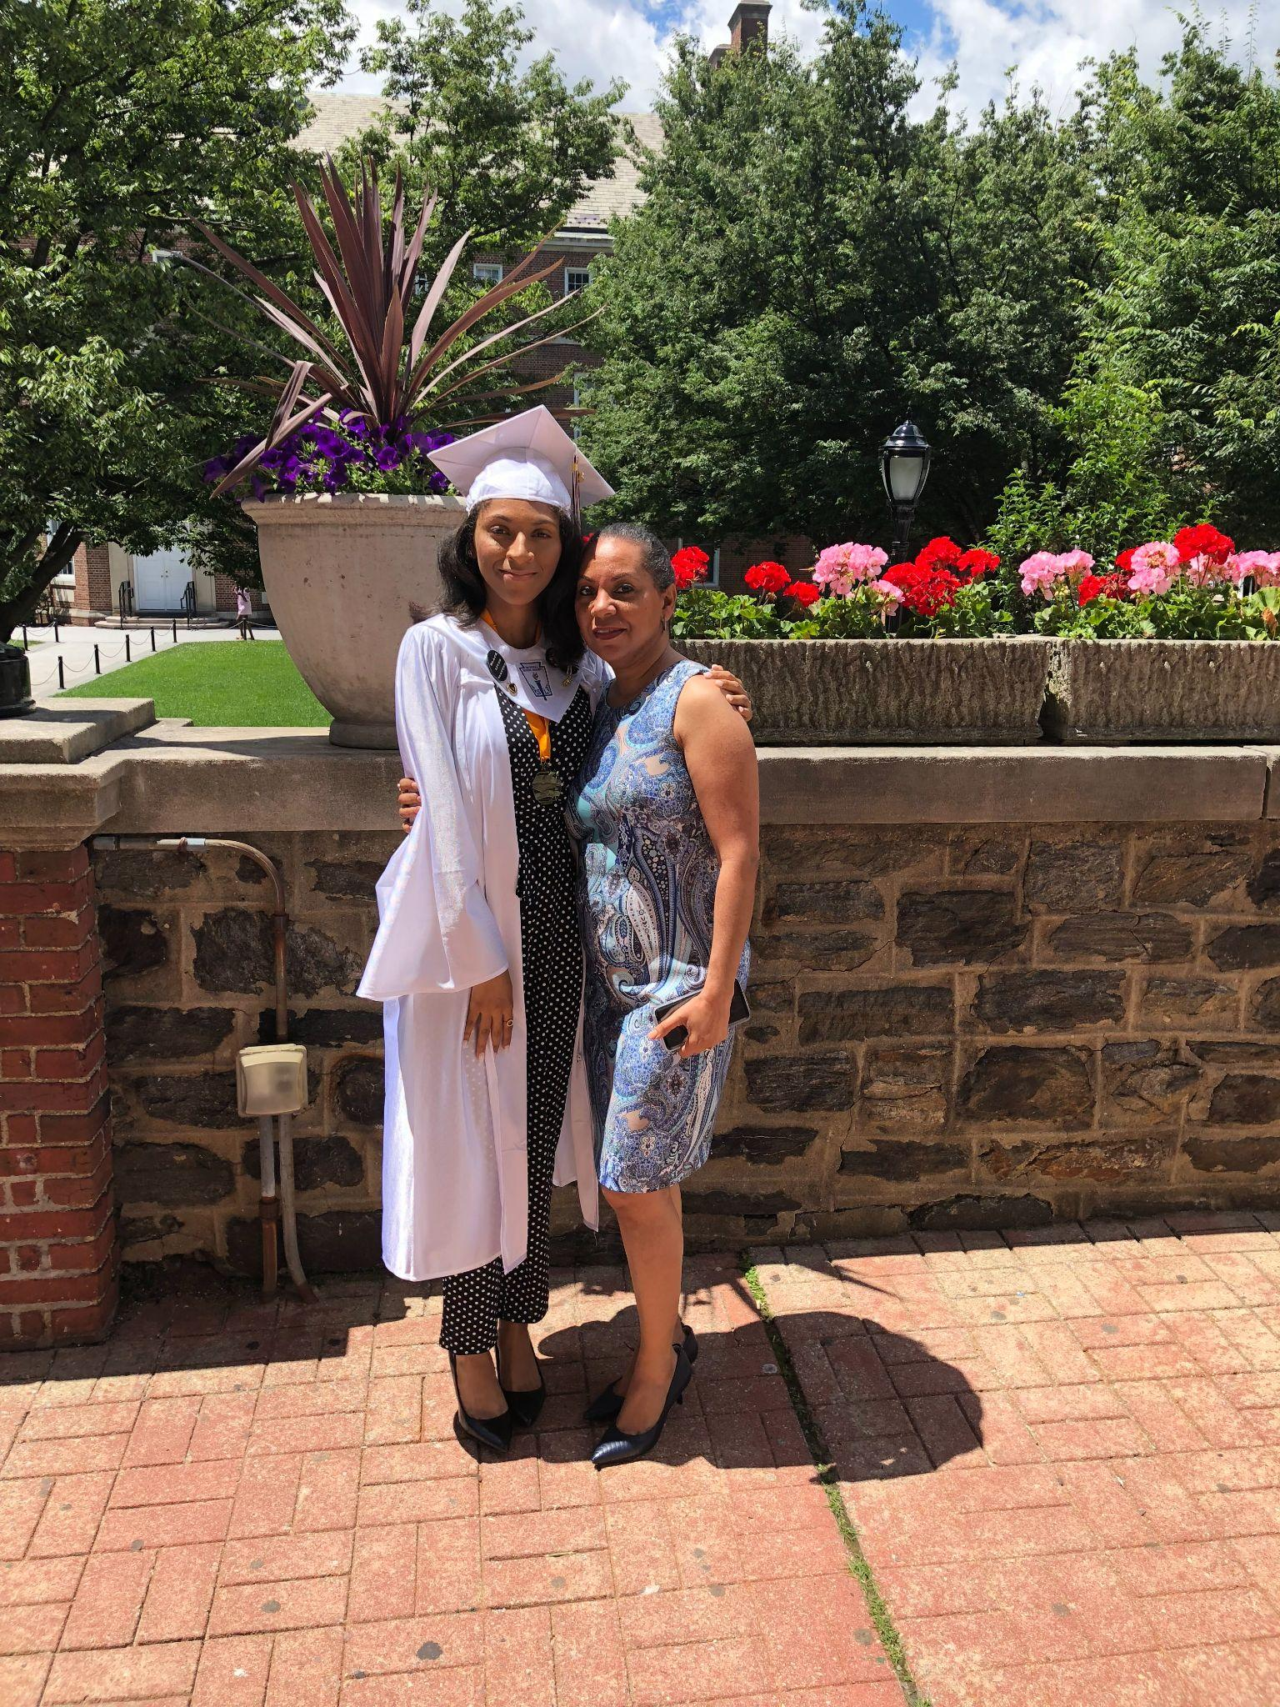
My mother is a Dominican-born immigrant who came to New York City with her mother, my late abuela, and siblings at only 8 years old. In an atmosphere much different and chaotic than the island, my mother made New York City home by finding herself in the Latinx culture of Queens. Now in her 50s, my mother and her friend Angel Segarra have worked up to own the A & R Restaurant and Deli, a humble food spot of Latin American cuisine in the Bronx.
She describes her reasoning for opening the business very simplistically; she had heard it was for sale and saw the earning potential of selling our cultural cuisine. My mother went through with it with a large and risky investment of $130,000 and bought the business on February 4th, 2019. It did fairly well in its first year. My mother explains, “It was only really making ends meet with a very small profit. Covid definitely didn’t help with that but in the first crucial year of a business that is expected anyway” (Peynado 2021). With four Latino employees, the business was open from 7AM to 7PM, 7 days a week. The customers were primarily healthcare workers from Jacobi Hospital and a nearby nursing home whose customer loyalty helped the business stay afloat. Then, just a little over a year after this small Latinx-owned business opened, a global pandemic shut the city down.
While the city officially shut down on March 13th with Donald Trump’s declaration of COVID-19 as a national emergency, my mother and Angel closed the business a handful of days prior due to the concern of the employees. She describes how “It was a rollercoaster. Everybody was panicking and the workers were very scared -considering that we work in food service with customers who are mostly employees from the hospital.” One of the employees contracted covid early on in March, which added to the understandable panic of the employees (Peynado 2021). They were afraid for their lives and rightfully so. This pandemic has been an unprecedented experience in our lifetimes already, and combined with the clientele of the restaurant being primarily healthcare workers, things were looking grim. Ultimately, the restaurant doors closed until mid-May. While brief, the impact of this shutdown was incredibly stressful not only for my mother and Angel, but for the employees as well whose only source of income was this restaurant.
When the business, fortunately, re-opened its doors in mid-May, only 3 employees returned (the fourth found another place of employment). While my mother received a grant of $9,000 dollars from the Restaurant Revitalization Program, the loss of the employee as well as insufficient funds has kept the restaurant from being open full-time. It is currently only open from 7AM to 5PM Monday - Saturday because there are not enough employees to run the business otherwise.
Despite my mother’s experience, the A & R Restaurant and Deli is a lucky one of the many small poc-owned businesses across New York City who have had to shut their doors permanently due to the financial strain of the pandemic that nearly everyone has felt. Given the rapid gentrification of New York City as well as the food swamps in predominantly Black and Latinx neighborhoods, maintaining businesses owned by people of color, like my mother’s, is vital to preserving the culture and financial independence of our neighborhoods. However, not only has the physical ailments of covid disproportionately impacted Latinx people, so too has its financially devastating effects.
Prior to the pandemic, the wealth gap across racial and ethnic lines has been as American as apple pie. According to data from the Survey of Consumer Finances, in 2019 the median wealth of Latino families was $36,000. Compared to the median wealth of white families being $189,100, these disparities exemplify the pre-COVID context of financial inequality for Latinxs in the U.S. (The Federal Reserve 2019). This prior context explains the data released by the Bureau of Labor Statistics showing unemployment rates by race during the pandemic. The data demonstrates that, at the spike of unemployment in April 2020, Latinxs had the highest percentage at 18.9%, compared to 14.2% of white unemployment (“Racial Economic Inequality” 2021). Both studies show that racial inequality was exacerbated by the pandemic, which in and of itself does not discriminate but -when applied to a system which uplifts whiteness- has very different impacts on different kinds of people.
When my mother had to temporarily close the restaurant’s doors, she turned to what millions of people across the country turned to in 2020, government assistance. Specifically, my mother applied for the Payroll Protection Program (PPP). However, despite being the owner of a fairly new small-business in need of the assistance, she did not receive any the first time she had applied. Unfortunately, she was not alone in her experience. From the Stanford Latino Entrepreneurship Initiative, researchers Marlene Orozco, Inara Sunan Tareque, Paul Oyer, and Jerry Porras surveyed a sample of 7,000 Latino and white business owners as well as closely studied 19 Latino-owned businesses to see how covid-19 impacted them between March and June 2020. They found several alarming, but personally unsurprising, results.
Firstly, they found that Latino applicants for PPP loans were approved at half the rate of their white counterparts. Moreover, those who did receive funding received a smaller proportion of full-funding than white-owned businesses (Orozco 2020). The day-to-day operations of Latino-owned businesses were also particularly negatively impacted by the pandemic. Researchers from the Journal of the American Medical Association studied 10 major cities across the U.S, including New York City, and found that “in counties where the population was substantially non-white with a median income defined as $60,240, the COVID-19 death rate was more than nine times higher when compared to counties that are substantially white with the same median income” (Adhikari 2020). This higher death rate may be accounted for, in part, by the lack of “work from home” options for low-income Latinx business owners and Latinx employees. The Stanford study also found that, among those they surveyed, only 28% of Latinx-owned businesses have a majority of employees who can work from home. In contrast, white-owned businesses were at 44% (Orozco 2020). Given the lack of PPP and inability to work under safe conditions, many Latinx-owned businesses have either had to cut their hours or shut their doors in the beginning of the pandemic, either temporarily or permanently. For many Latinxs across this country, the businesses they own or the Latinx-owned businesses they work for are their primary source of income. This is true of the Latino workers at my mother’s business. She too had to cut hours, lose employees, and temporarily shut down the business because of the systemic faults with the distribution of assistance as well as obvious health concerns. The U.S was already failing at ensuring the American Dream equally, but the pandemic has brought to light how deeply ingrained these failures have been.
It is clear that mother and her employees are one of the lucky few who made it through this and I am indescribably grateful for the survival of the business and, more importantly, the health of my mother and the employees. My mother is a person with a lot of gratitude for the good things in life, which I admire her for. While talking with her, she recognized how fortunate she has been and said, "I thank God the government helped and that we were helped because a lot of businesses unfortunately -you know- didn't get the same” (Peynado 2021). With all of her gratitude, she is also very reserved about the hardships. She has always been reserved about hardships in general, covid included, but I watched that shield forced open. March 2020 was the first time in my 19 years of life that I saw her visibly afraid; for the business, for our family, and for herself. Her fear stemmed from her severe psoriasis, an auto-immune disease. Her doctor had stopped prescribing her medication for it back in March of 2020 because the medication represses the way the body fights infections. Given this circumstance and her age, my mother is very high-risk for covid. In March, she gathered myself, my brother, and my sister, to discuss what to do if she and my father were to get it and pass away. My father is also high risk because he is 60 years old, has asthma, and has an obstructed nose due to it healing incorrectly from being broken years ago. We made plans with how to handle paying off the house, our inheritance, and what would happen to the business. It was the most frightening conversation I have ever had in my life. She was too young to die and my siblings and I were too young to have a dead mother. I am still heavily financially dependent on my parents so, not only would I have lost the two people I love most in the world, my life would have been completely transformed for the worst in that I would have to halt going to law school to take care of what was left behind.
My family is lucky it has only been a conversation, unlike so many children who have had to bury their parents too early in 2020. Now that she is vaccinated, she can take her medication again after over a year. My mother is unbelievably fortunate to have never contracted covid because it certainly would have been a death sentence for her. She could have just as easily been another statistic in the disproportionate number of Latinxs dying to the virus. However, the very fact that her experience is considered “lucky” in comparison to the larger demographic patterns speaks to a uniquely American fault to how not nearly enough has been done for communities of color in this time.
To make a better America for us all, not only in extreme times such as the current moment, but for the day-to-day struggle of low income people across the country, we need to take the losses we’ve had to COVID and turn them into some kind of change. There has been much frustration with how this virus has paused our lives, destroyed many, and how- more than anything- people want to go back to normal. Also being discussed is the fact that normal still never worked for most of us. Our pre-covid normal was the foundation of the exacerbated hardship low-income communities of color are now experiencing. Beyond momentary band-aids of loans and stimulus checks, what is truly needed is equitable systemic change. Primarily, for the context of how the covid has mostly impacted health and wealth, increasing wages to match the increased inflation over the last several decades as well as universal health care must be a part of our new normal post-COVID. People were barely staying afloat in “normal,” covid only pulled them under to drowning. If we go back to how we were, something else will come where we will drown again.
Work Cited
Adhikari, Samrachana. “Community-Level Disparities in Covid-19 Infections and Deaths in Large Us Metropolitan Areas.” JAMA Network Open, JAMA Network, July 2020, jamanetwork.com/journals/jamanetworkopen/fullarticle/2768723?resultClick=1.
Orozco, Marlene, et al. “The Ongoing Impact of Covid-19 on Latino-Owned Businesses.” Stanford Graduate School of Business, Stanford Latino Entrepreneurship Initiative, Aug. 2020, www.gsb.stanford.edu/faculty-research/publications/ongoing-impact-covid-19-latino-owned-businesses.
Peynado, Rosa. Personal Interview. Jun. 2021.
“Racial Economic Inequality.” Inequality.org, Aug. 2021, inequality.org/facts/racial-inequality/#racial-inequality-covid.
The Federal Reserve. “Survey of Consumer Finances.” Board of Governors of the Federal Reserve System, 2019, www.federalreserve.gov/econres/scfindex.htm.

