Brennen Johnson
Dr. Rhodes
HIS103A
30 November 2020
Pandemic to Historians

2020 is a year that historians will need a course to unfold everything that has happened. Social unrest due to social injustice was a headline. COVID-19, the election of 2020, and the rise of social movement Black Lives Matter. This year started with the acquittal of President Donald Trump and the death of NBA legends David Stern and Kobe Bryant. Within the first week of the new year, Iranian General Qasem Soleimani was killed in a United States drone strike. The World Health Organization was notified of the Novel coronavirus. While social media platforms are prevalent throughout the world, the differences of opinions and the general conspiracy theories spread rapidly.
Prominent leaders such as Donald Trump shared obscene cures to the virus, denouncing masks throughout the united states. Leaving more than 200,000 Americans dead, hospitals over capacitated, cycles of state and local shutdowns. While many Americans were in quarantine stocking up on toilet paper and Lysol wipes, adversity hit when sports, entertainment, and social gatherings came to a halt. While being stuck in the house, and the only communication was social media, more people shared their views on the pandemic and state and government officials’ handling. While many supporters of the President followed along with his tweets and briefings, downplaying the virus. Americans went on without a care for themselves and others’ health. May 25th, while many are still in their house, stopping the spread. A video surfaced of a Minneapolis police officer Derick Chauvin kneeling on 46-year-old African American male George Floyds’ neck for 8 minutes and 46 seconds. Police were called for an alleged $20 counterfeit bill, leading to Floyd’s hateful lynching while being taped by civilians. The Video spread rapidly throughout the world, prompting many supporters of Mr. Floyd and supporters of the defense of the cop who killed him. As the video shown on news stations, riots throughout the country erupted, looting of business and voices of the unheard were taking place, chants and posts of ‘Black Lives Matter’ were being heard the world. While many were outraged about the murder, many others were outraged by the response to the murder calling the movement of BLM “Burn, Loot, Murder” as the description to Black Lives Matter.
Pre-Columbian America, as shown below, shows the feelings of the Natives towards the government. As indigenous were in North America thriving with communication, crops, the infrastructure of houses and families. Before the Government was formed, and before Christopher Columbus showed up. Indigenous people were succeeding until inundated by Europeans. The Columbian exchange spread animals and new diets across the globe. Violence, Culture, trade, and people were among the business. The most significant transaction was the diseases brought over from Europe. 95% of Native Americans died from disease brought over. Natives have been forced westward, moved to reservations, and ultimately disrespected by the United States. Today we mark Columbus Day as the day Christopher Columbus discovered America, disregarding the Indigounes group already present.
The Second Great awakening experienced a response to powerful intellectual and social currents. There were conservatives were did not want social change, including “The market revolution, western expansion, and European immigration all challenged traditional bonds of authority and evangelicalism promised equal measures of excitement and order. Revivals spread like wildfire throughout the United States, swelling church membership, spawning new Christian denominations, and inspiring social reform” (The American Ywap). Modern-day has conservatives like the ‘old way’ that benefit them and their religion, race, and way of life. Change and hope for a better America are patriotic, unlike wanting to help a group of people. All groups of people want a better experience, and stopping others, going to meetings to organize others from creating change is oppressive.
“Bury me in the ocean, with my ancestors that jumped from the ships, because they knew death was better than bondage”(Erik Killmonger, The Black Panther). America’s enterprise was built off of the backs of hardworking Africans kidnapped and brought over by ships to the Americas and sold as property. While being transported, many died from lack of nutrients, living conditions from the long voyage. They were tossed overboard. When arriving in North America, Africans were slaves—working outside picking cotton and raising the capital of their master while getting next to nothing in return. If the job were not sufficient, slaves would be whipped, beaten, and even left without food. If slaves tried to escape, slave catchers would be waiting for them, returning them to their master, or killed. It sets up the scene of police brutality today. Widespread media that is accessible to almost everyone shows the repeated acts of police officers abusing power. After slavery, African Americans were just let go out and try to start a life, forgetting about slavery.
In contrast, their masters would be wealthy because of the free working Africans. African Americans had to start a life without any education or capital. While still being seen as inferior.
History is the only thing we have to learn from; past mistakes, successes, and trends can help understand why we are at the place we are today. Many people use historical events to compare and to prevent a mistake doubling. Social media and posting our thoughts are very freeing, and while many agree and many will disagree, history is not changing. Still, if we understand how we got here throughout history, we won’t make infamous decisions that are highlighted in future textbooks.

https://www.independent.co.uk/news/world/americas/us-election-2020/trump-garden-state-parkway-new-jersey-2020-maga-trucks-b1509844.html. (3&4 Religion and Reform)

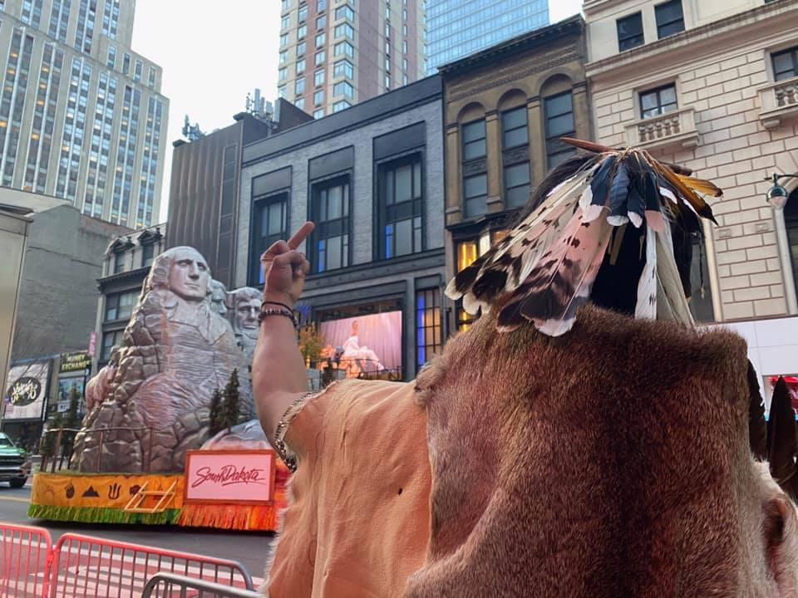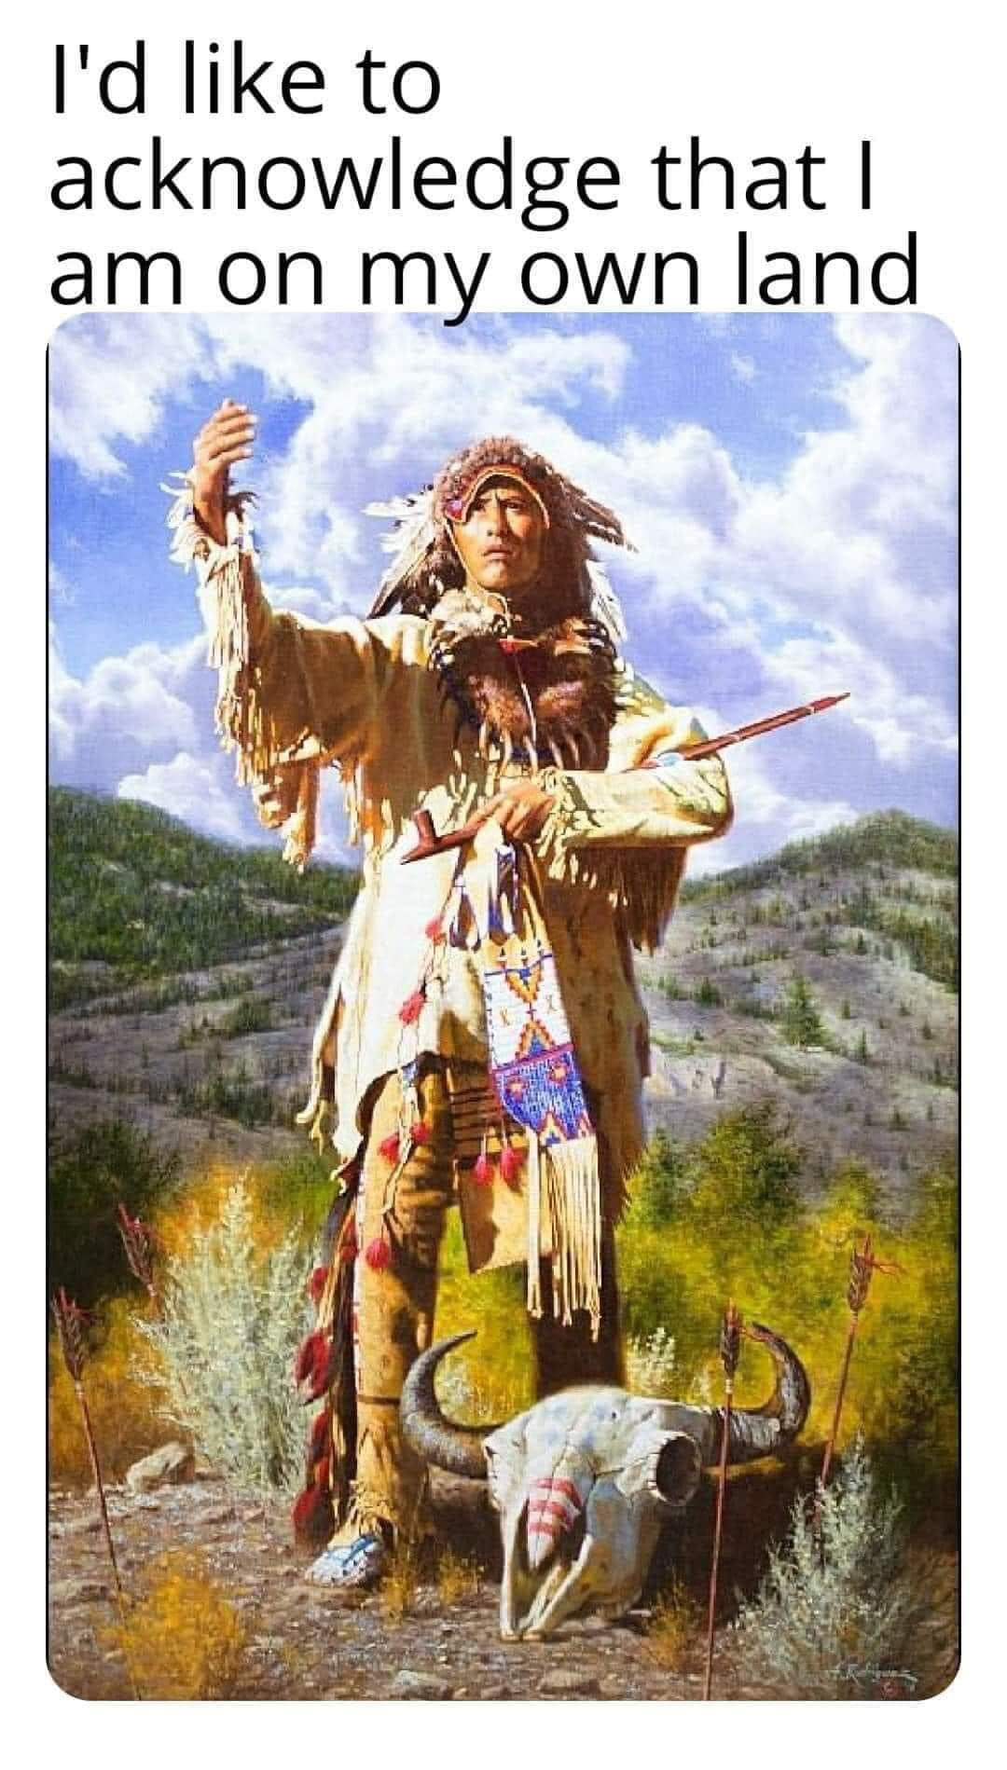(1&2 Pre Columbian America)
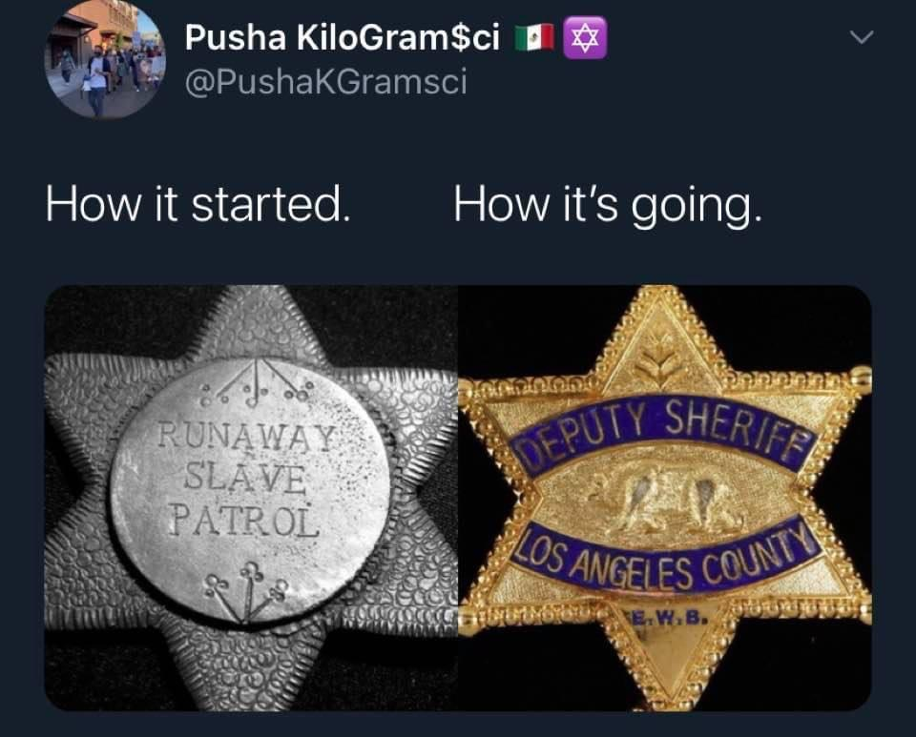
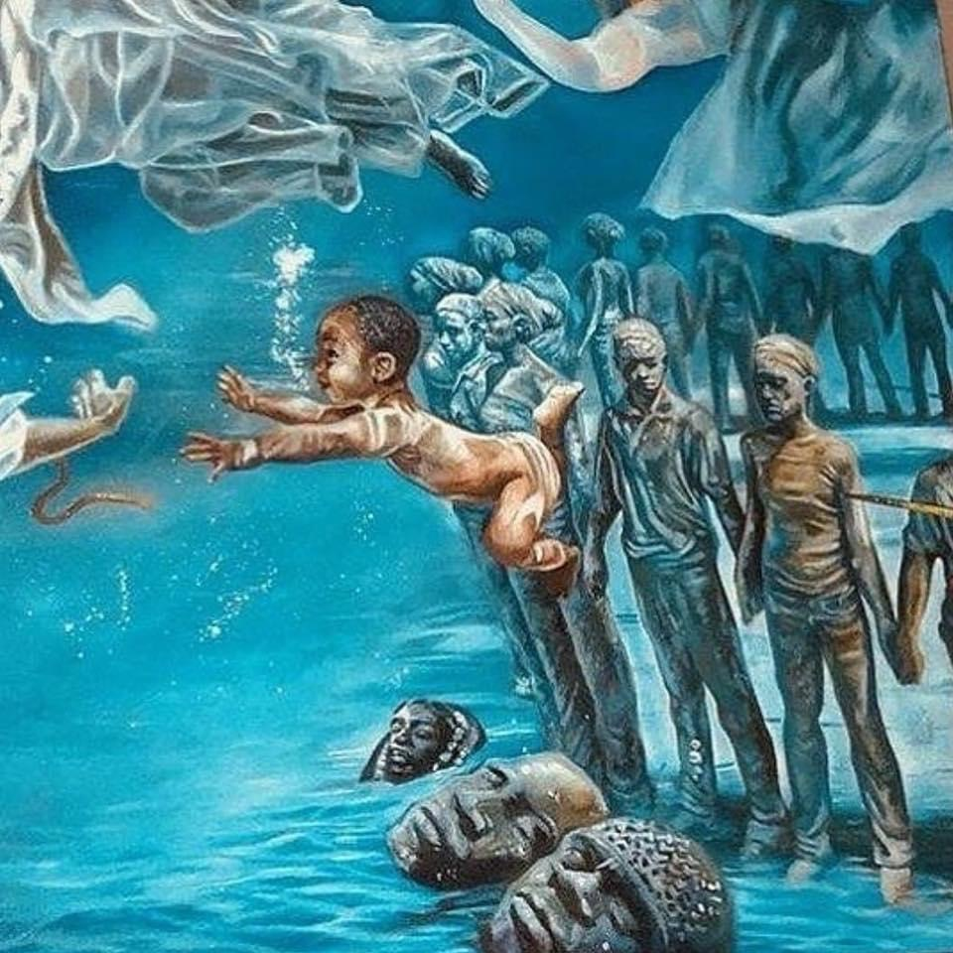
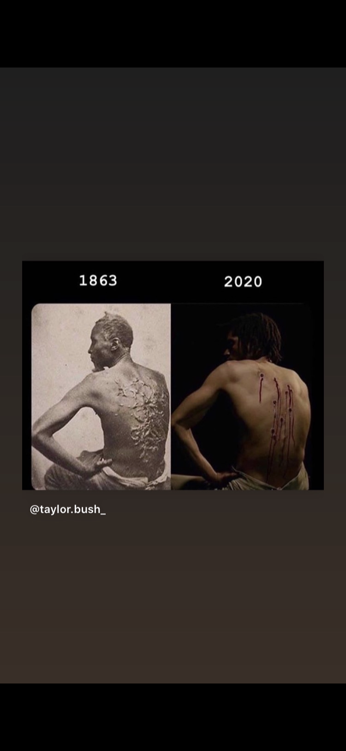
(5&6 Cotton Revolution)

