Translation of item number 9911 by Angelica S Ramos done 06/30/2021

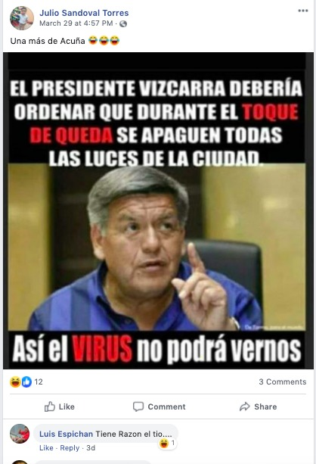
Julio Sandoval Torres
“One more than Acuna”

The president should order all the lights in the city to be turned off during the stay at home order so the virus wont see us

Luis Espichan
Uncle has a point…

