Hiromi Hashide
CORE 200.04
Unit 3
May 16, 2022
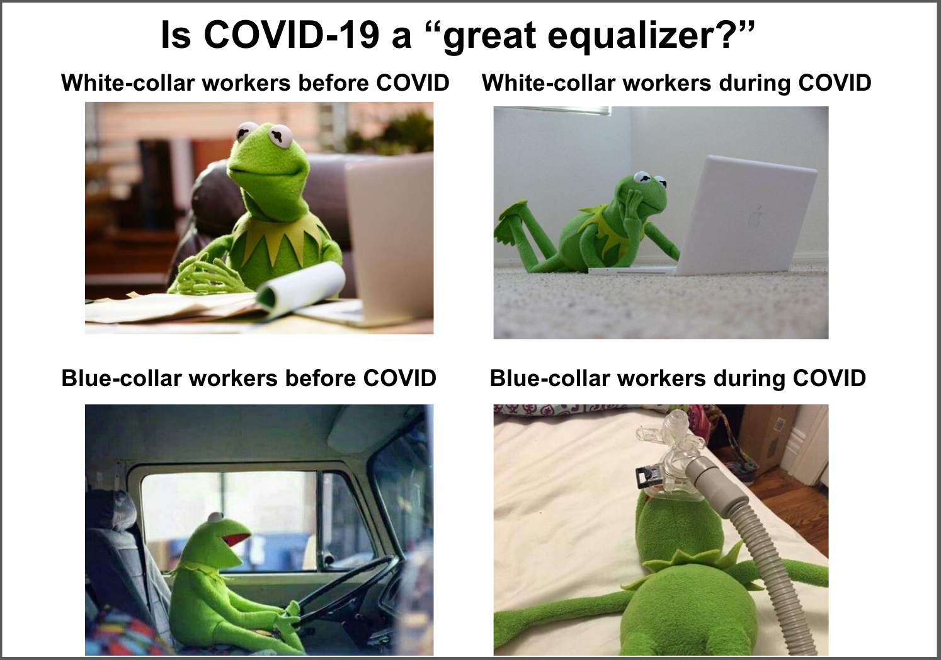
This meme is intended to answer the question, “Are pandemics the “great equalizers” in terms of social inequalities—do they level the playing field?” with the example of COVID-19. The answer should be “yes” because, on the surface, everyone in the world equally has the chance to contract COVID, regardless of race or social status. However, a deeper look reveals that the answer is “no,” and that the socially vulnerable are more exposed to the dangers of COVID. For example, during quarantine, students or some white-collar workers, including educators and office workers, did not have to go to schools or workplaces and were able to learn and work from home. On the other hand, many blue-collar workers, including bus drivers and construction workers, were forced to work in their workplaces as they had before the pandemic. Therefore, they could not avoid contact with people and were at risk of COVID.
The meme represents such contrast between white-collar workers and blue-collar workers. The frog, the bus driver, is on the verge of death because he got COVID from one of his passengers. In contrast, the frog, an office worker, is enjoying working from his home. The intended viewers of this meme are those who did not experience such inequalities under the COVID crisis. This meme does not want the viewers to simply notice the difference in COVID risks created by occupations. Instead, this meme illustrates the vulnerability of various members of society who were not able to escape the risks of COVID infection because of race, social status, and nationality.
The wealth status of an individual was also influential because poor people were more likely to contract COVID because many of them lived in the inner city and were blue-collar workers. Moreover, in A Journal of the Plague Year, Daniel Defoe, describes how the poor are vulnerable to the plague.
It is true a vast many people fled, as I have observed, yet they were chiefly from the west end of the town, and from that we call the heart of the city: that is to say, among the wealthiest of the people, and such people as were unencumbered with trades and business. But of the rest, the generality stayed, and seemed to abide the worst; so that in the place we call the Liberties, and in the suburbs, in Southwark, and in the east part, such as Wapping, Ratcliff, Stepney, Rotherhithe, the people generally stayed, except here and there a few wealthy families, who, as above, did not depend upon their business. (p. 6)
Due to the spread of the bubonic plague in London, many people tried to evacuate the city. However, only a few limited and wealthy people could do so. They survived without working in the area because of their assets and other resources. On the other hand, many poor people were employed, and leaving the workplace meant losing their source of income. They also did not have enough assets or money to move to a new location. Therefore, they could not leave London, even if it was dangerous. As a result, many poor people contracted the plague and died.
The meme also encourages the audience to realize that there are differences in risks to COVID not only on an individual basis but also on a national basis. For example, while many people in the U.S., were able to receive booster shots, in many African countries, including Burundi, COVID vaccination rates are low, and there are many people who have never received COVID vaccinations. People in such developing countries are even more at risk from COVID than people in developed countries.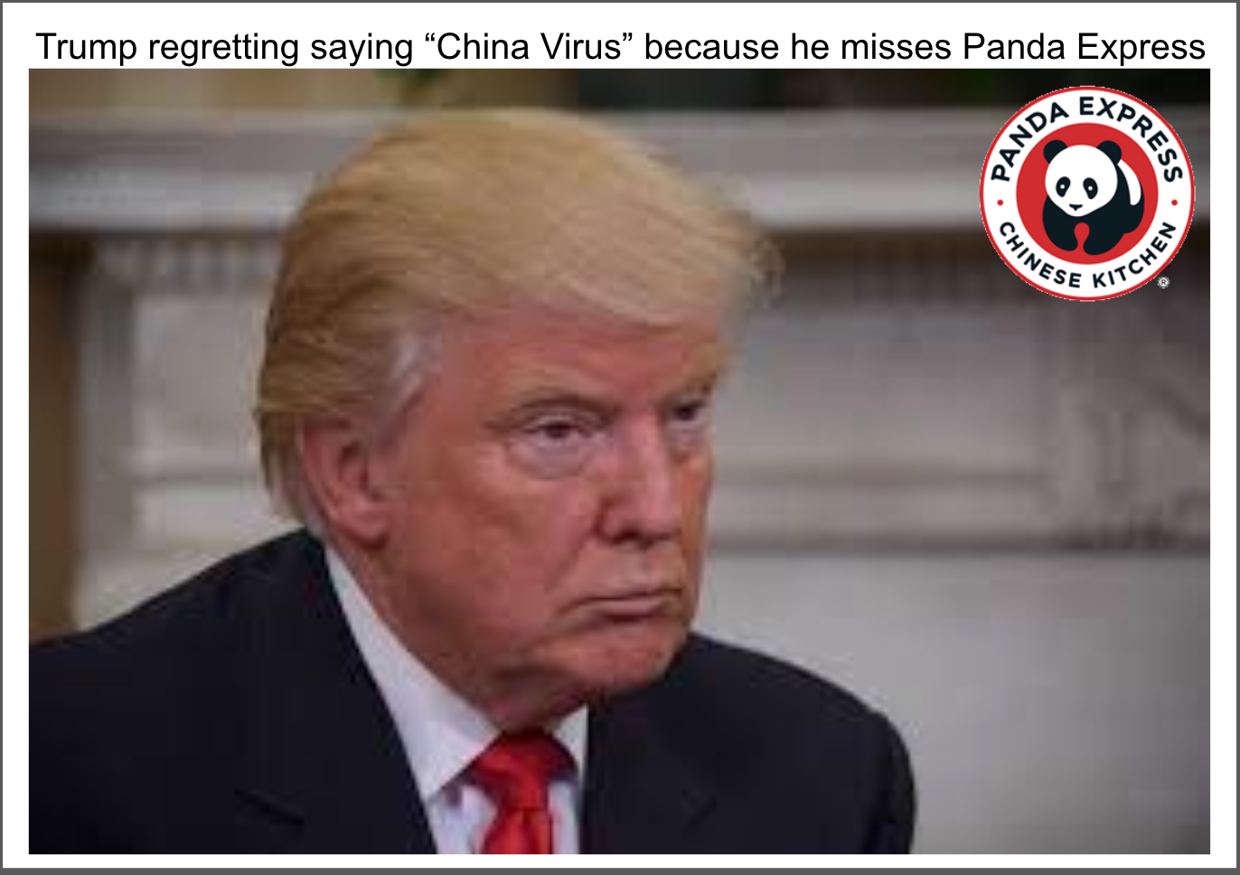

The second meme is intended to answer the question, “Have you observed any patterns of human behavior with the Covid-19 pandemic?”, and its intended audience is Americans who are not aware of how and why Asians have been scapegoated. Former President Trump called COVID the “China Virus” and fueled people’s hatred of Asians. This meme tries to remind the audience of his negative remarks but in a humorous way without offending Asian populations. It also illustrates how words can magnify feelings of racism, fear, and uncertainty, which can result in scapegoating. This meme gives the audience an opportunity to learn more about the unfair treatment of Asians during the pandemic and why it happened.
During COVID, in the U.S., Asians and Asian Americans were made scapegoats. The term “scapegoat” is the unfair blame towards a group of people or individuals. Although Asian people do not have any responsibility for COVID, many people blamed Asians without valid reasons. Asians have been subjected to a variety of abuses, including being told to “go back to your country,” being assaulted, deliberately avoided by people, and denied access to public transportation. In March 2021, six women were killed in a shooting at an Asian massage parlor in Georgia.
These irrational treatments of Asians have long been practiced in the U.S. In the 1870s, local health officials told citizens that Chinatown spread any epidemic that ever broke out in San Francisco, and the Chinese were made medical scapegoats. For example, many Chinese were quarantined, and their houses were destroyed without permission. Chinese immigrants were banned from entering San Francisco.
One of the reasons why the Chinese were scapegoated was because Whites tried to protect their employment opportunities. According to Trauner, “Proposals to quarter the Chinese outside of the city limits of San Francisco were advanced at this time, primarily under the sponsorship of the Anti-Chinese Council of the Workingmen’s party” (p. 74). He also states that there was “the economic argument, as advocated by nativist and workingmen's groups, that cheap Chinese labor undermined wage rates and adversely affected employment practices on the West Coast” (p. 72). This means that under the guise of protecting themselves from the epidemic, Whites segregated the Chinese from society to ensure their own employment.
Another reason for scapegoating was racism. According to Trauner, “by the 1860’s the Chinese were considered to be ‘an inferior race’ and a ‘degraded’ people. By the 1870's, the racist argument had broadened in scope, and the Chinese were viewed as ‘a social, moral and political curse to the community’” (pp. 70-72). This stigma against the Chinese spread because White people wanted to maintain a homogenous population and believed that intermingling with the inferior race would ultimately debase society. These prejudices resurfaced during the pandemic because former President Trump began calling COVID the China Virus, which encouraged people to scapegoat all Asians.
Another cause was fear and uncertainty. In times of epidemics, many people felt fear and struggled with the anxiety that came from uncertainty. In order to cope with such negative feelings, people blamed stigmatized people. For example, some people gained a sense of security by avoiding stigmatized people, whom they believed had viruses. Blaming and scapegoating gave some people a sense of control and certainty during the pandemic.

