Interviewer: Lyn Ribisi
Interviewees: Adelaide “Addy” Posner and Eloise “Ellie” Posner
Addy is 13, Ellie is 10
Location: North Hollywood, CA
Date: July 17 2020

Abstact: Adelaide and Eloise Posner are two sisters. Ellie is 10 and Addy is 13, going into 5th and 8th grades. This interview was interesting because their reaction to the Coronavirus was the exact opposite to the adults I’ve interviewed. The adults were really scared at first, but these kids were happy to get away from school for what they thought was a few weeks’ vacation. Then it turned into boredom and wanted to get out of the house and back to Disneyland and seeing their friends. Although they were looking forward to online school, they ended up being distracted at home and often handled their phones or got up instead of focusing on school. Ellie, the younger sister, felt that her teacher just gave up trying to teach by the end of the year.
Also, Ellie found that she wasn’t getting to sleep until 3-5am every night. She didn’t like this, but felt it was because of lack of structure of having to get up early for school in the morning. She is trying to adjust back to a more normal sleep schedule, but she keeps getting distracted by playing games on her phone. She was concerned about her screen time—feels it should be about 7 hours a day, but now it’s much more. Addy had a solution for only having screen time. She said to combat that think of an outdoor activity—even if it does involve the phone.
They both miss their friends and socializing
Addy really enjoys her animals now. And they both have enjoyed spending more time with family. Addy said that being with the animals are one of the good parts of being home. She also expressed the idea that humor is important to help people smile a bit in these times. Humor makes you feel like you can handle things more and makes the virus seem less scary. And she feels that if you find something funny, you should pass it on to help make someone else smile.

START OF INTERVIEW
Ribisi: (00:01):
All right, ladies, I'm here now to talk to you about the Corona virus period that we're all living through. I have sections of questions versus the background, and then I have some questions about your activities and what you, what you find funny during this time. Okay. Okay. All right. So let's do the background first. Why don't each of you say your names and your ages,
Ribisi: Ellie. Okay. [both laugh] Okay. Eloise, you go first. Maybe we should restart. Yeah, I guess. Well, okay. Restart you said? Yeah. Okay.
Ribisi: Okay. So I'll say your name after the question. I'll call on you. Okay. I'll just say your name. Alright. Alright. So we're going to be doing an oral history interview about this Corona virus time that we're all experiencing. And I really wanted to get information from kids because kids are very often neglected in their voices are not heard very often. Okay. So, all right. So Eloise, why don't you state your name?
Eloise: (01:20): My name's Elouise and I am 10.
Ribisi: Okay. And what's your last name?
Eloise: Posner.
Ribisi: Okay. And then Addy, I'm Adelaide Posner, and I’m 13.
Ribisi: (01:31): Good. Okay. All right. And where do you live? What town?
Addy (01:36): North Hollywood.
Ribisi: LA?
Yeah. LA North Hollywood. Both of your sisters then, right? Yes.
Ribisi: Okay.
Yes.
Ribisi: (01:45): Alright. So what kinds of things did you do before Corona virus came?
Addy: (01:51): Well a lot of times I was very focused on school because especially before homeschooling, there was a lot of work to do. And, but other than hanging out with my friends and going to school, my activities haven't changed that much. Cause I've always been a bit of an indoor person, but I do know that like, especially Ellie, she loves being out of the house and being with her friends. And of course I do too, but I've kept a lot of the same hobbies.
Ribisi: (02:23):
Okay. And Ellie, how about you? What did you do before Corona?
Ellie: (02:28): Before the Coronavirus, I would go to school. I’d hang out with my friends and have a lot of sleep overs. I'd go swimming at my friend's house. I unintelligible] cause we do have a pool in our backyard. I did go on vacation a lot. We'd go to Disneyland. They'll just a lot of, we’d just go a lot of places every day.
Ribisi: Yeah, that's for sure.
Eloise: Like we go to the shows after school, but now it's just really indoors.
Ribisi: (03:07): Tell me about school now. I know it's summertime, but how was it at home?
Addy: (03:14): Personally I think both of our schools could have handled it better. Cause it was such like a sudden change. And at first they only thought we were going to be home for two weeks, so they weren't really planning for the long run, but it was such a sudden change and a harsh one too. So it wasn't necessarily… they didn't really have much time to prepare or change it in the middle of it. So the experience was not necessarily ideal, even though I got the work done, communication was kind of hard and scheduling things.
Ribisi (03:51): Okay. What, sort of communication was difficult?
Addy (03:55): Well we were just kind of doing everything over a website and especially compared to actually being in school where you can flat out, ask the teachers. [Now] you have to like email them or message them through the website we were using. And oftentimes it would, they got tons of these emails and it would either take them a while to respond or there'd be technical issues or something like that.
Ribisi (04:21): Right. Okay.
Ribisi: And Ellie, how about you at homeschool? How did you, how did you like it at first? How did you adjust? What was it like for you?
Ellie (04:29): It was a hard because we didn't fully understand how it's going to work and like Addy said, communication problems. So it did take me like eight hours every day, probably more, to finish school
Ribisi: Really? Wow. And before it would just take, well your school day, but you'd have a lot of breaks and all that.
Addy (04:47): Well, it was also really difficult because especially around the house, there are so many things to distract us and so many things we could be doing instead, like at school, you are at a building made specifically for learning and you don't have like your phone with you or anything like that. So it was difficult a lot of times. It took longer because I would get distracted by other things or I'd start, my mind would be wandering. Cause I don't have a teacher to like keep me in check and stuff like that.
Ribisi: Totally. Did you notice that too Ellie?
Addy: Well, yeah, definitely. Like a lot. I would always just randomly get up and stall like going on my phone, I'll just stop drawing. It was very hard to keep my focus.
Ribisi: okay, I understand that. Now have your feelings changed about COVID-19 from the beginning till now?
Addy (05:55): Mine kind of have, because at the beginning it was more like, I was like, I don't understand why everyone's so sad about this. Like it's like a nice break from school and I do miss my friends, but it won't be for too long and stuff like that. But as it goes on and like I'm getting more antsy and home and I really just want to get out and see my friends. But like as time goes on, I'm getting really sick of having to just stay at home and not being able to do the things I used to do. And especially like it's even more sad on like the news and stuff. Like at the beginning it was more like this crazy new virus and everyone has to stay home, but now it's like, everyone knows about it and it's just more about like people dying and it's kind of sad.
Ribisi (06:51): Yeah. I understand. How about Eloise? What about you? Have your feelings changed since the beginning?
Ellie (06:59): Definitely. At the beginning I thought people were being like overdramatic about it. I thought that it's going to be like an nice break from school. I was really excited to start the online schooling and home schooling. And now it's kind of, it's just getting really boring and it's affected me a lot. Like it's affected my sleep. I've been staying up really late because I don't have to wake up at like 6:00 AM anymore to go to school and all of that stuff.
Ribisi (07:41): Yeah. How late do you end up staying up? Usually?
Ellie (07:45):Three to 5:00 AM.
Ribisi: What? Three to 5:00 AM? That’s about when I get up.
Ellie: Yeah
Ribisi (07:50): How about you Adelaide? Do you go to bed earlier?
Addy (07:56): Oh well for a long time, this is also like kind of relating to the question. Cause for a long time I was adjusted to my school schedule and I did have like a good schedule, but especially over summer vacation where I don't even have to wake up early to start online school. I have been going to bed later too.
Ribisi (08:23): As late as it's your sister?
Addy (08:26): No, not quite as late.
Ribisi: She pulls all nighters,huh?
Addy: Yeah, probably like 2:00 AM.
Ribisi (08:35): Wow. Eloise did you want to say something else?
Ellie (08:39): Yeah. I have been fixing my sleep because I'm, I want to get it better. And my, and I've been trying to get to bed by 12, but ends up being more like 3 because I don't know. I get very easily distracted and I ended up spending hours on my phone. It feels like 30 minutes.
Ribisi (09:02): Wow. Yeah, those phones are distracting. I understand. Even for us grownups. [cat comes across the video screen. Super close up of its eye.] Oh, there's your cat. Okay. Now let me go into the subject of this interview is about funny things about humor. So what what's made you laugh during this period?
Addy (09:24): Now more than ever. I've been watching a lot of like YouTube and stuff like that. And it's gotten to a point where it's not some scary news. It's not like a huge, scary thing and people are kind of joking about it. And so kind of makes it's kind of better to have a little bit of humor, like not too much, cause it was a serious issue, but to take people's mind off of it, it is better to have like some humor about it or even just humor in general.
Ribisi: Why?
Addy: because like it's such a big, serious kind of scary thing. And when you joke about it, even like, I'm not saying like make it seem like less of an issue. I just mean like if you're joking about it, it kind of makes it seem like something we can handle more and something that we don't need to be constantly scared of.
Ribisi (10:25): I totally understand that.
Ribisi: Ellie. How about you? What are you, what have you been able to enjoy and laugh at?
Ellie (10:34): Well first of all, when it [Coronavirus] was first starting people were like posting like small little jokes about it. And nother thing I kind of laughed at as how my teacher, she kind of just gave up at the end of the school year, which it's also kind of like sad, but it's kind of funny as well because she just kind of didn't care anymore. Oh, wow. Yeah.
Ribisi (11:11): Okay. Do you remember, Adelaide, what do you watch? Youtube videos? Like you said, YouTube videos, anything super particular that you like that makes you laugh on YouTube or on media?
Addy (11:23): Not anything super particular. I do like commentary videos, like especially ones about funny things, not necessarily serious ones, but funny commentary videos. I've always really liked.
Ribisi (11:39): Do you remember anyone that, any particular people that you follow that you liked?
Addy (11:46): Well there are people like Drew Gooden, Danny Gonzalez, and Jarvis Johnson [all on YouTube]. They kind of do stuff like that. And I do like those.
Ribisi (12:00): Okay. All right. How about you Ellie? Anything specific that you like to watch that are fun?
Ellie (12:07): Well, I was exploring stuff to watch on YouTube doing Corona just right now. And I found this Youtuber. It’s called Roblox.
Ribisi: It's a blog you said?
Kids: Roblox.
Ribisi (12:30): Rodblox, right. Okay.
Ellie (12:33): He's really funny and I really enjoy his videos.
Ribisi (12:39): Cool. Have you noticed that your TV viewing has changed or is it been the same?
Ellie (12:49): Well, if you mean my screen time hours they definitely have changed.
Ribisi (12:55): Tell me about that.
Ellie (12:57): Well, I'm definitely on my screen a lot more. So I'd say that like my screen time should be maybe eight, five, eight, seven-ish hours. Now it's like 11 hours per day. Like that's my average.
Addie: I'm going to say that hers is very extreme and mine is not that much, [laugh] but it has gone up because there's only so much you can do now that you can't like get out of the house and even still when you would get out of the house, it'd be like a social recharge, but it's really, those are really few and far between, so it's kind of hard to find things you really want to do. And a lot of time I end up watching a show or just going on my phone, but I think a good way to combat this is first of all, to like find something to do outside, even, even if it does have a screen to do with it, it's still a step in the right direction. Like sometimes if I can't think of anything to do, but I, I still want to go outside. Sometimes you even, it's nice to go in the pool with or just even sit outside with your phone, even, even though it's not necessarily as good as just playing outside, it is a step in the right direction. And if you want to like watch a movie or something like that, it's always fun to watch it with family and like make snacks and stuff like that.
Ribisi (14:39): Cool. How about what have you guys done? Not, you know, not screen time, have you found anything to do?
Addy (14:46): We're very lucky because we have a pool in our backyard. So the pool gets, it has been getting a lot of use over quarantine—a lot more than it did before, especially now that it's summer. And we've have, we've had a lot of socially distanced family visits. So like, cause it's very difficult not to see people for so long. So we have patio chairs outside and we, we visit people socially distanced.
Ribisi (15:22): Good. How about you Eloise? Have you done any projects at all? Or anything other than screening?
Ellie (15:30): Yeah, I do a lot of crafting with paper, so I've actually been looking at ways to make like fun stuff and I've made these dolls out of paper and much more
Ribisi (15:46):
Cool. I'd like to see some of those maybe after you could grab them and I could see it. Well, if you had to that's okay. All right. Now, do you remember any memes or videos about the virus that you re that you liked that made you laugh?
Addy (16:04):
Well, I remember the ones that you made, those made me laugh.
Ribisi (16:10): Why, tell me about them because other people won't have seen them.
Addy (16:15): Well it was pictures of frogs and this is one of them said the parentials teaching the kids and they were like fancy frogs. And then it said the kids homeschooling and they were like, frogs, just lying around or with funny faces. I liked that one.

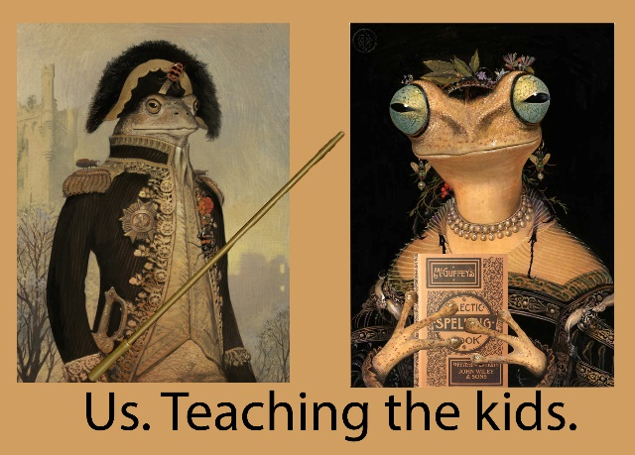
Ribisi (16:39): Thank you for liking it. No one else did. How about you, Ellie? Do you remember any, any memes or videos or anything about Corona that you liked?
Ellie (16:49): I liked this one, my dad kept sending everywhere. It's basically said wearing a mask like this and it showed a person waring a mask under his nose. [Addy looks shocked! And puts her finger to her lips to shush Ellie up.]
Ribisi (17:00): Go ahead. No, it's okay. Go ahead.
Ellie (17:03):
It's like your underwear like this and like, yeah.
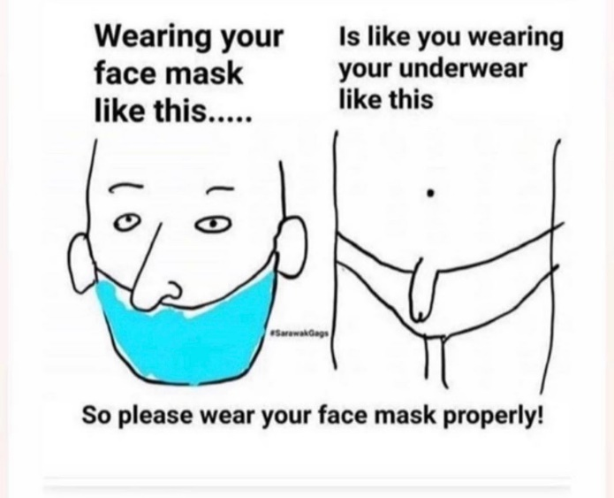

Ribisi (17:07): Okay. All right. So that made you laugh, huh?
Ellie: Yeah.
Ribisi: Okay. So I think those are my questions pretty much.
Ribisi: Do you have any other, anything else? We'll go with Eloise first. Is there anything else you'd like to say about things funny or jokes or humor during the virus period? Anything else you can think of?
Ellie (17:53): Well, I definitely noticed my animals being hilarious around the house.
Ribisi: Really? Like what?
Ellie: well, I usually ..Addy, would you like to say something about your rats?
Addy: Yeah, it has been a good time to hang out with our animals. I have two little rats and I've had a lot of time to hang out with them and they're really, really funny and kind of crazy. And there, cause there are some definitely some pros to being at home.
Ribisi (18:33): Oh, cool. And is that one of them?
Addy (18:37): Yes. Yeah. Being able to spend so much time with your pets and your family. That is definitely a pro. And I have, I have noticed I've been like cleaning my room more. Cause I mean, there's not much else to do.
Ribisi: Good, good.
Ribisi (18:56): Ellie, how about you? Anything else you'd like to say?
Ellie (19:01): Can I say one about animals again?
Ribisi: Of course.
Ellie: So my dog, well, yeah, her name is Ginger. She is very cute and small. She also likes to lick a lot. One time. I was pretty much asleep. It was pretty late, so I was getting tired and she just came and jumped up on my bed and I'm like, hi. And then she started wagging her tail and she wagged it in my face, like on my face. And then she went and barked at my window.
Ribisi (19:37): That's nice. Little Ginger. Okay. Anything else either one of you want to say about humor? About laughing?
Addy (19:44): Yeah. it's really important, to have humor like during this time and kind of try to flip the situation around, so it's not so bad. So like if you come across something that makes you laugh, maybe share it with people and make them smile too.
Ribisi (20:12): That sounds lovely. Thank you. Okay. So that's the end of the interview and I'm going to turn off the recorder now. Okay. Okay. Okay. Okay. It's off.

