Translation for item number 17335 by Angelica S Ramos 06/22/2021
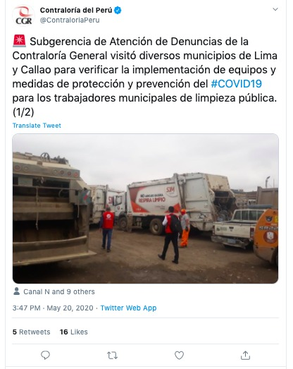
The Deputy of Care of Denucas visited several municipalities of Lima and Callao to verify the implementation of equipment and measures of protection and prevention against #COVID19 for the municipal workers of public cleaning. (1/2)
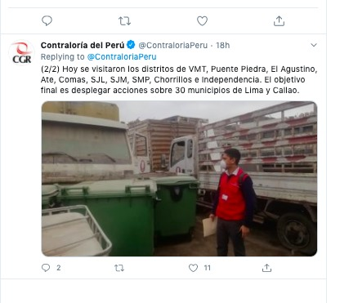
(2/2) Today the VMT districts, Puente Piedra, El Agustino, Ate, Comas, SJL, SJM, SMP, Chorrillos and Independencia were visited. The ultimate goal is to take action against 30 municipalities in Lima and Callao.

