Translation of item number 16240 by Angelica S Ramos 06/29/2021
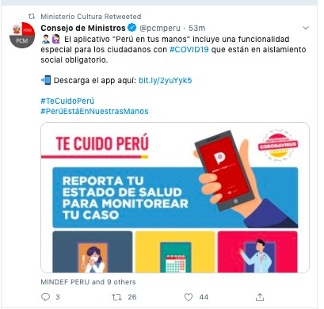

Ministry advice – The app “Peru in your hands” includes a special functionality for those with #COVID19 who are in mandatory social isolation.
Upload the app here: bit.ly/2yuYyk5
#Take CarePeru
#PeruIsInOurHands

I TAKE CARE OF YOU PERU

REPORT YOUR HEALTH STATUS TO MONITOR YOUR CASE

