Translation of item 12310 by Angelica S Ramos 07/06/2021
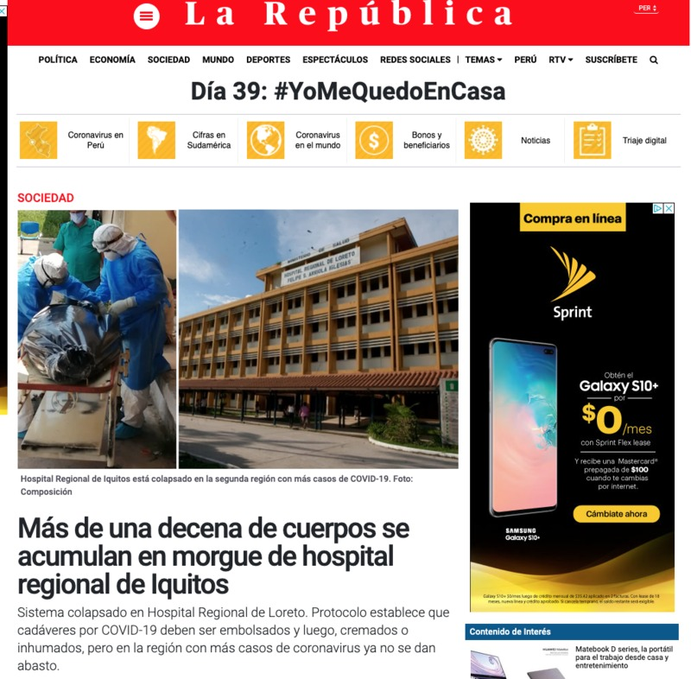
The Republic
Day 39: #IWillStayAtHome
MORE THAN ONE DOZEN BODIES ARE COMULATED IN HOSPITAL MORGUE IN IQUITOS

Collapsed system in Loreto Regional Hospital. Protocol states that deaths cause by COVID-19 must be embalmed and then cremated or inhumed, but in the region with more cases of coronavirus they are no longer supplied

